PRE-CONSTRUCTION INFORMATION

Responsive Repairs and Maintenance Framework – Ref 01003

1 Project Details

1.1 Description of Project
Tai Tarian is seeking to appoint contractors to participate in a responsive repairs and maintenance framework.
Contractors will be expected to deliver an effective service to our tenants in occupied properties across Tai Tarian’s area of operation (Appendix 1).
The successful contractors will complement Tai Tarian’s in house maintenance service. Lots to be included are:
- Domestic plumbing (excluding hot water systems) – In and out of hours
- Domestic electrical – In and out of hours
- Carpentry on fire door installation and maintenance – In hours
- Plastering – In hours
- Installation and maintenance of communal aerials – In hours
- Replacement of flooring in kitchens and bathrooms – In hours
- External works to paths, walls and fences – In hours
- Fabrication of handrails, fencing and gates – In hours

Works are to be complete in accordance with the M3NHF Schedule of Rates for Responsive Maintenance (Version 8).

1.2 Key dates of the Construction Phase
  - Planned start date: 1st April 2026

  - Duration:

    - Plumbing – 1 year
    - All other lots - 4 years

  - Planned completion date:
    - Plumbing – 31st March 2027
    - All other lots - 31st March 2030

1.3 Information for HSE Notification “F10”
  - The minimum time to be allowed between appointment of the principal Service Provider and instruction to commence work on site: 2 weeks.
  - Maximum number of people planned to be on site at any time: 3-4 per property.
  - Number of Service Providers planned to be used: up to 2

1.4 Duty Holder Details
Client
Name: Clare Way
Position: Director of Operations
Office Tel: 01639 506620
Mobile Tel: NA
E-mail address: clare.way @taitarian.co.uk
Address: Tŷ Gwyn, Baglan Energy Park, Brunel Way, Neath
Postcode: SA11 2FP

Designer
Name: Tai Tarian Limited
Position:
Office Tel: 0300 777 0000
Mobile Tel:
E-mail address: safety@taitarian.co.uk
Address: Tŷ Gwyn, Baglan Energy Park, Brunel Way, Neath
Postcode: SA11 2FP

Principal Designer
Name: Tai Tarian Limited
Position:
Office Tel: 0300 777 0000
Mobile Tel:
E-mail address: safety@taitarian.co.uk
Address: Tŷ Gwyn, Baglan Energy Park, Brunel Way, Neath
Postcode: SA11 2FP

Contract Administrator
Name: TBC
Position: TBC
Office Tel: 0300 777 0000
Mobile Tel:
E-mail address: TBC
Address: Tŷ Gwyn, Baglan Energy Park, Brunel Way, Neath
Postcode: SA11 2FP

1.5 Will the structure be used as a workplace (in which case, the finished design will need to take account of the relevant requirements of the Workplace (Health, Safety and Welfare) Regulations 1992)
Not applicable – Residential Dwellings

1.6 Extent and location of existing records and plans
Not available

2 Client’s considerations and management requirements
Arrangements for:

2.1 Planning for and managing the construction work, including any health and safety goals for the project
It is proposed that the work will be carried out by suitably experienced Service Providers.
The appointed Service Providers will be required to submit all relevant site-specific documentation in respect of the management of health and safety in the form of a developed Construction Phase Plan, prior to the works commencing. This should include detailed Method Statements, Risk Assessments and COSHH assessments.

A pre-construction meeting will be held before the contract commences and subsequent progress meetings will be held on a regular basis (monthly or quarterly) between the Client and each Service Provider, or more frequently if deemed required by the Client

Tai Tarian will appoint a designated Works Inspector (Team Leader) to the project who will visit work locations site on a regular basis during the construction phase at each property.

It is necessary that all works are planned and programmed to minimise risk to non-construction personnel. Each Service Provider is to consider the following project specific safety goals and to demonstrate how these will be delivered in the construction phase plan.

• No RIDDOR reportable accidents
• Minimal disturbance to property being worked on and neighbouring properties
• Minimal noise and dust, or other environmental impact
• Protection of Public
• All accidents and near-miss reports’ together with the recommendations for preventing re-occurrence shall be provided to the Client

Periodic safety inspections will be carried out on behalf of the Client throughout the duration of the project to ensure ongoing compliance with health and safety arrangements.

Materials or tools must not be stored within the Property, including communal areas or gardens.

As properties will be occupied during the works the Service Provider shall take all reasonable steps to ensure that inconvenience and disturbance to the occupiers is minimised.

The Service Provider is to allow for protection of all fixtures and fittings including carpets. Move, take up, reinstall and replace all furniture, fittings and fixtures as may be necessary to execute the works. Re-position items of furniture and appliances at the end of each working day whether work is completed or not.

The Service Provider is to make good to all adjacent structures and surfaces disturbed during the works, whether specifically mentioned or not. Any damage caused by carelessness or want of skill on the part of the Service Provider shall be immediately made good at the Service Providers expense.

All works to be carried out:

- In hours contracts - Monday-Friday between the hours of 08.00 – 16:30. No Weekend working permitted without prior consent of Tai Tarian.
- Out of hours contracts - The OOH service runs between the hours of: -
  - 16:00 and 08:00 Monday to Thursday
  - Weekends from 16:00 Friday through to 08:00 Monday.
  - During bank holidays or business closures.

Noise levels must be kept to a minimum. The use of radios on site is not permitted.

Tai Tarians’ goal is to aspire to zero accidents throughout the project duration.

2.2 Communication and liaison between client and others
Communication between parties privy to the contract will be co-ordinated by the Contract Administrator and will include Pre-Construction meetings, and regular site meetings regarding progress and safety inspections.

Tenant Liaison Officer(s) will be appointed to coordinate the requirements of tenants at each property.
Regular communication between all parties is required on this contract.

2.3 Security of the site
The Service Provider will be responsible for ensuring that the working area is secured during the undertaking of the works and that the property is secured at the end of each day.

2.4 Welfare provision
The Principal Service Provider must provide temporary and suitable welfare facilities for the duration of the contract.

Requirements relating to the health and safety of the client’s employees or customers of those involved in the project

2.5 Site hoarding requirements
Hoarding is not required at domestic properties. Hoarding / fencing will be required at any site compound that is established.

2.6 Site transport arrangements or vehicle movement restrictions
The sites are located in residential areas - parking facilities are not provided on site. The Service Provider must ensure that the movement of traffic is not obstructed and that Service Provider vehicles must not be parked on pavements, grass verges etc. Consideration must also be made of parking restrictions, which apply locally.

2.7 Client permit-to-work systems
Tai Tarian do not operate a permit to work system. It is the Service Provider’s responsibility to carry out their own where required.

2.8 Fire precautions
The Service Provider is responsible for the fire safety of each premises being worked in for the duration of the work. All work activities must limit the risk of fire as far as practicably possible. No flammable materials are to be stored on site at any time throughout the contract. Hot work will be undertaken in this contract so reasonable precautions will need to be carried out.

2.9 Emergency procedures and means of escape
The Service Provider is required to prepare a schedule of emergency procedures and submit them with their health and safety documentation.

2.10 ‘No-Go’ areas or other authorisation requirements for those involved in the project
Consultation will need to be arranged with Tai Tarian Limited to agree working areas prior to commencement of any work. The work is confined to the identified properties. Where Tai Tarian properties adjoin privately owned properties, the Service Provider is to ensure that no plant, materials, debris or personnel trespass onto same.

2.11 Any areas the client has designated as confined spaces
Works may be carried out within attic areas, and suitable and sufficient Risk Assessments and Method Statements will be required.

2.12 Smoking and parking restrictions
Strict no smoking policy at any time while at the premises.
Parking restrictions may apply locally.

3. Details of environmental restrictions and existing on-site risks, and safety hazards.

3.1 Boundaries and access, including temporary access – for example narrow streets, lack of parking, turning or storage space
Limited boundary access is available on the sites and the Service Provider is to take account of this with regard to safety in his tender submission.
Storage space is also limited and must be curtailed within the agreed Service Provider’s working enclosure.

3.2 Any restrictions on deliveries or waste collection storage
Consideration must be given to the residential nature of the streets in which the properties are contained. Deliveries and collections must be restricted to the working hours indicated above with any disruption to the normal flow of traffic limited to as short a period as possible. The areas are densely populated areas, with narrow roads.

3.3 Adjacent land uses – for example schools, railway lines or busy roads
The properties will be within residential areas. The work must be carried out with due consideration for the residents within these areas.

3.4 Existing storage of hazardous materials
No known hazardous materials currently stored at properties.

3.5 Location of existing services particularly those that are concealed
The properties will be serviced by mains gas, telecommunications, electricity, water and sewers.
The Service Provider is to satisfy themselves on the location of these services prior to the commencement of any work.
The Service Provider shall liaise with Statutory Authorities concerning working under or adjacent to live electricity cables, telecom and cable television cables.
Adequate safe systems of work must be developed and documented for each property.
The Service Provider must protect and maintain existing services at all times, inform the Customers prior to disconnection and adaptation Works, which are to be for the minimum period possible. No services are to be left disconnected overnight.

3.6 Ground conditions, underground structures or water courses where this might affect the safe use of plant, for example cranes, or the safety of ground works
Not applicable as all planned work is contained within the properties.

3.7 Information about existing structures – stability, structural form, fragile or hazardous materials, anchorage points for fall arrest systems (particularly where demolition is involved),
There are no recorded problems relating to the structural stability in the properties.

Asbestos containing materials may be present in all of the properties.
An Asbestos survey will be carried out by the Employer and any ACM’s identified will be removed prior to commencement of the Service Providers works.
If during the course of the work the Service Provider suspects any materials may contain asbestos, works shall be stopped, and a sampling request issued to Tai Tarian. Refer to 3.12 below.

3.8 Previous structural modifications, including weakening or strengthening of the structure (particularly where demolition is involved),
Any structural modifications discovered by the Service Provider to be notified Tai Tarian Limited with immediate effect.

3.9 Fire damage, ground shrinkage, movement or poor maintenance which may have adversely affected the structure
Not applicable

3.10 Any difficulties relating to plant and equipment in the premises, such as overhead gantries whose height restricts access
Not applicable

3.11 Health and safety information contained in earlier design, construction or ‘as-built’ drawings, such as details of pre-stressed or post tensioned structures
Not applicable

Health hazards, including
3.12 Asbestos/Hazards
No work is to be undertaken in any Tai Tarian properties unless a suitable and sufficient Asbestos Survey has been completed. All Service Providers must request an asbestos survey for the properties allocated to them and a copy must be kept on site for the duration of the work.
The Principal Service Provider is to ensure that there are adequate safe systems of work in place should ACMs be identified. They will need to be vigilant when carrying out the works and if they suspect the presence of any Asbestos Containing Materials (ACM’s) they are to stop work and follow Tai Tarians’ asbestos procedure.

Where possible, Tai Tarian will arrange for all asbestos containing materials likely to be disturbed to be removed prior to the Service Provider starting on site. However, should any suspect materials be identified during the course of the contract, or where suspected but not confirmed in the original survey, the Service Provider will need to contact Tai Tarian to arrange sampling to ascertain the presence of asbestos. During this process, no work should take place on or near any materials suspected of containing asbestos.
Any damage to asbestos containing materials must be reported immediately and work stopped, and the emergency procedures followed.

No Service Provider personnel should work in or on a Tai Tarian property unless they have up to date asbestos awareness training as a minimum – evidence of training records should be provided with the tender submission and kept up to date for the duration of the contract.

Any asbestos related enquiries should be addressed to Tai Tarian at: asbestos@taitarian.co.uk.

Hazards
Biohazards and sharps:
The Principal Service Provider is to ensure that there are adequate safe systems of work in place. Where Hazards or sharps are identified, consultation with Tai Tarian Works Inspector must take place to determine the correct course of action.

3.13 Contaminated land, including results of surveys
Currently no known land contamination.

3.14 Health risks arising from client’s activities
None identified.

4 Significant design and construction hazards

4.1 Significant design assumptions and suggested work methods, sequences or other control measures
The scheme has been designed in compliance with the employers’ requirements. Once work commences in a property it must be continuous without interruption until completion. The Service Provider is required to determine the sequence of work involved, provide, and show the sequence on a master programme with key dates etc. highlighted.

4.2 Arrangements for co-ordination of ongoing design work and handling design changes
Any design changes will be communicated to the Service Provider by Tai Tarian Limited and recorded on the project job file for subsequent cost amendments.

No extra work can be invoiced without a signed official Tai Tarian Site Instruction.

4.3 Information on significant risks identified during design
  - Noise & Vibration from use of handheld tools,
  - Working at height and the use of ladders,
  - Manual handling of materials,
  - Working in confined spaces,
  - The use of disc cutters,
  - Transfer of material to and from working area,
  - Gas - Appropriate Isolation and testing by competent persons,
  - Hot works - welding/grinding,
  - Working near overhead electricity cables - which must be sheathed before work begins,
  - Electricity - upgrading of internal wiring, changing electrical accessories,
  - Aggressive or abusive behaviour by tenants / visitors – Tai Tarian’s “Client Alert” process will be used to notify the Principal Service Provider in advance of work commencing at a property.

4.4 Materials requiring particular precautions
- Asbestos Containing Materials e.g., Textured coatings, Vinyl floor tiles. asbestos-cement based materials
- The use of Silicone type products, plumbing flux, solvents, and adhesives etc. based materials will require appropriate COSHH Assessments.
- Floor coverings that may contain asbestos.
- The use of cement-based products.
- Mineral Fibre Insulation
- Water proofing solutions
- Treated timbers
- Use of aggregates

5 The health and safety file
The Service Provider is required to provide all relevant site-specific paperwork for the property to Tai Tarian Limited inclusive of:

- Electrical Test Certificates - where appropriate
- Gas Safety Certificates – where appropriate
- Material Safety Data Sheets.
- Services – certificates for all works carried out.
- Waste tipping certificates – where appropriate.
- Waste transfer notes

All product information, data sheets, certificates, and guarantees to be submitted by the Service Provider in electronic format.
Note
All information contained within this PCI is provided for information only and to assist the Service Provider to develop his Health & Safety procedure and Construction Phase Plan.

Appendix 1 – Electoral Wards/Post Codes

Neath Port Talbot – Electoral Wards

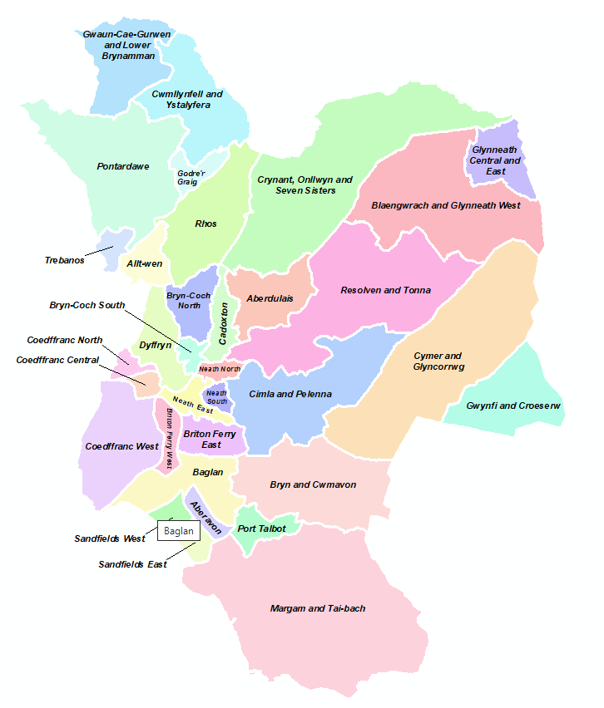
Source: https://www.npt.gov.uk/1286

Number of properties by Ward

Ward | No. |  | Ward | No.
ABERAVON | 213 |  | MELIN | 217
ABERDULAIS | 12 |  | NEATH NORTH | 258
ALLTWEN | 99 |  | NEATH TOWN CENTRE | 152
BAGLAN | 148 |  | OAKWOOD | 15
BLAENGWRACH | 97 |  | ONLLWYN | 39
BRITON FERRY | 509 |  | Outside NPTCBC | 6
BRYN | 46 |  | PELENNA | 79
CADOXTON | 40 |  | PENCAERAU | 242
CAEWERN | 231 |  | PONTARDAWE | 370
CILFREW | 48 |  | PORT TALBOT | 17
CIMLA HILLSIDE | 329 |  | RESOLVEN | 153
CIMLA TOP | 227 |  | RHOS | 43
CRYNANT | 121 |  | ROMAN WAY | 22
CWMAVON HIGHER | 237 |  | SANDFIELDS EAST 1 | 513
CWMAVON LOWER | 283 |  | SANDFIELDS EAST 2 | 273
CWMLLYNFELL | 82 |  | SANDFIELDS LITTLE WARREN | 141
CYMMER | 390 |  | SANDFIELDS WEST 1 | 381
DYFFRYN RHONNDA | 22 |  | SANDFIELDS WEST 2 | 481
GLYNCORRWG | 77 |  | SEVEN SISTERS | 203
GLYNNEATH | 186 |  | SKEWEN CENTRAL | 314
GODRERGRAIG | 22 |  | SKEWEN LOWER | 149
GOYTRE | 43 |  | TAIBACH | 24
GWAUN CAE GURWEN | 291 |  | TONNA | 110
GWYNFI | 66 |  | TREBANOS | 89
LLANDARCY / JERSEY MARINE | 43 |  | VELINDRE | 42
LONGFORD | 125 |  | YNYSMEUDWY | 153
LOWER BRYNAMMAN | 84 |  | YSTALYFERA | 306
MARGAM | 204

Number of properties by Post Code

Post Code | No. |  | Post Code | No.
SA1 6A | 3 |  | SA9 2G | 21
SA1 6R | 1 |  | SA9 2H | 16
SA7 9Q | 2 |  | SA9 2J | 33
SA8 3A | 93 |  | SA9 2N | 3
SA8 3B | 5 |  | SA9 2Q | 9
SA8 3D | 1 |  | SA9 2R | 18
SA8 3E | 15 |  | SA10 6 | 506
SA8 3H | 28 |  | SA10 7 | 378
SA8 4A | 2 |  | SA10 8 | 221
SA8 4B | 1 |  | SA10 9 | 242
SA8 4D | 86 |  | SA11 1 | 435
SA8 4H | 34 |  | SA11 2 | 919
SA8 4J | 52 |  | SA11 3 | 690
SA8 4L | 50 |  | SA11 4 | 153
SA8 4N | 214 |  | SA11 5 | 283
SA8 4P | 20 |  | SA12 6 | 1108
SA8 4Q | 153 |  | SA12 7 | 892
SA8 4R | 6 |  | SA12 8 | 151
SA9 2A | 86 |  | SA12 9 | 614
SA9 2B | 5 |  | SA13 1 | 73
SA9 2D | 27 |  | SA13 2 | 302
SA9 2E | 143 |  | SA13 3 | 555
SA9 2F | 43 |  | SA18 1 | 375

