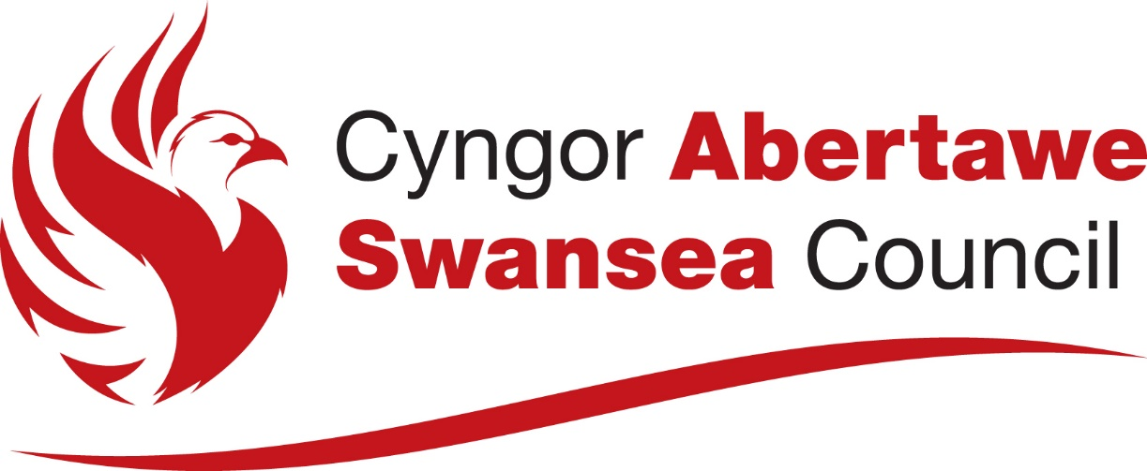

Swansea Council E-Cycle Hire Scheme
Preliminary Market Engagement
Procurement Policy Note (PPN)

Swansea Council

February 2026

Table of Contents
1. Introduction 1
1.1 Project summary and objectives of this preliminary market engagement 1
1.2 Indicative timelines 1
2. Engagement process 1
2.1 Response format 1
2.2 Timeline 2
2.3 Opportunity to meet with Swansea Council 2

Tables
Table 1: Indicative timelines 1

Introduction

Project summary and objectives of this preliminary market engagement
Swansea Council is exploring the procurement of a city-wide rental micromobility scheme, with an initial focus on e-bikes and associated services, to support its wider transport, environmental, and economic objectives. Swansea Council is engaging with the micromobility market to explore options and approaches for a city-wide rental e-bike scheme. This Preliminary Market Engagement (PME) exercise will be used to test the feasibility of Swansea Council’s indicative proposals, explore potential delivery models, and understand market capacity and appetite ahead of any future procurement.
The objectives of the PME are to:
- Provide advance notice that Swansea Council is considering undertaking a tendering exercise to set up a rental e-bike scheme contract;
- Understand market interest in the proposed procurement;
- Provide a high-level overview of the project and its objectives;
- Understand market feedback on the draft scope of services; and
- Identify suppliers interested in participating in a Market Sounding Questionnaire and/or 1:1 discussion with Swansea Council as part of PME process.

Engagement process

Response format
Participants are requested to respond to the questions in the optional Market Sounding Questionnaire using the link provided. Participants are advised that:
- Participants response to the Market Sounding Questionnaire must be submitted via MS Forms.
- Responses should not include executive summaries or any general marketing, promotional and/or company literature, as well as confidential or sensitive information in their responses.
- Participants are advised that information submitted via URL links to content shall not be considered.
- Responses should be factual, comprehensive and succinct.

Indicative timelines
The indicative timeline in Table 1 sets out the provisional schedule for PME activities. They may be subject to change as the project develops and does not commit Swansea Council to any specific procurement process or delivery timetable.
Table 1: Indicative engagement timelines
Item | Deadline for Completion
Issue date for PME documents | W/C 23rd February 2026
Last day to request an optional 1:1 virtual meeting with Swansa Council. | 4th March 2026
Last day to complete optional Market Sounding Questionnaire | 6th March 2026
Optional follow-up 1:1 virtual supplier discussion with Swansea Council | W/C 9th of March 2026

Opportunity to meet with Swansea Council
Alongside the completion of the optional questionnaire, Swansea Council would like to invite any participants to an optional virtual 1:1 meeting of no more than 45 minutes to discuss the scope of services the participant can offer in response to this PME.

Should a participant wish to take part in this opportunity, please confirm via email message to Stephen.Williams1@Swansea.gov.uk and Katie.Watkins@Swansea.gov.uk no later than 4th March 2026.

Swansea Council reserves the sole discretion, to proceed or not, with all or any optional virtual 1:1 meeting request(s).

