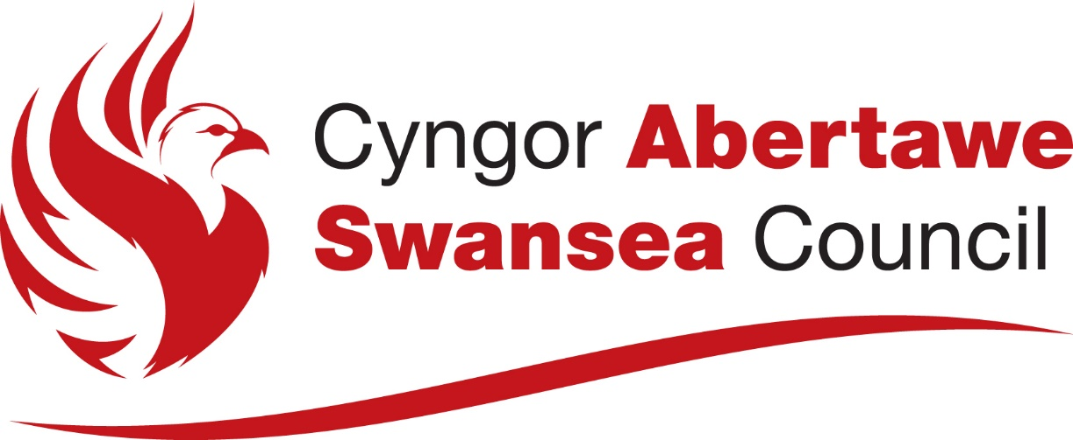

Swansea Council E-Cycle Hire Scheme
Preliminary Market Engagement
Project Information

Swansea Council

February 2026

Table of Contents
1. Project Information 1
2.1 Overview 1
2.2 Scope of services 1
2.2.1 Operating area 1
2.2.2 Fleet size 2
2.2.3 Scope of Service 3

Figures
Figure 1: Swansea rental e-bike scheme indicative operating area 2

Tables
Table 1: Swansea rental e-bike Swansea rental e-bike scheme indicative fleet size and parking bay requirements 3
Table 2: A high-level draft of the scope of services 3

Project Information

Overview
Swansea Council is considering developing a new city-wide rental e-bike scheme, designed to provide a high-quality, accessible and a reliable rental micromobility service for residents, students, workers and visitors. The project aims to address gaps in the public transport network, support active travel adoption and contribute to the city’s wider decarbonisation priorities.
The project will build on lessons learned from previous engagement and lessons learned from existing micromobility schemes in the UK, as well as local evidence from the existing Swansea University bike share scheme which has been in operation since July 2018.
The scheme objectives have been developed and refined to incorporate considerations around usability, commercial viability and policy alignment. The draft scheme objectives are:
  - Operate a high quality, reliable and scalable city-wide rental micromobility service.
  - Enhance integrated travel to support sustainable modal shift.
  - Improve accessibility to support social inclusion and community health and wellbeing.
  - Maximise potential of long-term commercial viability.
  - Support economic growth, city attractions, and placemaking.
The project is progressing through WelTAG Stage 3. It is anticipated that capital funding will support the procurement, mobilisation, physical parking infrastructure and subsidy of e-bikes.
Swansea Council proposes to launch the scheme in Autumn 2026/Spring 2027, for an initial five-year contract, with the option to extend for a further two years.

Scope of services
The Council is yet to confirm the indicative scope of services and key requirements; it is the intention of this PME to gather feedback from the market to help inform the development of detailed requirements for the contractual specification.
It is currently proposed that the Swansea rental e-bike scheme will operate city-wide. There will be a denser parking network in and around the city centre, and other areas of high demand and activity.
Swansea Council would welcome feedback from the market on the indicative operating area, target fleet size and parking requirements, outlined below.

Swansea Council is exploring different commercial and operating models for the rental e-bike scheme and would welcome feedback from the market on preferred commercial models and operating models (Swansea Council owned and privately operated or privately owned and privately operated) and any relevant considerations based on the market’s experience.

Operating area
Figure 1 outlines the proposed initial operating area, with the potential for scheme expansion across City and County of Swansea. Note that this map is indicative and subject to change and is therefore provided for illustrative purposes only to show the proposed geographical scope of the scheme.

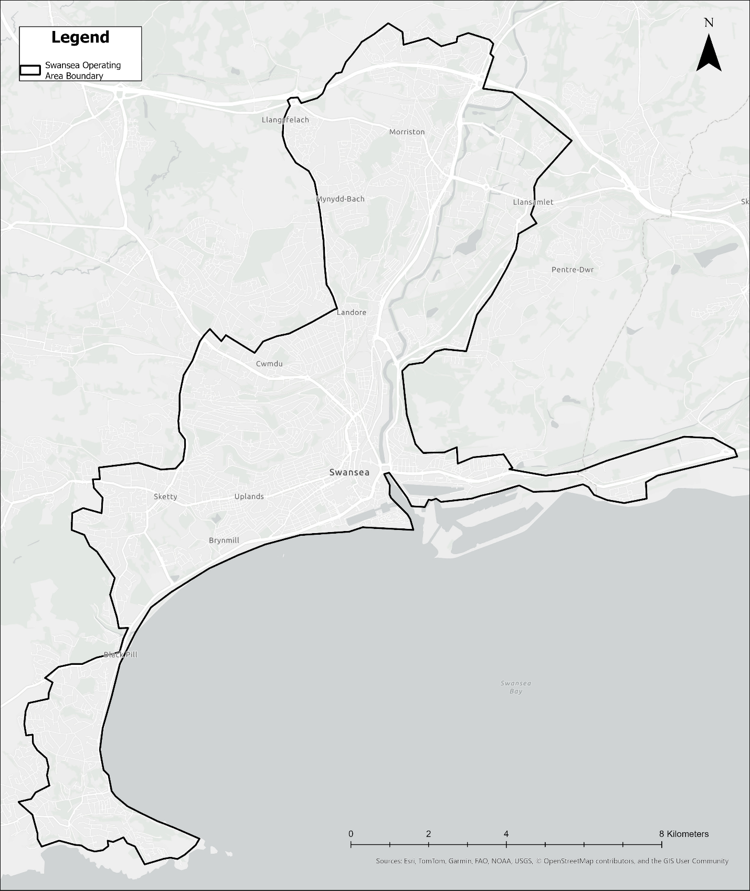
Figure 1: Swansea rental e-bike scheme indicative operating area

Fleet size
Table 2 outlines the minimum indicative target fleet size and parking bay configuration. Note that these figures are indicative, draft, and subject to change and are provided to illustrate the proposed minimum target fleet size and parking requirements only.

Table 1: Swansea rental e-bike Swansea rental e-bike scheme indicative fleet size and parking bay requirements
Zone | Minimum Target Number of Vehicles | Minimum Target Number of Bays | Minimum Target Number of Parking Spaces | Average Number of Spaces per Bay
Indicative Operating Area | 500 e-bikes | 130 | 1,400 | 6-20 per bay (location dependent)

Scope of Service
A high-level draft of the scope of services and requirements is presented in Table 3. Swansea Council is yet to confirm any of these aspects and welcomes feedback from the market to help inform the development of detailed requirements for the contractual specification.
Table 2: A high-level draft of the scope of services
# | Specification | Indicative requirements
1 | Strategy and Scheme Design | - Operating area: covers the city of Swansea, including central Swansea, Mumbles, Morriston Hospital, the two universities, and significant employment sites such as Amazon. Expansion within Swansea Council or into neighbouring Neath Port Talbot may be agreed by mutual consent. As Swansea University’s Bay Campus is located within Neath Port Talbot, it is anticipated that agreement could be reached between Swansea Council and Neath Port Talbot to include this site within the scheme’s operating area.  - Fleet mix: e-bikes only (e-scooters to be considered subject to regulation/legislation change in Wales).  - Target fleet: Minimum 500 e-bikes, to be scaled to this limit during an operational mobilisation phase.  - Age limits: 16+  - Time of operation: 24 Hours per day / 7 days per week.  - Branding: opportunity to include partnership with local stakeholders.  - CoMoUK: operator to be CoMoUK accredited.
2 | Parking and Operations | - Parking model: designated geofenced parking bays only.  - Minimum target number of parking bays: 130.  - Physical parking infrastructure: in high usage areas physical parking infrastructure to be considered.  - Geofencing: areas where power assist will be inactive to be specified.  - Application Programming Interface (API) access: operator to provide Swansea Council access to their API.  - Data: data to support monitoring of Key Performance Indicators (KPIs). The operator is required to collect user data and comply with GDPR. Formats required expected to include Mobility Data Specification (MDS) and General Bikeshare Feed Specification (GBFS).  - KPIs: fleet size and availability, parking compliance and tidiness, customer satisfaction and service uptime.  - Operations & maintenance: operator to undertake battery swaps and fleet balancing to ensure good availability across the scheme.  - Theft & vandalism: operator to manage issues of asset theft/vandalism and recovery of abandoned vehicles.
3 | User Experience | - Customer service: 24/7 customer service provision in compliance with Welsh language legislative requirements, ensuring full support and correspondence in both Welsh and English.  - Smartphone app: dual-language (Welsh and English) smartphone app.  - User onboarding: training, verification and secure payment.
4 | Commercial | - Capex funding: Swansea Council may support a percentage of the upfront capex cost of the purchase of the bikes. As an alternative model, the Council may retain ownership of the fleet, leasing it to the Operator and selling it back at a residual cost at the end of the contract.  - Revenue funding: fixed annual fee from revenue funding to cover the Council’s contract management costs, with the exact amount to be determined by agreement.  Open book accounting: operate an open book approach with Swansea Council through quarterly reporting of ongoing income/expenditure. For transparency as well facilitating the approach toward the commercial management of the scheme.  - Customer fares and passes: The operator to set out fares and passes in the tender. Fares and passes to be fixed for the first two years, after which yearly indexation is permitted.
5 | Deliverability | - Contract duration: five-year contract + two-year extension.  - Contract type: Concession.  - Multi/single operator: single operator.  - Change control: by mutual agreement between Swansea Council and operator.
6 | Management | - Reporting: scheme performance recorded weekly/monthly/quarterly and regular contract management meetings with the Council.  - KPI penalties: council to establish criticality levels and financial penalties.  - Data management: operator API or third-party web-based dashboard.  - Monitoring and Evaluation: operator should support M&E activities including sharing data, facilitating user surveys and engagement activities.

