Appendix 3 - Bridge kit examples

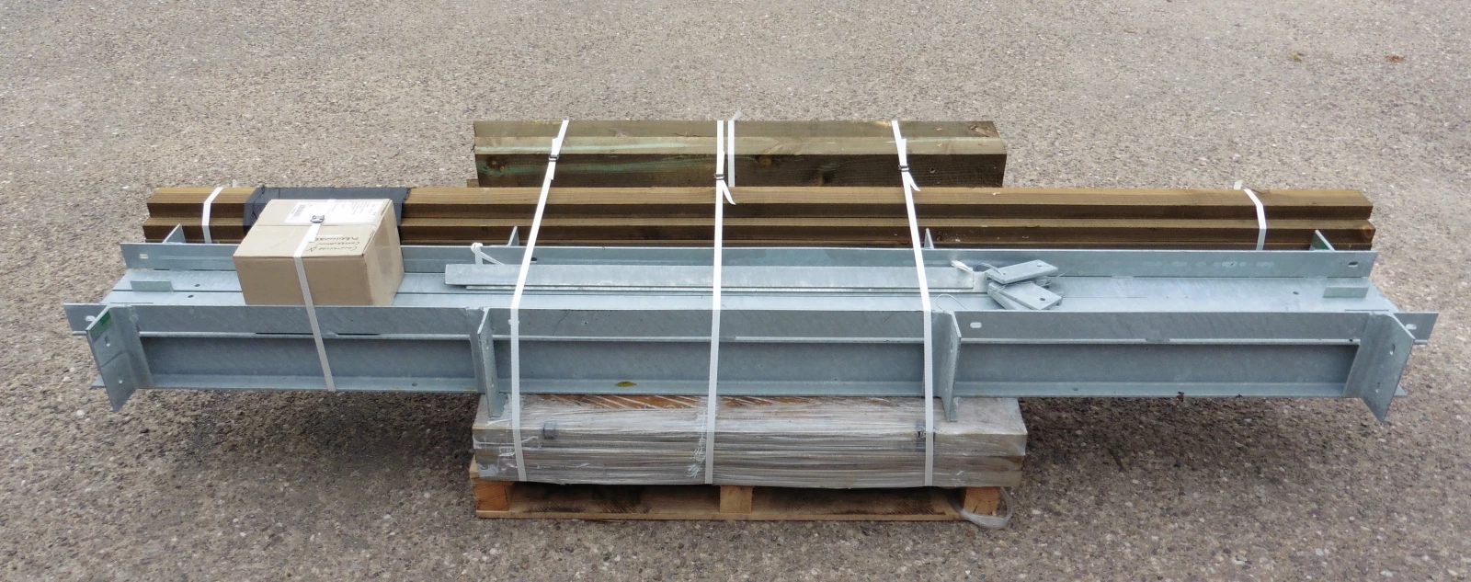

This is an example of how you can expect your bridge kit to arrive

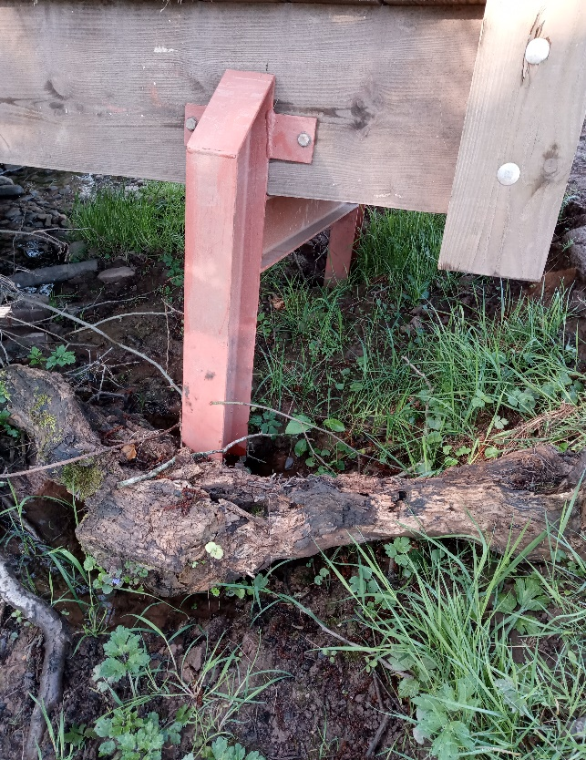

This is an example of a supporting H-frame

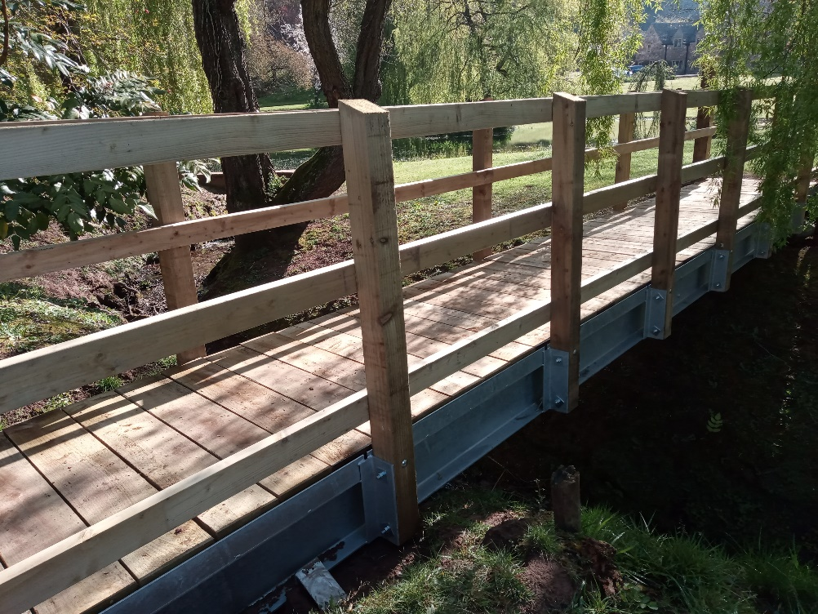

Example of how the kit bridge should look once assembled

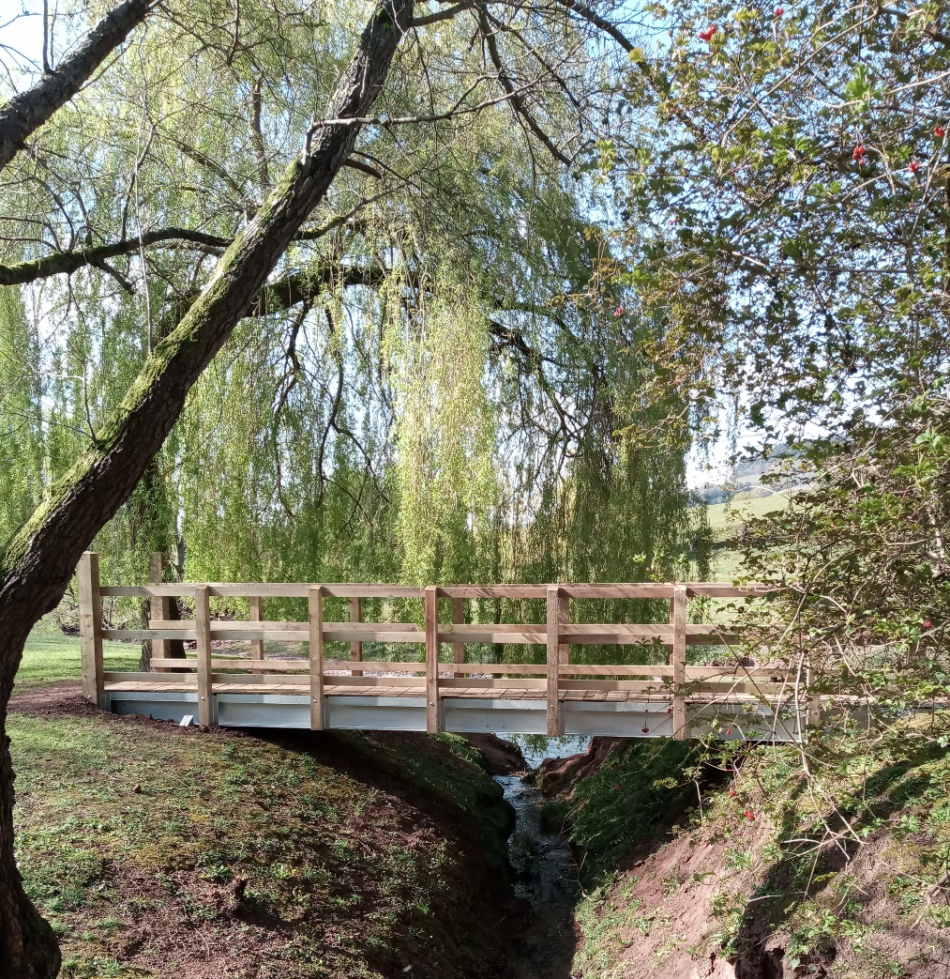
Example of a footbridge in situ

