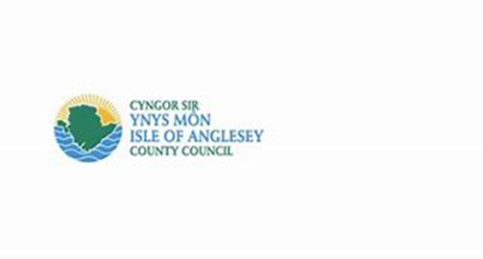

Document 2: Specification For:

Design, Build and Installation of Sculptures at Market Street, Holyhead
1 INTRODUCTION

The Isle of Anglesey County Council is seeking a competent consultancy to design, build and install 4 Corten steel sculptures as part of wider improvements to the Crown site, Market Street, Holyhead.

The site is located on the land of the former 89-97 Market Street, Holyhead, is a vacant property on the entrance to the Market Street and adjacent to Victoria Road, opposite the Cenotaph. The existing premises is earmarked for demolition by July 2026, having been vacant since 2016 and previously used as the Ex-Serviceman’s club / Pocket Bar.

Upon demolition of the existing premises, the site will be redeveloped into open green space for public use with soft and hard landscaping. The requirement for this project is to design, build and install sculptures to be situated in a memorial garden on the site to commemorate the links between the Port and its residents.

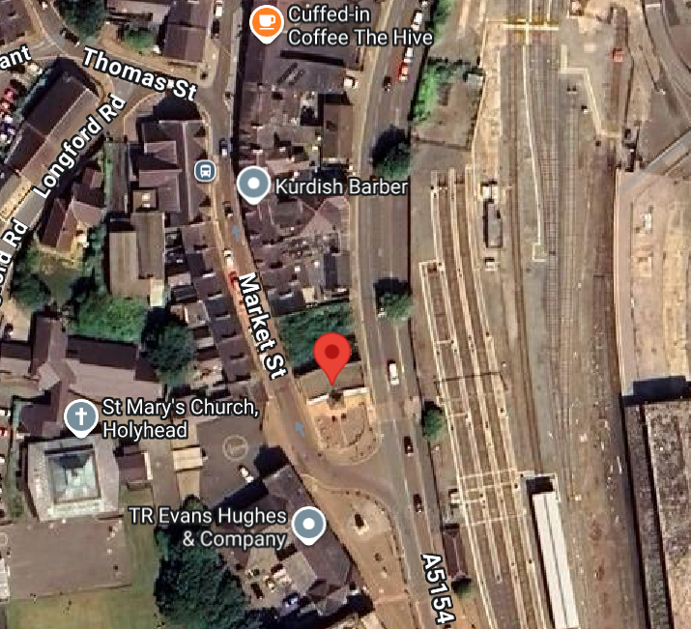

The area surrounding the memorial is used for gatherings on Remembrance Day and the Site itself is the location of town’s Christmas Tree. The Site is located near to the Inner Harbour and is visually connected to this area of townscape. The harbour forms a distinctive feature of the settlement however there are limited views from the Conservation Area towards the harbour due to the inward nature of the historic core. The Site sits in one of the areas that provides a visual and physical link between these two important elements of the town and is visible from the Harbour bridge entrance at the town’s railway station.

Due to the diverse mix of uses around the Site, the area is well used by Pedestrians as they walk to and from various locations within the town. A main bus stop is to the south and there is a signalled crossing to facilitate pedestrian crossing of Victoria Street. There is also a recently added pedestrian crossing (not signalled) between the Site and the east side of Victoria Road.

2 SCOPE

The purpose of this work is to design, build and install four (4) Corten steel sculptures that will form part of a memorial garden. The sculptures need to reflect the maritime and military links of Holyhead’s past. An element of the garden will need to be more general and contribute to quiet reflection.
The visible dimensions of the proposed sculptures are as follows, 900mm (l) x 2000mm (h) 100mm (w).

The final designs will need to be reviewed by the Holyhead Town Council as they will be responsible for their maintenance.

The successful company will be required to initially undertake:
- Review of the site and design of the four sculptures.
- An overview of the current site proposals.
- Liaison with relevant organisations.
- Develop an understanding of the project and its links to the wider community.

The following will need to be considered as part of the brief:
- The maritime history of Holyhead and those lost at sea in particular the Merchant Navy
- The military links to Holyhead
- The need to have an area of quiet contemplation for bereaved families

The successful company must consider the following guiding principles when undertaking the review:
- The diverse range of issues in Holyhead
- The need for objectivity and impartiality
- The use of the Site by the general public
- Links to the Town Centre, Station and Port in particular Cruise Ships

The following images provide an overall concept design for the site following completion:

Image A: Proposed General Arrangement Plan of the redeveloped site

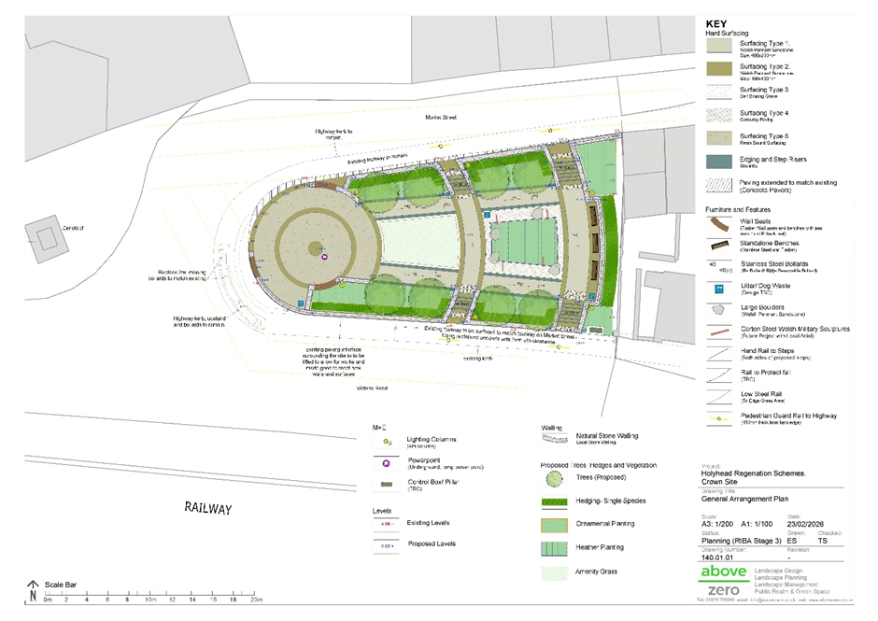

Image B: Proposed Visuals of the sculptures

3 GENERAL REQUIREMENTS

If any problems arise during the tendering process, please use the sell2wales “Postbox” facility. Tender submissions must be submitted through Sell2Wales only. Any submissions through other means will not be accepted.

All necessary tools and machinery shall be provided by the contractor, who shall be responsible for the safe use of these appliances, as may be required for the carrying out of the contract, in accordance with the Health & Safety requirements.

Important- Your employees/representatives are not to deviate from the designated work area.

During the tender period, arrangements to attend the site and assess all local conditions and any restrictions likely to affect the execution of the works. The contractor shall be deemed to have included for any such local conditions or restrictions within his tendered price. Arrangement to visit site can be made with Adam Morris – AdamMorris@ynysmon.llyw.cymru

Full details of the requirements for the project can be found in the supporting documents.

4 PERFORMANCE REQUIREMENTS

The Contractor’s performance and provision of the service shall be monitored by the Authorised Officer.

The Performance Framework, including Outcomes and Key Performance Indicators, will be agreed between the chosen provider and the council, and will be monitored by the council throughout this Contract.

In addition to the Outcomes and Key Performance Indicators, monitoring processes may be put in place in relation to social, environmental and other relevant issues.

The Authorised Officer will work with the Contractor to achieve continuous improvement in the Contractor's performance throughout the duration of the Contract.

5 TIMESCALES AND MILESTONES

The length of contract is estimated to be 44 weeks from appointment in April 2026 to February 2027, when the redevelopment works on-site are due for completion. During this period, the appointed company will be expected to have agreed the design, created and installed the final product(s).

6 CONTRACT / SERVICE MANAGEMENT REQUIREMENTS

The council shall appoint a Contract Manager to act generally in the name of the council for the purposes of this contract (the "Authorised Officer"). The council shall give notice in writing to the Contractor of the identity of any person so appointed and of the replacement of any such person.

Monitoring will focus on the key aspects of the contract including overall performance, quality, price, delivery, customer service, and social value commitments.

The Contractor shall be responsible for monitoring its performance under the Contract and provide the Council with full particulars of any aspects of its performance which fail to meet the requirements of the Contract, unless otherwise notified in writing by the Council.

The council reserves the right, for the duration of the contract, to monitor compliance with information submitted in the Quotation / Tender including as part of the initial screening questions in response to Company Information questions.

The Contractor will be required to submit management and monitoring information in a mutually agreed format to be agreed at the commencement of the Contract.

From time to time the Contractor (and/or any subcontractors) may be requested to attend specially arranged meetings at any of premises of the Customers using this Contract.

The Contractor may, taking into account all requirements arising from the Contract, issue appropriate operating and procedural instructions in writing to all staff engaged in the Contract. These must be approved and copies provided to the council prior to issue.

The Contractor shall provide copies to the council of any instructions, which withdraw, notify or supplement any instructions prior to issue to the individual Customer’s instructions on who is to receive said copies.

The Contractor shall maintain such records in respect of the Contract as the council may reasonably require and shall on request produce them for inspections.

The Contractor shall make available such records for the use of the council when required. They shall not be released, published or disposed of without the prior written consent of the council.

The Contractor shall as required by the council’s representative make written submission or oral presentations of the work done under the Contract in aid of any reviews or of the conduct of business at the locations.

Liaison meetings
Liaison meetings between the council and the Contractor shall be held on an agreed basis or as required by the council or the Contractor. The council will make the necessary arrangements for these meetings, which will be held at premises determined by the council. A record of all meetings shall be made by the Contractor and supplied to and approved by the council.

The Contractor shall arrange for the attendance of such members of its staff and those of its Subcontractors or agents who may be required by the council to attend as necessary.

APPROACHING CONTRACT EXPIRY
Prior to expiry of the initial term of the Contract, the council will notify the Contractor if it wishes to extend the Contract based on price, quality and performance.

To assist any subsequent procurement exercise, the contractor must provide management information data to the lead authority when requested and in a timely manner. Such management information must be provided in the requested format.

7 SKILLS AND EXPERTISE REQUIRED

The appointed contractor should be specialised in design, build and installation of such sculptures or have appointed sub-contractors eligible to undertake these works on their behalf. The appointed company, or the sub-contractors, must have proven experience of delivering such projects to time and cost with consideration for ensuring public safety is prioritised during works.

8 ANNEXES

A complete document list:

Document 1: Invitation to Tender
Document 2: Specification (this document)
Document 3a: Wales Procurement Specific Questionnaire
Document 3B1: Qualitive Response
Document 4: Terms and Conditions
Document 5: Form of Tender and Confidentiality

