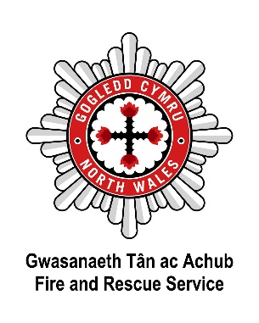

North Wales Fire and Rescue Service Social & Sustainable procurement considerations

1. Sustainable Development
The core principle of the Act is sustainable development, which means balancing the needs of the present with those of the future. In procurement, this means considering how the goods, services, and works being procured will impact the long-term well-being of Wales.

2. Seven Well-being Goals
Procurement must align with the seven well-being goals outlined in the Act:
- A prosperous Wales
- A resilient Wales
- A healthier Wales
- A more equal Wales
- A Wales of cohesive communities
- A vibrant culture and thriving Welsh language
- A globally responsible Wales
Procurement decisions should contribute to these goals, either directly or indirectly.

3. Five Ways of Working
Procurement must follow the Five Ways of Working, which are:
- Long-term: Consider the long-term impact of decisions and whether they contribute to sustainable outcomes.
- Prevention: Prioritise solutions that prevent problems from occurring rather than just addressing issues after they arise.
- Integration: Ensure that procurement decisions integrate with the broader objectives of NWFRS policies and well-being goals.
- Collaboration: Work with other organisations, communities, and stakeholders to achieve collective outcomes where possible.
- Involvement: Involve individuals and communities in decision-making processes to ensure that procurement meets their needs and interests.

4. Well-being Impact Assessments (WIA)
A key requirement in procurement under the Act is conducting Well-being Impact Assessments. These assessments help the service understand how procurement decisions will impact the well-being goals and ensure that the long-term benefits outweigh any potential harm.

5. Monitoring and Reporting
Procurement practices should include regular monitoring and reporting to evaluate how procurement activities contribute to the well-being goals. This can involve tracking sustainability outcomes, social value, and how supply chains impact the environment and communities.

6. Social Value and Ethical Procurement
The Act encourages the integration of social value into procurement decisions, ensuring that contracts deliver not only financial value but also contribute positively to society (e.g. by promoting fair work, environmental sustainability, or community involvement).

