Invitation to Tender for the provision, implementation, and support of a fully integrated Broadcast Management System (BMS)
Competitive flexible procedure pursuant to the Procurement Act 2023

Procurement Timetable
Dates and times | Procurement activity
20/03/26 | Issue Invitation to Tender to Bidders
12:00 on 02/04/26 | Deadline for submitting clarification questions
12:00 on 28/04/26 | Deadline for submitting Tender Responses
28/04/26 to 19/05/26 | Evaluation of Tenders Responses
19/05/26 to 16/06/26 | Highest scoring three bidders may be invited to participate in interviews and/or demonstrations to S4C
16/06/26 | Estimated date for issuing assessment summaries to all assessed Bidders
16/06/26 | Estimated date for publishing contract award notice
16/06/26 to 25/06/26 | Estimated date for standstill period
21/07/26 | Estimated date for entering into the contract
24/07/26 | Estimated date for publishing contract details notice

(See also Section 7)

THIS DOCUMENT IS ALSO AVAILABLE IN WELSH
CONTENTS
1 This Invitation to Tender 1
2 Introduction to S4C 1
3 Definitions 2
4 Overview of S4C’s requirement 6
5 Contract details 7
6 Preliminary market engagement 8
7 The Procurement Process 9
8 Contract terms 10
9 Communications regarding the Procurement 11
10 Requests for clarification 11
11 How to respond to this ITT 12
12 What Bidders are required to submit as part of their Tender Response 13
13 Interviews and demonstrations 16
14 Award criteria 16
15 Clarifications of Tender Responses 17
16 The Tender Response assessment process 18
Appendix 1 Procurement terms and conditions 28
Appendix 2 S4C’s Requirements 37
Appendix 3 Draft Contract terms and conditions 45
Appendix 4 CWMWL Commissioning and Ideas Portal 46
Appendix 5 PAC: Programme as Completed Document Portal 58
Appendix 6 Bidder roadmap and submission guide – how to respond to this ITT 65
Appendix 7 Tender Response Documents 68

The deadline for responding to this Invitation to Tender is 12:00, 28/04/2026. Bidders must ensure that their completed Tender Response is submitted before that deadline. Any late submissions may be rejected.
See paragraphs 7 (The Procurement Process) and 11 (How to respond to this ITT) of this Invitation to Tender in particular for further information.
Please read this Invitation to Tender carefully. Tender Responses that do not comply with the requirements set out in this Invitation to Tender may not be evaluated as part of this Procurement.

This Invitation to Tender
  - This Procurement is being conducted in accordance with the Act using the Competitive Flexible Procedure.
  - This ITT describes how the Procurement will be conducted, including details of the associated Procurement Timetable, award criteria and how to respond to this opportunity. Bidders are strongly encouraged to read this document before preparing their Tender Response.
  - Please read this document carefully, as failure to comply with this document may result in exclusion from the Procurement and/or rejection of any Tender Response.
  - This document should be read in conjunction with the Tender Notice and any other Procurement documents which have been made available at this stage of the Procurement.
  - S4C reserves the right to issue updated versions of this document to Bidders as and when the need arises, in order to reflect any changes to the Procurement or any other new information.
  - Please read and ensure compliance with the Procurement terms and conditions contained in Appendix 1 (Procurement terms and conditions).

Introduction to S4C
  - S4C is conducting a tender process for the provision, implementation and support a fully integrated Broadcast Management System ("BMS" or the "Services") for a period of ten (10) years with an option to extend the contract for a further two (2) years (the "Contract").
  - S4C is the Welsh television channel and one of the UK's five public service media organisations and the only Welsh language public service media organisation. It is an independent broadcasting authority established under the Broadcasting Act 1981 and regulated by the Communications Act 2003 and the Broadcasting Act 1990.
  - This Procurement is being conducted by the Broadcast Technology Directorate within S4C. The Broadcast Technology Directorate is responsible for supporting the Broadcast and enterprise IT Technology used by S4C.
  - For further background information about S4C, please refer to the Annual Report 2024/25, available on the S4C website (s4c.cymru) or by contacting the Viewers’ Hotline:
  - Tel: 0870 600 4141
  - hotline@s4c.cymru

Definitions
  - Common terms and expressions shall have the following meanings ascribed to them:
Defined term | Definition
Act | means the Procurement Act 2023.
Associated Bidders | means a Bidder who is associated with another Bidder if either:  - the Bidders are submitting a tender together; or  - S4C is satisfied that the Bidders will enter legally binding arrangements to the effect that the Bidder will sub-contract the performance of all or part of the Contract to the other; or  - the other Bidder will guarantee the performance of all or part of the Contract by the Bidder (as set out in section 22(9) of the Act).
Bidder Information Questionnaire | means the questionnaire set out in Document A of Appendix 7 (Tender Response Documents) of this ITT which Bidders must complete and submit as part of this ITT.
Bidder(s) | means a supplier or suppliers (as the case may be) participating in the Procurement.
Central Digital Platform or CDP | means the online system defined by regulation 4 of the Procurement (Wales) Regulations 2024.
Certificate of non-collusion and non-canvassing | means the certificate of non-collusion and non-canvassing found at Document F of Appendix 7 (Tender Response Documents).
Competitive Flexible Procedure | means the competitive flexible procedure as defined by section 20 of the Act.
Contract | means the contract to be entered into by S4C with the successful Bidder.
CWMWL | means the S4C Programme ideas and commissioning website for external production companies, further details of which can be found at Appendix 4 (CWMWL Commissioning and Ideas Portal).
Form of Tender | means the form of tender found at Document E of Appendix 7 (Tender Response Documents).
FTP | (File Transfer Protocol) is a widely used network protocol for transferring files between a client and a server.
Invitation to Tender or ITT | means this invitation to tender available to all interested parties and published on Sell2Wales.
Managed Service | shall comprise the supplier’s end-to-end responsibility for the secure, resilient, and ongoing operation of the BMS platform, encompassing hosting, backup, application configuration, and support, as well as (where applicable) the procurement and lifecycle management of all underlying infrastructure and associated system environments.
Method Statement | means the method statement detailed in at Document B of Appendix 7 (Tender Response Documents).
PAC | means the Programme as Completed submission website for S4C’s commissioned programming.
Portal | means the Sell2Wales website used by S4C for the purposes of this Procurement and which can be accessed here: https://www.sell2wales.gov.wales/
Pricing Questionnaire | means the pricing questionnaire found at Document D of Appendix 7 (Tender Response Documents).
Procurement | This Competitive Flexible Procedure procurement process.
Procurement Timetable | The timetable for this Procurement as set out in this document.
Requirement(s) | means S4C’s Requirements for the Services, as detailed in Appendix 2 S4C’s Requirements.
Technical Questionnaire | means the technical questionnaire found at Document C of Appendix 7 (Tender Response Documents)
Tender Notice | means the tender notice in relation to the Procurement published on the CDP.
Tender Response | means a Bidder’s tender response submitted in response to the Invitation to Tender (which shall be formed of the following document:  - Bidder Information Questionnaire (Document A);  - Method statement (Document B);  - Technical Questionnaire (Document C);  - Pricing Questionnaire (Document D);  - Form of Tender (Document E); and  - Certificate of non-collusion and non-canvassing (Document F).
Tender Response Documents | means the documents found in Appendix 7 and made up of the following documents (which the Bidder must complete and submit in order to submit a Tender Response):  - Bidder Information Questionnaire (Document A);  - Method statement (Document B);  - Technical Questionnaire (Document C);  - Pricing Questionnaire (Document D);  - Form of Tender (Document E); and  - Certificate of non-collusion and non-canvassing (Document F).
UNC | (Uniform Naming Convention) is primarily used by Windows devices to access shared files, printers, and other resources on a local area network (LAN).

  - All references to a "section" are to a section in the Act unless otherwise stated.
  - All references to a "paragraph" or "schedule" are to a paragraph or schedule of this ITT unless otherwise stated.
  - All references to dates and times within this document shall be interpreted in accordance with the United Kingdom time zones applicable at the date of the Procurement (i.e. GMT/BST).

Overview of S4C’s requirement
  - S4C is conducting a tender process for the provision, implementation and support of a fully integrated Broadcast Management System ("BMS" or the "Services") for a period of ten (10) years with an option to extend the contract for a further two (2) years (the "Contract").
  - S4C currently utilises an in-house BMS for all planning, scheduling, reporting and rights management processes. In order to meet the growing demand for these services, S4C wishes to procure a replacement BMS to replace the internal solution.
  - The BMS must provide a unified workflow for planning and delivering content across all platforms, including linear broadcast, BBC iPlayer, S4C’s own VOD platform (S4C Clic), and third-party digital/social channels.
  - The system must be capable of managing the end-to-end lifecycle of broadcast content, including:
    - Idea submission and commissioning
    - Rights management & payments
    - Preview of content available on existing MAM system
    - Programme finance
    - Scheduling and media planning including promotions
    - Production of rundown schedules for playout automation
    - Compliance tracking
    - Multi-platform distribution (linear, social and VOD)
    - Analysis of player data from S4C Clic users and User Data store
    - Management of access services (e.g. subtitles, audio description, signing)
    - Create management reports e.g. OFCOM reports etc.
  - The BMS must also include integrated functionality for the tracking and administration of programme rights, contributors, and associated metadata, ensuring robust support for editorial and legal compliance across all platforms.
  - Full details of the Requirements are set out in Appendix 2 (
S4C’s Requirements).

Contract details

Duration
    - The duration of the Contract will be a period of 10-years from the commencement of the Contract.
    - S4C will have an option to extend the Contract at the end of the ten-year period for a further period (or periods) of up to 2 years.
    - S4C will have the right to terminate the contract after five-years by giving prior written notice to the Bidder.

Lots
    - S4C shall be awarding one Contract to one Bidder and as such there will be no lots.

Known risks
    - S4C have identified the following known risks that, due to their nature, require bidders to make appropriate allowances in their Tender Responses.
      - Data Migration and Data Quality
The System will be required to migrate data from existing systems and data sources. The quality, structure, completeness and consistency of such data may vary. Bidders are responsible for satisfying themselves as to the scope and complexity of data migration activities and for making appropriate allowances for validation, reconciliation and remediation within their proposed solution and delivery approach. See Appendix 2.
      - Integration with Third-Party Systems
The System is expected to integrate with third-party systems and services, some of which are not operated or controlled by S4C. Bidders should ensure that their proposed solution is capable of accommodating technical, security and scheduling dependencies associated with such integrations, in accordance with the requirements set out in Appendix 2.
      - Operational Continuity and Transition
S4C requires continuity of operations during implementation and transition to the new System. Bidders are responsible for proposing and delivering appropriate approaches to cutover, parallel running (where applicable), stabilisation and risk management, consistent with the service requirements set out in Appendix 2.
      - Change and Evolution of Requirements
While S4C’s requirements are set out in Appendix 2, Bidders should recognise that operational, technical or regulatory requirements may evolve over the Contract term. Bidders should describe how their proposed solution and delivery approach can accommodate reasonable change in accordance with the change control provisions of the Contract.
    - Should any of those known risks materialise during the course of the Contract (other than as a result of any act or omission of S4C or the successful Bidder) and as a result of such materialisation of the risk the Contract cannot be performed to S4C’s satisfaction and awarding a further contract would not be in the public interest, then S4C reserve the right to modify the Contract pursuant to paragraphs 5 to 7 of Schedule 8 of the Procurement Act 2023.

Preliminary market engagement
  - S4C, prior to the publishing of the Tender Notice, undertook preliminary market engagement in accordance with section 16 of the Act for the purpose of:
    - developing S4C’s Requirements and approach to the Procurement;
    - designing a procedure, conditions of participation or award criteria;
    - preparing the Tender Notice and associated tender documents;
    - identifying suppliers that may be able to supply the Services required;
    - identifying likely contractual terms;
    - building capacity among suppliers in relation to the Contract being awarded.
  - Between Q4 2024 and Q2 2025, S4C contacted several identified suppliers and invited those suppliers to respond to a questionnaire which requested details as to how their systems operated in order to assist S4C in developing its Requirements.
  - Additionally, a number of suppliers were invited to provide demonstration of their systems to S4C to assist S4C in developing its Requirements.
  - S4C has taken steps to ensure that no suppliers who participated in the preliminary market engagement have been put at an unfair advantage and that competition is not otherwise distorted.
6.5 S4C published a preliminary market engagement notice on the CDP on 9 October 2025. This can be found here:- https://www.sell2wales.gov.wales/search/show/search_view.aspx?ID=OCT551232

The Procurement Process
  - This Procurement is being conducted by S4C in accordance with the Competitive Flexible Procedure pursuant to section 20 of the Procurement Act 2023.
  - This Invitation to Tender is open to all interested suppliers. Any Bidder wishing to participate must submit a Tender Response in accordance with the instructions set out in this ITT and by the deadline stated in the Procurement Timetable. See Procurement Timetable.
  - The timetable for this Procurement is set out in the following table (the "Procurement Timetable"):
Dates and times | Procurement activity
20/03/26 | Issue Invitation to Tender to Bidders
12:00 on 02/04/26 | Deadline for submitting clarification questions
12:00 on 28/04/26 | Deadline for submitting Tender Responses
28/04/26 to 19/05/26 | Evaluation of Tenders Responses
19/05/26 to 16/06/26 | The highest scoring three bidders may be invited to participate in interviews and/or demonstrations to S4C
16/06/26 | Estimated date for issuing assessment summaries to all assessed Bidders
16/06/26 | Estimated date for publishing contract award notice
16/06/26 to 25/06/26 | Estimated date for standstill period
21/07/26 | Estimated date for entering into the contract
24/07/26 | Estimated date for publishing contract details notice

  - Failure to meet these deadlines will result in a Bidder’s Tender Response not being considered unless there are exceptional mitigating circumstances such as a technical failure in connection with the Portal.
  - Please note that S4C reserves the right, in its absolute discretion, to amend the Procurement Timetable or extend any time period in connection with the Procurement. Any changes to the Procurement Timetable will be notified simultaneously to the Bidders.

Contract terms
  - The draft Contract terms and conditions are set out in Appendix 3 (Draft Contract terms and conditions).
  - The Contract terms and conditions are non-negotiable. Shortlisted Bidders will, however, have the opportunity to raise any comments on the draft Contract terms and conditions through the clarification process. Should Bidders have any such comments then they should submit such comments via the Portal in accordance with paragraph 10 (Requests for clarification) of this Invitation to Tender.
  - Having considered any such clarifications raised by Shortlisted Bidders, S4C may, at its discretion, consider such comments and issue updated draft Contracts terms and conditions where clarification or changes are considered necessary following supplier feedback (but reserves the right to adopt them in full without modification) and, if so, will publish final form Contract terms and conditions prior to the deadline for submitting a Tender Response.
  - Shortlisted Bidders will be asked to confirm acceptance of those terms as part of their Tender Response. A failure to confirm acceptance of those terms will result in their Tender Response being disregarded.
  - By submitting a Tender Response, Bidders are indicating they accept the terms of the draft Contract and should they be successful agree to enter into a Contract based on those terms.
  - S4C reserves the right to amend the draft Contract after award to the extent necessary to conform to the deal specific terms agreed with the successful Bidders as set out in their Tender Response and/or to clarify the terms of the draft Contract only. If following the award of the tender, the contract is not finalised satisfactorily S4C reserves the right to award the Contract to an alternative Bidder or to re-tender the Contract.
  - The successful Bidder will be required to comply with the following codes of practice, legislation and guidelines (amongst others):-
    - Health and Safety Legislation;
    - S4C Technical Requirements;
    - S4C Data Protection and Privacy Policies;
    - S4C Statement of Commitment to Diversity;
    - Ofcom’s Broadcasting Code; and
    - S4C’s Social Media Policy.
  - Each Bidder should include the cost of complying with the above (including to cost of appropriate advice) within their Tender Response. Many of these guidelines are available on the S4C Production Website which is available at http://www.s4c.cymru/en/production/page/1154/guidelines/

Communications regarding the Procurement
  - All communication regarding this procurement process must be directed via the Portal.
  - Under no circumstances should bidders directly contact any of S4C’s employees via any other method of communication to discuss this Procurement.
  - Bidders who encounter any technical issue with the Portal should report it to the Portal provider for resolution and they should contact S4C without delay via the following contact point:-
cyfreithiol_legal@s4c.cymru

Requests for clarification
  - Any requests for clarification relating to the Procurement must be submitted via the Portal, no later than the deadline in the Procurement Timetable at paragraph 7 (The Procurement Process) above to allow S4C sufficient time to respond prior to the closing date for receipt of Tender Responses.
  - Any requests for clarification should clearly reference the appropriate paragraph of the ITT or schedule of the procurement documentation that requires clarification.
  - S4C will endeavour to respond to requests for clarification submitted in accordance with these requirements as soon as possible.
  - S4C reserves the right not to answer any requests for clarification submitted after the deadline set out in the Procurement Timetable at paragraph 7 (The Procurement Process) above or submitted via any means other than the Portal.
  - Where S4C considers any requests for clarification to be relevant to the proper functioning of the Procurement, it will transmit to all other Bidders (without reference to the identity of the Bidder which submitted the clarification question) the clarification question raised and S4C's response, with the exception of those deemed confidential as provided below.
  - If a bidder considers that its request for clarification should be treated as confidential and not disclosed to other bidders, it must communicate this and the reason why to S4C at the time of the submission of that clarification request. S4C will advise the bidder in advance of providing the clarification response if it considers that all or any part of the request for clarification cannot be treated as confidential and will provide an opportunity for the bidder to withdraw such aspects of the request for clarification.
  - In such circumstances, the Bidder may either submit an amended request for the clarification to be treated as confidential, which would be considered by S4C in the same manner as the original request, or raise a new request to be treated as a non-confidential request for clarification.
  - It is the responsibility of each Bidder to monitor all clarifications issued by S4C. S4C accepts no liability for any Bidder's failure to keep abreast of clarifications issued.

How to respond to this ITT
  - Bidders must submit their completed Tender Responses via the Portal by the deadline set out in the Procurement Timetable. No submissions outside of the Portal will be accepted.
  - Bidders must submit their Tender Response via the Portal. No submissions outside of the Portal will be accepted.
  - Tender Responses may be submitted in either Welsh or English and any Tender Response submitted in Welsh will be treated no less favourably than a Tender Response submitted in English.
  - Bidders must ensure their Tender Response is received by the deadlines set out in the Procurement Timetable. Failure to meet these deadlines will result in a Bidder’s submission not being considered unless there are exceptional mitigating circumstances such as a technical failure in connection with the Portal.
  - S4C accepts no responsibility for the shortcomings of any delivery system (including the Portal) for any lost, delayed or defective Tender Response. It is up to the Bidder to ensure that its Tender Response is completed in good time (taking into account the possibility of staff absences or technical failures) and is submitted by the deadline set out in the Procurement Timetable. Bidders are advised to not leave submission of the Tender Responses until near the deadline and to allow for sufficient time to submit their Tender Responses.
  - Where any question within any of the Tender Response Documents states that there is a word count limit, S4C shall not assess any content beyond the word count limit. Any text included in any photographs, diagrams, charts or other material included within the Tender Response shall be included within the word count.

What Bidders are required to submit as part of their Tender Response
  - Bidders will be required to submit each and every one of the following Tender Response Documents in order to submit a valid Tender Response. Any failure to submit any of the below documents, or any incomplete documents, will results in the Bidder’s response being disregarded.

Bidder Information Questionnaire
    - Bidders are required to complete the Bidder Information Questionnaire found at Document A of the Tender Response Documents and upload and submit their completed Bidder Information Questionnaire into the Portal by the deadline.

Method statement
    - Bidders are required to complete a comprehensive written method statement detailing how their proposed Broadcast Management System (BMS) solution meets the full scope of S4C's requirements. Covering each of the areas raised in Document B of the Tender Response Documents (Method Statement) and upload and submit their completed method statement into the Portal by the deadline.
    - Bidders’ responses must be made in accordance with the instructions provided in the method statement and in this ITT.
    - Bidders should not assume that S4C has any prior knowledge of the Bidder, its practice or reputation, or its involvement in existing services, projects or procurements.
    - The Method statement has a total word count limit of 15,000 words. The word count of each section of the method statement is clearly stated. S4C shall not assess any content beyond the word count limit. Any text included in any photographs, diagrams, charts or other material included within the Tender Response shall be included within the word count.
    - Bidders must only insert, attach or provide attachments as part of their Tender Response where requested to do so, and only in response to the questions specified by S4C. If Bidders attach a document where not requested, S4C will not consider or evaluate that document.
    - Bidders may include additional information where relevant to their Tender Responses, but Tender Responses should not include any extraneous information not specifically requested or required by the ITT including, for example, sales literature and your own standard terms of trading (which, for the avoidance of doubt, will not be accepted).
    - If at any time the Bidder (or, in the case of a tender response submitted by a consortium, any member of the consortium) becomes aware that any information which it (or, in the case of a Tender Response submitted by a consortium, any member of the consortium) has provided to S4C in connection with this Procurement is incomplete, inaccurate or misleading in any respect or has ceased to be correct, S4C must be immediately notified thereof.
    - The Method Statement should be submitted in PDF format.

Technical Questionnaire
    - Bidders are required to complete the Technical Questionnaire found at Document C of the Tender Response Documents and upload and submit their completed Technical Questionnaire into the Portal by the deadline.
    - Bidders’ responses to the specific questions in the Technical Questionnaire must be made in accordance with the instructions provided in the Technical Questionnaire and in this ITT.
    - Bidders should not assume that S4C has any prior knowledge of the Bidder, its practice or reputation, or its involvement in existing services, projects or procurements.
    - Where any question within the Technical Questionnaires states that there is a word count limit, S4C shall not assess any content beyond the word count limit. Any text included in any photographs, diagrams, charts or other material included within the Tender Response shall be included within the word count.
    - Bidders must only insert, attach or provide attachments as part of their Tender Response where requested to do so, and only in response to the questions specified by S4C. If Bidders attach a document where not requested, S4C will not consider or evaluate that document.
    - Bidders may include additional information where relevant to their Tender Responses, but Tender Responses should not include any extraneous information not specifically requested or required by the ITT including, for example, sales literature and your own standard terms of trading (which, for the avoidance of doubt, will not be accepted).
    - If at any time the Bidder (or, in the case of a tender response submitted by a consortium, any member of the consortium) becomes aware that any information which it (or, in the case of a Tender Response submitted by a consortium, any member of the consortium) has provided to S4C in connection with this Procurement is incomplete, inaccurate or misleading in any respect or has ceased to be correct, S4C must be immediately notified thereof.
    - The Technical Questionnaire should be submitted in Excel format.
    - Bidders should note that they are required to complete both the “Questions” and “NFR” tabs in the spreadsheet.

Pricing Questionnaire
    - Bidders are required to fully complete the Pricing Questionnaire set out in Document D of the Tender Response Documents and upload and submit their completed Pricing Questionnaire into the Portal by the deadline.
    - S4C requires the managed Services to be provided for an annual fixed fee to include any set up costs, account management, administration, staffing, meetings, incentives, software costs and all other costs and expenses incurred in providing the service. This fixed fee must be expressed in or converted into pounds sterling, exclusive of VAT and must be fixed (for the duration of the Contract (subject to any provisions in the Contract relating to indexation).
    - The provider of the Managed Service should have at least these development environments:
      - Data Migration Test area that becomes Training under BAU
      - SIT (System Integration testing becoming UAT under BAU
      - Pre-Production
      - Production
    - The information provided in the Pricing Questionnaire shall be used to determine a total price for each Bidder and it is this total price that will be evaluated (as set out below).
    - No Bidder is permitted to amend the format of the Pricing Questionnaire in any way. If a Bidder amends the format of the Pricing Questionnaire (which for the avoidance of doubt includes but is not limited to any amendment, addition, or deletion other than the input of the data requested) then their Tender Response shall be disregarded and excluded from further assessment.
    - If a Bidder has any queries regarding the content, completion and / or submission of the Pricing Questionnaire, these must be submitted as clarification questions in accordance with paragraph 10 (Requests for clarification of this ITT).
    - Prices included in any Tender Response must not be subject to any pricing qualifications or indexation. In the event that any prices in a Tender Response are expressed as being subject to any pricing qualifications or indexation not provided for by S4C in the Pricing Questionnaire, or in the Requirements or in the Contract, S4C will reject the Tender Response.
    - The Pricing Questionnaire should be submitted in PDF format.

Form of Tender
    - Bidders are required to fully complete the Form of Tender set out in Document E of the Tender Response Documents and upload and submit their completed Form of Tender into the Portal by the deadline.

Certificate of non-collusion and non-canvassing
    - Bidders are required to fully complete the Certificate of non-collusion and non-canvassing set out in Document F of the Tender Response Documents and upload and submit their Certificate of non-collusion and non-canvassing into the Portal by the deadline.

Interviews and demonstrations
  - Interviews and/or demonstrations may be requested from the three (3) highest-scoring Bidders, at S4C’s discretion, for the purposes of clarifying, validating, and verifying aspects of their Tender Responses and to support S4C in finalising its evaluation.
  - Interviews and/or demonstrations shall focus solely on the solution and information already provided in the Tender Response and shall not permit Bidders to introduce any new or materially different information or proposals.
  - S4C reserves the right to take into account information provided during any interview and/or demonstration when finalising scores under the Method Statement and the Technical Questionnaire, provided that any such adjustments are strictly limited to the published award criteria and assessment methodology.
  - Following completion of any interviews and/or demonstrations, S4C may confirm, increase, or decrease a Bidder’s scores, where appropriate, to reflect the evaluators’ improved understanding of the Bidder’s Tender Response.
  - S4C reserves the right not to conduct interviews or request demonstrations where it determines that sufficient information has been provided in the written submission.

Award criteria
  - S4C will award the Contract to the Shortlisted Bidder who is the most advantageous tender in accordance with the award criteria set out below.
  - The award criteria shall be as follows:
Award Criteria | Sub-criteria | Weighted score
Method Statement - 55%  Note: each of the sub-criteria will include further sub-criteria, each of which will be allocated a sub-weighting. See Document B of the Tender Response Documents for further details. | A) Company Experience and Personnel | 2.5%
 | B) Proposed System Features and Innovation | 15%
 | C) System Architecture | 10%
 | D) Software Licensing terms | 2.5%
 | E) Data Migration and Transition Strategy | 10%
 | F) Project Implementation Plan | 10%
 | G) Post Implementation Support | 5%
Technical Questionnaire - 25% | Each of the questions within the Technical Questionnaire will be scored separately and multiplied by the applicable weight, and the total weighted scores for all Technical Questions for a Bidder will then be aggregated together to reach a total score for that Bidder for the Technical Questionnaire (out of a possible total score of 7233) | 25%
Pricing Questionnaire – 20% | N/A | 20%
Total - 100%

Clarifications of Tender Responses
  - S4C reserves the right (but is not obliged) to seek clarification of any aspect of a Bidder’s Tender Response at any stage during the assessment phase.
  - Bidders are required to respond to any requests for clarification promptly within the time period stipulated by S4C when seeking such clarification.
  - In the event a Bidder fails to respond to S4C seeking clarification, or does not provide the clarification requested, S4C reserves the right to assess the original Tender Response as received.
  - S4C reserves the right to evaluate the original Tender Response received without taking into account any clarification response received from the Bidder where it considers that it is reasonable to do so.

The Tender Response assessment process
  - S4C shall assess Tender Responses as follows:

Stage 1 - Compliance Check
    - Following receipt of a Bidder’s Tender Response, S4C will undertake an overall compliance check to ensure that the Tender Response complies with the instructions or procedural requirements set out in the Tender Notice, this ITT or associated procurement documents.
    - Tender Responses which fail to comply with the instructions or procedural requirements may be determined by S4C to be non-compliant and therefore rejected.
    - This assessment will include (but not be limited to):
      - completion of all required submission documents;
      - compliance with mandatory procedural requirements;
      - acceptance of the Contract Terms; and
      - satisfaction of any minimum threshold or pass/fail criteria set out in the Bidder Information Questionnaire.
    - S4C may also disregard a Tender Response that contains:
      - any caveats or any other statements or assumptions qualifying the Bidder’s Tender Response that are not capable of assessment in accordance with the assessment methodology or seeks to qualify S4C’s Requirements in any way.
      - gaps, omissions, misrepresentations, error, uncompleted parts, or changes to the format of the tender documentation provided.

Stage 2 – Assessment of Bidder Information Questionnaire
    - S4C shall assess the Bidder Information Questionnaire as follows:

Core Supplier Information
      - Bidders will be required to be registered on the CDP and to provide core supplier information in relation to their own organisation and their connected persons, as well as that of any associated persons or sub-contractors which they are relying on to satisfy the conditions of participation.
      - Bidders are responsible for ensuring that the CDP contains complete, accurate and up-to-date information about their organisation and any associated suppliers which are relevant for the purposes of this Procurement. Bidders must notify S4C immediately if it is unable to register on the CDP and/or provide accurate and up-to-date information via the CDP.
      - S4C may disregard a Tender Response where the Bidder fails to provide the relevant information from the CDP in the PDF file format or code share as requested.
      - S4C may also disregard a Tender Response from a supplier that is not a United Kingdom supplier or a treaty state supplier or that intends to sub-contract the performance of all or part of the contract to a supplier that is not a United Kingdom supplier or a treaty state supplier.

Exclusions and debarment
      - Once the initial compliance check has been carried out, S4C will confirm that neither the Bidder nor any connected persons, associated persons relied on to meet the conditions of participation, or proposed sub-contractors are listed in the Cabinet Office debarment list (which can be found here). To the extent that any such entities are listed on the debarment list, S4C will consider whether to exclude the Bidder from participating in the Procurement in accordance with its obligations under the Act.
      - S4C will also consider, in respect of each Bidder that submitted a tender, whether the supplier or any connected persons, associated persons relied on to meet the conditions of participation, or proposed sub-contractors, are excluded or excludable suppliers and will consider whether to disregard the Tender Response submitted in accordance with its obligations under the Act. If the Bidder is an excluded or excludable supplier only by virtue of an associated person or proposed sub-contractor, S4C will notify the supplier or its intention to disregard its Tender Response and provide the Bidder with reasonable opportunity to replace the associated person or sub-contractor.
      - If because of this process S4C disregards a Tender Response from an excluded or excludable supplier or is aware of an associated person or sub-contractor having been replaced, it will give notice of this fact within 30 days of its decision to the Welsh Procurement Review Unit.

Conditions of Participation
      - S4C will disregard any Tender Response from a supplier that does not satisfy the conditions of participation.
      - Conditions of participation will be assessed on a Pass/Fail basis, unless stated otherwise. Further details as to what constitutes a Pass and what constitutes a Fail is set out in the Bidder Information Questionnaire.
      - Bidders should refer to the accompanying Bidder Information Questionnaire for the full conditions of participation.

Stage 3 - Evaluation of Method Statement
    - Each question within the Method Statement will be assessed on a scored basis.
    - Each area will be scored a score of 0, 1, 2, 3, 4, 5 in accordance with the following assessment methodology:
TABLE: 1
Score | Category | Description
0 | Zero Response/ Very poor | Failure to address S4C’s requirements or no evidence has been provided to address S4C’s requirements.
1 | Poor | A poor proposal in terms of addressing S4C’s requirements or supported by poor evidence that such proposals will be delivered, which has major gaps, and is not convincing in many respects or seriously lacks credibility.
2 | Below satisfactory | A proposal that is below satisfactory in terms of addressing S4C’s requirements, or supported by below satisfactory evidence, which has moderate gaps or is unconvincing or irrelevant.
3 | Satisfactory | A satisfactory proposal in terms of addressing S4C’s requirements or supported by satisfactory evidence that such proposals will be delivered, but which has minor gaps or which to a small extent is unconvincing or lacks credibility.
4 | Good | A good proposal to address S4C’s requirements supported by good evidence that such proposals will be delivered that is sufficient (in qualitative terms), convincing and credible.
5 | Excellent | An excellent proposal which addresses and exceeds S4C’s requirements in a way that S4C considers offers deliverable additional functionality, services or standards (as applicable) and which is supported by excellent evidence that such proposals will be delivered which is consistent, comprehensive and compelling.

    - The Method Statement will be evaluated by a panel of evaluators. Each individual evaluator will first make an individual evaluation of each point to determine an individual score and reasons for that score for each question in accordance with the assessment methodology and award criteria.
    - The panel of evaluators will then meet to moderate the scores and reach a final consensus score and reasons for each answer in accordance with the assessment methodology and award criteria. S4C may, but are not obliged to, appoint an independent moderator to support evaluators in reaching a consensus score.
    - Each question will be allocated a weighting and the score for each question will be multiplied by that weighting to generate a weighted score for the question.
    - The total weighted scores for the Method Statement questions for a Bidder will then be aggregated together to reach a total score for that Bidder for the method statement.

    - The following example is provided by illustrative example only
Section | Main title | Question | Weighting | Score (0–5) | Weighted Score
A | Company Experience and Personnel 2.5%
 |  | A.1 | 2.0% | 3 | 1.20%
 |  | A.2 | 0.5% | 5 | 0.50%
B | Proposed System Features 15%
 |  | B.1 | 15.0% | 1 | 3.00%
C | System architecture 10 %
 |  | C.1 | 7.0% | 0 | 0.00%
 |  | C.2 | 2.0% | 4 | 1.60%
 |  | C.3 | 0.5% | 5 | 0.50%
 |  | C.4 | 0.5% | 5 | 0.50%
D | Software Licensing Terms 2.5%
 |  | D.1 | 2.5% | 5 | 2.50%
E | Data Migration and Transition Strategy 10%
 |  | E.1 | 10.0% | 2 | 4.00%
F | Project Implementation Plan 10%
 |  | F.1 | 10.0% | 5 | 10.00%
G | Post-implementation support 5%
 |  | G.1 | 5.0% | 2 | 2.00%
 |  |  |  | Evaluators weighted score Total out of 55% | 25.80%

Stage 4 - Evaluation of Technical Questionnaire
    - The questions within the Technical Questionnaire will be assessed on a scored basis.
    - Each question will be scored according to the requirement type and the level of compliance demonstrated. Scores are awarded using the table below.
TABLE 2

Requirement Type | Compliance | Roadmap Date | Response Classification | Score
SHALL | Compliant |  | Fully compliant (available at contract commencement) | 5
SHALL | Roadmap | Within 6 months after contract commencement | Roadmap delivery within 6 months after contract commencement | 3
SHALL | Roadmap | Within 12 months after contract commencement | Roadmap delivery within 12 months after contract commencement | 1
SHALL | Non-compliant |  | Non-compliant / not supported / no clear statement | -5
SHOULD | Compliant |  | Fully compliant (available at contract commencement) | 3
SHOULD | Roadmap | Within 12 months after contract commencement | Roadmap delivery within 12 months after contract commencement | 1
SHOULD | Non-compliant |  | Non-compliant / not supported / no clear statement | 0

    - The Technical Questionnaire will be evaluated by a panel of evaluators. Each evaluator will first undertake an individual assessment of each technical question to verify whether the Bidder’s declared response classification is substantiated by the evidence provided. Where the evidence does not support the declared classification, evaluators may adjust the classification accordingly.
    - The final score for each question will be derived from the agreed response classification in accordance with Table 2. Where a Roadmap Delivery response is provided, scoring will reflect whether it is expected to be in place ‘within 6 months after contract commencement’ or ‘within 12 months after contract commencement’.
    - Following individual assessments, the evaluation panel will meet to moderate and agree a final consensus classification, score and rationale for each technical question. S4C may, but is not obliged to, appoint an independent moderator to support evaluators in reaching consensus.
    - Where a technical question states that a Bidder must score at least a minimum threshold for that technical question and the Bidder does not score at least that minimum threshold, then the Tender Response shall be disregarded, and the Bidder shall not participate further in the Procurement.
    - Each technical question has a weighting. The score for each technical question will be multiplied by that weighting to generate a weighted score for the question.
    - The total weighted scores for all technical questions for a Bidder will then be aggregated together to reach a total score for that Bidder for the Technical Questionnaire (out of a total of 7233)
    - The Technical Questionnaire contributes 25% of the total tender evaluation score so the Technical Questionnaire total is finally expressed as a percentage total of the 25% available for that section. This is achieved using the following formula:
Overall Technical Questionnaire score = (total weighted scores / 7233 (being the maximum available score) x 25%

    - The following is an illustrative example only:
Item | Status | Compliance | Roadmap Date | Score | Dept Weight | Weighted Score | Max possible score
R1 | Shall | Compliant |  | 5 | 6 | 30 | 30
R2 | Shall | Roadmap | With 6 months after contract commencement | 3 | 6 | 18 | 30
R3 | Should | Compliant |  | 3 | 2 | 6 | 6
 |  |  |  |  | Total | 54 | 66
 |  |  |  |  | Total out of a possible 25% for questionnaire | 20.45 | 25

Stage 5 - Evaluation of pricing
    - The information provided in the Pricing Questionnaire shall be used to determine a total price for each Bidder and it is this total price that will be evaluated.
    - The score for price for each Bidder shall be calculated on a comparative basis, with the lowest priced compliant Bidder scoring the full 20% for pricing and all other Bidders scoring comparatively against that lowest compliant bid using the following formula:
Price score = $\left(\frac{Total price of lowest price compliant bid}{Total price of tender being evaluated }\right)×20\%$
    - The following example is provided by illustrative example only:
Bidder | Total price | Weighted score
A | £2,000 | 15%
B | £2,500 | 12%
C | £1,500 | 20%
D | £1,750 | 17%
E | £ 3,000 | 10%

    - S4C may disregard and exclude any Tender Response that offers a price that S4C considers to be abnormally low. Before disregarding a Tender Response on that basis, S4C will:
      - notify the relevant Bidder that S4C considers the price to be abnormally low and that it intends to disregard its Tender Response on that basis; and
      - give the relevant Bidder the opportunity (within the time period stated in the notification from S4C to the Bidder) to demonstrate that the Bidder will be able to perform the Contract for the price offered.

Stage 6 - Total scores
    - Following completion of Stages 1 to 5, the total weighted scores for the method statement, technical questions and pricing submission for each Bidder shall be added together to calculate a total score for each Bidder.
    - It is that total score that will be used to identify the top 3 most advantageous tenders.

Stage 7 – Demonstrations and Clarification
    - The three (3) highest scoring Bidders at Step 3 will be invited to participate in interviews and/or demonstrations in accordance with section 13 of this ITT.
    - The purpose of interviews and demonstrations will be to clarify, validate and verify aspects of the submitted Tender Responses and to assist S4C in finalising its evaluation.
    - S4C may consider information provided during interviews and/or demonstrations when finalising evaluation scores, provided that any such adjustments are strictly limited to the published award criteria and assessment methodology.
    - S4C reserves the right:
      - not to proceed to interviews or demonstrations where it considers that sufficient information has been provided in writing; and/or
      - to vary the number of Bidders invited to interviews or demonstrations where appropriate.

Contract award
    - Following Stage 7, the most advantageous tender shall be identified as the Bidder with the highest total score.
    - S4C will send each assessed bidder an assessment summary communicating its decision to award the Contract. Please note that the issuing of the assessment summary to the successful Bidder will not amount to acceptance of the successful Bidder’s Tender Response, nor will it constitute an offer to contract with the successful Bidder.
    - Following the issuing of the assessment summaries, S4C will publish a contract award notice on the CDP.
    - Upon the publishing of the contract award notice, S4C must observe a standstill period of a minimum period of 8 working day (with working days being any other day other than a Saturday, Sunday or a bank holiday in any part of the United Kingdom). The day upon which the contract award notice (assuming it is a working day) shall be the first day. The contract award notice shall set out the exact details of the duration of the standstill period.
    - S4C shall not enter into the Contract with the successful Bidder during the standstill period.
    - Following issuing the assessment summaries, S4C shall work with the successful Bidder to finalise the terms of the Contract and following the completion of the standstill period and having received all necessary approvals may enter into the Contract with the successful Bidder.
    - The Contract will only be formed and become binding when it is signed by both S4C and the successful Bidder.
    - Where S4C is unable to conclude the Contract with the successful Bidder or the award is revoked, terminated or rescinded, S4C reserve the right to award the Contract to the next highest scoring Bidder. This process may be repeated until a Contract has been entered into.
    - S4C publish a contract details notice within 30-days of entering into the Contract.
Appendix 1
Procurement terms and conditions

Procedural requirements
      - This document together with all other associated documents provided to Bidders in connection with this Procurement contain procedural requirements which Bidders must follow. Failure to comply with or follow any procedural requirement may result in the exclusion of the Bidder from the Procurement at S4C’s sole discretion.

Sell2Wales Portal
      - Bidders that wish to participate in this Procurement are responsible for ensuring that the Sell2Wales portal contains complete, accurate and up-to-date information about their organisation and any Associated Bidders which are relevant for the purposes of this Procurement. Bidders must notify S4C immediately if it is unable to register or use any aspect of the portal.

Disclaimer
      - S4C gives no warranty or representation regarding the completeness or accuracy of any information contained in this ITT and any reliance placed on any such information by you is at your own risk.

Transparency
      - Bidders should note that, in accordance with general transparency obligations and procurement law obligations under the Act, S4C routinely publishes details of its procurement processes and awarded contracts. This includes, but is not limited to, the contract value, the identity of the successful Bidder, compliance with payment obligations and contract performance. Compliance with these obligations may involve S4C taking steps without consultation with Bidders. Where required under the Act, a copy of the contract will be published (subject to making any reasonable and proportionate redactions permitted under the Act).
      - S4C reserves its absolute right to share within government any of the documentation/information submitted by Bidders during this Procurement (including any information that a Bidder considers to be confidential and/or commercially sensitive).
      - Where required, S4C will disclose on a confidential basis any information it receives from Bidders during the Procurement to any third party engaged by S4C for the specific purpose of assessing or assisting S4C in assessing the Bidder’s submission. In providing such information the Bidder consents to such disclosure.

Bidder Costs
      - Bidders will remain responsible for all costs and expenses incurred by them, their staff, and their advisers or by any third party acting under their instructions in connection with this Procurement. For the avoidance of doubt, S4C is not liable for any costs or expenditure resulting from any cancellation or amendment of this Procurement.

Modifying the Procurement
      - Neither the Tender Notice, this document nor any information given as part of the Procurement shall be regarded as a commitment or representation on the part of S4C (or any other person) to enter into a contractual agreement.
      - S4C reserves the right to cancel the Procurement at any point and/or to choose not to award any contract as a result of this Procurement.
      - Bidders will remain responsible for all costs and expenses incurred by them, their staff, and their advisers or by any third party acting under their instructions in connection with this Procurement. For the avoidance of doubt, S4C is not liable for any costs or expenditure resulting from any cancellation or amendment of this Procurement.
      - S4C reserves the right at any time:
        - to issue amendments, modifications or additional information to any documentation which forms part of this Procurement, including the Procurement terms and conditions contained in this Appendix 1;
        - to require a Bidder to clarify their proposal(s) and/or tender submission in writing and/or provide additional information – failure by a Bidder to respond adequately may result in their tender submission being rejected;
        - to alter the Procurement Timetable for this Procurement;
        - to rewind and re-run any part of the Procurement on the same or alternative basis; or
        - to amend the Procurement as described herein, including the number of stages and the number of Bidders to be selected at any stage

Option to direct award
Having invited Bidders to submit Tender Responses, should S4C not receive any Tender Responses or any suitable Tender Responses (as further detailed in section 43 of the Act) and considers that an award pursuant to a competitive tendering procedure is not possible in the circumstances, it may directly award the Contract in accordance with section 43 of the Act.

Confidentiality and publicity
      - Save to the extent made publicly available by S4C, the information in this document (together with all attachments and any other information communicated to Bidders during the Procurement) is made available on the condition that it is treated as confidential information by the Bidder and is not disclosed, copied, reproduced, distributed or passed to any other person at any time except in order to comply with legal obligations or for the purpose of enabling a submission to be made to S4C, provided that such person has given an undertaking prior to the receipt of the relevant information (and for the benefit of S4C) to keep such information confidential.
      - Bidders must not take part in any publicity activities with any part of the media about this Procurement without obtaining the express prior written agreement of S4C. By submitting a Tender Response, Bidders agree not to, and agree to ensure that their employees do not, issue any publicity of any kind (including but not limited to notices via social networking sites such as Facebook or X or otherwise) regarding the subject of this Procurement or any decision of S4C in relation to any element of this Procurement unless S4C has provided prior written consent to such communication.
      - When requesting prior written agreement, Bidders are required to detail the proposed media coverage including format and content of any publicity.

Freedom of information and environmental information
      - S4C is subject to the Freedom of Information Act 2000 (FOIA) and the Environmental Information Regulations 2004 (EIR). All information submitted to S4C may be disclosed in response to a request made pursuant to the FOIA or the EIR.
      - In respect of any information submitted by a Bidder that it considers to be commercially sensitive, the Bidder should:
        - clearly identify which information is considered commercially sensitive and complete the table contained within the Tender Response;
        - explain the potential implications of disclosure of such information; and
        - provide an estimate of the period of time for which the Bidder considers that such information will remain commercially sensitive
      - S4C will endeavour to:
        - hold confidential all information submitted by a Bidder that it identifies as being commercially sensitive; and
        - consult with a Bidder about commercially sensitive information before making a decision on any FOIA requests and EIR requests received
      - Bidders should note, however, that the final decision on any FOIA request and EIR request rests with S4C, subject to applicable law. Even where information is identified as commercially sensitive, unless an exemption/exception provided for under the FOIA/EIR is applicable, S4C will be obliged to disclose that information in response to a request. Accordingly, S4C cannot guarantee that any information marked "commercially sensitive" will not be disclosed.

Requirements on sub-contractors and consortium
      - If requested to do so by S4C, a Bidder will be required to enter into a legal arrangement with other members of a consortium or with any parties which are relied on in order to satisfy the conditions of participation relating to this Procurement (in accordance with section 72 of the Act). Acceptance of this request shall be considered a mandatory requirement and failure to accept the same may result in the Bidder’s exclusion from the Procurement.

Parent company guarantee or other securities
      - S4C reserves the right to require a parent company guarantee or alternative equivalent form of security should the Bidder be successful in this Procurement. If S4C decides that a parent company guarantee is required, S4C will reject a Tender Response if the Bidder is unable to offer a commitment to make such provision.
      - Where the Bidder’s parent company is incorporated outside the United Kingdom, S4C will require a legal opinion from an independent firm of lawyers practising in that jurisdiction (at the Bidder’s own cost and expense) as to the capacity/authority of the parent company to enter into the parent company guarantee and the enforceability of the terms of the parent company guarantee in the relevant overseas jurisdiction.
      - Notwithstanding the above, S4C may specify minimum contractual financial security requirements as appropriate having regard to the financial assessment undertaken during this Procurement. Where S4C specifies any financial security requirements, acceptance of the requirements shall be considered a mandatory condition and failure to accept the same may result in the Bidder’s exclusion from the Procurement.

Inappropriate Conduct
      - If a Bidder or an appointed advisor to a bidder makes any attempt to inappropriately influence this Procurement process or the award of the Contract in any way, S4C may disqualify that Bidder.

Non-collusion, non-canvassing
      - Any attempt by a Bidder or their advisers to influence the Procurement in any way may result in the exclusion of the Bidder, without prejudice to any other civil or legal remedies available to S4C and without prejudice to any criminal liability that such conduct by a Bidder may attract.
      - Specifically, Bidders must not directly or indirectly at any time:
        - devise or amend the content of their submissions in accordance with any agreement or arrangement with any other person, other than in good faith with a person who is a proposed partner, subcontractor, consortium member insurance provider or provider of finance;
        - enter into any agreement or arrangement with any other person as to the form or content of any other submission or offer to pay any sum of money or valuable consideration to any person to effect changes to the form or content of any other submission;
        - enter into any agreement or arrangement with any other person that has the effect of prohibiting or excluding that person from submitting a Tender Response in this Procurement;
        - canvass any employees, members or agents of S4C in relation to this Procurement;
        - attempt to obtain information from any of the employees, members or agents of S4C or their advisors concerning another Bidder or submission; and
        - carry out any other co-operation or collusion with another Bidder or any other person which S4C considers capable of undermining fair competition

Conflicts of interest
      - Bidders are responsible for ensuring that no actual, potential or perceived conflicts of interest (within the meaning of the Act) exist between themselves and S4C or its advisers. Bidders must notify S4C immediately of any actual, potential or perceived conflict of interest.
      - In the event of any actual, potential or perceived conflict of interest, S4C shall in its absolute discretion decide on the appropriate course of action. S4C reserves the right to:
        - exclude any Bidder that fails to notify S4C of an actual, potential or perceived conflict of interest, or where an actual conflict of interest exists; and
        - request further information from any Bidder and require any Bidder to take reasonable steps to mitigate a conflict of interest. This may include requiring any Bidder to enter into a specific conflict of interest agreement with S4C. Failure to do so may result in the Bidder being excluded from participating in, or progressing as part of, the Procurement process
      - S4C strongly encourages Bidders to contact S4C as soon as possible using the Portal should it have any concerns regarding actual, potential or perceived conflicts of interest.

Conflict assessments
      - S4C confirms that, prior to the issue of the Tender Notice in this Procurement, a conflict assessment has been prepared in accordance with the Act.

Intellectual property
      - Bidders are reminded that all intellectual property rights, including copyright, in the documents and materials supplied by S4C and/or its advisers in this Procurement, in whatever format, belong to S4C, its advisers or the relevant owner/licensor. Bidders shall not copy, reproduce, distribute or otherwise make available any part of these documents to any third party (except for the purpose of preparing a submission) without the prior written consent of S4C. All documentation supplied by S4C in relation to this Procurement must be returned or destroyed on demand, without any copies being retained by Bidders.

Anti-competitive behaviour
      - Bidders are reminded of their obligations under applicable competition laws. S4C may require evidence from Bidders that their arrangements are not anti-competitive and reserves the right to require any Bidder to comply with any reasonable measures which may be needed to verify that no anti-competitive arrangements are in place.
      - Any evidence of anti-competitive behaviour may result in a Bidder being disqualified from the Procurement. S4C also reserves the right to refer any suspected breaches of applicable competition laws to the relevant authorities including, but not limited to, the Competition and Markets Authority and the Serious Fraud Office.
      - Bidders should note that anti-competitive behaviour may result in the Bidder being excluded from bidding for contracts under Schedule 7, Paragraph 7 of the Act. Where a relevant decision has been made by the Competition and Markets Authority under the Competition Act 1998, the Bidder may also be excluded from bidding for contracts under Schedule 6, paragraph 41 and may be added to the debarment list and/or be liable for civil and/or criminal penalties.

Contract
      - A tender submission is an offer to enter into a contract on the terms of the contents of the submission. Notification of an award decision does not constitute acceptance by S4C. Any document submitted by a Bidder shall only have contractual effect when it is contained within an executed written contract.
      - The Bidder’s final Tender Responses must remain valid for acceptance for a period of 180 days from the date of its submission or until any procurement challenge/s have been resolved.

Bidder withdrawal
      - Bidders may withdraw from the Procurement at any time before the final Tender Response submission deadline by providing written notification to S4C via the Portal
      - Where a Bidder withdraws from the Procurement at any stage prior to contract award, S4C reserves the right (at its discretion) to invite the next highest scoring Bidder(s) to participate in any subsequent stage of the Procurement, including interviews or demonstrations, and/or to proceed with the remaining Bidders.

Modifying your Tender Response
      - Bidders may modify their submitted Tender Responses prior to the submission deadline. S4C will not open Tender Responses until after the submission deadline set out in the Procurement Timetable.

Bidder eligibility
      - Bidders are reminded that the eligibility requirements in this document, Tender Notice and all other associated tender documents apply to the Procurement at all times.
      - S4C reserves the right to require any Bidder to provide such further information as S4C may require (and for the avoidance of doubt, S4C may make multiple requests) as to any issue addressed in the ITT, including, but not limited to, the economic and financial standing of the Bidder at any stage of the Procurement and prior to the notification of the award decision and/or the award of the Contract.
      - S4C must be notified in writing via the Portal promptly of any changes in the information that the Bidder has provided in its Tender Response to this Procurement (including but not limited to arrangements in relation to any Associated Bidders) at any point before the entry into the Contract so that S4C may assess whether the Bidder continues to satisfy the relevant conditions of participation and should continue to qualify for participation in the Procurement. For the avoidance of doubt, S4C reserves the right to take such action as it deems appropriate in the light of its assessment of the updated information, including (but not limited to) excluding the Bidder concerned from the Procurement.

Bidder warranties
      - In responding to this Invitation to Tender, the Bidder warrants, represents and undertakes to S4C that:
        - it understands and has complied with the conditions set out in this document;
        - all information, representations and other matters of fact communicated (whether in writing or otherwise) to S4C by the Bidder, its staff or agents in connection with or arising out of the Procurement are true, complete and accurate in all respects, both as at the date communicated and as at the date of the submission of the Tender Response to this document;
        - it has made its own investigations and undertaken its own research and due diligence, and has satisfied itself in respect of all matters (whether actual or contingent) relating to the invitation and has not submitted its Tender Response in reliance on any information, representation or assumption which may have been made by or on behalf of S4C (with the exception of any information which is expressly warranted by S4C); and
        - it has full power and authority to respond to this document and to perform the obligations in relation to the contract and will, if requested, promptly produce evidence of such to S4C.
      - Bidders should note that the potential consequences of providing incomplete, inaccurate or misleading information include that:
        - S4C may exclude the Bidder from participating in this Procurement;
        - the Bidder may be excluded from bidding for contracts under Schedule 7, Paragraph 13 of the Act;
        - S4C may rescind any resulting contract under the Misrepresentation Act 1967 and may sue the Bidder for damages; and
        - if fraud or fraudulent intent can be proved, the Bidder may be prosecuted and convicted of the offence of fraud by false representation under section 2 of the Fraud Act 2006, which can carry a sentence of up to 10 years or a fine (or both) – if there is a conviction, then the Bidder may be excluded from bidding for contracts under Schedule 6, Paragraph 15 of the Act and may be added to the debarment list

Third parties
      - Nothing in these terms is intended to confer any rights on any third party under the Contracts (Rights of Third Parties) Act 1999. This does not affect any right or remedy of any person which exists or is available apart from that Act.

Applicable law
      - The laws of England and Wales (as they apply in Wales) are applicable to this Procurement.
      - Bidders must agree to submit to the exclusive jurisdiction of the Courts of England and Wales in relation to any dispute arising out of or in connection with this Procurement.
Appendix 2
S4C’s Requirements

    - INTRODUCTION
      - In addition to the functional system requirements described in this Appendix 2, S4C’s requirements include technical, non-functional, delivery and strategic requirements, which will be assessed through the Method Statement (Document B of the Tender Response Documents) and the Technical Questionnaire (Document C of the Tender Response Documents).

S4C’s BMS Background Information
      - The existing in-house S4C BMS system is 25-30 years old and is maintained by an in-house team of developers. It is based on an Oracle database and developed in Delphi hosted on premise. S4C is procuring a replacement system to provide all the functions of the existing BMS through this Invitation to Tender.
      - These functions include but are not limited to the following:
        - Planning.
        - Advance and detailed daily schedules including secondary events and access services.
        - Automation Playout schedules with ad breaks populated by an external supplier Axiom.
        - Campaign management for Promos and special events.
        - Access to 25+ years of historic programme records.
        - Rights management and Accounting payment functions including Repeat Payments calculations for Artists etc.
        - Programme Finance data.
        - External portals for Programme ideas (CWMWL) and for Programme as Completed (PAC) delivery information including music cue sheets which are stored in the BMS additionally incorporating data to comply with diversity data.
        - Scheduling for S4C linear channels.
        - Track as-run-log data.
        - Scheduling for S4C VOD platforms – BBC iPlayer (ads free – this may change) and S4C Clic (with ads).
        - The BMS solution can interrogate the S4C Clic AWS-RDS Database to extract user data for marketing emails, these are exported to Intuit Mailchimp. For ad hoc reporting users can do a database query directly to AWS-RDS instance from within the BMS where they can filter and sort within BMS. The system also exports Clic player analytics user data to the Insight team at S4C who use a duplicate Oracle database to do the analysis (daily copies) including device type and time spent etc for use analysis and reporting of S4C Clic usage (see also Technical Questionnaire (Document C of the Tender Response Documents)).
        - Search and metadata management for all programmes.
        - Ability to schedule content and track metadata for social media channels such as YouTube, facebook, Instagram etc.
        - Industry reporting of historic schedule data with demographics and accessibility compliance for regulators such as OFCOM.
        - Incorporation of data on viewing figures from S4C Clic, BARB etc.
        - EPG and metadata export to common platforms such as Sky, Freely, Freeview, Virgin Media Cable.
        - It is intended that the replacement system will be developed and tested to meet S4C’s delivery criteria before a managed handover to the new system.
        - S4C will provide a project team made up of both technology staff and users to manage the process on our side. The successful bidder will create a project team to manage the project and work with the S4C team to migrate the historic and live data from the existing BMS and to manage the transition to the new platform.
        - There will be detailed milestones and gateways for this project developed in association with the successful bidder Ref: Appendix 3.
        - The successful bidder will demonstrate satisfactory performance to our BMS super-users per departmental activity in the new system prior to handover to BAU.
        - At all times successful bidder will ensure that existing operations are not affected and that the new system is fully de-bugged and tested before handover.
        - The successful bidder shall provide necessary training courses and training material for the existing S4C staff and any new users.

System load/scaling and further information
      - Important information for bidders interested in replacing the Broadcast Management System (BMS) at S4C.
      - S4C have provided estimated user numbers and user roles below as a snapshot of a typical day. This is to assist bidders with their estimation, this may vary from day to day depending on circumstances.

Type | Number | No active in one day
Total Users with logins | 132
No of users with Write access | 63 | 28
No of users with read only access | 69 | 13
Planning users from total | 5
Scheduling users from total | 23
Web scheduling from total | 5
Those adding script notes to schedule | 11
Those adding asset metadata | 32
Those creating sponsorship or promo material | 3
Those dealing with royalty payments | 5
Those accessing as run logs | 15

Software Licensing and environments
      - Bidders should provide “Concurrent user licences” – meaning a pooled number of seats that can be used by any users and not tied to named users, to satisfy the typical use case above. Especially in the case of read-only users.
      - Bidders shall provide no less than 80 concurrent user Licences from a total pool of 150 licences.
      - Bidders shall provide support services during S4C hours of operation.
      - The provider of the Managed Service should have at least these development environments:
        - Data Migration Test area that becomes Training under BAU.
        - SIT (System Integration testing becoming UAT under BAU.
        - Pre-Production.
        - Production.
      - Bidders should propose a cloud-based service with an appropriate active backup zone.
      - Bidders shall provide a redundant system that is fully recoverable in case of failure.
      - Bidders should make available a browser-based user interface as well as the native application user interface.
      - The proposed system shall be capable of supporting S4C’s full operational needs across linear broadcast, social and VOD/IP Platforms - live streamed and VOD.
      - Bidders shall provide evidence of their cyber security compliance and certification e.g. SOC 2 Type II and or ISO/IEC 27001.
      - Bidders shall provide evidence of the security penetration tests for their platform and propose how they would ensure the security of the proposed system with regular security penetration testing.

System Integration Requirements
      - The system proposed shall include or allow for the development of the following core modules and integrations:
        - Bidders shall integrate with the current Grass Valley Morpheus automation system and ICEbox playout server or equivalent, operated by the BBC on behalf of S4C in Cardiff. (note at some point in future these systems could be changed)
        - Bidders shall integrate with the DALET MAM system operated by BBC. (note at some point in future these systems could be changed)
        - Bidders shall integrate with S4C’s implementation of Caspar CG, for generation of now/next and other graphic slides (“Stickers”) from scheduled content.
        - Bidders shall integrate with the S4C file transcoding platform to trigger encodes for S4C Clic and BBC iPlayer live and VOD services as scheduled.
        - On-boarding of 25+ years of planning and scheduling history from legacy system. Estimated capacity as follows:-
          - Contracts to date - 28K only maybe 1K currently live
          - Programmes - 400K (includes some 10-yr old historic data that may be culled)
          - Series – 14K including Dubs, Versions and Segments
          - 600K - media file references
          - 600K - Users of S4C Clic
          - 135GB of data
          - For information there are seven (7) x existing Database instances – e.g. Live, Stage Test and Dev
      - Bidders’ system shall generate reports required by regulatory and industry bodies such as Ofcom These may be Excel or PDF files and typically consist of are not limited to:
        - Ofcom Monthly reports for Accessibility data e.g. Subtitling hours etc
        - DCMS – reports as required for Location of original production e.g. Wales, England etc.
        - Music Publishing societies as required music rights consumed in a period of time.
      - The proposed system should have the capability to receive and incorporate audience measurement and scheduling data from services such as BARB.
      - Ad Sales - S4C have an external partner for Ad Sales -Axiom Media. Bidders shall integrate with Axiom Media to schedule ad breaks.

Scheduling and Multi-Platform Distribution Requirements
      - Planning, scheduling, and version management of programming Bidders shall provide the following functionality:
        - Linear broadcast
        - BBC iPlayer (non-commercial) Live stream and VOD
        - S4C CLIC VOD platform (ad-supported) Live stream and VOD
        - Social media platforms (YouTube, Facebook, Instagram, etc.
        - Support for manual and automatic promo scheduling and campaigns
        - Export and formatting for platform-specific content needs and metadata e.g. EPGs and Synopses and billings (press pack) for various platforms e.g. Freeview, Freesat, Freely, Sky & Virgin Media Cable and other platforms in future.
        - Ability to manage and trigger secondary events, particularly now, next, later slides and associated graphics across playout systems. SCTE-35 Support in exported files for S4C Clic.

Commissioning and Ideas Portal Requirement
        - Bidders shall provide a secure, web-based portal for the submission and management of programme ideas from independent producers.
        - Users accessing the Commissioning and Ideas Portal (CWMWL) portal shall not require a paid or named user licence from the core Broadcast Management System (BMS).
        - The solution must support a minimum of 800 registered external portal users, with the ability to scale beyond this level without additional per-user licensing costs.
        - All portal user accounts shall be fully manageable by authorised S4C administrative users within the BMS, including:
• creation and deletion of user accounts
• password management and authentication controls
• user activity monitoring and audit logging
The system must allow S4C administrators to manage portal users without requiring vendor intervention.
        - Bidders shall provide workflow tracking of submissions, editorial decisions, and commissioning outcomes.
        - Successful Programme ideas which are to be commissioned shall be added as assets within the core BMS and contracts generated and managed in scheduling, rights, and contracting modules.
        - The existing internal Solution is called CWMWL:
    - See CWMWL document in Appendix 4 also Technical Questionnaire (Document C of the Tender Response Documents)

Production Paperwork Portal Requirement
      - Bidders shall provide a secure flexible web – based portal for independent production companies to upload remotely and manage required production documentation.
      - This module will provide online forms and document tracking for:
        - Music cue sheets
        - 3rd party footage information
        - Contributor information
        - Programme synopses and billing data
        - Perceived diversity in production data
        - Cost breakdowns and union details of artists
        - Editorial and compliance-sensitive content descriptors
        - Information for non-linear and online platform versions
      - These documents must be stored and referenced within the BMS, with links to associated programme records and schedule entries
      - Users accessing the Paperwork as Completed (PAC) portal shall not require a paid or named user licence from the core Broadcast Management System (BMS).
      - The solution must support a minimum of 550 registered external Paperwork portal users, with the ability to scale beyond this level without additional per-user licensing costs.
      - All portal user accounts must be fully manageable by authorised S4C administrative users within the BMS, including:
• creation and deletion of user accounts
• password management and authentication controls
• user activity monitoring and audit logging
The system must allow S4C administrators to manage the Paperwork portal users without requiring vendor intervention.
      - The existing internal Solution is called PAC (Paperwork as Completed):
    - See PAC document in Appendix 5 also Technical Questionnaire (Document C of the Tender Response Documents)

Project Staffing Requirements
      - Bidders shall provide a Project team to deliver the programme from Mobilisation, Discovery, Design, Migration Build/Integrate, Functional Testing, Acceptance, Training and Go Live, including the migration and verification of S4C’s legacy data into the system.
      - Bidder suggested Project team: -
        - Account Manager
        - Project Manager
        - Solutions Architect
        - Business Analyst
        - Software Engineering team
        - Workflow Architect
        - Customer Support team
      - On S4C’s side it is our plan to have an internal Project team typically consisting of:
        - Project Sponsor
        - Programme Manager
        - Project Engineering
        - BMS Super Users
        - Data Migration Lead & Database Admin support (legacy systems)
        - Technical Business Analyst
        - Technology Delivery Manager
        - Project Support (PMO)
        - Departmental users

Project Timeline
      - The bidder shall supply a recommended project timeline with all the suggested phases shown below marked up and with an estimate of the time to allow for each phase (adding in your recommended steps if not listed here). It is expected that all phases of the project will be completed within 14 months of contract commencement.
        - Mobilisation: Project setup
        - Detailed Design
        - Discovery
        - Build and Integration
        - Data analysis and migration plan
        - Functional Testing (SIT) and the validity of data migration
        - User Acceptance Testing (UAT)
        - Training and operational testing
        - Departmental screen/menu design for each area and approval with super users
        - Phased operational handover recommended approach
        - De-bugging prior to launch
        - Live tests
        - Operational Readiness & Go Live
        - Post implementation review and de-bugging
        - Live service BAU.

APPENDIX 3
Draft Contract terms and conditions
C.1 PLEASE SEE SEPARATE DOCUMENT ON SELL2WALES

APPENDIX 4
CWMWL COMMISSIONING AND IDEAS PORTAL
D.1 INTRODUCTION AND OVERVIEW

      - This schedule provides a visual and procedural overview of Cwmwl, S4C’s existing Commissioning and Ideas Submission Portal. The included screenshots of forms and workflow diagrams illustrate how the system supports independent producers, the S4C commissioning team, and the Business Affairs team throughout the life cycle of programme idea submission, assessment, and approval.
      - Cwmwl functions as a secure, web-based portal through which registered users can propose new programme ideas, monitor progress, and communicate with S4C’s commissioning and Business Affairs teams. It forms an essential part of the commissioning workflow, ensuring transparency, accountability, and a comprehensive audit trail from initial idea submission through to commissioning or rejection.
      - Cwmwl provides:
        - an intuitive homepage interface, allowing users to view active and past submissions and create new ideas.
        - Captures detailed submission data through structured online forms, including programme metadata, production details, and editorial descriptors.
        - Supports workflow tracking, showing the progress of each idea through review stages.
        - Offers commissioning, content, Business Affairs and 3rd party production company user type views, allowing internal teams to assess, comment on, approve, or reject submissions. For approved projects contractual and rights processes are then manually initiated in the BMS.
        - Maintains a secure audit and notification framework, ensuring that all interactions and decisions are logged and traceable.
      - Bidders should use this schedule to inform their understanding of S4C’s Commissioning and Ideas Portal requirements as outlined in Appendix 2, ensuring that the proposed BMS can accommodate and integrate comparable functionality.

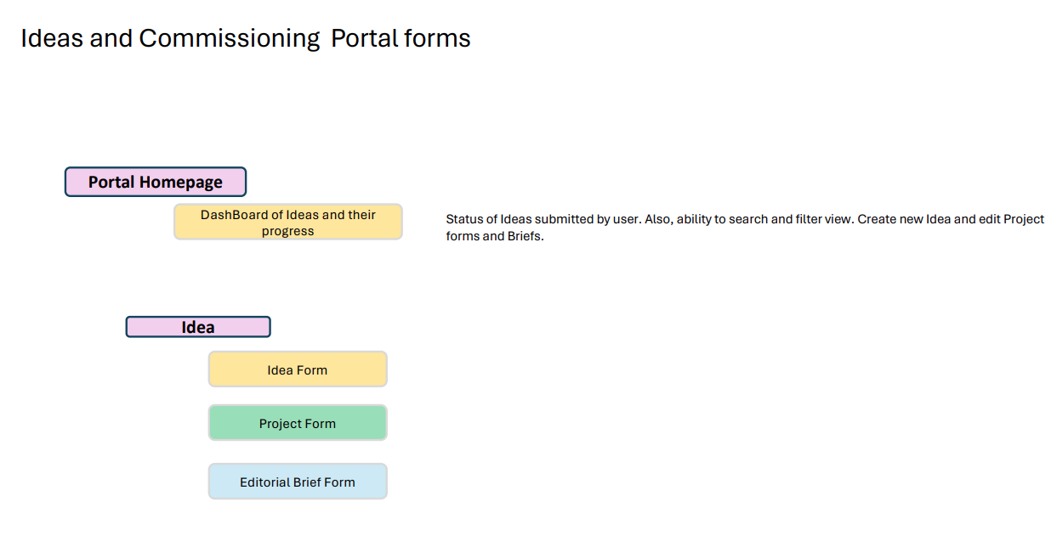

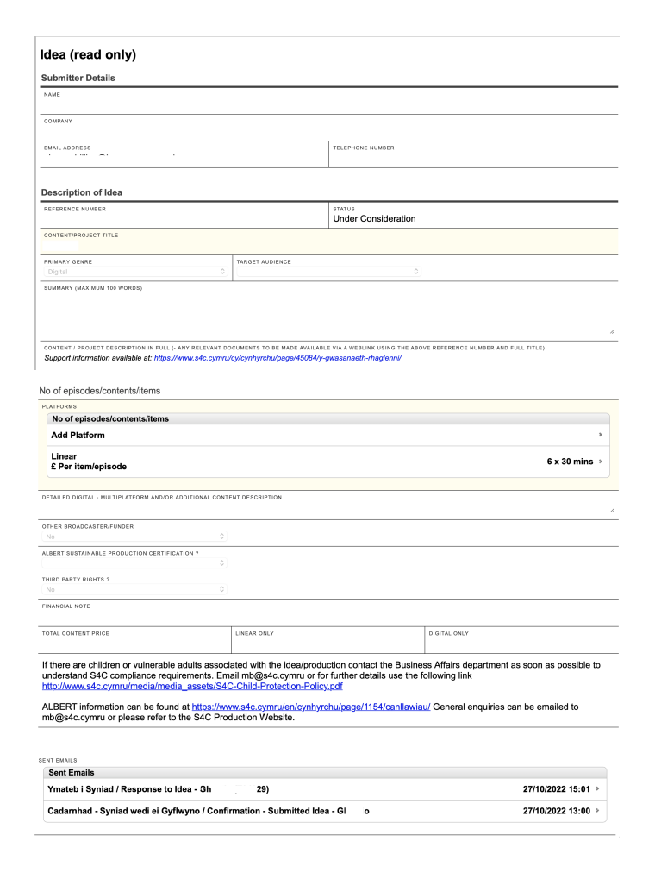

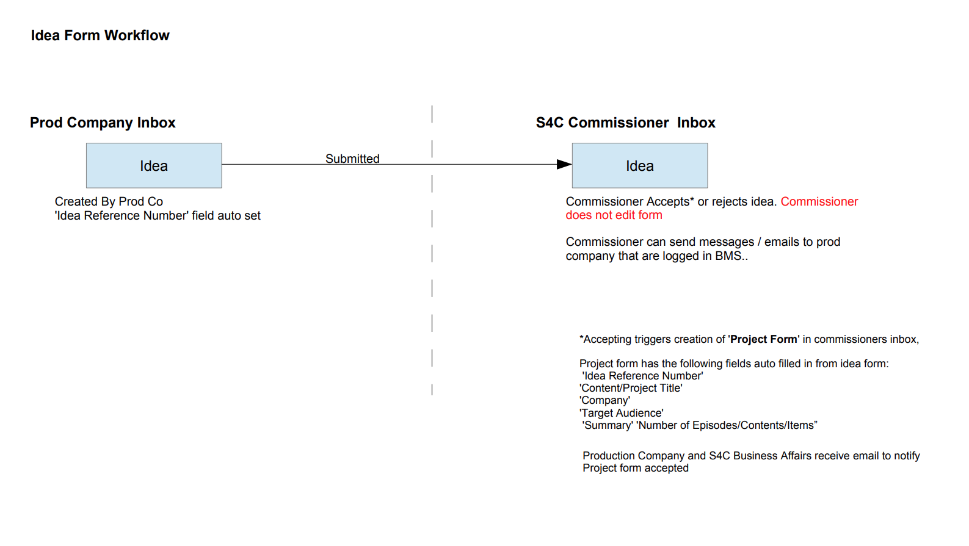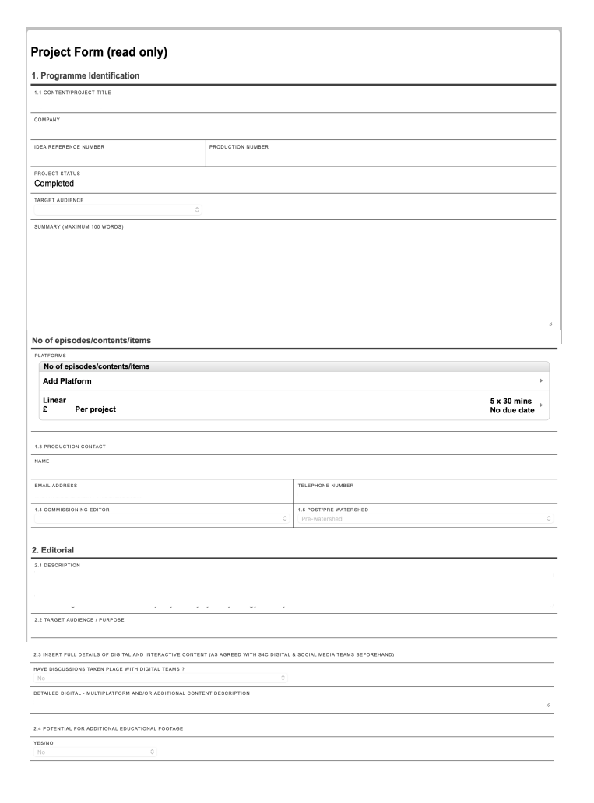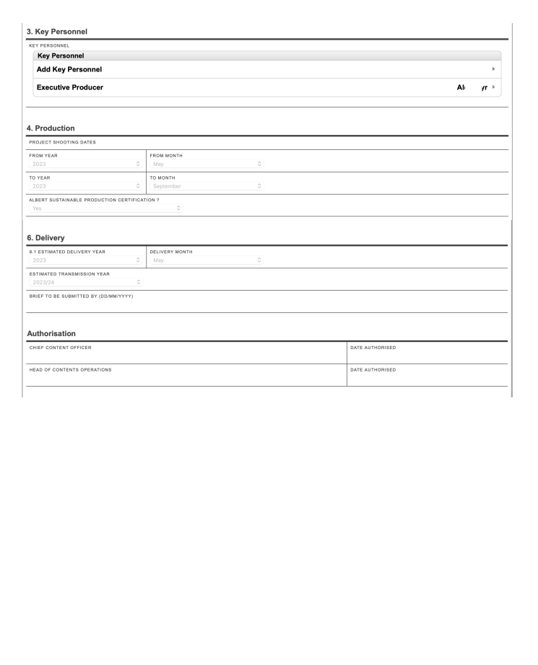

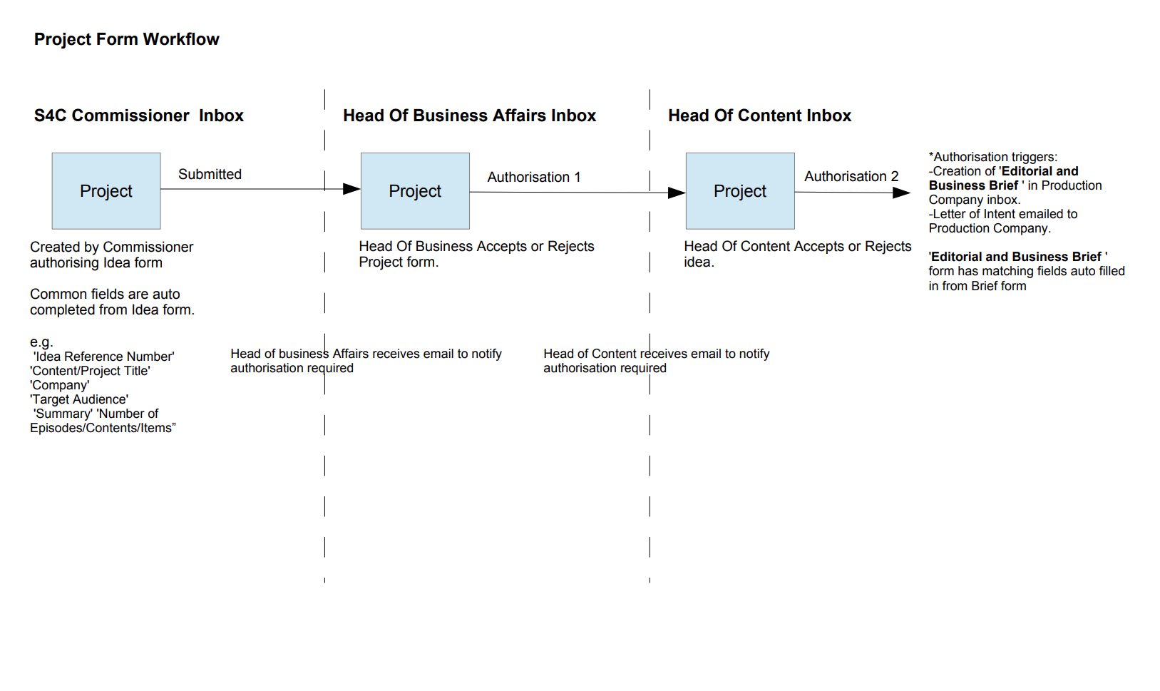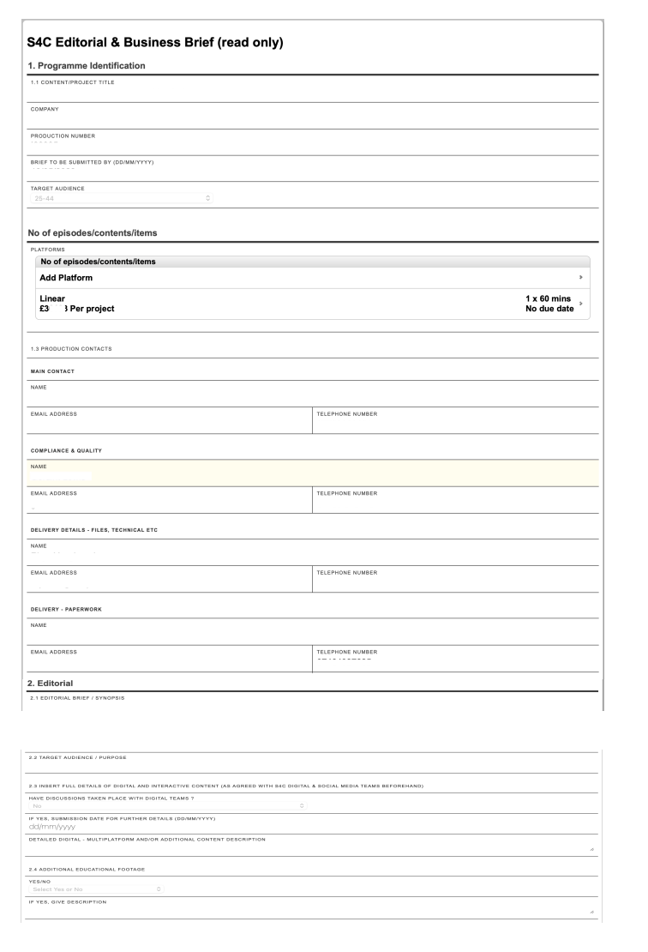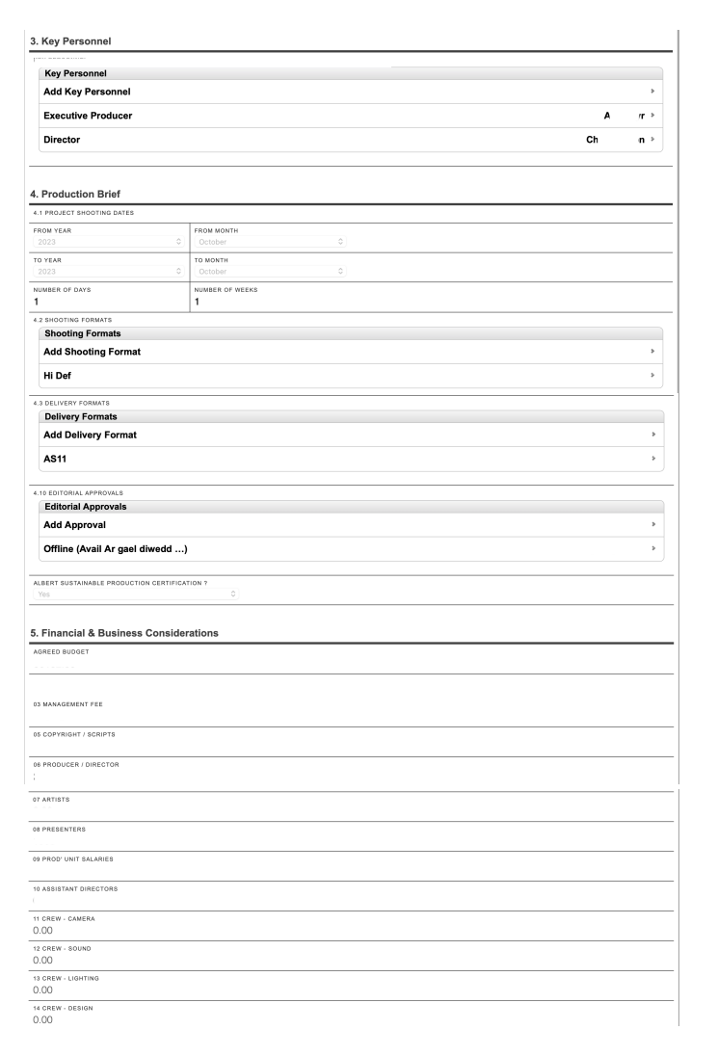

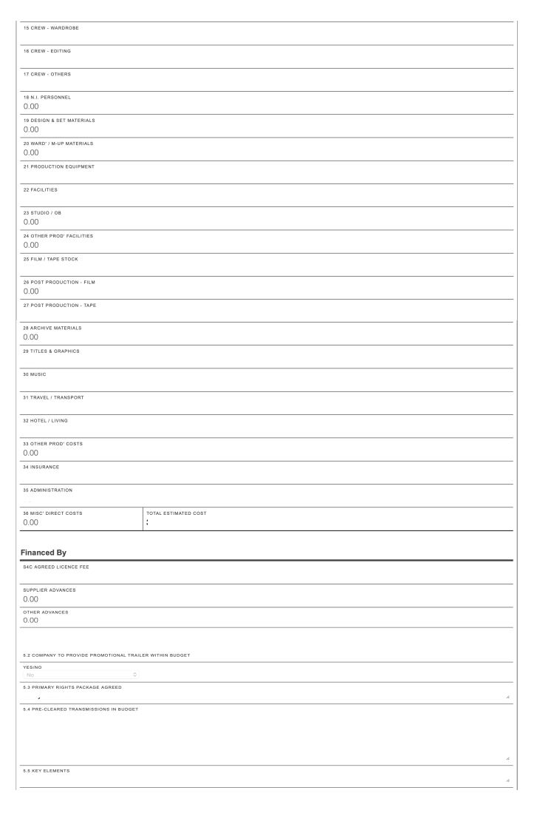
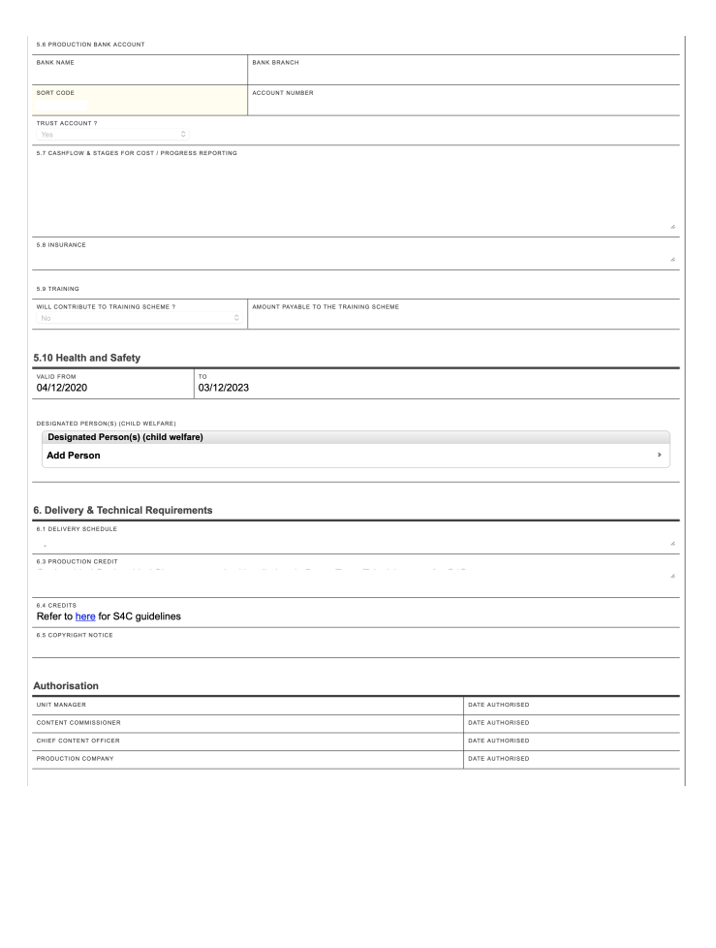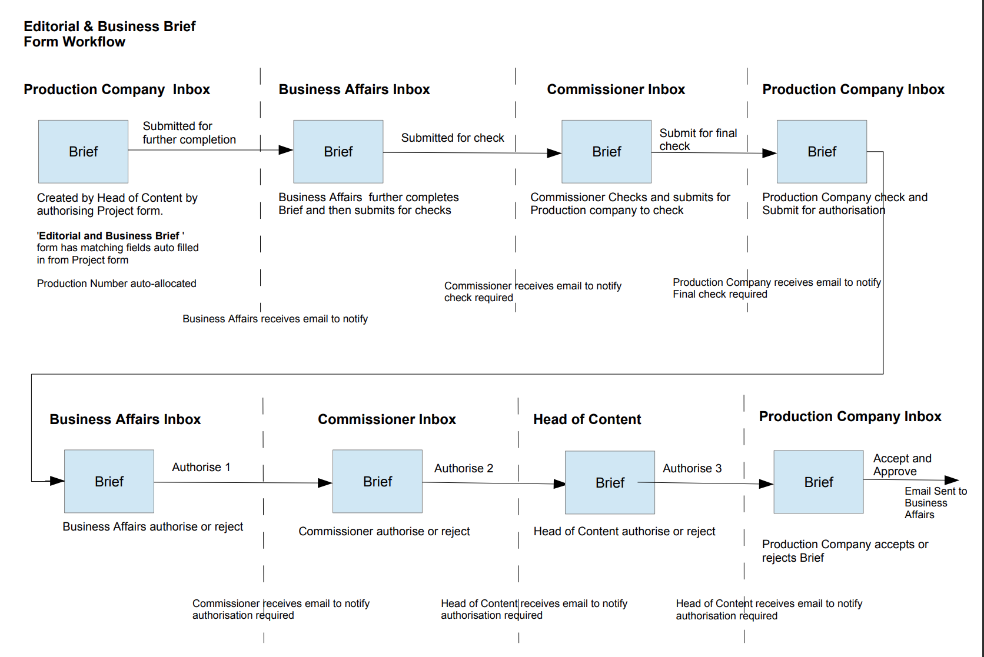
APPENDIX 5
PAC: Programme as Completed Document Portal
E.1 INTRODUCTION AND OVERVIEW

      - This schedule provides an overview of PAC, S4C’s internal Programme as Completed (Production Paperwork) Portal. The accompanying screenshots comprise a mixture of forms currently in service and mock-up designs created to give the closest possible representation of the High-Level Design (HLD) required for the new system. Together, these materials illustrate how the PAC system enables production companies and internal S4C teams to manage and submit the full range of programme completion documentation securely and consistently.
      - PAC functions as a web-based platform that ensures every commissioned programme is accompanied by accurate and complete metadata, rights, and compliance documentation. It supports both internal and external users in the structured collection of key information relating to production, broadcast, and regulatory requirements.
      - PAC provides:
        - A secure portal interface for production companies to submit all required programme paperwork remotely.
        - Online forms that capture:
          - Music cue sheets
          - 3rd party footage information
          - Contributor information
          - Programme synopses and billing data
          - Perceived diversity in production data
          - Cost breakdowns and union details of artists
          - Editorial and compliance-sensitive content descriptors
          - Information for non-linear and online platform versions
        - The ability to upload and manage still images associated with programme records, ensuring supporting visual assets are stored alongside documentation for publicity, EPG, or compliance purposes.
        - The ability to upload documents.
        - Programme/ Series form configurations automatically set up based on pre-transmission (pre-TX) interface values in BMS, with the flexibility to handle different contract types and their associated form permutations.
        - Support for series / programmes and promos types
        - Tracking and workflow functionality, allowing Business Affairs, finance, Content teams to review, query, and approve submitted materials.
        - Integration with S4C’s core BMS, ensuring that PAC data, uploaded documents, and still images are linked to the relevant programme records and can be referenced within scheduling, rights, and reporting systems.
        - Tracking of additional deliverables not directly uploaded through PAC, such as paper contracts and live feed materials, ensuring that all programme deliverables can be monitored, recorded, and verified within the wider workflow.
        - Use of cascade and copy functions between series and programmes for all relevant form fields, ensuring consistent application of data.
        - An intuitive, easy-to-use interface allowing users to navigate freely between different levels of information and documentation.
        - Multiple concurrent sessions per user, supporting efficient multi-tasking and collaboration.
        - An integrated music database that can auto-suggest track titles as users enter song data into cue sheets.
        - A searchable artist database, enabling users to locate contributors via their unique identifier (UID) and associate them with programme metadata.
      - Bidders should use this schedule to inform their understanding of S4C’s Production Paperwork Portal requirements as outlined in Appendix 2, ensuring that the proposed BMS can incorporate equivalent PAC functionality.

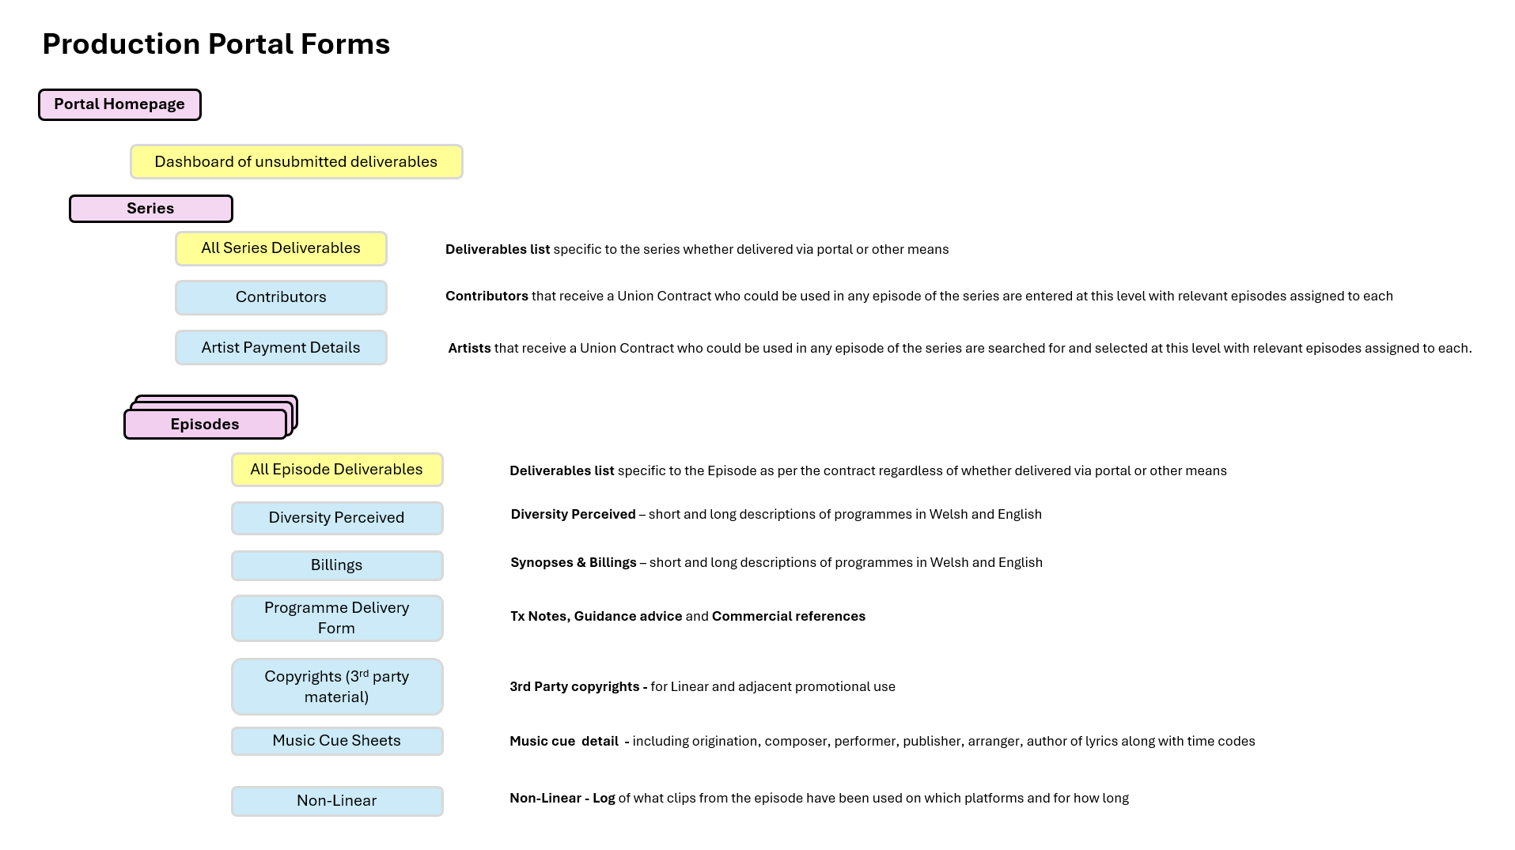

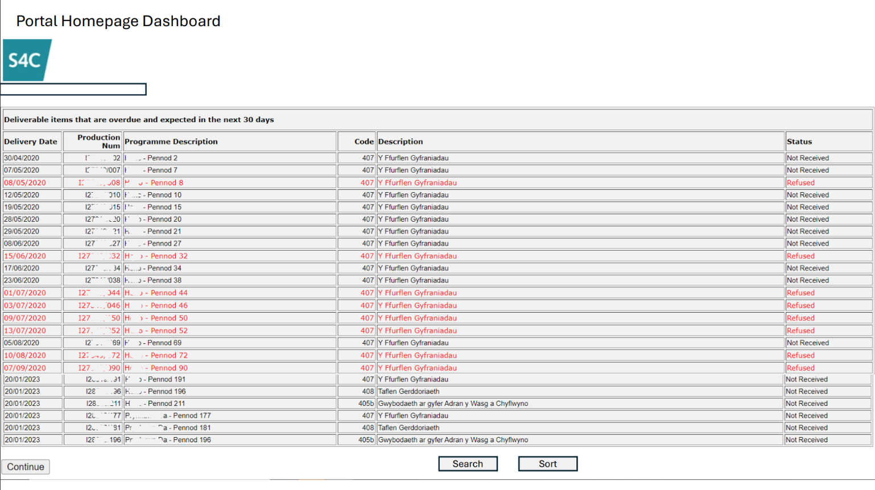

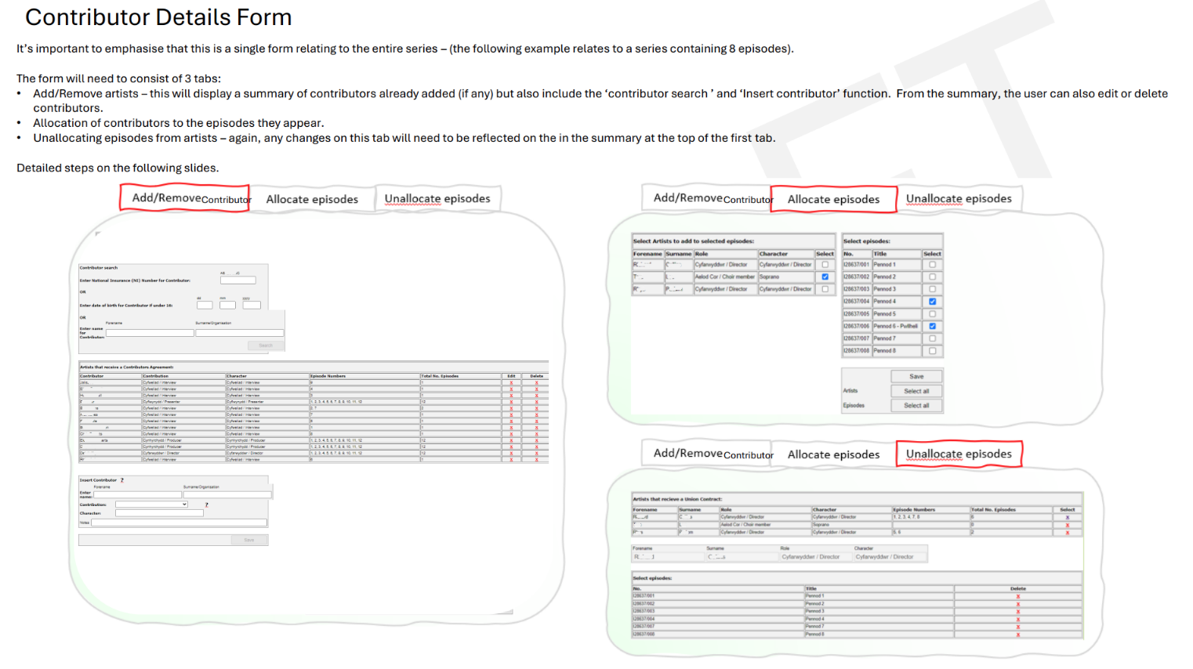

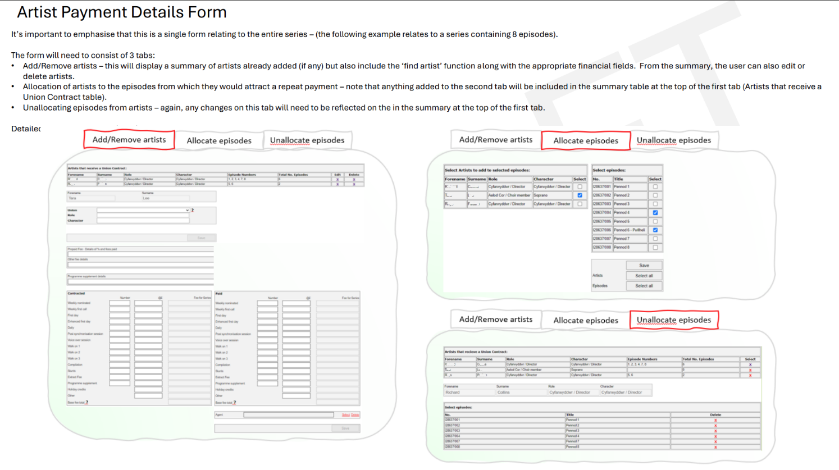

Diversity Perceived

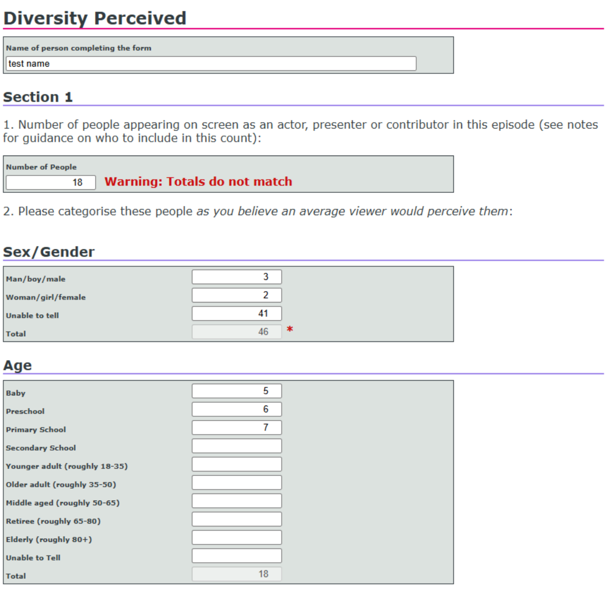

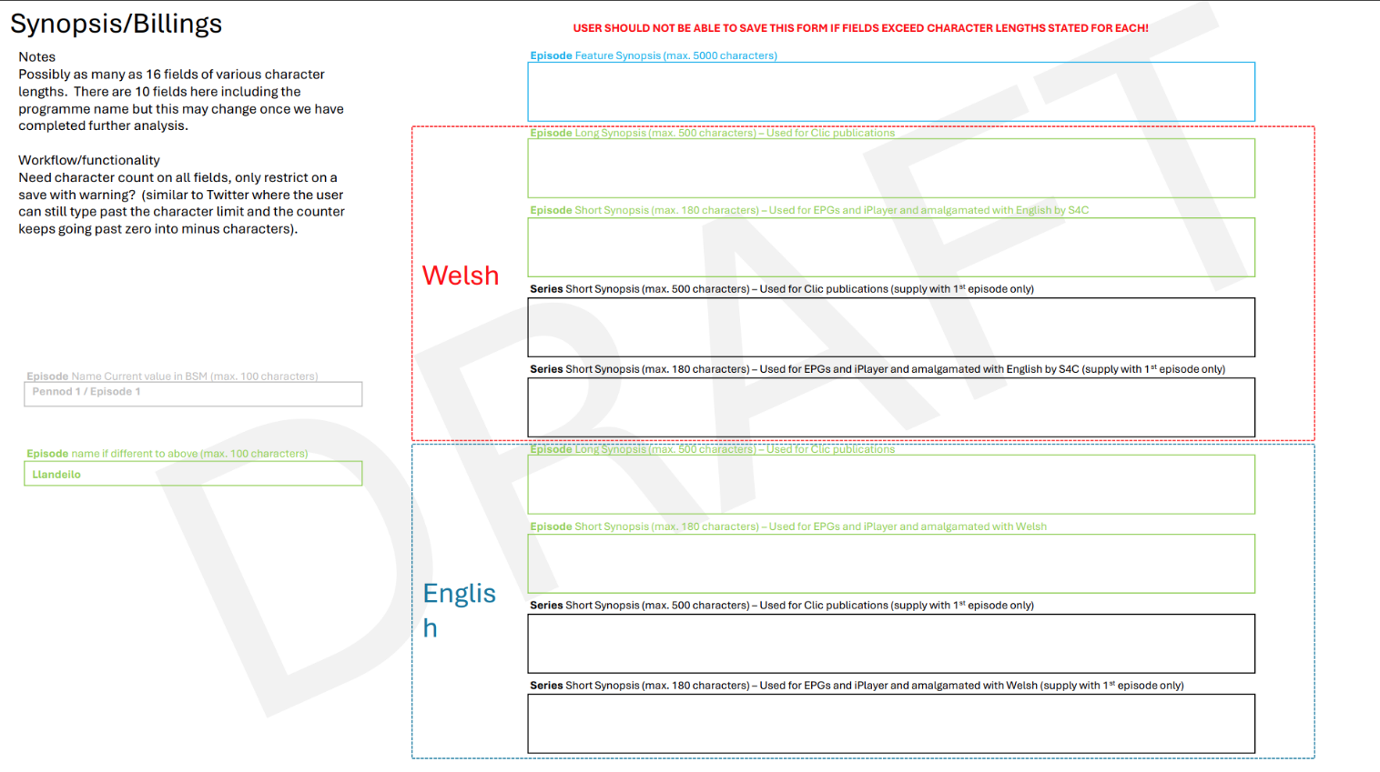

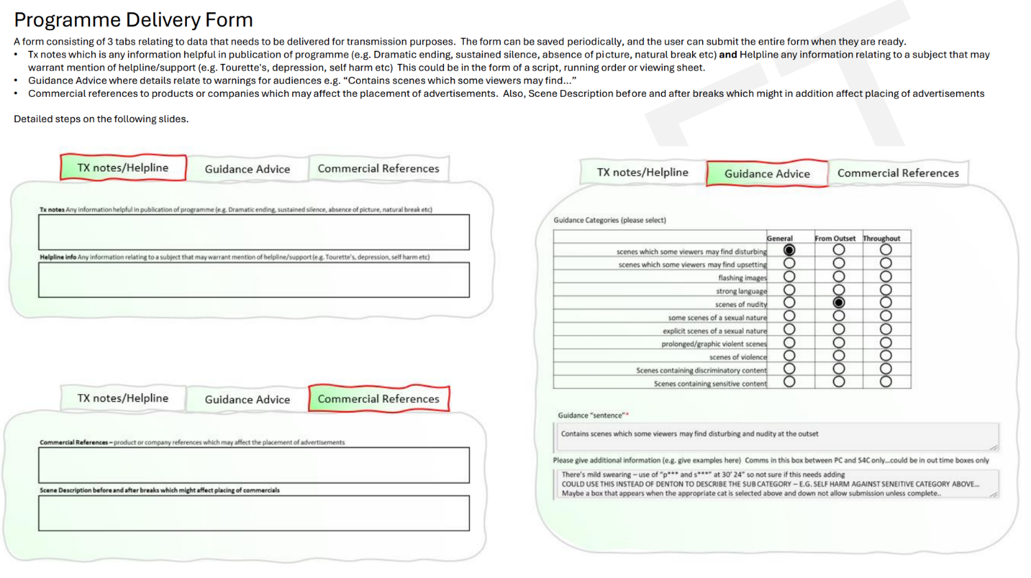

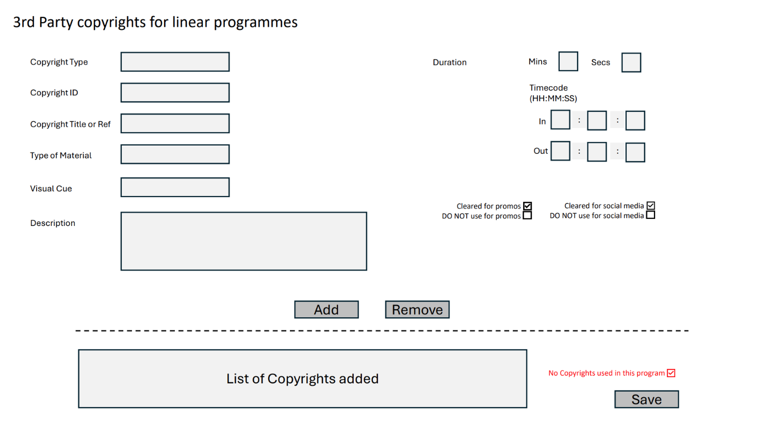

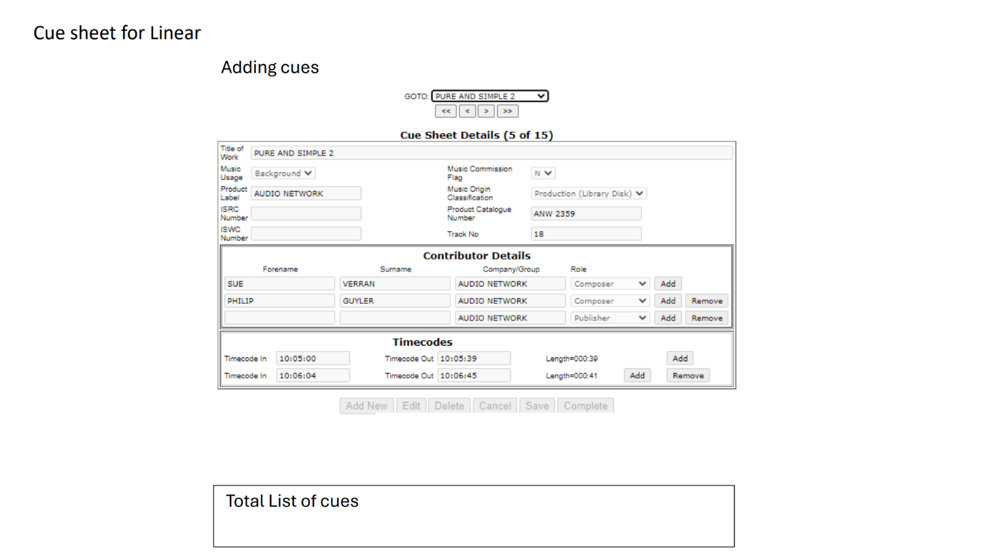

Non-Linear
This form is still under development. Its job is to record in and out point of clips, what platform the clip has been loaded onto and how long it’s going to be on there.

appendix 6
Bidder roadmap and submission guide – how to respond to this ITT
F.1 This schedule is provided for guidance only.
F.2 In the event of any inconsistency between this schedule and the remainder of this Invitation to Tender, the provisions of the ITT shall prevail.

      - Step 1 – Read the Core Documents
        - Bidders should familiarise themselves with the following documents before preparing their Tender Response:
          - This Invitation to Tender (ITT)
          - All schedules
          - The Tender Response Documents

Step 2 – Prepare Your Tender Response
        - Bidders are required to submit all of the documents listed below. Failure to submit any mandatory document may result in the Tender Response being rejected as non-compliant.
Document | Purpose | Format | Schedule / Reference
Bidder Information Questionnaire | To demonstrate that you and associated suppliers satisfy the conditions of participation | PDF | Document A of the Tender Response Documents
Method Statement | Explains how the proposed BMS solution meets S4C’s requirements and how it will be implemented, supported and developed | PDF | Document B of the Tender Response Documents
Technical Questionnaire | Detailed responses to S4C’s technical questions | Excel | Document C of the Tender Response Documents
Pricing Questionnaire | Sets out all prices for the Services | PDF | Document D of the Tender Response Documents
Form of Tender | Formal confirmation of the Bidder’s offer and acceptance of Contract terms | PDF (signed) | Document E of the Tender Response Documents
Certificate of Non-Collusion and Non-Canvassing | Mandatory compliance declaration | PDF (signed) | Document F of the Tender Response Documents

Step 3 – Observe Word Counts and Formats
        - Word limits apply where stated and will be strictly enforced.
        - Text contained in diagrams, tables or images will be included within word counts.
        - Submissions must be provided in the specified formats only.

Step 4 – Submit Clarification Questions
        - All clarification questions must be submitted via the Portal by the deadline set out in the Procurement Timetable. Clarification responses may be shared with all Bidders on an anonymised basis.

Step 5 – Submit Your Tender Response
        - Tender Responses must be submitted via the Portal only.
        - Late submissions will not be accepted.
        - Bidders are advised to allow sufficient time for upload and submission.

How Your Tender Will Be Evaluated (Summary)
        - Method Statement – 55%
        - Technical Questionnaire – 25%
        - Pricing Questionnaire – 20%

Key Reminders
        - Do not amend the format of any questionnaire.
        - Do not include pricing outside the Pricing Questionnaire.
        - Do not assume prior knowledge of your organisation or solution.
        - Ensure all declarations are completed and signed (where required).

Appendix 7
Tender Response Documents
G.1 PLEASE SEE SEPARATE DOCUMENTS A TO F ON SELL2WALES.
- Bidder Information Questionnaire (Document A);
- Method statement (Document B);
- Technical Questionnaire (Document C);
- Pricing Questionnaire (Document D);
- Form of Tender (Document E); and
- Certificate of non-collusion and non-canvassing (Document F).

