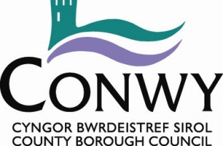

Environment, Roads & Facilities

Flood Risk and Infrastructure

Volume 3 - Drawings

Pont Segrwyd, Groes

May 2026

G.B. Edwards BEng (Hons) CEng FICE
Head of Environment, Roads & Facilities,
PO. Box 1, Colwyn Bay, LL29 0GG

01492 575337
affch@conwy.gov.uk / erf@conwy.gov.uk

Issue and Revision Record

Document Title | Volume 3 - Drawings
Version | V1
Status | Tender
Filename | ERCF2509N 14 Pont Segrwyd - Volume 3 Drawings.docx

Revision | Notes | Date
V1 | Tender | 14/05/2026

 | Signature | Name | Date
Prepared by | 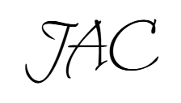 | John Castle | 14/05/2026
Checked by | GRJ | Gerallt James | 14/05/2026
Approved by | BS | Bryn Shiland | 14/05/2026

DRAWING NUMBER | REVISION | TITLE
ERCF2509N 14 T101 | A | Site Location Plan & Site Extents
ERCF2509N 14 T102 | A | Existing Long and Cross sections
ERCF2509N 14 T103 | A | Existing General Arrangement
ERCF2509N 14 T104 | A | Proposed General Arrangement
ERCF2509N 14 T105 | A | Proposed Construction Details
ERCF2509N 14 T106 | A | Proposed Drainage Details
ERCF2509N 14 T201 | A | Site Clearance
ERCF2509N 14 T501 | A | Drainage and Service Ducts
ERCF2509N 14 T601 | A | Earthworks
ERCF2509N 14 T701 | A | Pavements and Waterproofing
ERCF2509N 14 T2401 | A | Stonework and Repointing
ERCF2509N 14 BBS | A | Bar Bending Schedule

