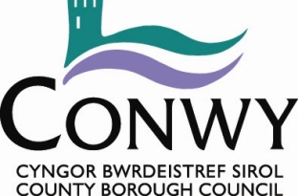

Environment, Roads & Facilities

Consultancy

Volume 4 - Pre-Construction Information

Pont Segrwyd, Groes

May 2026

G.B. Edwards BEng (Hons) CEng FICE
Head of Environment, Roads & Facilities,
PO. Box 1, Colwyn Bay, LL29 0GG

01492 575337
affch@conwy.gov.uk / erf@conwy.gov.uk

Issue and Revision Record

Document Title | Volume 4 - Pre-Construction Information
Version | V1
Status | Tender
Filename | ERCF2509N 14 Pont Segrwyd - Volume 4 PCI.docx

Revision | Notes | Date
V1 | Tender Issue | 14/05/2026

 | Signature | Name | Date
Prepared by | 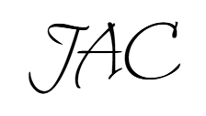 | John Castle | 14/05/2026
Checked by | GRJ | Gerallt James | 14/05/2026
Approved by | BS | Bryn Shiland | 14/05/2026

Introduction

CDM Regulations 2015
This document should be read in conjunction with the Regulations - ‘Managing health and safety in construction’ Construction (Design and Management) Regulations 2015. HSE Document Reference: L153.

Purpose of this document
Appendix 2 of the Regulations states that the Pre-Construction information is to be concise and in an easy and understandable form so as to enable duty holders involved in the project to carry out their responsibilities. To this end, only primary information that is either expressly required by the Regulations or that is project specific is contained in the document. Normal construction hazards that a competent Contractor should be aware of are not included.

Duty Holders
The Client is Conwy County Borough Council (CCBC) Flood Risk and Infrastructure Department:

- Contact: Owen Conry, Flood Risk and Infrastructure manager
- Address: ERF, Coed Pella, Conwy Rd, Colwyn Bay, LL29 7AZ
- Email: Owen.conry@conwy.gov.uk
- Telephone: 01492 575 338
The Principal Designer is CCBC Flood Risk and Infrastructure Department:

- Contact: Gerallt James, Principal Infrastructure Engineer
- Address: ERF, Coed Pella, Conwy Rd, Colwyn Bay, LL29 7AZ
- Email: gerallt.james@conwy.gov.uk
- Telephone: 01492 5741744
The Principal Contractor will be the successful Tenderer.
- TBC

F10 Notification to HSE
The Construction Phase is estimated at 50 working days (10 weeks) and will have an average of 4 persons on site throughout the project – an average of 200 person days

- In accordance with Regulation 6, the Project is not notifiable.
If when tendering the works the Contractor considers that the above assumption is incorrect and that the project exceeds the triggers in the Regulations, then this should be clearly stated in the submission so that appropriate Notification might be made.

Construction Phase Plan
The Principal Contractor is required to take the Pre-construction Information and, after visiting the site so as to make his own assessment of the Site and proposed Works, develop the Construction Phase Plan (CPP). Duties placed on the Principal Contractor are detailed in the Regulations, Part 3.

Guidance on preparing the CPP is contained in the Regulations, Appendix 3.

The CPP should include detailed project specific method statements and a thorough assessment of significant project specific risks of the Construction Phase. The CPP should be a systematic consideration of Part 4 ‘General requirements of Construction Sites’ of the Regulations.

Project Information

Location
Pont Segrwyd is south of Groes
NGR 301727, 363877
See Location Plan ERCF2509N 14 T101A LP in Volume 3 Drawings

Client Brief
Pont Segrwyd is in poor condition in certain areas. The south parapet and south spandrel walls are failing and require restoration. There is a crack between the northwest sidewall and the bridge abutment. Other areas on the bridge and adjacent wall are affected by vegetation ingress and loss of pointing.

The works comprise the following:

- Take down section of existing south parapet, spandrel wall and northwest sidewall and set aside masonry and stone slabs for reuse.
- Vegetation clearance from existing structure.
- Rebuild spandrel wall and parapet using existing masonry and stone from local quarry
- Repair and repoint remaining sections of bridge parapets, retaining walls and spandrel walls.
- Construction of southwest river training wall, repurposing existing stone parapet slabs.

The above is a precis of the Works. The Contractor should refer to the Scope for more detailed information.

Key Dates
Construction Phase Start: 27/07/2026
Duration: 10 weeks
Construction Phase Finish: 02/10/2026

Programme restrictions: None.
Working hours are expected to be normal working hours (0800-1800 Monday to Friday), unless agreed otherwise with the Client.

Planning and Management

Design Phase
The Principal Designer has prepared the proposed scheme based on the following information:

A topographical survey
A topographical survey has been undertaken and forms the basis for line and level. This will be made available to the successful tenderer.

An ecological survey
An ecological survey has been carried out, indicating no special requirements other than recommendation to install two ‘woodstone’ specialist nesting boxes for dippers; (Cinclus cinclus) and grey wagtails; (Motacilla cinerea) on the underside of the bridge. The ecology report is found in Appendix A

In order to avoid any impact on the Afon Ystrad, working methods will adhere to good working practices and following pollution prevention measures for working near water. GPP5 Environment Agency guidelines should be followed.

Desk top survey
There are no special designations for the site.

A walk over survey
A visual walk over survey has identified the following restrictions that have a bearing on health and safety:
- The bridge is in a poor state of repair. The south elevation of the structure and the north east sidewall has loose masonry that are liable to fall away from the structure.
- A road runs through the side and therefore will need to be closed.
- Statutory authority information shown in 3.1.5 below

Statutory undertakes equipment searches
Searches regarding the presence and location of statutory undertakers’ equipment has been sought and is included in the Site Information. In summary:

- No Wales & West Utilities or Welsh Water assets in the area
- There is Openreach overhead apparatus that crosses the bridge to the north
- There is SP Energy Network LV overhead apparatus that crosses the bridge to the north
- CAT scans and careful monitoring of excavations for unchartered services should be undertaken.

Ground Investigation
There has not been any ground investigation.

Health and Safety File for the structure.
There is no current Health and Safety File for the structure.

Invasive testing
No invasive coring or trial pits have been undertaken to confirm the existing structure.

River flow
A primary hazard identified for safe execution of the works is the river. The following requirements of in regard to managing flood risk to allow the safe passage of water through the Works is:
- The Contractor to have a river level monitoring system in place and action plan for evacuation of river channel in the event of flooding.
- The contractor to monitor the met office 5 day and long-term forecast during the construction period and dynamic risk assessments to be undertaken as required.

Adjacent Works
None known.

Design Principles
The basic design principles to be complied with are that safe, practical and robust solutions shall be developed, which adopt proven and reliable technology whilst offering the Client value for money.
Designer should outline the basic design principles/philosophies.

The principles of the design anticipate the following:

- The existing structure may require support as work commences due to the risk of collapse. The design, erection and maintenance of access and support arrangement is the responsibility of the principal contractor.

Health and Safety Hazards

Hazards identified by the Client
The primary site-specific hazards identified by the Client and suggested method as to how the Contractor may manage the hazards during the Construction phase – refer to Scope for details

- Road traffic – road closure signs and diversion to be provided
- Pedestrians – Provisions to be made to divert pedestrians
- Livestock - suitable temporary fencing to eliminate livestock from entering Site
- River – normal river flows managed as per 3.1.9 above – extraordinary flows to be monitored and evacuation procedure put in place
- Statutory undertakers equipment
- Access equipment – Ladders/access towers to be pulled back during non-operational hours. All access equipment to be fenced off to avoid unauthorised access.

Hazards Identified by the Principal Designer
The primary site specific hazards identified by the Designer and suggested method as to how the Contractor may manage the hazards during the Construction phase – refer to Scope for details

- Possible contamination of watercourse due to in river works
  - Provide a flume / over-pumping, use UCS additive.
- Principal Contractor to review weather forecast in advance to reduce the potential for flooding
- Statutory undertakers’ equipment
  - Contractor to be aware of statutory undertakers’ equipment as detailed in volume 2
- Work at height
  - Work at height activities need to be considered throughout the entire duration of the work
- Part of the works access is through a garden property
  - Consultation before start is required to determine safe access and egress
- Work to an unstable structure
  - Temporary propping of existing structure – To be designed by principal contractor

Health and Safety File
If there is more than one Contractor on site, a Health and Safety File will be required in accordance with Regulation 12.

A template health and safety file is included in the appendix of the contract documentation.

Appendix A


Cambrian Ecology Ltd
5 Tan y Bwlch
Maentwrog
Gwynedd
LL41 3YU

chris@cambrianecology.com 07765 254035

Pont Segrwyd Ecological Survey Report

16.02.2022

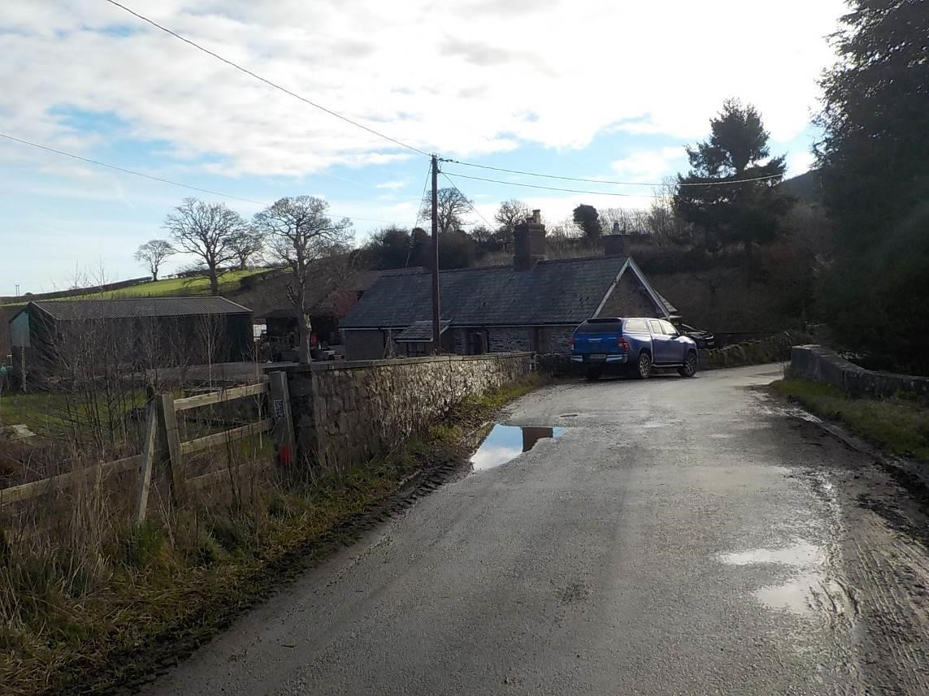
Report by: | Lizzie Richardson
Client:  Planning | Conwy County Borough Council
Authority:  Grid | Denbighshire County Council
Reference: | SJ 0172 6387
- CONTENTS Page No

- Summary 3

- Introduction 4

- Methodologies 4

- Survey Limitations 5

- Results 5

- Impact Assessment 9

- Mitigation Measures 10

- Biodiversity Enhancements 11

- Legal Implications 12

- Appendices 13

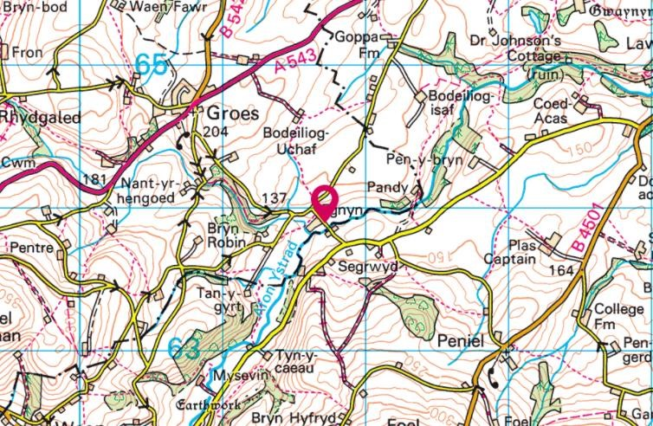 Fig 1: Site Location

Ecological Assessment Pont Segrwyd Bridge Repair Works

16th February 2022

- 1. Summary

An ecological and preliminary protected species assessment was carried out by Cambrian Ecology Ltd at Pont Segrwyd near Groes in Denbighshire. Essential maintenance works are required in order to prevent the further deterioration of the bridge.

The works will necessitate the removal of areas of vegetation, both on and surrounding the bridge. Therefore, an assessment was made of the importance of these habitats as well as their potential to support protected species. The survey also included an assessment of the bridge structure itself to support protected species and any bio-security issues such as the presence of ‘Invasive Non-Native
Species’ (INNS) in the immediate vicinity were also recorded.

No direct evidence of any protected species was recorded during the site visit on the 1st February 2022. To facilitate the works there will be the requirement for the removal of some vegetation which has potential to provide habitat for nesting birds. However, this suitability will be limited due to the sparseness and immaturity of the vegetation. Recommendations are made with regard to the timing of works to avoid any impact on nesting birds.

The vegetation did not offer any suitability for bat roosting, such as crevices or rot holes, and due to the limited amount of vegetation removal it is not considered likely that there will be any negative impacts on bats in terms of habitat fragmentation. Although there are some minor gaps and crevices in the bridge exterior, these were all thoroughly inspected with an endoscope, and none were judged as being suitable for supporting roosting bats. It is, therefore, concluded that there should be no negative impact on bats as a result of the proposed works.

There are no protected or designated sites that cover the proposed work area and due to the limited scale of the works there should be no impact on protected sites in the wider area.

No INNS were recorded during the site visit.

In order to avoid any impact on the Afon Ystrad, working methods will adhere to good working practices and following pollution prevention measures for working near water.

Under Chapter 6 of Planning Policy Wales 11, planning authorities must seek to maintain and enhance Biodiversity in the exercise of their functions. In this case it is recommended to install two ‘woodstone’ specialist nesting boxes for dippers; (Cinclus cinclus) and grey wagtails; (Motacilla cinerea) on the underside of the bridge.
Key Messages:

- The works will be required to avoid the nesting bird season 1st March to 31st August or a pre-works survey carried out, see Section 7.2.
- Natural Resources Wales Guidelines will need to be followed to prevent potential pollution of the river, see Section 7.1.
- Due to the limited amount of immature vegetation which will be removed it is considered that there will be no long-term impact on biodiversity from the proposed works.
- As Biodiversity enhancement for the site it is recommended to install two ‘woodstone’ nesting boxes suitable for dippers and wagtails.

- 2. Introduction

An ecological assessment was carried out by Cambrian Ecology Ltd at Pont Segrwyd near Groes in Denbighshire. The bridge which forms part of a minor road crossing the Afon Ystrad has been classed as a sub-standard structure due to significant deterioration and maintenance, strengthening and repair works are now essential. In order to carry out these works, areas of vegetation will need to be cleared from both the bridge structure and immediate surrounding.

The relevant planning authority is Conwy County Borough Council.

Pont Segrywd is located at Grid Reference SJ 0172 6387.

- 3. Methodologies

3.1 Site Assessment

The site survey was carried out on 12th January 2022 by ecologist Lizzie Richardson (S085724-1). Lizzie is a qualifying member of Chartered Institute of Ecology and Environmental Management (CIEEM) and an accredited agent on the bat licence of ecologist Chris Hall (S085724-1). She has been employed by CEL since 2021.

The site was walked and searched for signs of protected species. In particular, the vegetation, which will be removed during the course of the works, was assessed on its ability to support protected species such as nesting birds and roosting bats. An inspection was also made of the bridge structure itself in terms of potential roosting opportunities for bats. The riverbanks were also searched for signs of otter; (Lutra lutra) presence and/or holts and a thorough search was conducted for any other signs of protected species or INNS.

3.2 Desk Study

The desktop study aims to collate existing information about priority species, habitats and designated sites within 1km of the survey area. This information has relevance to the likelihood of priority species being present within the survey area, as well as giving context to any species and habitat records from the actual site.

- 4 Survey Limitations

Field signs for protected and important species are often difficult to find or absent from a site. For this reason, the site and its habitats are assessed on their potential to support these species.

While this survey was carried out outside of the normally accepted period for habitat/vegetation surveys, due to the limited habitat and vegetation cover present it is not considered that this timing has had any adverse effect on the survey results.

- 5 Results

5.1 Habitats

- Bankside Vegetation
To the south-west of the bridge is a training wall upon which there is small amount of vegetation growing, this is quite sparse and there are many areas of bare earth. The species present include cow parsley; (Anthriscus sylvestris), hart’s tongue fern; (Asplenium scolopendrium), ivy; (Hedera helix), broad-leaf dock; (Rumex obtusifolius) and wild strawberry; (Fragaria vesca). Where the wall adjoins the river there is no vegetation present. The opposite riverbank, on the southern side of the bridge, falls within a private garden and the riverbank is comprised of a low stone wall upon which sits a lawned area.

The vegetation present on the north-west side of the bridge is denser and taller with scrub species such as bramble; (Rubus fruticosus) and bracken; (Pteridium aquilinum) present as well as taller vegetation including hogweed; (Heracleum sphondylium), nettle; (Urtica dioica) and cock’s foot grass; (Dactylis glomerata).

On the opposite bank there is a stone abutment above which sits another private garden with a lawned area. There is a single stand of snowberry; (Symphoricarpos alba), which is an ornamental non-native shrub, overgrowing the abutment on this side.

- Bridge
The bridge is comprised of a mixture of brick and mortared stone construction, there are some superficial cracks in the bridge exterior and some larger shallow gaps where brickwork is missing.

The underside of the bridge is comprised of concrete girders between which there are narrow, shallow gaps. These are all heavily cobwebbed.

There is ivy growth present on the bridge exterior, but this is very sparse and immature and does not provide any cover. On the north-west corner the parapet is partly covered with a stand of holly; (Ilex aquifolium) and hazel; (Corylus avellana) which has overgrown from the bordering hedgerow.

- Improved Grassland
There is an area of improved grassland verge present alongside the southern bridge parapet and also an area of improved grassland to the northern side of the north parapet, both of which will likely be impacted by the works. The dominant species in both these areas is perennial rye grass; (Lolium perenne) with a limited range of other species present including cow parsley, broad-leaf dock, nettle and creeping buttercup; (Ranunculus repens).

- River
The Afon Ystrad is, at this location, shallow and fast flowing over a rocky substrate. The river is approximately 4m in width and is bordered by low riverbanks or the stonework associated with the bridge. There is a wooded riparian corridor of mature trees running alongside the river on both sides.

- Trees
The only tree which will be removed during the works is a previously pollarded sycamore; (Acer pseudoplatanus) with immature new growth located on top of the south-west training wall. There are also some immature ash; (Fraxinus excelsior) saplings next to the riverbed on the northern side of the bridge.

There is a large mature conifer; (Cupressus spp.) tree growing on the southern side of the bridge. However, the location of this tree within a private garden means that it is unlikely to be impacted by the proposed works.

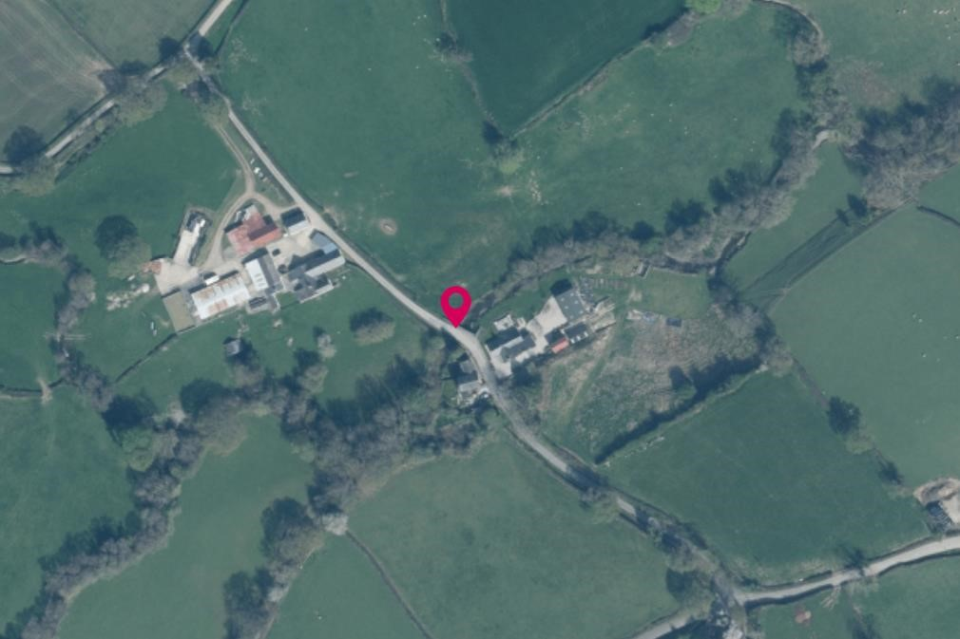
Fig.2: Aerial photo showing the wooded riparian corridor of the Afon Ystrad

5.2 Protected Species

- Bats
The vegetation which will be removed during the course of the works is very immature and sparse and does not have any features for roosting bats such as crevices or rot holes. The surrounding mature trees do potentially provide bat roosting habitat, as well as potentially providing a flight corridor for bats.

The bridge does not have any suitable features to support roosting bats. Where there were gaps present in the stone and brickwork these were either too open or too shallow to provide roosting opportunities.

- Nesting Birds
The scrub vegetation which will be removed during the course of the works is generally very immature and sparse and offers only limited potential to nesting birds. The holly and hazel growth do offer enhanced opportunities for nesting birds but accounts for only a very small proportion of the potential habitat offered in surrounding mature vegetation and trees.

- Otters
No signs of otters were recorded during the site visit and there was no suitable habitat identified for otter holts in the immediate vicinity.

5.3 INNS

There were no INSS recorded during the site visit.

5.4 Desk Study

The proposed work is not located within any statutory protected or designated sites although there are several non-statutory designated sites within the 1km search area. The nearest of these is the Coed Shed wildlife site which is located 306m to the north-west of the survey area. There are also a number of Restored Ancient Woodland Sites (RAWS) and Semi-Natural Ancient Woodland Sites in the search area.

In regard to protected species there are several records for badgers’ setts within the search radius, but these are all located at distances over 600m from the site. There are a small number of bat records which are limited to records for brown long-eared; (Plecotus auritus) and a few records for unidentified bat species. The closest bat record is located 747m from the survey area.

There are records for brown/sea trout; (Salmo trutta) and bullhead; (Cottus gobio), associated with the Afon Ystrad. The brown/sea trout is listed under Section 7 of the Environment Wales Act as a
‘Priority Species’.

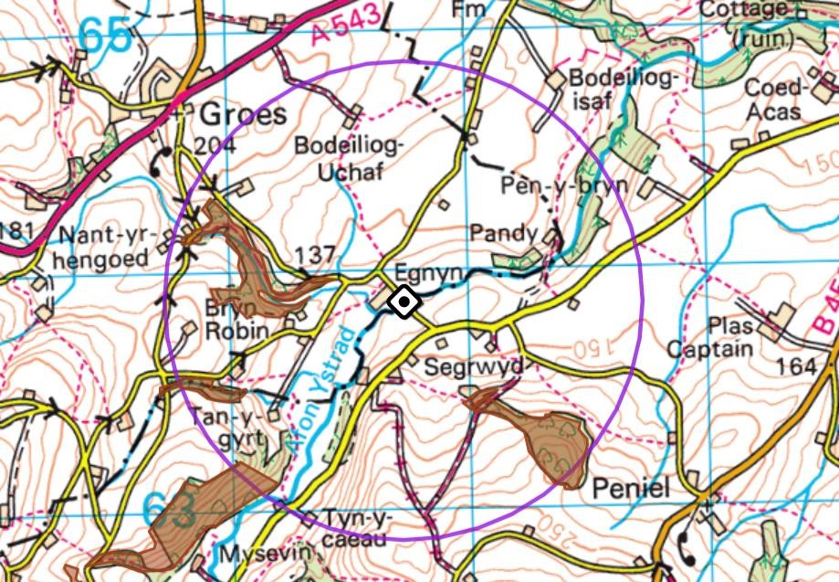
Fig.3: The location of the Wildlife Sites (in brown)

- 6 Impact Assessment

6.1 Habitats

- Bankside Vegetation
The areas of vegetation that will be impacted are very small and generally lacking in diversity with no species of particular botanical interest present. There is some potential for nesting birds to be present within the taller vegetation and ornamental shrub at the appropriate time of year, see Section 6.2.

- Bridge
The bridge was assessed as having no features that could support protected species and, therefore, there will no negative impact on Biodiversity as a result of repair works to the structure.

The ivy growth on the exterior is very sparse and does not provide any cover suitable for nesting birds or roosting bats.

The area of holly and hazel growth, which is overgrowing the south-west parapet from the bordering hedgerow, could provide cover for nesting birds at the appropriate time of year, see Section 6.2. The removal of this small area of growth should have no impact on the hedgerow itself.

- Improved Grassland
The grass verge and section of improved grassland to the north-west of the bridge are species poor and of no value to Biodiversity. Therefore, there will be no negative impact as a result of disturbance to these habitats.

- River
It is possible that the repairs may include some in-river works and there is the potential for wider negative impacts in the event of a pollution incident.

Provided that precautionary measures are in place, the risk of any negative impacts is considered to be minimal.

- Trees
Due to the immaturity of the new vegetation present on the pollarded sycamore there are no features which could support protected species at any time and the tree plays no role in providing habitat connectivity along the wooded riparian corridor. The removal of the ash saplings will also have no negative impact on biodiversity.

6.2 Protected Species

- Badgers
Although there are records for badger setts withing the 1km search area, these are all located at a significant distance from the site and there is no suitable habitat for badgers or setts in the immediate vicinity of the survey area. Therefore, it is considered that there will be no impact on badgers due to the proposed works.

- Bats
There were no features within the bridge structure which were assessed as providing potential roosting opportunities. Furthermore, none of the vegetation removal works will affect the connectivity along the river or result in any loss of habitat or habitat fragmentation. It is concluded that it is highly unlikely for there to be any impact on bat species due to the proposed works.

- Nesting birds
There is potential for nesting birds to be present within the taller scrub vegetation and holly and hazel growth, which will be removed during the course of the works. The removal of vegetation during the bird nesting season could result in disturbance which could lead to the failure of the brood. This could have impacts on some species at the local level and would represent an illegal activity.

- Otters
No otter holts will be damaged or destroyed and there are no signs or records of otter presence at this location or nearby. Therefore, it is highly unlikely that there will be any impact on this species due to the proposed works.

- 7 Mitigation Measures

7.1 Habitats

The work will take place directly above a normal watercourse. Rivers and streams are on the list of Section 7 Habitats that are of principal importance for the maintenance and enhancement of Biodiversity in Wales.

In order to ensure that there is no impact on the wider area, good working practices must be followed. Due to the potential for any pollution incidents to have a negative impact downstream of the works, extending the ‘zone of influence’ of the proposals outside the site boundaries, precautionary measures will be required to be in place.

All works must be carried out in accordance with (Pollution Prevention guidelines (PPG 5) which can be found at:-
http://www.netregs.org.uk/media/1303/gpp-5-works-and-maintenance-in-or-near-water.pdf

7.2 Protected Species

- Bats
It is considered that there will be no negative impact on bats due to the proposed works therefore no mitigation measures are necessary.

- Nesting Birds
The proposed vegetation clearance work should be scheduled to avoid the nesting season (1st March to 31st August inclusive). If this timing is followed, it is not considered likely that there will be any disturbance to nesting birds as a result of the proposed works. If this is not possible, a survey for nesting birds by a suitably experienced ecologist must be carried out and if any active nests are encountered, work must be delayed until such time as the young have fledged.

- Otters
It is considered unlikely that otters will be disturbed as a result of the proposals and no actual or potential holts damaged or lost.

Precautionary pollution prevention measures are required to prevent any impacts on the species, see Section 7.1 above.

- 8 Biodiversity Enhancement

Under Chapter 6 of Planning Policy Wales 11, planning authorities must seek to maintain and enhance biodiversity in the exercise of their functions.
In this case it is recommended that following the completion of the repair works to the bridge, two specialist nest boxes suitable for dippers and grey wagtails are installed on the underside of the bridge at opposite sides. Both of these species are known to be present in the area through the results of the data search and favour nest sites over fast flowing water as found at this site.
It is recommended that a nest box of ‘woodstone’ construction is used due to the longer life span of this material as well as the enhanced insulting properties that it provides.
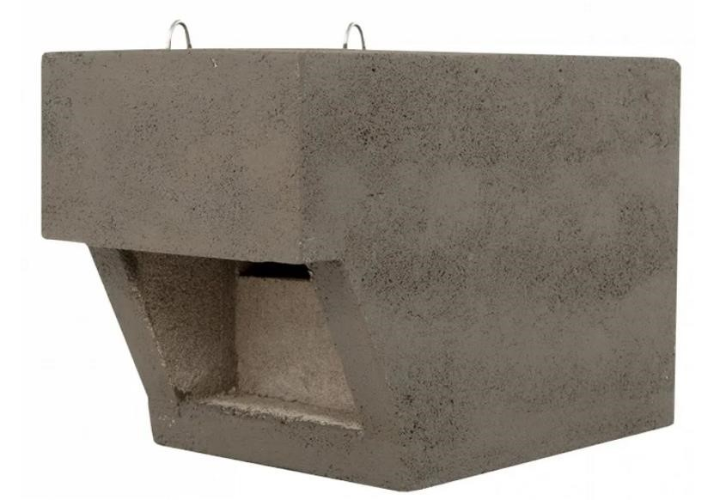
Fig.4: Example of a ‘woodstone’ specialist dipper and grey wagtail nesting box

- 9 Legal Implications

9.1 Bats

Bats are protected under UK law by the Wildlife and Countryside Act 1981 (as amended) and also under European law by the Habitat and Species Regulations 2021. Under these laws it is an offence to deliberately kill or injure a bat, to disturb a bat or to damage, destroy or block access to a roost. Bat roosts are protected under these laws whether the animals are present at the time of survey or not. NRW are empowered to issue licences to carry out work to bat roosts for reasons of overriding public interest.

9.2 Nesting Birds

Under the Wildlife and Countryside Act 1981 (as amended), all nesting birds and their nests are protected. Once a bird places a single piece of material then it constitutes a nest. It is then an offence to cause damage to the bird, nest, eggs or chicks and immediate habitat which is likely to result in damage by causing the bird to desert its nest. This covers all bird species, with a small number of exceptions (pest species which can be controlled by special license.

In 2000, the Countryside and Rights of Way Act (CROW Act) was made law, strengthening the legal protection for many species and introducing a ‘reckless disturbance’ offence.

9.3 Otters

Otters are protected under UK law by the Wildlife and Countryside Act 1981 (as amended) and also under European law by the Habitat and Species Regulations (2021). Under these laws it is an offence to deliberately kill or injure an otter, to disturb them or to damage, destroy or block access to their place of shelter. Under both laws NRW are empowered to issue licences to disturb them, and disturb or destroy their habitat for reasons of overriding public interest.

- 10 Appendices

10.1 Site photographic record

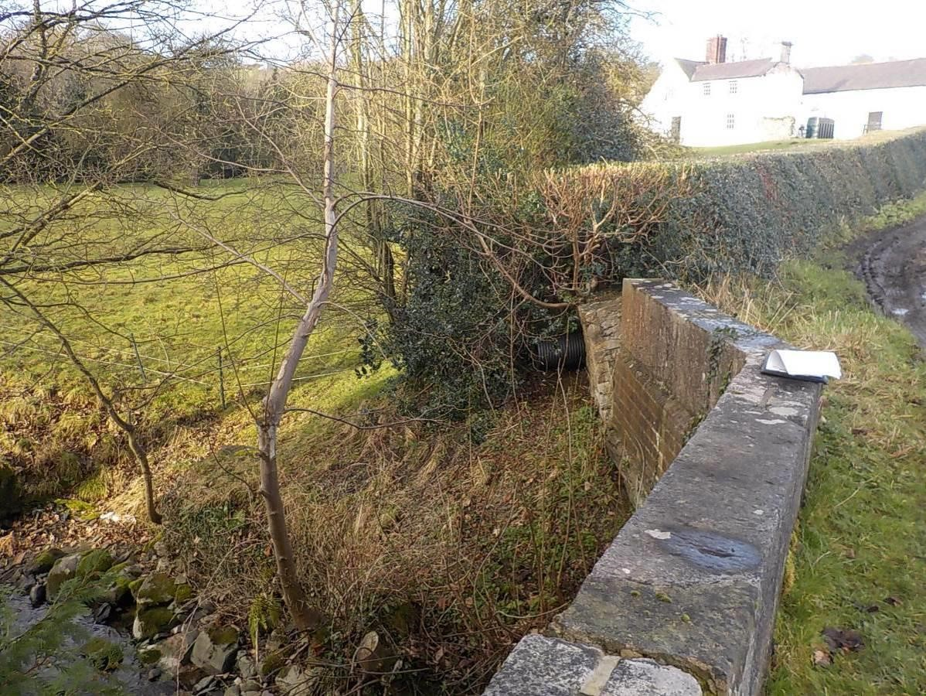
The immature growth from the pollarded sycamore which will be removed during the works

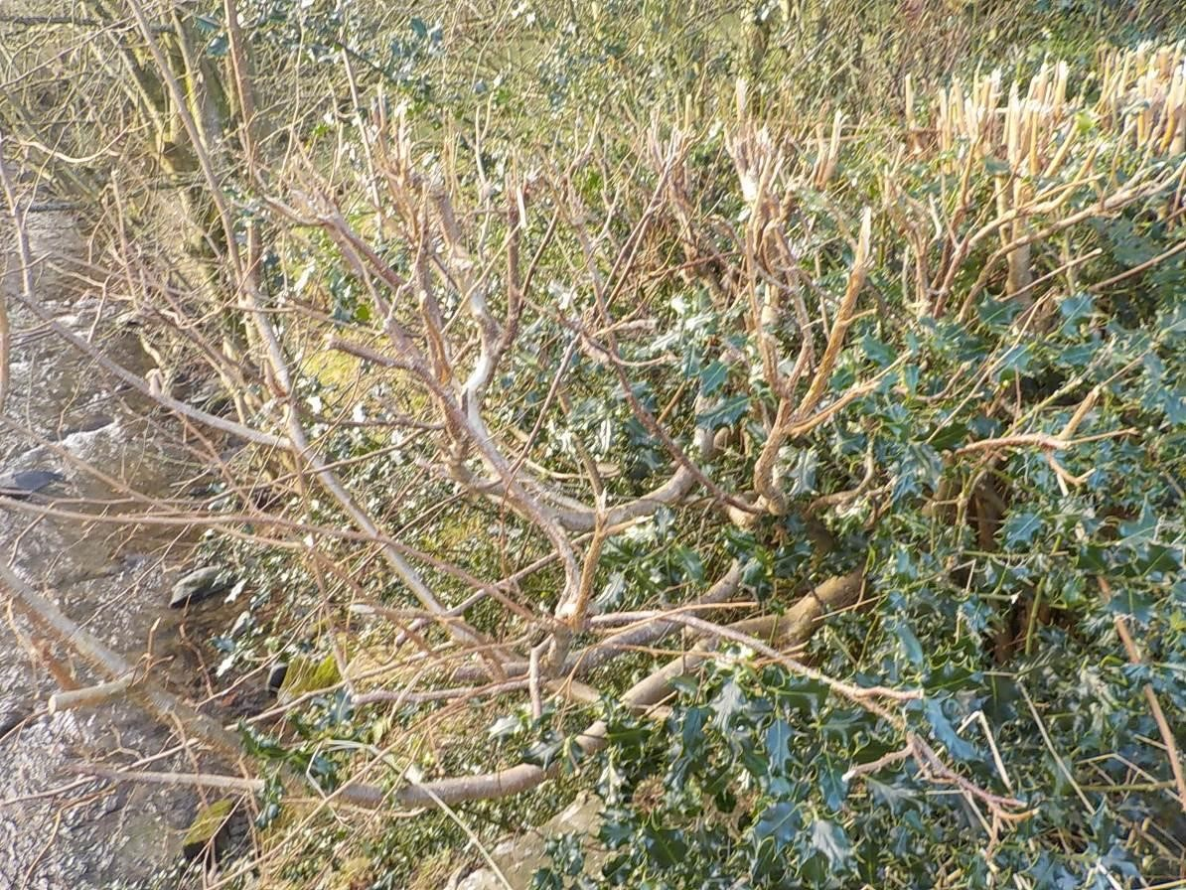 The holly and hazel growth which is overgrowing the parapet on the south-west side

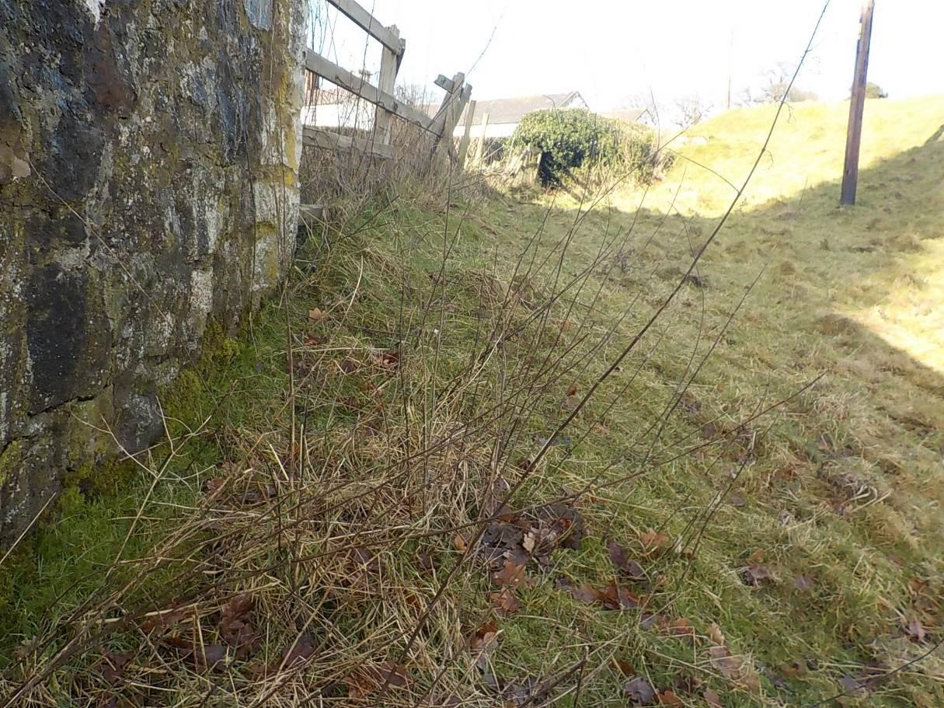
The section of improved grassland to the north of the structure which will be impacted.

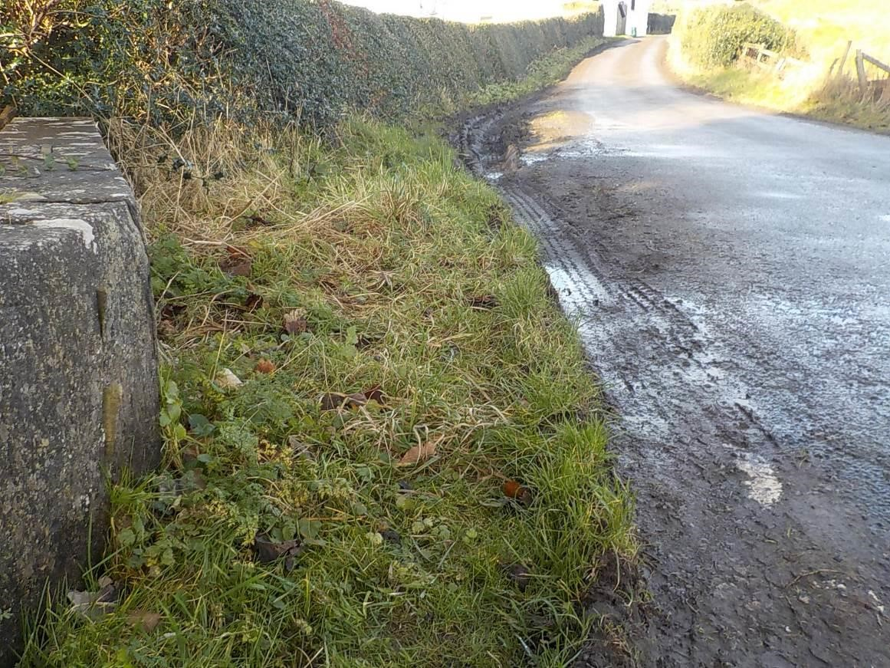
The improved grassland verge which will be impacted by the works

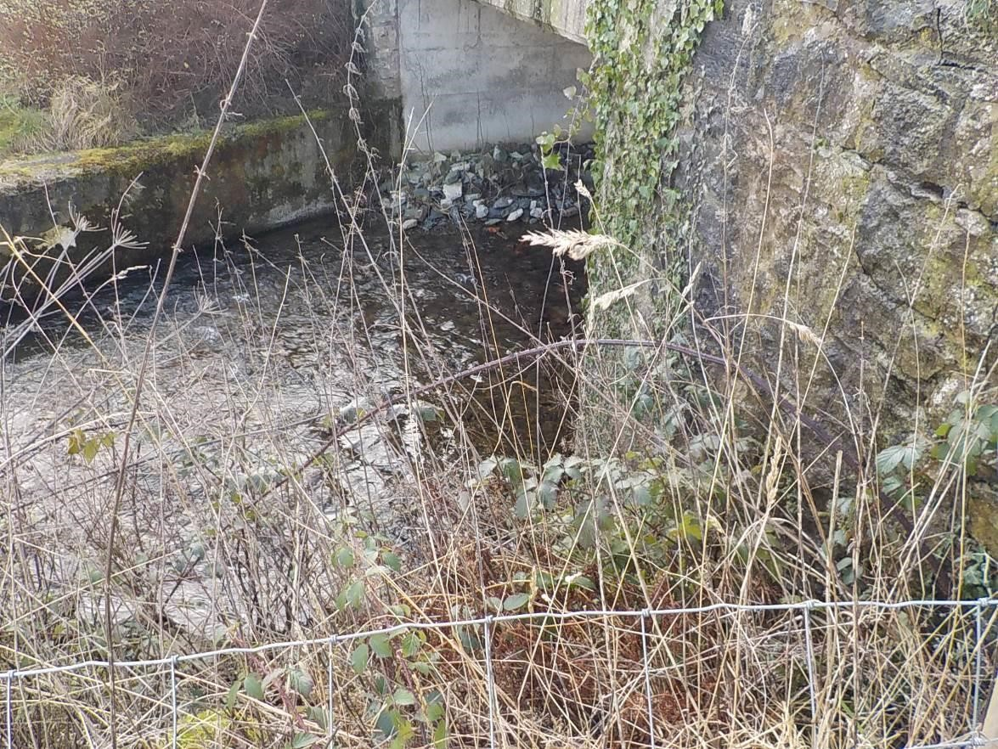
The stand of taller vegetation on the bank to the north of the structure with scrub species and taller grasses present.

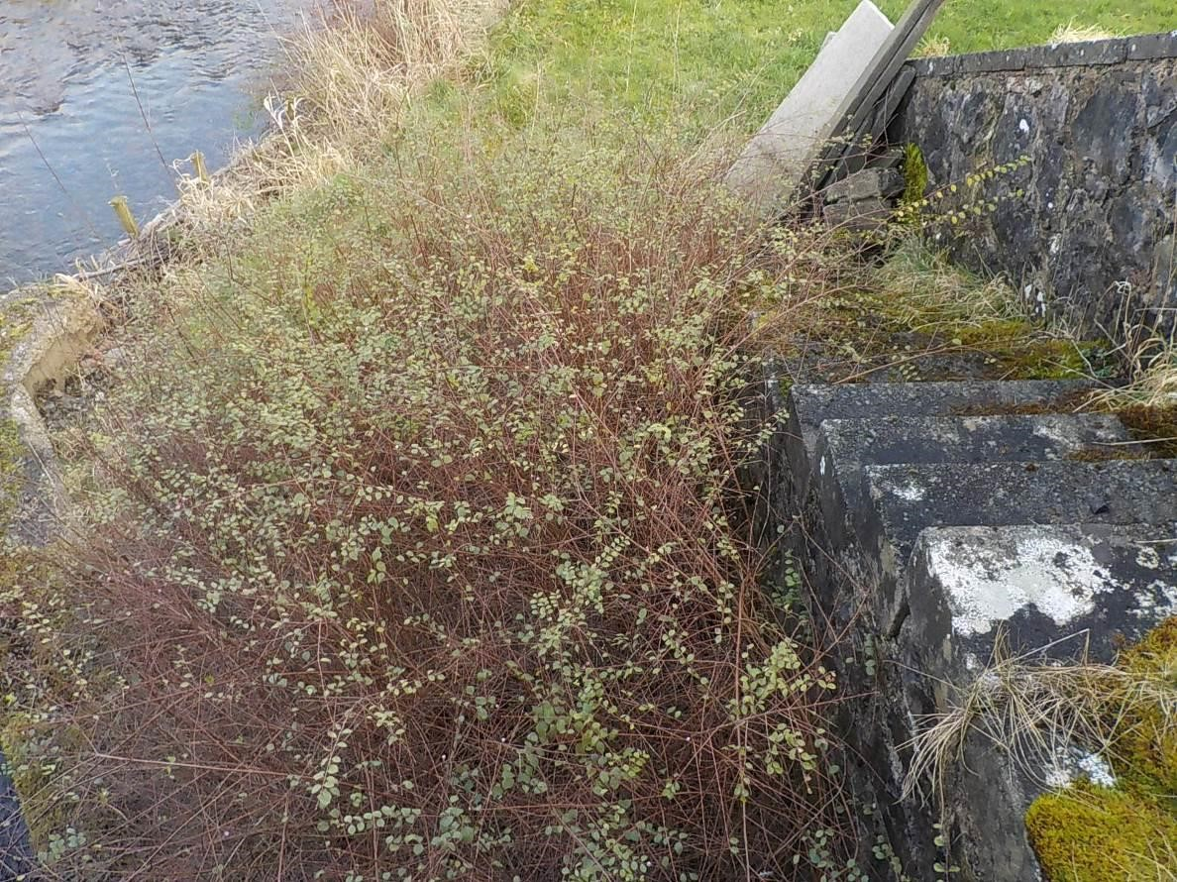
The ornamental shrub obscuring the abutment on the north-east side.
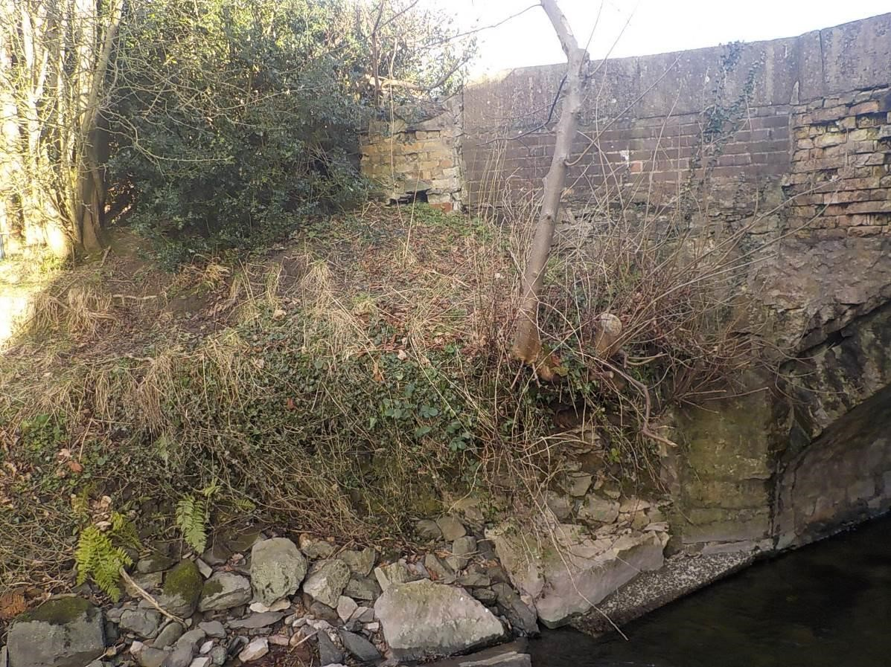
The vegetation present on the south-west training wall, also showing the immature sycamore and holly growth

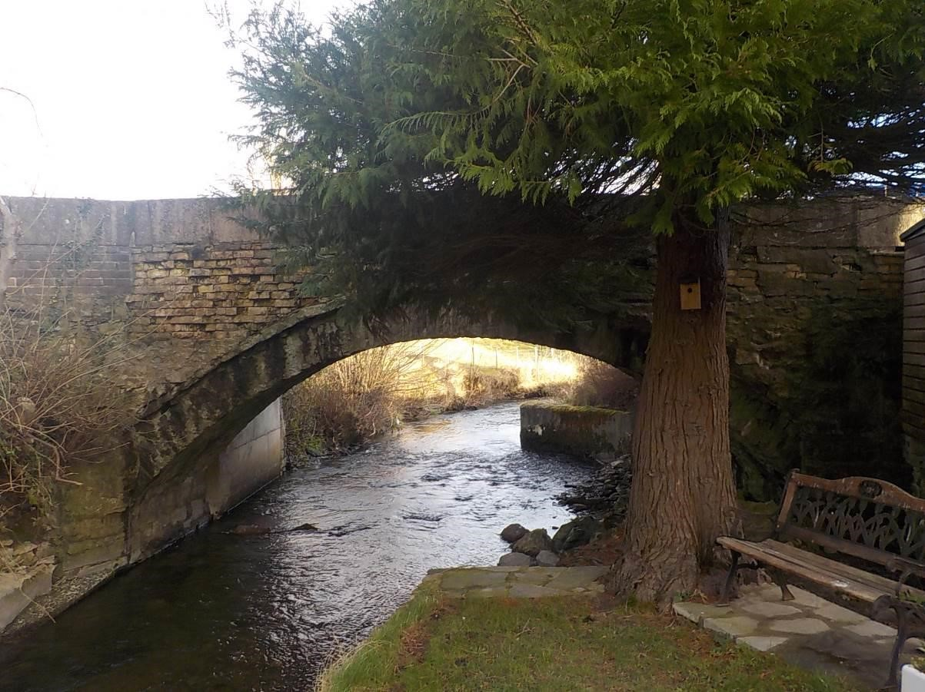
The mature conifer tree located in a private garden, also showing condition of the bridge exterior
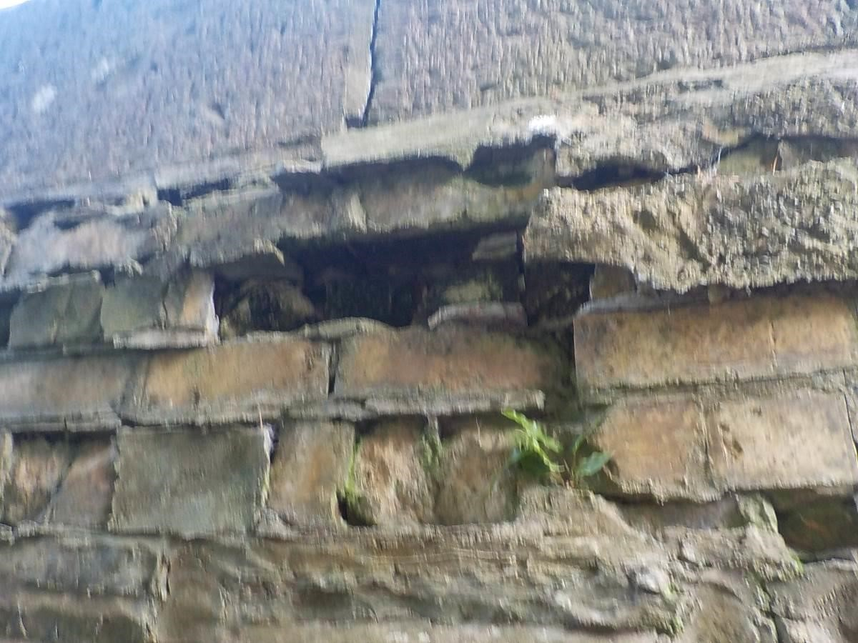
An example of one of the large shallow gaps present in the bridge brickwork

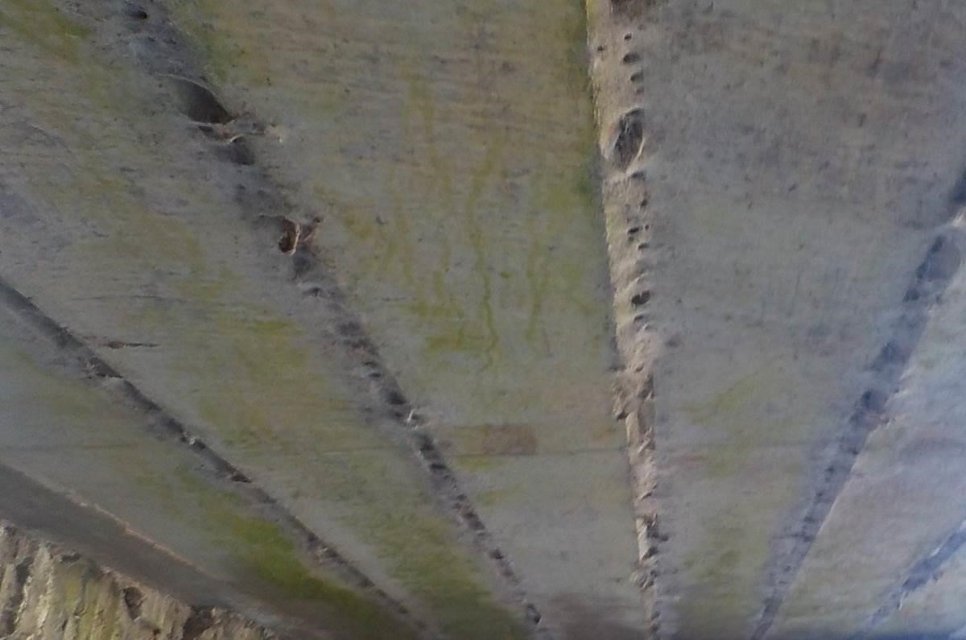
The concrete underside of the bridge with heavily cobwebbed shallow gaps between struts

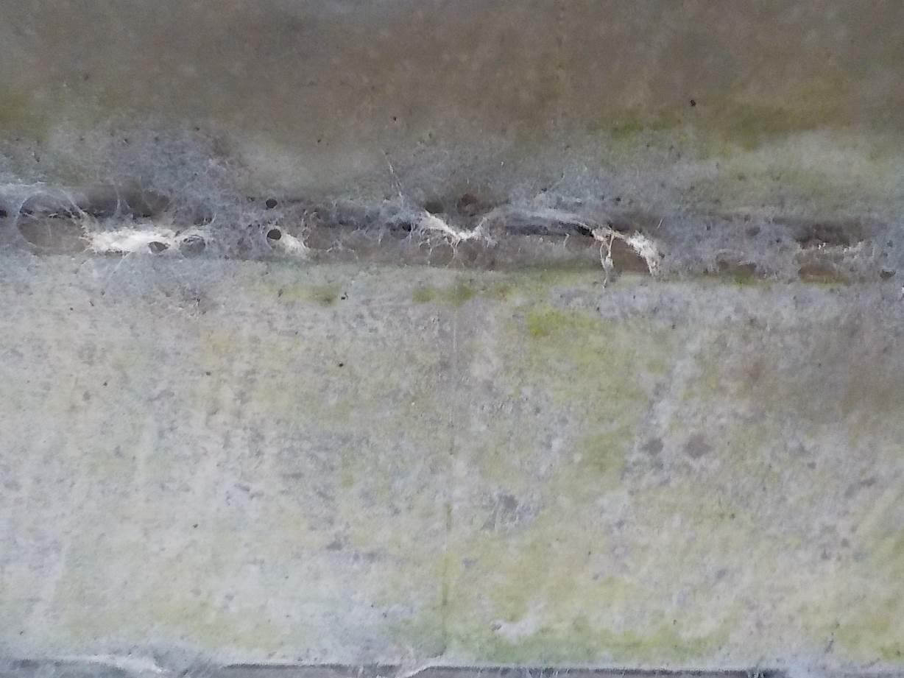
A close up view of one of these gaps

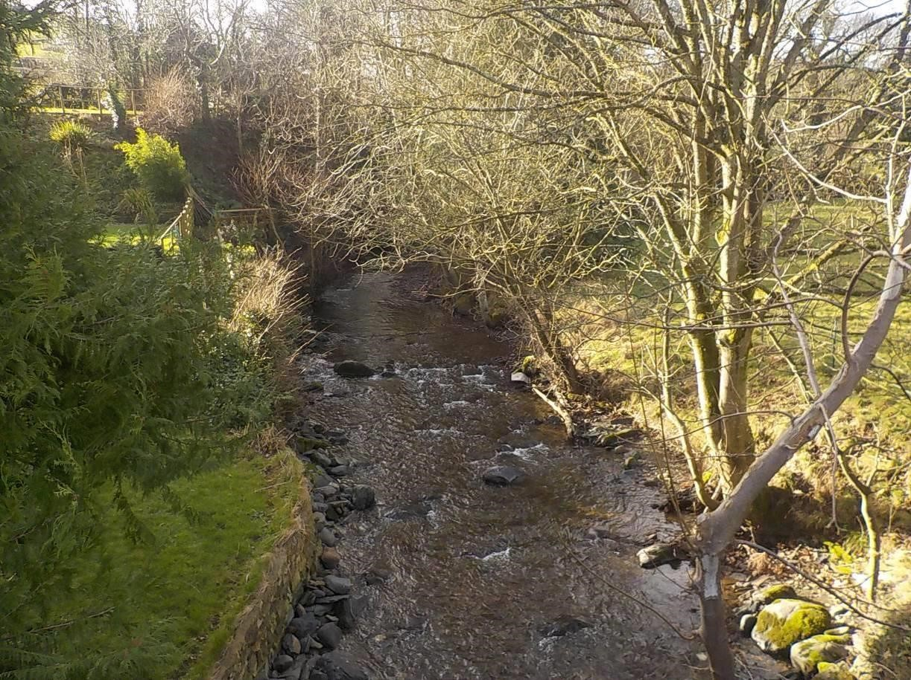
View looking south from the bridge showing wooded riparian corridor
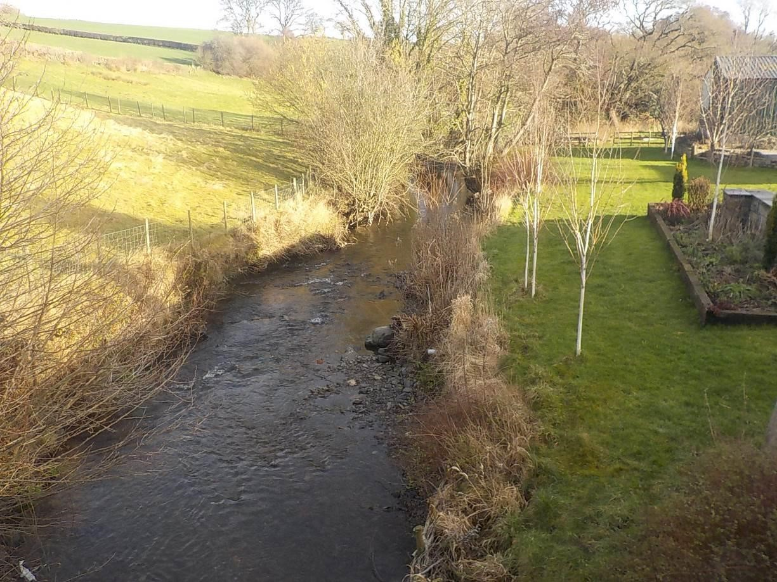
View looking north from the bridge

10.2 Review Table

Name | Task | Date
Lizzie Richardson | Author | 16.02.2022
Chris Hall | Review | 16.02.2022
Kate Williamson | Proof Reading | 16.02.2022

