
Cyngor Tref Aberystwyth Town Council

Tender Notice for Christmas Lighting Works
2026-28

Contents
Section 1 - Scope 2
What the council is looking for 2
Description of works 2
Technical Requirements 3
Specification 4
Estimated contract value 9
Contract dates 9
Main procurement category 9
CPV classifications 9
Contract location(s) 9
Section 2 – Participation 10
Particular suitability 10
Section 3 - Submission 10
Notice publication date 10
Deadline for submission of tenders 10
Instructions for submission 10
Disclaimers 11
Section 4 – Award criteria 12
Section 5 – Procedure 12
Procurement type 12
Section 6 – Contracting authority 12

Section 1 - Scope

What the council is looking for
The Council is seeking to appoint a contractor to undertake the annual inspection, testing, installation, connection and removal of festive lighting and decorations across Aberystwyth. The Council owns a stock of decorations for the purpose.

The contractor must be a suitably qualified and competent electrician, and have demonstrable experience of carrying out similar works, in particular of carrying out electrical work at height and over the public highway.

The contract will be for a duration of three years, with an option to extend for an additional two years at the Council’s discretion.

Description of works
- Preparation of decorations
In September each year, the contractor shall attend the Council’s storage location to undertake preparation of the decorations. This shall include:
  - Inspection of all decorations, to ensure that all are in good working order;
  - Inspection of all electrical components, including wiring, barrel connectors, wire connectors etc.;
  - Electrical testing and certification of all components (PAT BS 7671);
  - Remedial repairs as necessary (e.g. replacement bulbs etc.);
  - Cleaning as necessary.

The contractor shall satisfy themselves of the safety and good working condition of all the decorations and associated parts.

Any faults or shortcomings shall be reported to the Council, together with a reasonable estimate of work needed to rectify the position, in adequate time to meet the switch-on date. The Council shall be free to seek other estimates. The costs of minor remedial works shall be borne by the contractor.

- Installation
To be completed in the month of November, commencing after Remembrance Sunday and to be completed in ample time for the switch-on date. The switch-on date is usually the last weekend in November / first weekend in December.

The installation shall include:
  - Inspection, testing and certification of all anchorage points prior to any installation;
  - Inspection, testing and certification of all electrical installations/circuits;
  - Installation of icicle drape street crossing lights;
  - Dressing of real and steel Christmas trees;
  - Installation of appropriate digital time clocks, programmed for all decorations to be operational between the hours of 15:00 and 01:00 each day.

- Availability and emergency
The contractor shall undertake regular (weekly) visual inspections of the decorations and undertake minor remedial works where necessary; any substantial works needed shall be reported to the Council, together with a reasonable estimate of work needed to rectify the position. The Council shall be free to seek other estimates. The costs of minor remedial works (e.g. fuses, resetting RCCBs etc.) shall be borne by the contractor.

The contractor shall provide 24 hour availability throughout the whole duration of the decorations’ installation, with attendance to any reported emergency within 2 hours. The contractor’s details may be shared with the local highway authority(ies) for this purpose.

- Removal
All decorations shall be switched off by the Twelfth Night (i.e. 5 January), and shall be removed in their entirety by no later than 31 January.

Decorations are to be removed and stored neatly and labelled in storage containers provided. Once dismantled, all decorations are to be returned to the Councils storage location.

Technical Requirements
- General
- All works must be carried out in accordance with the standards set out in the Code of Practice for the Installation, Operation and Removal of Seasonal Decorations (County Surveyors Society / Institution of Lighting Professionals). Knowledge and experience of the Code is essential.
- Membership of the HEA (Highway Electrical Association) and HERS (Highway Electrical Registration Scheme) is desirable.
- The contractor must be familiar with the anchor point testing process before carrying out any electrical works; this will involve the use of anchor point testing equipment, calibration and will be able to complete and provide anchor point testing certificates prior to installing any cabling.
- The contractor shall submit, with their tender, suitable risk assessments and method statements for this contract.
- The contractor shall submit, with their tender, a document outlining the staff roles & chain of command, named duty holder, and staff competencies & qualifications for this contract.
- The contractor shall provide all tools, equipment, and consumables required for the undertaking of the contract, and shall provide for this within their tender price.
- The contractor shall ensure that all installations comply with all relevant regulations and standards, and that all work undertaken is compliant with relevant health and safety legislation.

- Electrical
- The contractor must be a “Skilled Electrical Person” as defined by the JIB, holding a valid ECS card.
- The contractor must be registered with the National Inspection Council for Electrical Contracting (NICEIC).
- The contractor must be registered with the Electrical Contractors Association (ECA).
- The contractor must hold a G39 certificate.

- Traffic management & access
- The contractor must be in possession of a valid IPAF – PAL (International Powered Access Federation – Powered Access Licence).
- The contractor will need to provide evidence of (LOLER - Lifting Operations and Lifting Equipment Regulations) safety inspections.
- The contractor must be familiar with the highway working requirements (signing, lighting, guarding etc.) of the New Roads and Street Works Act 1991 (NRSWA). Qualification under this act is desirable.
- Works in the public highway should be carried out between the hours of 18:30 and 07:00, to minimise disruption to traffic.
- Any road closure(s) required for these works shall be the responsibility of the contractor; the contractor should submit a draft traffic management plan with their tender.
- All work shall follow any requirements/standards set by the relevant highways authorities (Ceredigion County Council and the NMWTRA). Works should be done in consultation with these authorities.

Specification
Location / Street | No of crossings | Anchor Point Testing | Type of Xmas light
Upper Great Darkgate Street -  Market Hall to Premier Shop | single | yes | single strand of icicles
Great Darkgate Street - Starbucks | single | yes | single strand of icicles
Great Darkgate Street –  Claires to Accessorize | double | yes | double strand of icicles
Great Darkgate Street –  Café Nero to Poundland | double | yes | double strand of icicles
Great Darkgate Street –  Vodafone to Betfred | double | yes | double strand of icicles
Great Darkgate Street –  Boots Optician to Santander | double | yes | double strand of icicles
Chalybeate Street – Boots Optician to TUI | double | yes | double strand of icicles
Terrace Road - Spartacus to John Francis | single | yes | single strand of icicles
Terrace Road - KFC to Venus Barbers | single | yes | single strand of icicles
Terrace Road - Alexanders to Mobile Phone shop | single | yes | single strand of icicles
Terrace Road - TSB Bank to Care Society | single | yes | single strand of icicles
Terrace Road - Siop-y-Pethe to Tesco Express | single | yes | single strand of icicles
Terrace Road - Barclays Bank to Inkwells | single | yes | single strand of icicles
Terrace Road - 24hr Spar to The Works | single | yes | single strand of icicles
Terrace Road – Outside Clive Menswear | single | yes | single strand of icicles
Terrace Road - White Horse to Ceredigion Museum | single | yes | single strand of icicles
Pier Street - Penguin Café to Art Shop | single | yes | single strand of icicles
Pier Street –Sports Direct to Home Café | single | yes | single strand of icicles
Pier Street – Ice Cream Shop to Driftwood Designs | single | yes | single strand of icicles
New Street – Carpet shop to Welsh Computers | single | yes | single strand of icicles
Town Clock Tower | drapes 4 sides | All sides | drapes of icicle lights
Bridge Street - Corals to Agnellis | single | yes | single strand of icicles
Bridge Street – Oriel y Bont to barbers | single | yes | single strand of icicles
Bridge Street – R. Benjamin to Llew Du | single | yes | single strand of icicles
Market Street - Vision Express to Claire Lloyd | single | yes | single strand of icicles
Eastgate - Thatch to Antique shop | single | yes | single strand of icicles
Eastgate – Downies Vaults to Light of Asia | single | yes | single strand of icicles
Christmas Trees
Real
Owain Glyndwr Square (main tree) | N/A | N/A | Xmas tree lights only
Penparcau – top of 3rd Avenue | N/A | N/A | Xmas tree lights only
Trefechan - Entrance to Marina | N/A | N/A | Xmas tree lights only
Steel
Alexandra Road – Outside Wetherspoons | N/A | N/A | Xmas tree lights only
Neuadd Goffa Green Penparcau | N/A | N/A | Xmas tree lights only
Llys-y-Brenin Square | N/A | N/A | Xmas tree lights only
Top of Great Darkgate Street – By seating area | N/A | N/A | Xmas tree lights only

Street Maps
Pier Street, Bridge Street, Upper Great Darkgate Street, Great Darkgate Street, Chalybeate Street, Eastgate, Market Street, Owain Glyndwr Square & Terrace Road.
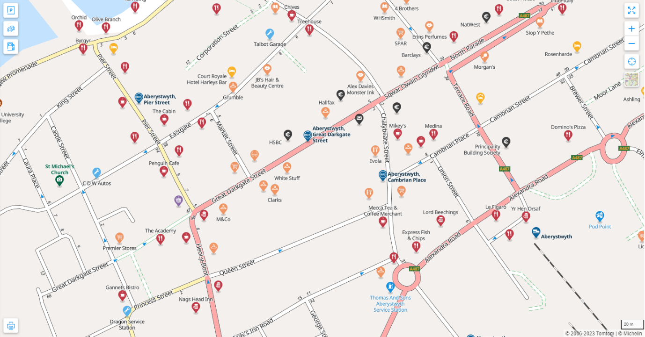
Christmas Trees (Real) Steel Christmas Tree
Christmas Light Draped Crossing points -

Terrace Road, Llys-y-Brenin Square
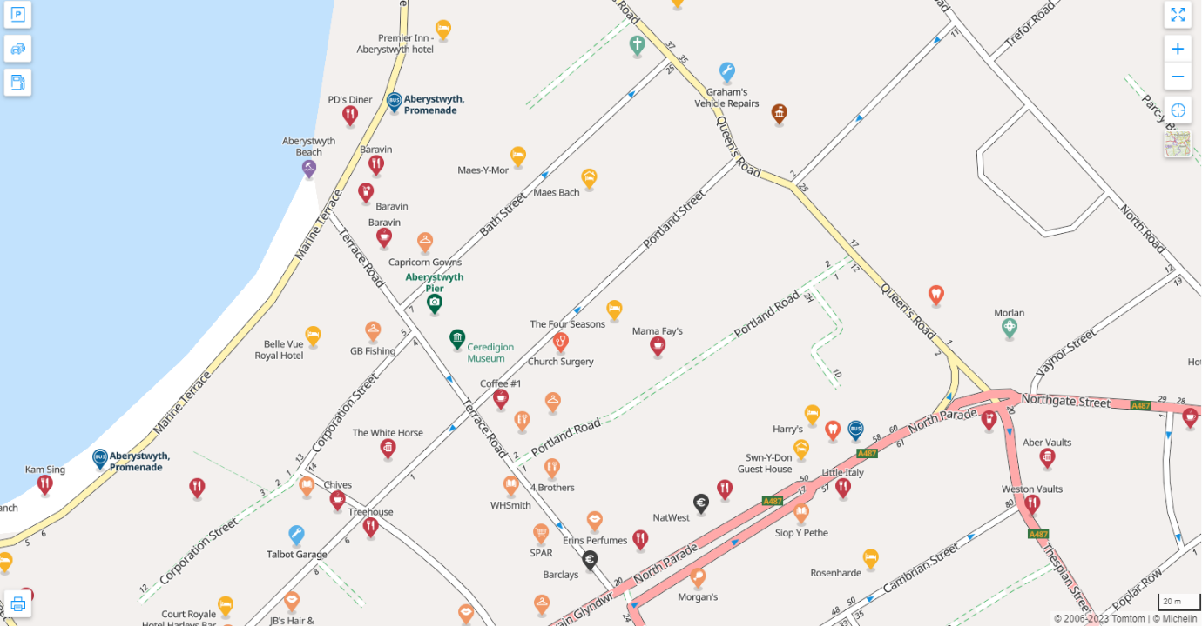
Steel Christmas Tree –
Christmas Light Draped Crossing points -

Other Christmas Tree Locations
Trefechan – 25ft Nordman Fir
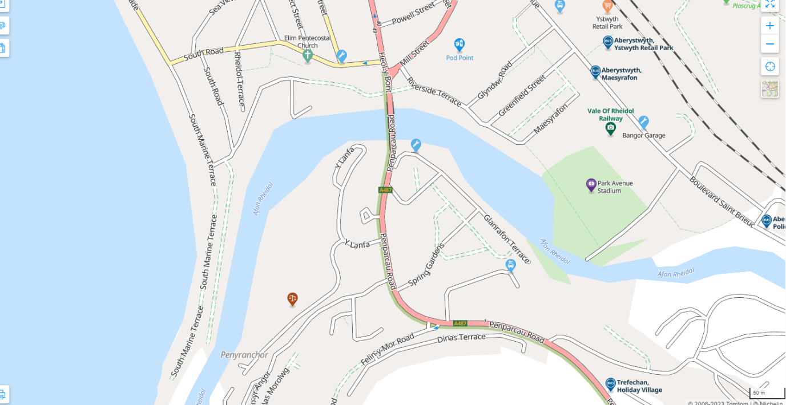

Penparcau - 25ft Nordman Fir & Steel Tree
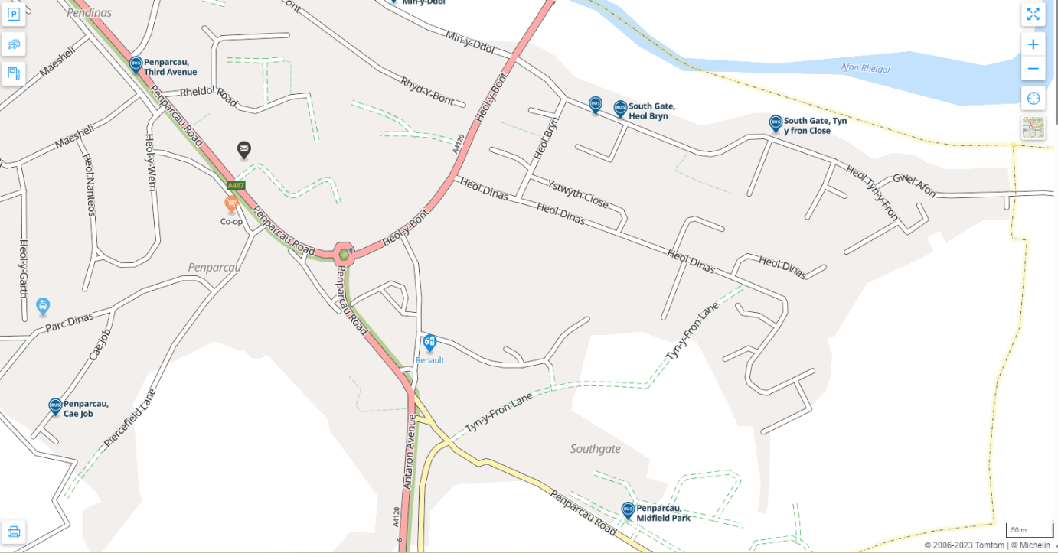
Christmas Tree installations are to be carried out by an alternative contractor, however the holder of this contract may be called upon to assist with the tree erection prior to installing the Christmas lights; this may be at an additional cost, to be agreed prior with the Council.

Estimated contract value
The value of this contract is estimated to be in the region of £25,000 (exc. VAT) per annum (i.e. total £75,000 exc. VAT).
Below the relevant threshold.

Contract dates
Contract award date
28.7.2026
Contract signing date
10.8.2026
Contract length
Contract start date: 1.9.2026
Contract end date: 28.2.2029
Contract length: 2 years and 6 months

Main procurement category
Services

CPV classifications
- 31522000 – Christmas tree lights
- 45316100 – Installation of outdoor illumination equipment
- 31000000 – Electrical machinery, apparatus, equipment and consumables; lighting
- 50000000 – Repair and maintenance services
- 51000000 – Installation services (except software)
- 71630000 – Technical inspection and testing services

Contract location(s)
UKL1 - West Wales and the Valleys (Aberystwyth)

Section 2 – Participation

Particular suitability
- Small and medium-sized enterprises (SME)
- Voluntary, community and social enterprises (VCSE)

Section 3 - Submission

Notice publication date
26.5.2026

Deadline for submission of tenders
1.7.2026 (12:00 noon)

Instructions for submission
This tender form must be responded to in full even if your organisation has previously submitted a Form to the council. It is not sufficient to refer to earlier or other forms. All questions must be answered, using “none” or “N/A” where appropriate. Clearly mark on any additional sheets the name of your organisation and the question number it refers to.

Except where instructed otherwise, please give details that relate to the organisation applying for the contract, not to the whole of the group if your organisation forms part of a group.

Please do not include general marketing or promotional material for your organisation to answer any of the questions in this form or for any other reason.

Please return the completed form, together with relevant supporting documents by 12:00 noon on Wednesday the 1st of July 2026. Late submissions will be rejected.

Tenders may by submitted electronically, using the Sell2Wales online portal (https;//www.sell2wales.gov.wales/).

Paper tenders may be submitted using a plain envelope, marked clearly with the wording “Christmas Lights Tender” to the address below. Paper submissions not marked clearly as above may accidentally be opened prior to the closing date, and thereby invalidated. Pre-labelled envelopes can be provided on request.

Cyngor Tref Aberystwyth Town Council
The Presbytery
Neuadd Gwenfrewi
Queen’s Road
Aberystwyth
SY23 2HS

Disclaimers
General
The Town Council reserves the right to raise such additional questions it may consider necessary in the light of the information given before accepting or rejecting any application.
Costs
The Council will not re-reimburse any expenses incurred by organisations in preparing their responses to the form. The Council reserves the right to discontinue the procurement process at any time and will not accept any liability towards organisations should it have to do so.
Freedom of Information
Under the Freedom of Information Act 2000 (the Act) the public have the general right of access to council information. This right of access to information will not only include access to information about the Council’s contracts but also its procurement arrangements with potential contractors.
This right does not extend to information which is commercially sensitive or otherwise “exempt” from disclosure under the Act.
Organisations are asked to identify those areas in their form that they consider to be commercially sensitive, and for how long as these may be subject to discussion as part of the tender process and during post-tender negotiations (if any).
The Council reserves the right to hold all or any information from organisations in confidence whether or not it is identified as commercially sensitive by the organisation.
The forms of organisations not invited to tender will be disposed of in accordance with the council’s document retention and disposal policy.
Public Contracts Regulations
As a public contract, the conditions of the Procurement Act 2023; Procurement (Wales) Regulations 2024; and the Bribery Act 2010; shall apply.
The Council reserve the right to reject the applications of any organisation that do not meet the requirements set out in these legislations.

Section 4 – Award criteria
No specified scoring system shall be used in the evaluation of submitted tenders. The contract award shall be made by a democratic decision of the Full Council, following consideration of the tenders by the Council’s Finance Committee. The contract shall be awarded to the supplier that submits, in the Council’s view, the most advantageous tender.
Key elements that Council, and its members, shall consider in determining the most advantageous tender include:
- Price;
- Relevant experience.
The Council shall ensure that al tenders are evaluated fairly and consistently, in accordance with the information provided / requested in the tender document(s). A clear record of the evaluation and decision-making process shall be maintained and available, on request, after the awarding of the contract.

Section 5 – Procedure

Procurement type
Below threshold – open competition.

Section 6 – Contracting authority
Aberystwyth Town Council
Public Procurement Organisation Number: PGYM-1835-DRLV
The Presbytery
Neuadd Gwenfrewi
Queen’s Road
Aberystwyth
SY23 2HS
Contact name: Will Rowlands / Steve Williams
Telephone: 01970 624 761
Email: council@aberystwyth.gov.uk
Region: UKL1 - West Wales and the Valleys (Aberystwyth)
Organisation type: Regional and local public authority (sub-central) - UK or devolved administrations.

