

Environment, Roads & Facilities
Infrastructure (Consultancy)

ERCF2509N 20
Pont Gell, Llangernyw

Volume 4 - Pre-Construction Information

June 2026

G.B. Edwards BEng (Hons) CEng FICE
Head of Environment, Roads & Facilities,
PO. Box 1, Colwyn Bay, LL29 0GG

01492 575337
affch@conwy.gov.uk / erf@conwy.gov.uk

Issue and Revision Record

Document Title | Volume 4 - Pre-Construction Information
Version | V1
Status | Tender Issue
Filename | ERCF2509N 20 Pont Gell - Volume 4 PCI.docx

Revision | Notes | Date
V1 | Tender Issue | 12/06/2026

 | Signature | Name | Date
Prepared by | GRJ | Gerallt James | 12/06/2026
Checked by |  | John Castle | 12/06/2026
Approved by | BS | Bryn Shiland | 12/06/2026

Introduction

CDM Regulations 2015
This document should be read in conjunction with the Regulations - ‘Managing health and safety in construction’ Construction (Design and Management) Regulations 2015. HSE Document Reference: L153.

Purpose of this document
Appendix 2 of the Regulations states that the Pre-Construction information is to be concise and in an easy and understandable form so as to enable duty holders involved in the project to carry out their responsibilities. To this end, only primary information that is either expressly required by the Regulations or that is project specific is contained in the document. Normal construction hazards that a competent Contractor should be aware of are not included.

Duty Holders
The Client is Conwy County Borough Council (CCBC) Flood Risk and Infrastructure Department:

- Contact: Owen Conry, Flood Risk and Infrastructure manager
- Address: ERF, Coed Pella, Conwy Rd, Colwyn Bay, LL29 7AZ
- Email: Owen.conry@conwy.gov.uk
- Telephone: 01492 575 338
The Principal Designer is CCBC Flood Risk and Infrastructure Department:

- Contact: Gerallt James, Principal Infrastructure Engineer
- Address: ERF, Coed Pella, Conwy Rd, Colwyn Bay, LL29 7AZ
- Email: gerallt.james@conwy.gov.uk
- Telephone: 01492 5741744
The Principal Contractor will be the successful Tenderer.
- TBC

F10 Notification to HSE
The Construction Phase is estimated at 30 working days (6 weeks) and will have an average of 4 persons on site throughout the project – an average of 120 person days

- In accordance with Regulation 6, the Project is not notifiable.
If when tendering the works the Contractor considers that the above assumption is incorrect and that the project exceeds the triggers in the Regulations, then this should be clearly stated in the submission so that appropriate Notification might be made.

Construction Phase Plan
The Principal Contractor is required to take the Pre-construction Information and, after visiting the site so as to make his own assessment of the Site and proposed Works, develop the Construction Phase Plan (CPP). Duties placed on the Principal Contractor are detailed in the Regulations, Part 3.

Guidance on preparing the CPP is contained in the Regulations, Appendix 3.

The CPP should include detailed project specific method statements and a thorough assessment of significant project specific risks of the Construction Phase. The CPP should be a systematic consideration of Part 4 ‘General requirements of Construction Sites’ of the Regulations.

Project Information

Location
Pont Gell is located on near Llangernyw
NGR 285165, 369470
See Location Plan ERCF2509N 20 T101 LP in Volume 3 Drawings

Client Brief
The proposed works comprise the full replacement of the existing box culvert beneath the highway due to its poor condition and insufficient hydraulic performance. The works will be undertaken under a full road closure to ensure the safety of the public and workforce and to allow construction to be carried out efficiently.
The primary works are:
- Installation of a full road closure & traffic management.
- Implementation of temporary diversion.
- Excavation of the carriageway and adjacent areas to expose the existing culvert
- Demolition and removal of the existing box culvert
- Installation of a new reinforced concrete box culvert
- Construction of new inlet and outlet headwalls
- Backfilling and compaction around the structure
- Full reinstatement of the highway construction
- Final reconnection of the watercourse and removal of temporary works
- Site clearance and removal of traffic management prior to reopening the road
The above is a precis of the Works. The Contractor should refer to the Scope for more detailed information.

Key Dates
Construction Phase Start: 07/09/2026
Duration: 6 weeks
Construction Phase Finish: 16/10/2026

Programme restrictions: None.
Working hours are expected to be normal working hours (0800-1800 Monday to Friday), unless agreed otherwise with the Client.

Planning and Management

Design Phase
The Principal Designer has prepared the proposed scheme based on the following information:

A topographical survey
A topographical survey has been undertaken and forms the basis for line and level. This will be made available to the successful tenderer.

An ecological survey
An ecological survey has been carried out and available in Appendix A.

Desk top survey
There are no special designations for the site.

A walk over survey
A visual walk over survey has identified the following restrictions that have a bearing on health and safety:
- The existing box culvert has suffered erosion damage, resulting in a loss of support to sections of the structure. Therefore, water flows have bypassed the culvert rather than being conveyed through it, leading to erosion of the surrounding fill material and causing settlement of the carriageway above, which is evident as a dip in the road.

Statutory undertakes equipment searches
Searches regarding the presence and location of statutory undertakers’ equipment has been sought and is included in the Site Information. In summary:

- There is Openreach overhead apparatus to the downstream site (North)

Statutory undertakes searches are located in Appendix B
It is the contractor’s responsibility to CAT scan prior to any excavations

Ground Investigation
A ground investigation survey was not undertaken

Health and Safety File for the structure.
There are no current Health and Safety File for the structure.

Invasive testing
See 3.1.6

River flow
A primary hazard identified for safe execution of the works is the river. The following requirements regarding to managing flood risk to allow the safe passage of water through the Works is:

- The Contractor to have a river level monitoring system in place and action plan for evacuation of river channel in the event of flooding.

Adjacent Works
None known.

Design Principles
The principles of the design anticipate the following:

- The historic bridge abutments appear to be still in place and will be required to be removed.

Health and Safety Hazards

Hazards identified by the Client
The primary site-specific hazards identified by the Client and suggested method as to how the Contractor may manage the hazards during the Construction phase – refer to Scope for details

- Road traffic – works are on the public highway but and will be closed for construction for vehicles and pedestrians.
- River – normal river flows managed as per 3.1.9 above – extraordinary flows to be monitored and evacuation procedure put in place
- Statutory undertakers’ equipment – will not affect the works

Hazards Identified by the Principal Designer
The primary site-specific hazards identified by the Designer and suggested method as to how the Contractor may manage the hazards during the Construction phase – refer to Scope for details.

- Road traffic – road closure signs and diversion to be provided – road closure to vehicles and pedestrians.
- Possible contamination of watercourse due to concreting for foundations – Provide a flume / over-pumping, use UCS additive. Principal Contractor to review weather forecast in advance to reduce the potential for flooding until the scour apron has hardened.

Please refer to the risk register in the Appendix C of the contract documentation, The risks that have been identified and will require detailed assessment and the preparation of a considered method statement before commencement of the element of work

Health and Safety File
If there is more than one Contractor on site, a Health and Safety File will be required in accordance with Regulation 12. A template health and safety file is included in the Appendix D of the contract documentation

Appendix A – Ecological survey

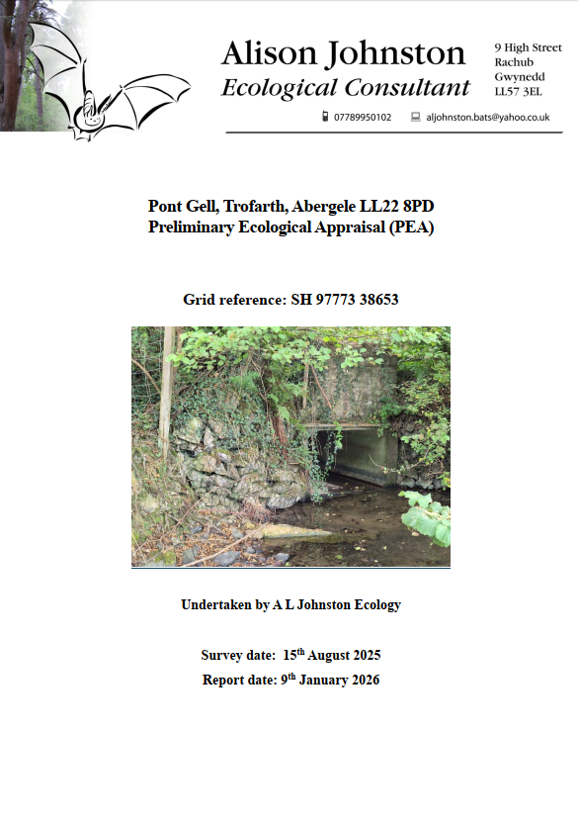

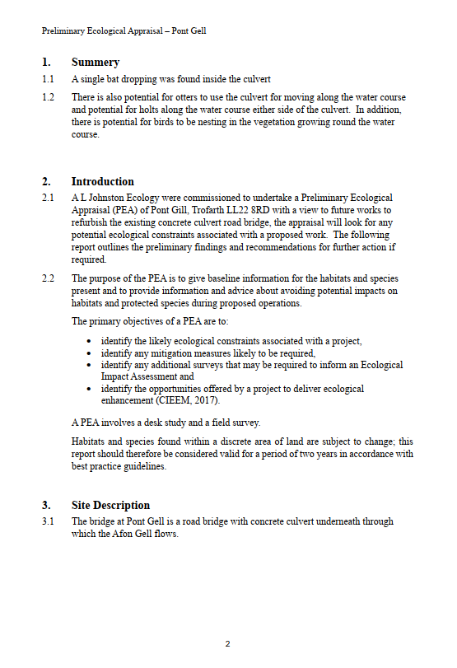
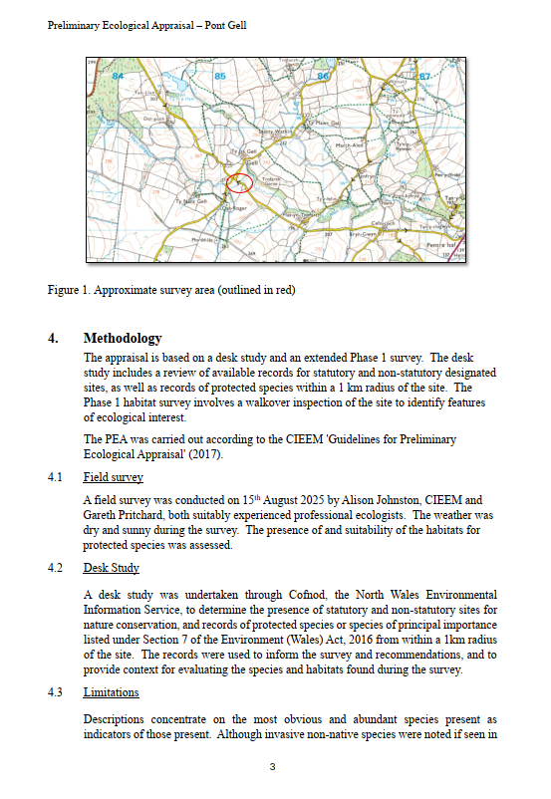
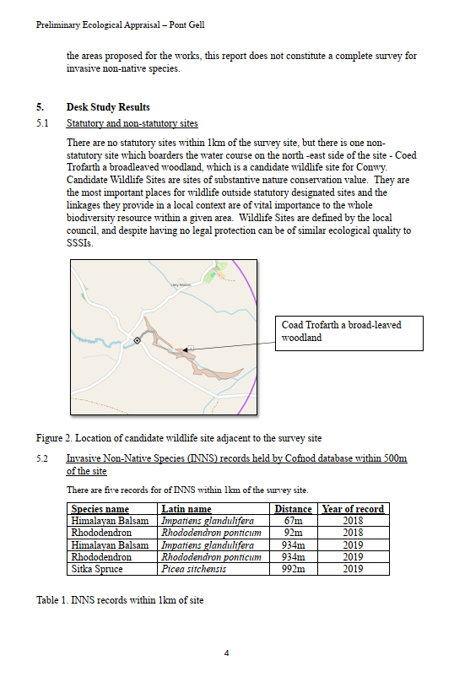
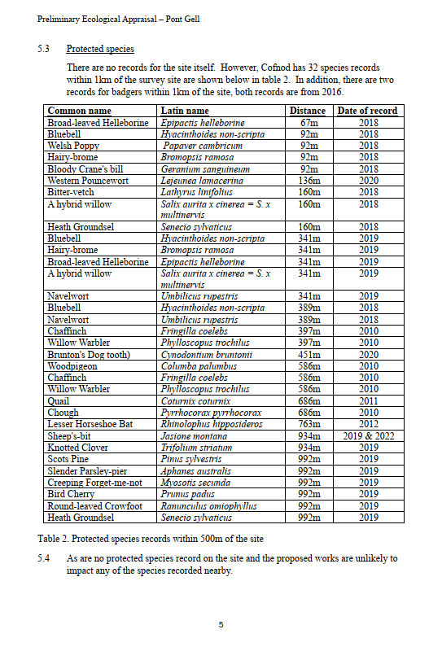
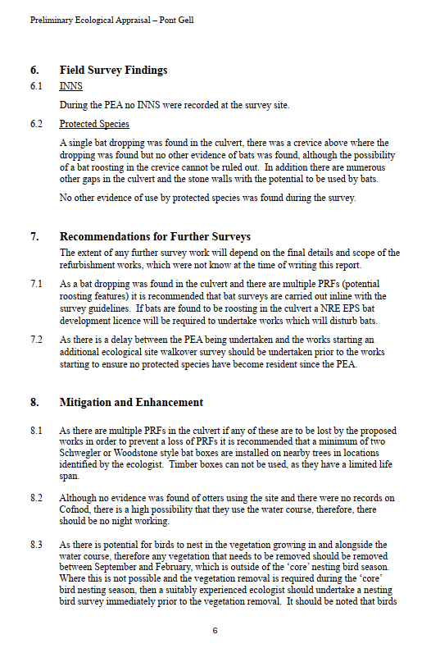
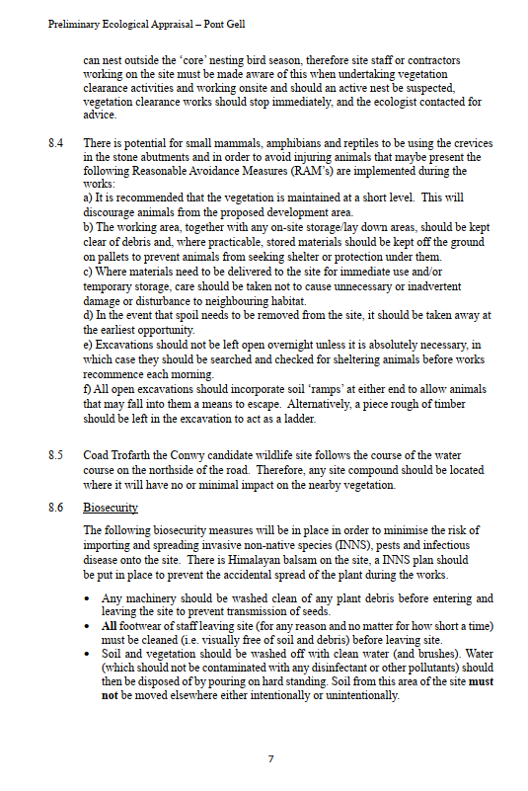
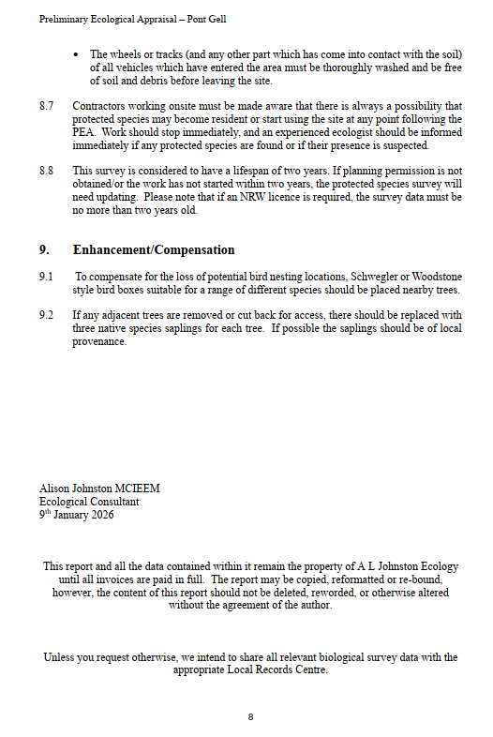
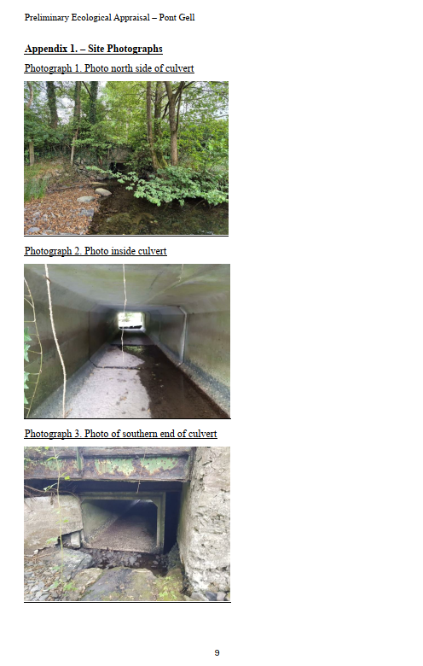
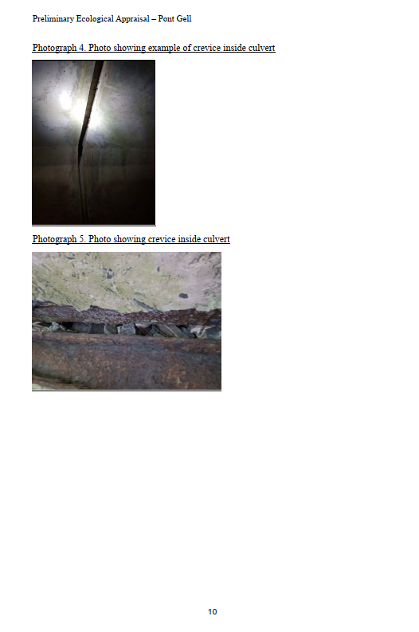
Appendix B – Statutory Undertakers

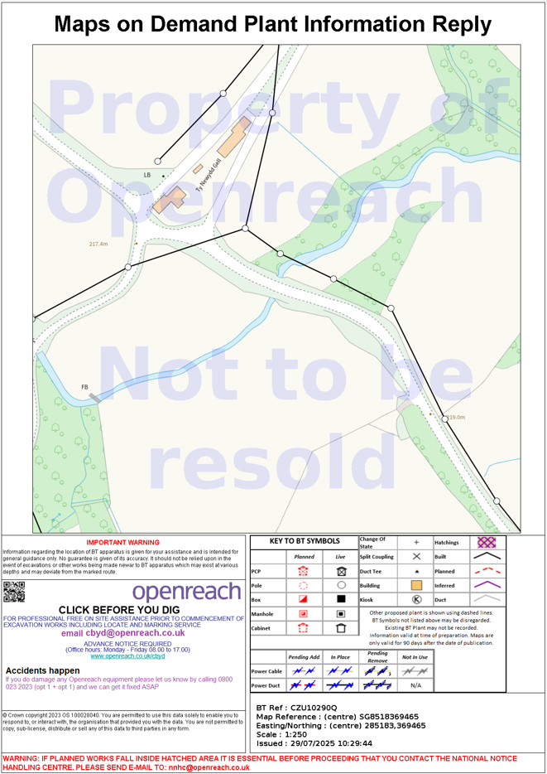

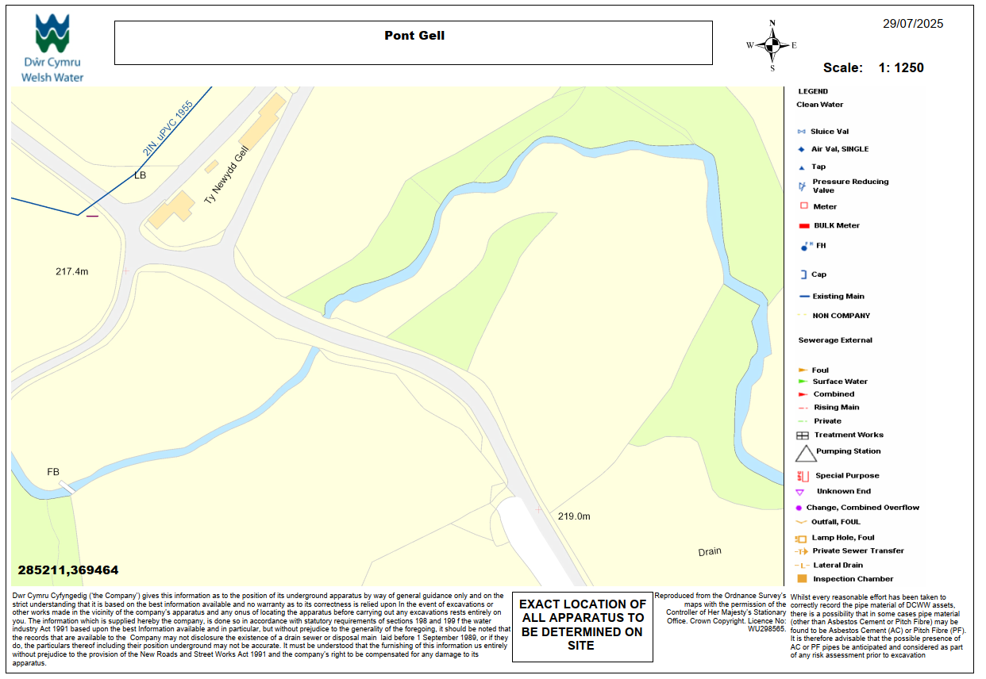
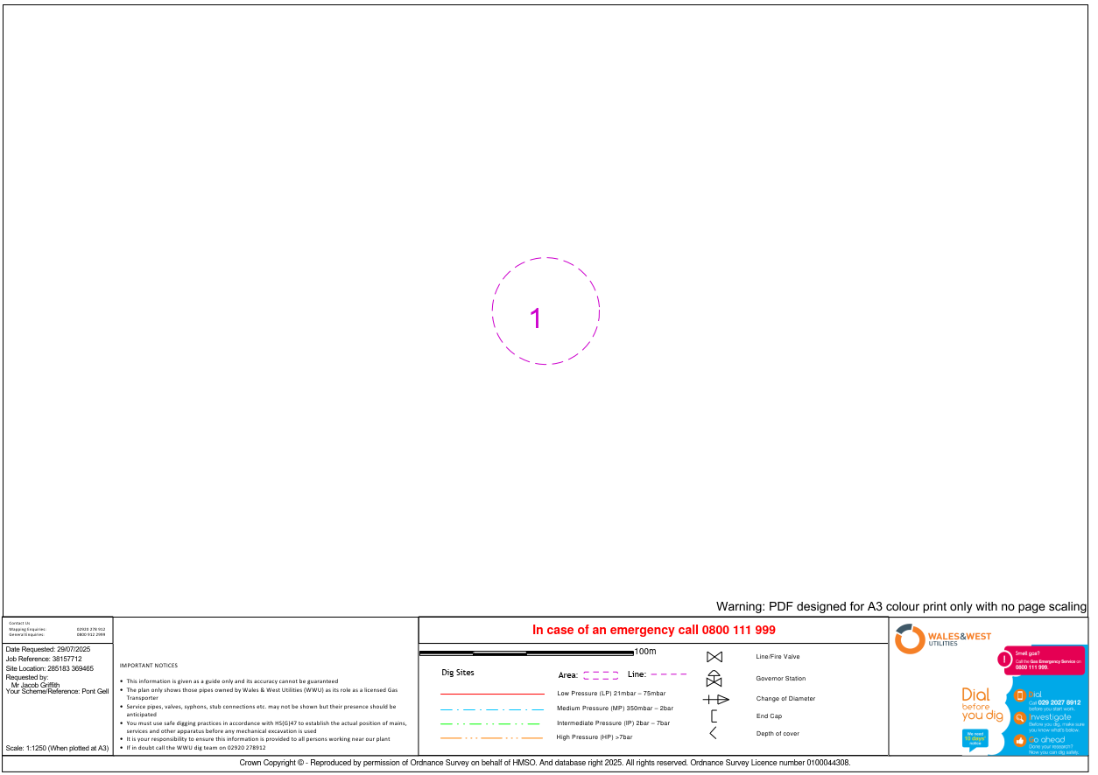
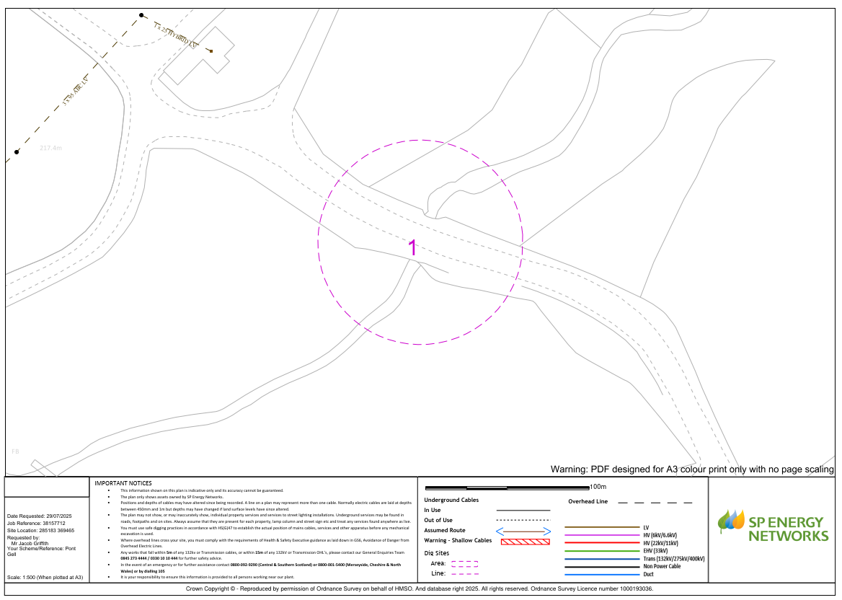

Appendix C – Risk Register

Risk Register

■ | The following risks have been identified and will require detailed assessment and the preparation of a considered method statement before commencement of the element of work.
Risk No. | Risk Description | EW Signs (causes & 1st indications) | Immediate Impact if occurs | Possible Responses: Avoid, Minimise, Mitigate, Transfer
1 | Availability of materials |  | Programme delays | Early award of works
2 | Uncharted utilities found during works |  | Delay to programme and costs of diversions | Regular communication between all parties. Contractor to scan and plot all services and provide a drawing. Contractor to engage Utilities as required.
3 | Disruption to local populace and stakeholders (residents, shops and businesses) |  | Dissatisfaction of local residents and complaints | Liaise with local community early and regularly update the local community about ongoing progress and any disruptions
4 | Using NEC4 form of contract |  | Project delays - Contractor not familiar with this form of contract | Encourage contractor to demonstrate his knowledge and experience in using this type of contract for the job
5 | Poor communication | Confusion, misunderstandings | Will affect delivery, time delay, mistakes in design, loss of reputation | Regular meetings and open communications
6 | Works delayed due to adverse weather conditions – particularly in respect of external construction works | Daily record keeping of weather and view of long term weather forecasts. | Delays | Phase works in accordance with weather forecasts
7 | Working near housing. |  | Risk of accidents and injury to local site users. Cost and Time implications | Contractor to ensure that measures are taken to ensure that dust and noise levels are monitored and are acceptable. All working areas are to be secured to prevent children accessing the works.
8 | Access for deliveries | Traffic incidents | Traffic delays ,risk of accidents and injury to local site users | Deliveries accompanied by banksman. Deliveries to be carried out during quiet times when traffic and Pedestrian activity is reduced.
9 | Excessive dust arising from construction works | Complaints from home occupants and School users | Endeavour to use dust suppressant systems or improve screening of work area. | Contractor to minimise dust when working inside the building and ensure working areas are effectively screened.
10 | Discovery of rock during excavation | Contractor / Suppliers / Sub-Contractors / Project manager | Programme delays and increased cost | Contractor to supply cost for excavation in hard material
11 | Working within water course |  | Contactor to remove works in the event of flooding | Contactor to supply suitable over pumping and evacuation plan in the event of extreme weather

Appendix D – Health and Safety File

Environment, Roads & Facilities

Consultancy

T039 Heath and Safety File

Pont Gell, Llangernyw

June 2026

G.B. Edwards BEng (Hons) CEng FICE
Environment Roads and Facilities
Consultancy (Infrastructure)
PO Box 1,
Colwyn Bay
LL29 0GG
Tel. (01492) 574000
.

Tel. (01492) 574000 Fax. (01492) 575199

Index
1 Introduction 1
2 Brief Description of the Project 2
3 Residual Hazards from the Construction Phase 2
4 Key Structural Principles 2
5 Hazardous Materials Used 2
6 Removal or Dismantling of Installed Plant and Equipment 2
7 Health and Safety Information about Equipment provided for Maintenance and Cleaning 2
8 Nature, Location and Markings of Significant External Services 3
9 Nature, Location and Markings of Significant Internal Services 3
10 As Built Architectural Drawings 3
11 As Built Services Drawings 3

Issue and Revision Record

Document Title | Volume 4 - Pre-Construction Information
Version | V01
Status | Tender Issue
Filename | T039 Health & Safety File

Revision | Notes | Date

 | Signature | Name | Date
Prepared by
Checked/Approved by

List of Figures

No table of figures entries found.

List of Tables

Table 1 - Report Objectives 1

Glossary & Abbreviations
Term | Definition / Meaning
PCI | Pre-Construction Information
CDM | Construction Design and Management Regulations 2015
CPP | Construction Phase Plan

Introduction

Terms of Reference
This document sets out the format and information required for the Health and Safety File as required by the Construction (Design and Management) Regulations 2015 and is based on the guidance contained in the HSE Managing Health and Safety in construction L153 Appendix 4 the Health and Safety File.

Reference should also be made to the Authority’s Organisation and Employer’s Information Requirements in relation to Building Information Modelling.

Reference should be made to WI03 FM/Consultancy Interfaces.

Report Objectives
Table 1 - Report Objectives

Ref | Objective
01 | To provide an agreed format for the Health and Safety File to assist Designers and Contractors to meet the requirements of Appendix 4 of the CDM Regulations 2015.
02 | To provide consistency in Health and Safety files across the Authority and assist with the ongoing maintenance of the asset.
03 | To communicate this requirement to all parties.
04 | To assist with the soft landings strategy for the project.

Brief Description of the Project
A brief description of the works carried out, new build, refurbishment, extension and external works including associated services.

Residual Hazards from the Construction Phase
List hazards that have not been eliminated through the design and construction processes and how each residual hazard has been addressed.

This may include surveys information, asbestos records, contaminated land or other record information.

Key Structural Principles
Tabulate/list safe working loads for floors, roofs, balconies and other key structural components/elements.

Identify any structural elements that are sources of substantial stored energy including pre and post tensioned members, bracing, diaphragm walls etc.

Hazardous Materials Used
Detail the type and extent of any hazardous or specialist coatings used in the works. Would we also ask for COSHH sheets etc

Removal or Dismantling of Installed Plant and Equipment
State any special arrangements for the removal or dismantling of any plant or equipment used in the works such as lifting equipment, cranage or other arrangements that need to be employed at asset expiry or for refurbishment.

This could include water tanks, boilers, air handling plant, hot water storage vessels, lifts and other large plant.

Where routes traverse floors, roofs or other areas, consideration should be given to protection and loading.

Health and Safety Information about Equipment provided for Maintenance and Cleaning
Identify all equipment provided in the works for the maintenance and cleaning of the asset.

This could include window cleaning cradles/hoists, lifting beams for lifts and other plant, roof fall arrest/guarding systems, access proposals for roof inspection and external facades including the type of access equipment/mobile platforms and the provisions for power, water and drainage.

Nature, Location and Markings of Significant External Services
Plans identifying the incoming locations, routes and isolation points for underground and overhead services including gas, water, electricity, foul and surface water drainage, rainwater harvesting, telecoms and data infrastructure, sprinkler and fire hydrants.

This should include all utility substation and meter compartments and meter locations.

Information provided should include how these services are marked for identification purposes including any rodding or access/inspection chambers.

Nature, Location and Markings of Significant Internal Services
Plans identifying the incoming termination points within the building, distribution routes and containment, sub metering and isolation of internal gas, water, sprinkler and hydrant, data, telecoms or above ground drainage services.

Fire alarm and other specialist suppression systems should be noted including type, location and isolation points.

As Built Architectural Drawings
A drawing register should be provided of all as built drawings with copies of each drawing in the agreed format.

As Built Services Drawings
A drawing register should be provided of all as built drawings with copies of each drawing in the agreed format.

