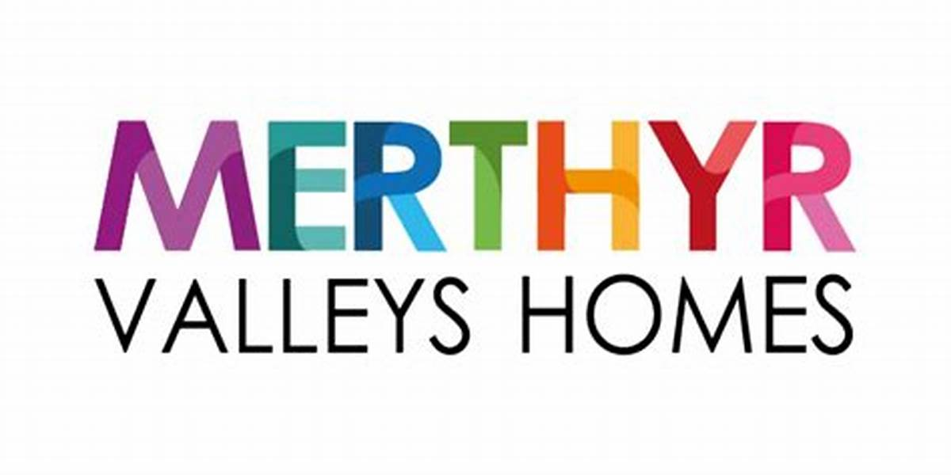

Loft Insulation Installation

Pricing Information and Schedule

Preliminaries, Overheads and Profit
All tendered rates shall be deemed to be fully inclusive of all preliminaries, overheads, and profit, and no separate allowance will be made unless explicitly stated within the pricing schedule.
The Contractor shall ensure that all rates submitted incorporate (but are not limited to) the following:
Preliminaries
- Site establishment and mobilisation/demobilisation
- Supervision and management of works
- Preparation, submission, and compliance with RAMS
- Access arrangements, including working in occupied dwellings
- Protection of tenant property and existing building fabric
- Temporary works, including safe working platforms and crawl boards where required
- Health & Safety compliance, including PPE, RPE, and welfare provisions
- Tenant liaison, scheduling, and communication
- Cleaning and clearance of work areas upon completion
- Attendance on inspections, audits, and quality checks
Operational Allowances
- Gaining access to loft spaces, including handling and temporary relocation of stored items
- Working around existing services, tanks, and obstructions
- Minor enabling works necessary to complete the installation in accordance with this specification
- Compliance with ventilation requirements, including installation of trays/baffles where required
- Protection and/or minor adjustment around electrical services in line with regulations
Waste Management
- Collection, handling, and lawful disposal of all waste materials
- Licensed waste carrier costs
- Waste transfer documentation and hazardous waste consignment notes where applicable
- Meeting environmental targets set out within this specification
Overheads and Profit
- Corporate overheads including administration, insurance, training, and compliance costs
- Provision and maintenance of plant, tools, and equipment
- Allowance for business risk, inefficiencies, and programme constraints
- Profit margin

Pricing Assumptions
- Rates shall be deemed to cover all works necessary to achieve full compliance with this specification, regardless of whether each individual activity is explicitly stated.
- No additional payment will be made for items considered incidental or necessary for the proper execution of the works.
- The Contractor shall be deemed to have fully inspected and satisfied themselves as to the nature and extent of the works prior to submission of rates.
Daywork Rates
Daywork rates shall only be applied where works have been explicitly instructed in writing by the Contract Administrator as dayworks prior to commencement. No retrospective claims for dayworks will be accepted.
All submitted daywork rates shall be deemed to be fully inclusive of all labour, supervision, preliminaries, overheads, and profit, together with all associated operational costs necessary to complete the instructed works.
Inclusions within Daywork Rates
The Contractor shall ensure that daywork rates include (but are not limited to):
Labour
- Skilled operatives, labourers, and supervision
- All wages, holiday pay, National Insurance, and statutory costs
- Travel time and costs to and from site
- Waiting time, standing time, and inefficiencies
Preliminaries and Supervision
- Site supervision and management time
- Preparation and compliance with RAMS
- Coordination with tenant and access arrangements
- Health & Safety compliance, including PPE/RPE
Plant and Equipment
- All small tools, access equipment, and minor plant
- Maintenance, fuel, and operational costs
- No separate charges for hand tools or standard equipment
Materials
- Materials used shall be charged at net cost, supported by invoices where required,
plus the percentage uplift stated in the tender (if applicable), which shall include handling, storage, waste, overheads, and profit
Waste and Clearance
- Removal and lawful disposal of all waste materials
- Cleaning and reinstatement of work areas
Overheads and Profit
- All corporate overheads including administration, insurances, compliance, and training
- Allowance for risk and disruption
- Contractor’s profit

PRICING SCHEDULE :-

Item | Unit | Description | Rate
1 | M2 | Insulation: Supply and lay new up to 400mm thick insulation quilt to loft area including gain access and moving/replacing contents within loft area in order to undertake work.
2 | M2 | Insulation: Gain access to loft area, moving/replacing contents within loft area in order to undertake work, overlay existing insulation with up to 100mm thick insulation quilt to achieve required thickness to meet Client's Standard.
3 | M2 | Insulation: Gain access to loft area, moving/replacing contents within loft area in order to undertake work, overlay existing insulation with up to 150mm thick insulation quilt to achieve required thickness to meet Client's Standard.
4 | M2 | Insulation: Gain access to loft area, moving/replacing contents within loft area in order to undertake work, overlay existing insulation with up to 200mm thick insulation quilt to achieve required thickness to meet Client's Standard.
5 | M2 | Insulation: Gain access to loft area, moving/replacing contents within loft area in order to undertake work, overlay existing insulation with up to 300mm thick insulation quilt to achieve required thickness to meet Client's Standard.)
6 | Per Property | Removal of existing insulation (non-contaminated) waste management certification deemed inclusive
7 | Per Property | Removal of contaminated insulation. Contaminated waste management certification deemed inclusive
8 | Per Property | Rodent Baiting by licensed pest controller. (follow up visit deemed inclusive)
9 | Per Property | No access charge (3 evidenced attempts)
10 | HR | Daywork rate per operative if required

