Project A – 24/7 medium size ambulance station.
1.1 Building Description
An existing ambulance station, with a GIA of 390m², and an approximate build year of 1980. Purpose built single story, with a flat roof of traditional brick construction to the accommodation block which has deteriorated and requires replacement and flat roof with block construction to the garage areas that has developed a small leak. Incoming electrical supply sits within bay 1 (closest to the accommodation block). The site sits within a residential area and is located adjacent to a primary school and Fire Station. See Fig 1.
Minor reactive works has taken place throughout its lifecycle, and a minor refurbishment of locker and toilets took place in the early 1990’s. Garage appliance bay doors are manual and require upgrade to meet current legislation. Asbestos is present including floor tiles and AIB to garage ceilings.
Heating is via a combination gas boiler; lighting has been retrofitted in some areas to LED. Electricity supply is single phase 80amp, with a non-half hourly meter.
Building layout is very busy, with lots of small rooms with various designations, external storerooms, four ambulance bays. See Fig 2.
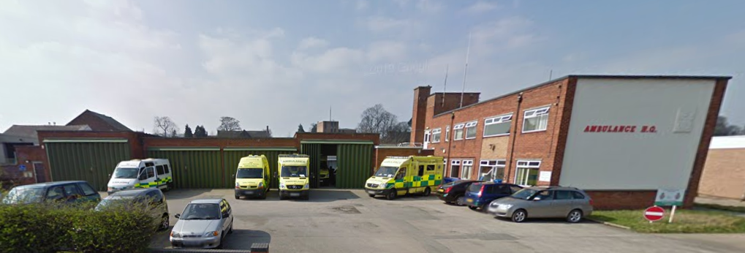
Figure 1: External view Project A
Figure 2: Generic Layout Project A
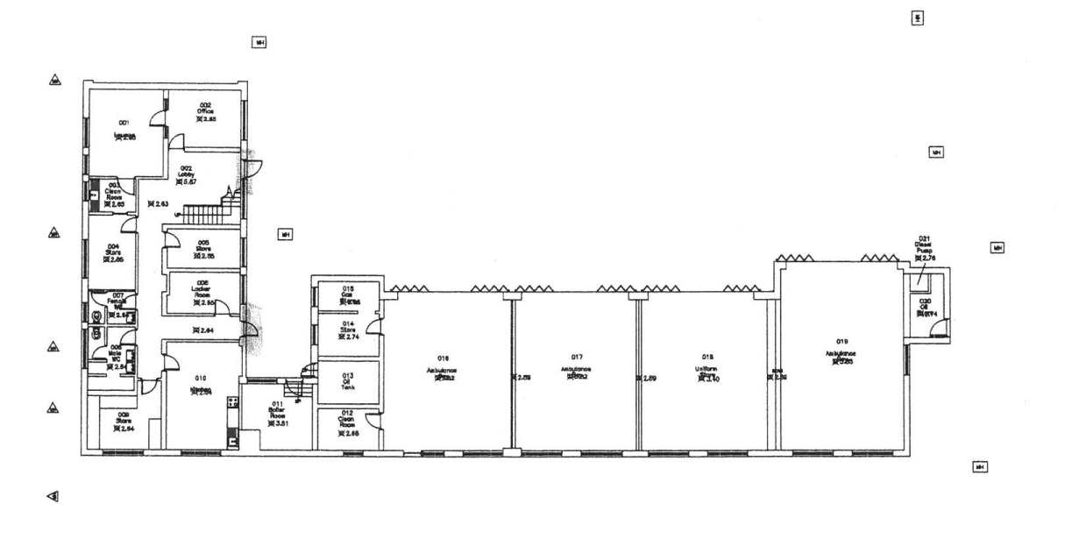
1.2 Project Description- Client Brief- All must comply with building regulations as a minimum and include client changes.
- Budget: £950,000 Gross. To include Design Team fees and VAT.
- External parking upgrades and install a compliant vehicle wash bay
- New signage and way finding signs
- Roof- refurbishment and upgrade
- New UPVC windows and doors
- External redecoration
- Replacement appliance bay doors from manual to electric
- PV installation and associated falls arrest system.
- Complete internal reconfiguration of the accommodation block, developing larger rooms, additional toilet and shower.
- Replacement sanitaryware and showers.
- New kitchen as per client specification.
- Redecoration and flooring.
- New lighting and fire alarm system.
- Replacement low carbon heating system alongside low carbon hot water design.
- Replacement fire doors.
- Attendance at a minimum of 3 design meetings and 5 contractor meetings.
- Pre-tender cost estimates and post tender cost review.

