

e-Trading Specification

IMCA Services
COMM-FTS-60883
tENDER CLOSING time and date: 4TH AUGUTS 2026 AT 12:00HRS

Overview
Electronic invoicing (e-Invoicing) seeks to improve efficiencies of the invoicing system process, from the generation and delivery of an invoice, to matching against a purchase order and payment between the buyer and supplier. e-Invoicing is an ‘enabler’ for a standard automated process that captures invoices electronically and moves the organisation a step closer to a paperless environment, supporting timely payments and more efficient query management with suppliers.

e-Invoicing delivers efficiencies by reducing process and transactional costs. Which also speeds-up and simplifies the invoice matching process. Electronic invoices are endorsed by HMRC as a valid invoice document type and invoices generated from transactions are fully HMRC VAT compliant with HMRC VAT regulations.

e-Invoicing is also promoted by Welsh Government who provide access to eProcurement tools to improve electronic procurement within Welsh Public Sector organisations and meet the requirements of The Public Procurement (Electronic Invoices etc.) Regulations 2019, https://www.gov.wales/welsh-procurement-policy-note-wppn-e-invoicing-html.

e-Invoicing Summary
Electronic Trading is one of the key business objectives for NHS Wales Shared Services Partnership (NWSSP) and there is a requirement for every supplier to NHS Wales to commit to and implement one of the current NHS Wales e-Trading solutions. The supplier awarded the contract will therefore be expected to (as a minimum) implement the following solutions at contract award and before trading commences:

- Be in a position to send PDF invoices to a secure mailbox to be processed using scanning technology (OCR). (As a stepping stone to e-Invoicing implementation) Full details of what is required in order to successfully use the OCR system to transmit PDF invoices are detailed on page 6 of this document. NWSSP reserve the right to request that a supplier not trade electronically if it is identified that e-Invoicing would be unsuitable. If a supplier is deemed unsuitable for e-Invoicing, NWSSP will work with that supplier to resolve any identified issues.

Following award of the contract suitable suppliers will be identified by NWSSP to implement one of the following solutions (within 6 months of the contract award):

- Implement a suitable e-Invoicing solution (3rd party) to receive purchase orders and send invoices electronically.

- Implement an integrated ‘back-office’ solution allowing purchase orders and invoices to be exchanged directly to and from NHS Wales (via a 3rd party where necessary).

*Alert: NHS Wales reserve the right, as part of the Terms & Conditions, to deduct 1% of the total invoice value during the contract period if these conditions are not met by the supplier. This is to cover administration costs.

NB: The 3rd party exchanges currently available with NHS Wales are Basware (formerly Procserve) and GHX.

Basware currently form part of eTradingWales which enables suppliers to access and trade electronically with Welsh Government and other public sector organisations in Wales.

Global Healthcare Exchange (GHX) currently only offers a Back Office Integration (BOI) option to trade.

Benefits of e-Invoicing
There are a number of benefits to switching from paper invoices to e-invoicing, including improved efficiencies for buyers and suppliers, financial benefits and environmental advantages. Here are some examples:

- Reduced manual work can provide for workforce efficiencies.
- Reduces postage, paper, envelopes and labour costs associated with paper invoices.
- More environmentally friendly / reduced carbon footprint - removes the printing, sending, storing and destroying of paper.
- Reduced administrative costs, less errors and eliminates late payment fees.
- Increased savings – estimated at 64% for buying organisations and 59% for suppliers (Making it Happen, 2015).
- Improved cash collection through quicker invoice approval processes.
- Reduction in overall cost of credit control and debt management.
- Increased security / invoice visibility / control of data / cash flow.
- Improves customer satisfaction through reduced invoice processing and payment issues.

Benefits of e-Invoicing
There are a number of benefits to switching from paper invoices to e-invoicing, including improved efficiencies for buyers and suppliers, financial benefits and environmental advantages. Here are some examples:

- Reduced manual work can provide for workforce efficiencies.
- Reduces postage, paper, envelopes and labour costs associated with paper invoices.
- More environmentally friendly / reduced carbon footprint - removes the printing, sending, storing and destroying of paper.
- Reduced administrative costs, less errors and eliminates late payment fees.
- Increased savings – estimated at 64% for buying organisations and 59% for suppliers (Making it Happen, 2015).
- Improved cash collection through quicker invoice approval processes.
- Reduction in overall cost of credit control and debt management.
- Increased security / invoice visibility / control of data / cash flow.
- Improves customer satisfaction through reduced invoice processing and payment issues.

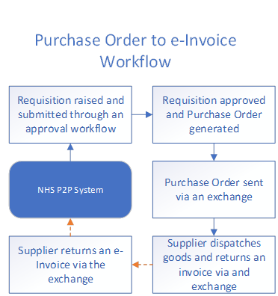
e-Invoice Workflows
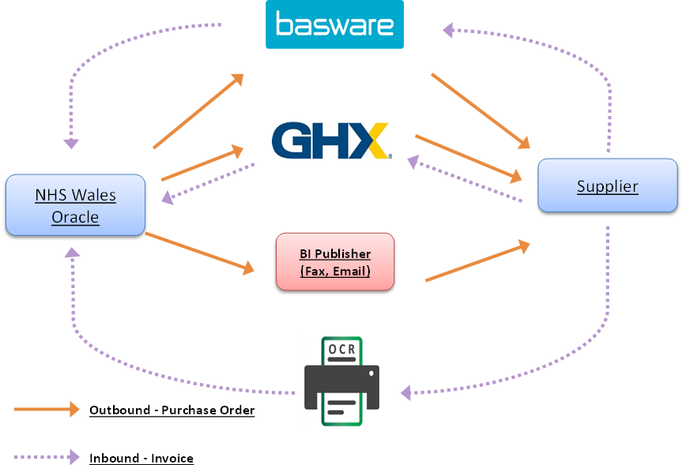

Supplier Actions & Responsibilities
When sending emails, it is essential you adhere to the following rules:

- All e-mailed documents to be sent to NWSSP_PSU_P2P@wales.nhs.uk.
- An email must contain only PDF formatted documents. Any other document types will be rejected.
- A PDF document must only contain a single invoice (or a single credit note document), these can be single page or multiple page. If any additional invoices are included in the PDF document, then the document will not be processed and will be rejected. You may also send in statements or documents concerning the account via e-mail, again only one e-mail per document.
- The total size of each e-mail must not exceed 10MB.
- The PDF document must ideally be in portrait format and in a good quality, readable format.
- The document must contain a valid PO Box invoicing address.
- An e-mail must not include additional emails or other document types as attachments. In such cases, the email will be rejected.
- An e-mail must not contain any content in the body with additional information. Such content will not be picked up by the automated email processing service.
- A single email can contain multiple PDF formatted documents.
- Do not send any important letters or notifications to the email address as these will not be processed in a timely manner.
- Documents cannot be submitted as a secured PDF document.

Please note, if there is no valid purchase order number the invoice will still process but the invoice will then need to be verified by the department who raised the order which will cause delay in payment.

Important: You will not receive any email notification confirming whether your email has been rejected. Consequently, it is important to ensure the information adheres to the stipulated rules. If there are any queries regarding any emails then please contact the NWSSP.APOracleCustomerHub@wales.nhs.uk.

