Transport for Wales Tendering System - Atamis
A quick guide on how to use TfW’s Atamis System
Available to Suppliers
01/06/2026

Contents
Contents 2
How to tender via Atamis 3
Registering on the Portal 3
Finding opportunities and registering your interest 4
Submitting a bid 7

Version V1
Sensitivity Suppliers Only
Date 01/06/2026

How to tender via Atamis

Registering on the Portal
To register on the Transport for Wales Atamis portal, click here - Welcome
Once you have registered, you will find your home screen with various access links.
Remember to keep your Company Details and Contacts up to date, as this information is pulled through to tenders.
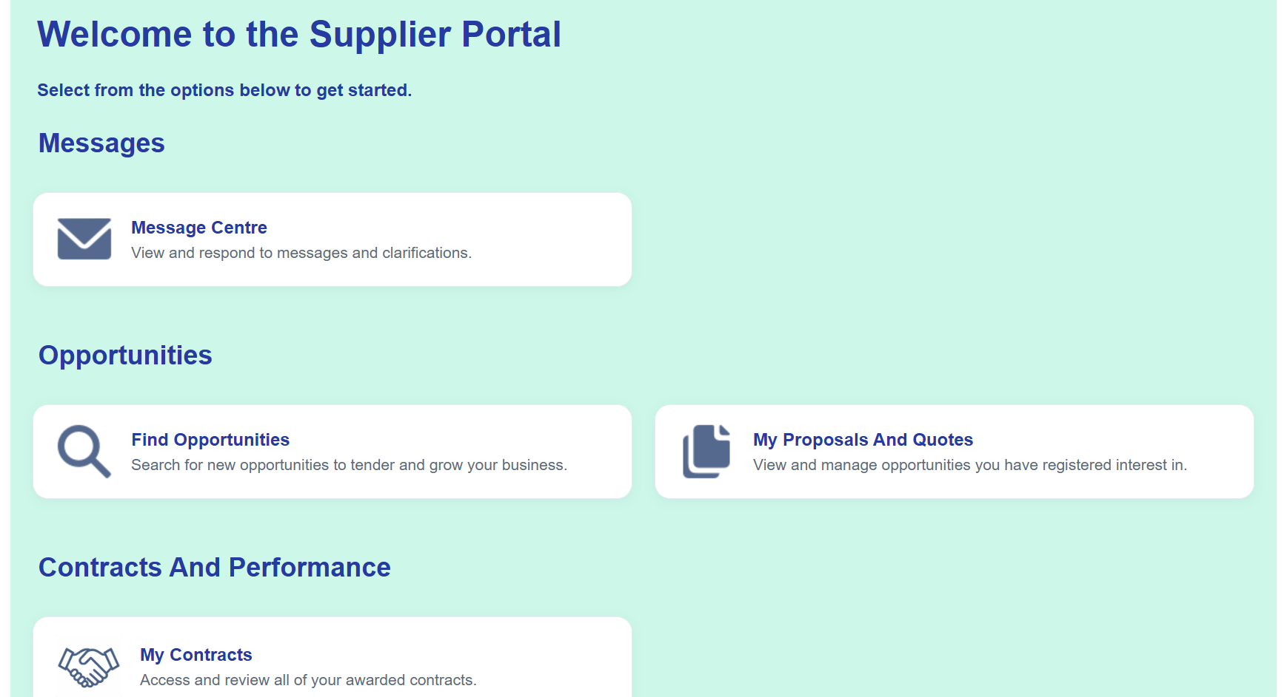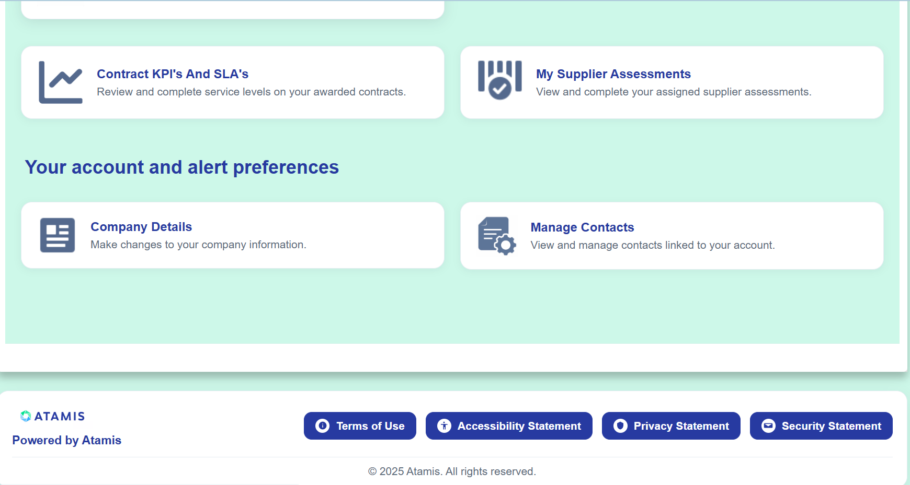

Central Digital Platform
Transport for Wales will ask for your CDP sharecode during the tender, please ensure your details on the CDP are accurate and up to date before generating a new share code.
If you have not got an account on the Central Digital Platform, you can register here Sign in - Supplier Registration Service
You should generate a new share code for each tender opportunity you bid for.

Finding opportunities and registering your interest
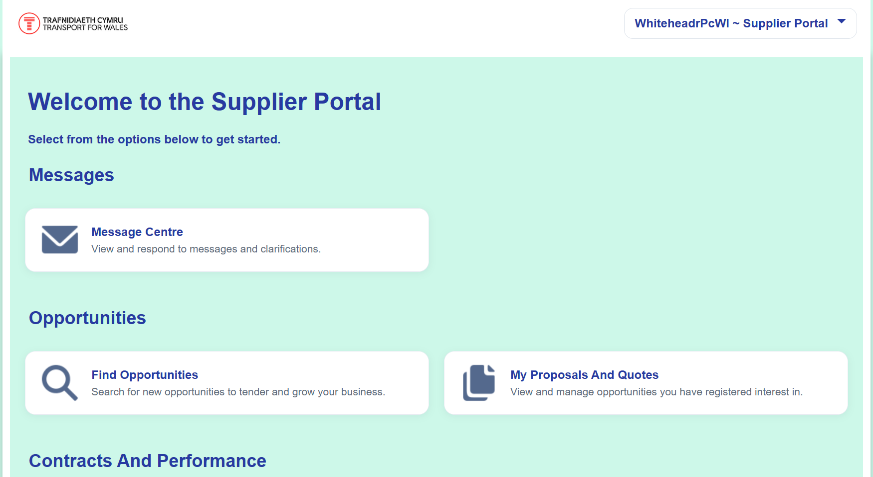
To view and register onto any Transport for Wales tender opportunities, click on the ‘Find Opportunities’ section on the home page.
If you have been invited to participate in a Framework mini-competition, skip this step and click into ‘My Proposals and Quotes’. Further guidance of next steps is available under the section Submitting a Bid.

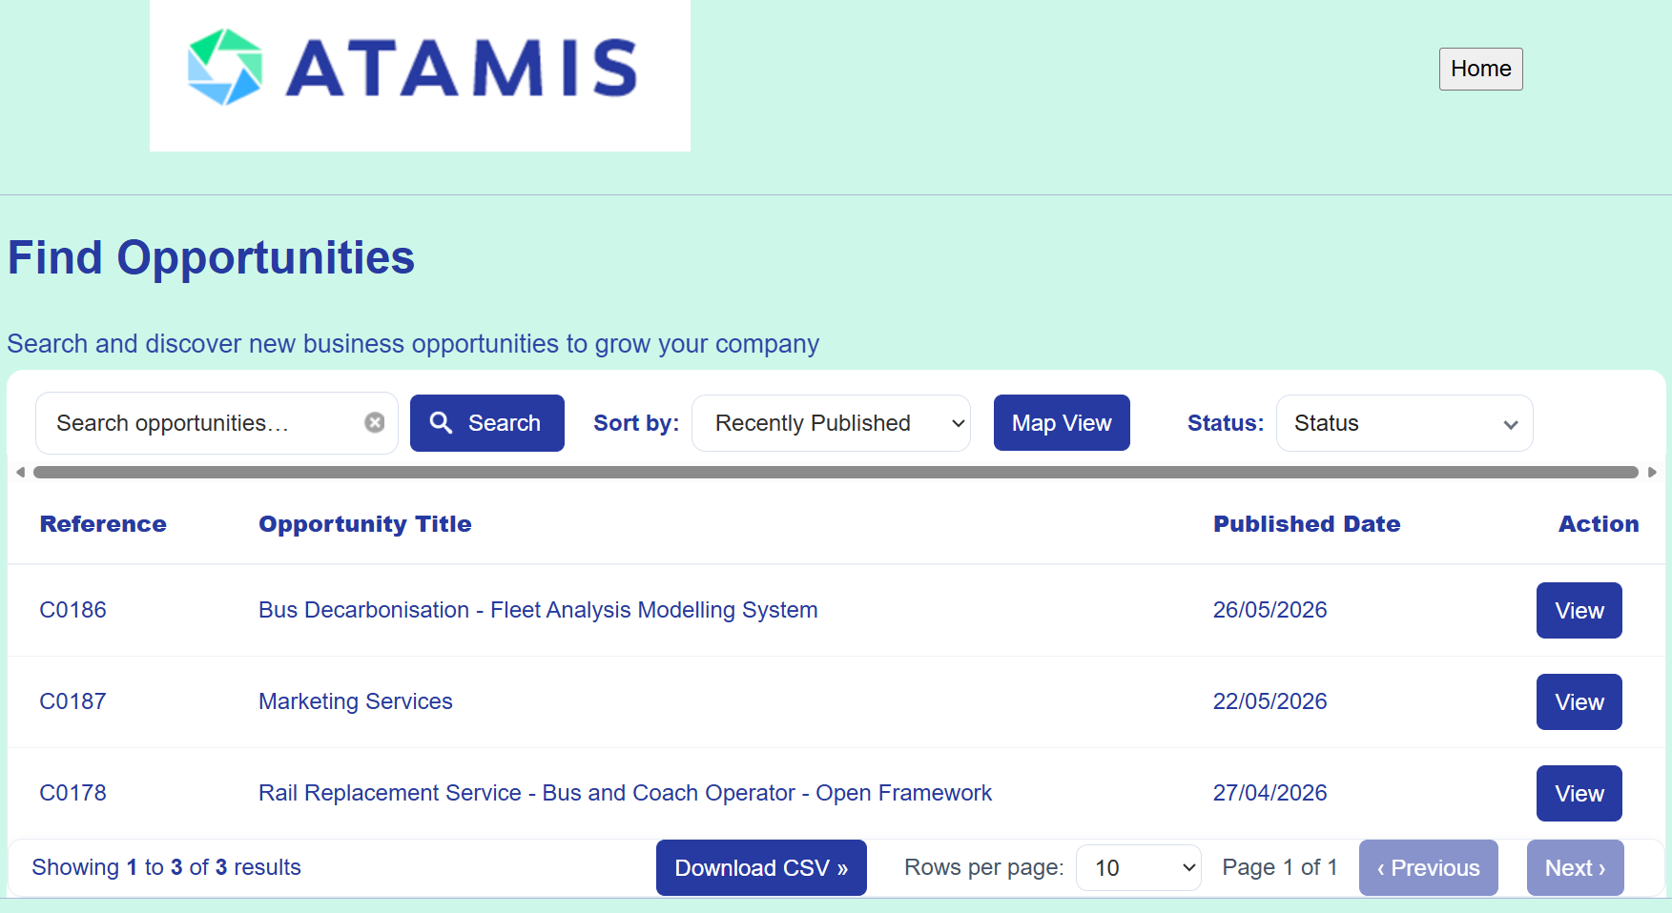
A list of all the live tender opportunities will be available. To click into a tender, click on the View button.

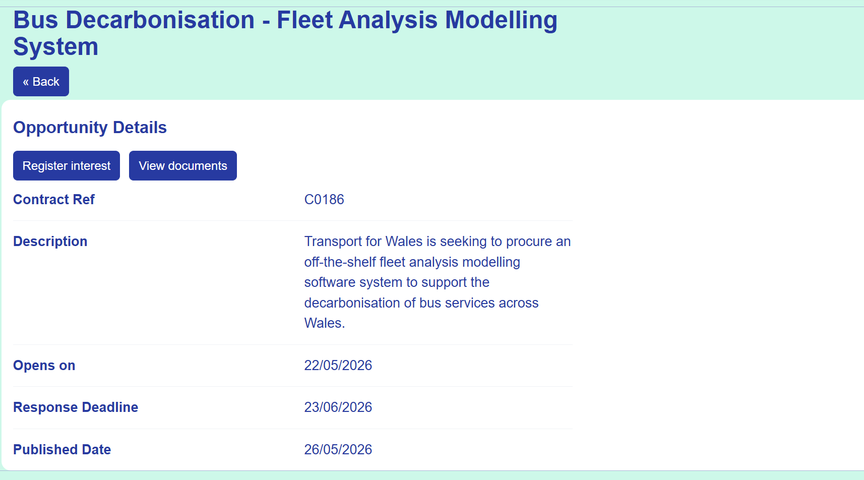
To register an interest and/or gain more information about the tender, the tender documentation and requirements, click on the register interest button.
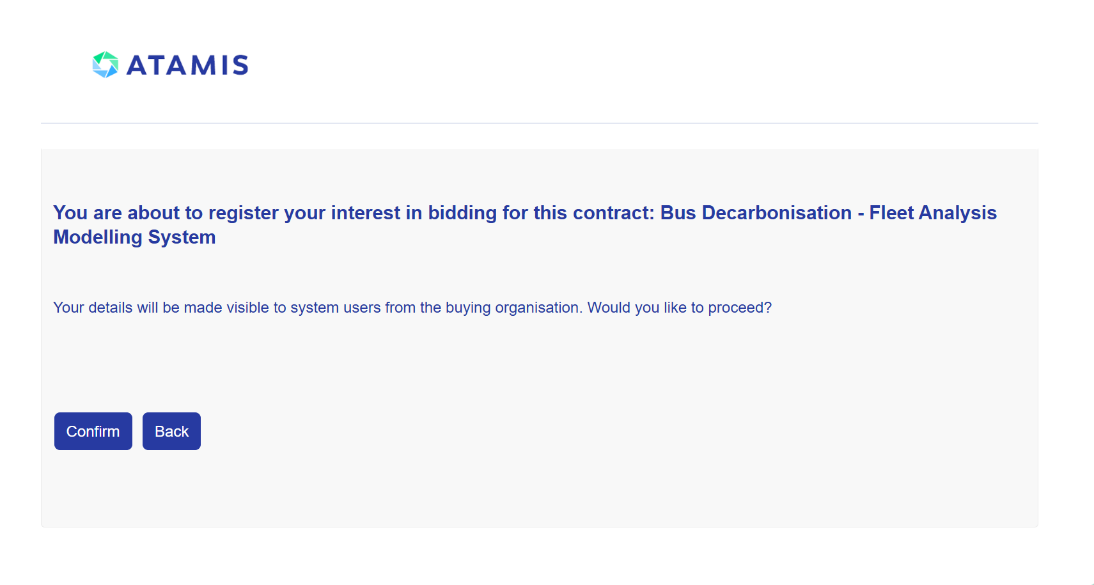
Click ‘Confirm’ to proceed.

To view more information about the tender you have registered an interest on, click the home button on the top right-hand side, and then follow the steps in the ‘Submitting a bid’ section below.

Submitting a bid
Once you have registered for the tenders you are interested in, return to the home page where you’ll find the ‘My Proposals and Quotes’ button.

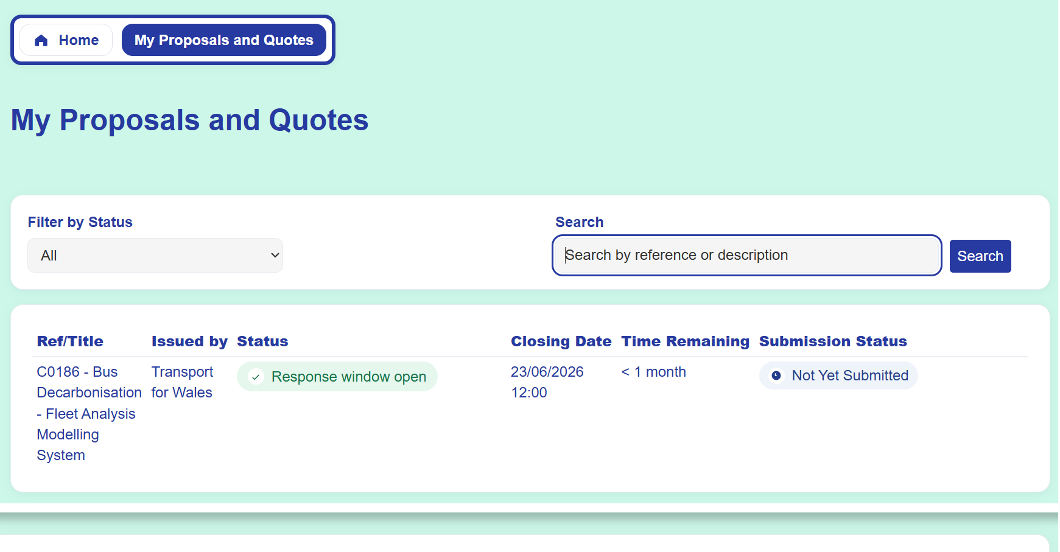
You will see all the tenders you have registered for within the ‘My Proposals and Quotes’ section. To view documents, requirements and to begin drafting your bid, click on the ref/title of the requirement.

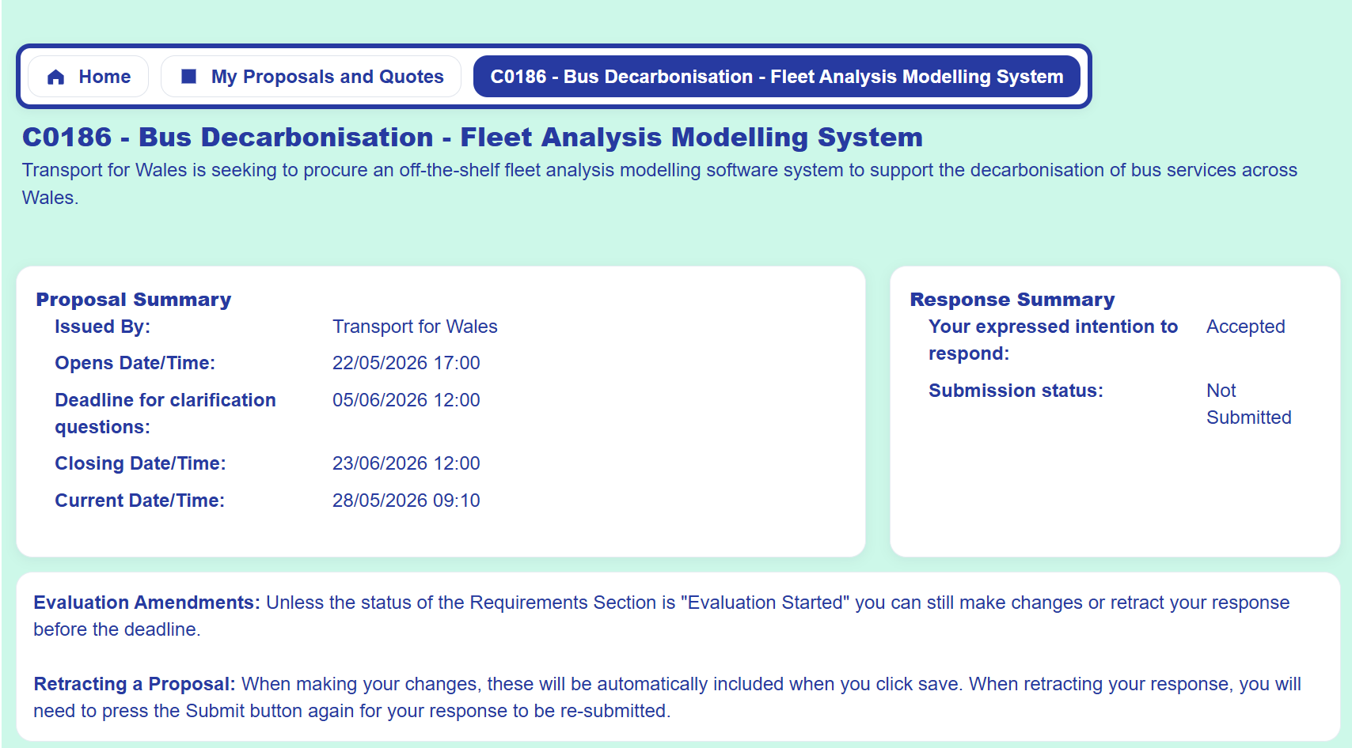
This page will contain all the details for the tender, including clarification deadline, tender deadline, submission status, requirements and documentations.

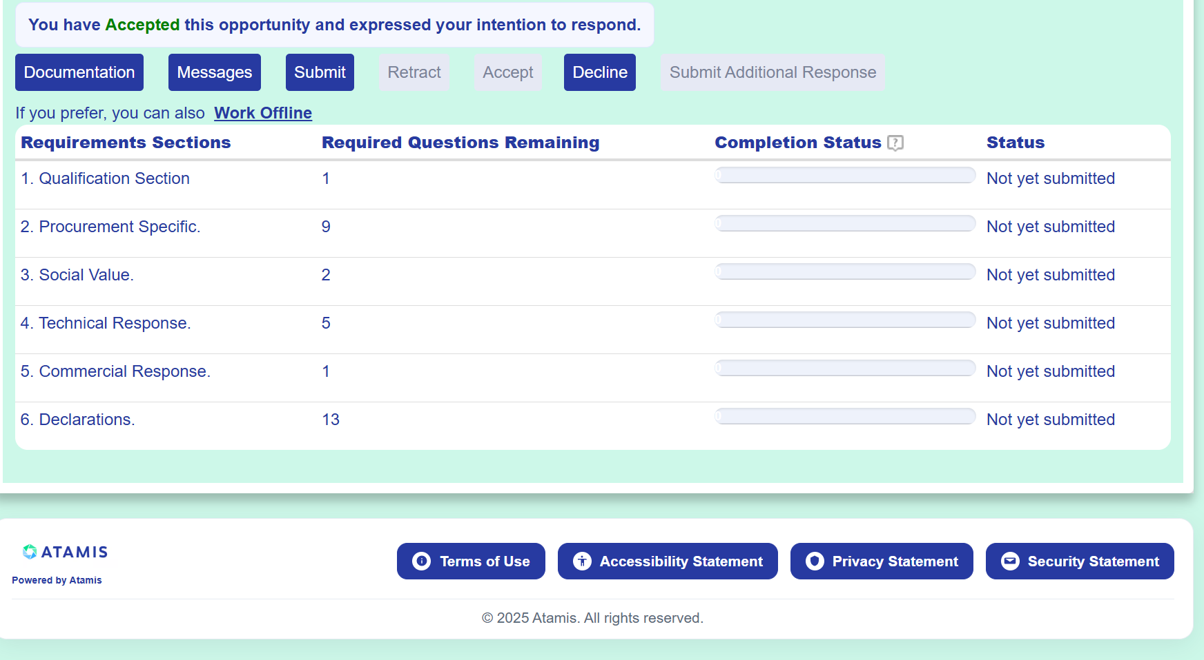
By scrolling down, you will be able to view the requirements and documentations.

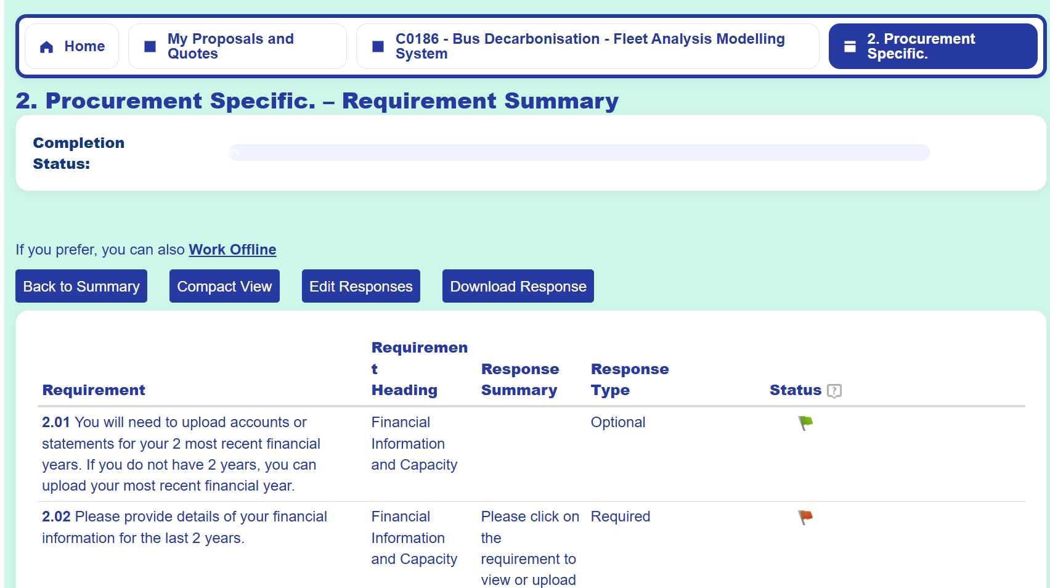
To view or begin completing the requirements, click on the requirement section title.

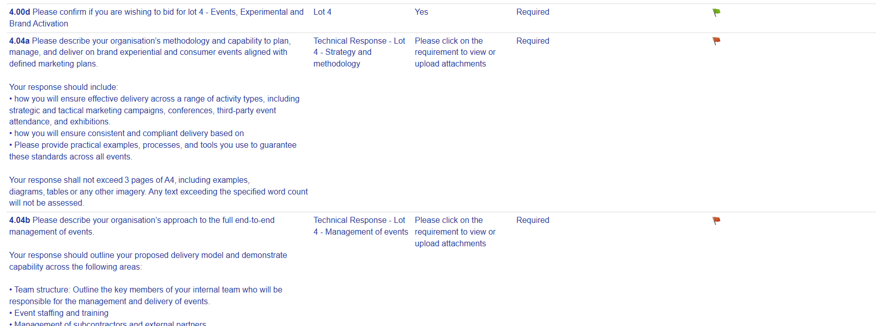
Where there is a lot specific questions, confirm the lots you are looking to submit a bid for by choosing the "Yes" picklist option and then "Save" the response. Once your answers for these questions has saved, you will then see the lot specific questions that need responding to.
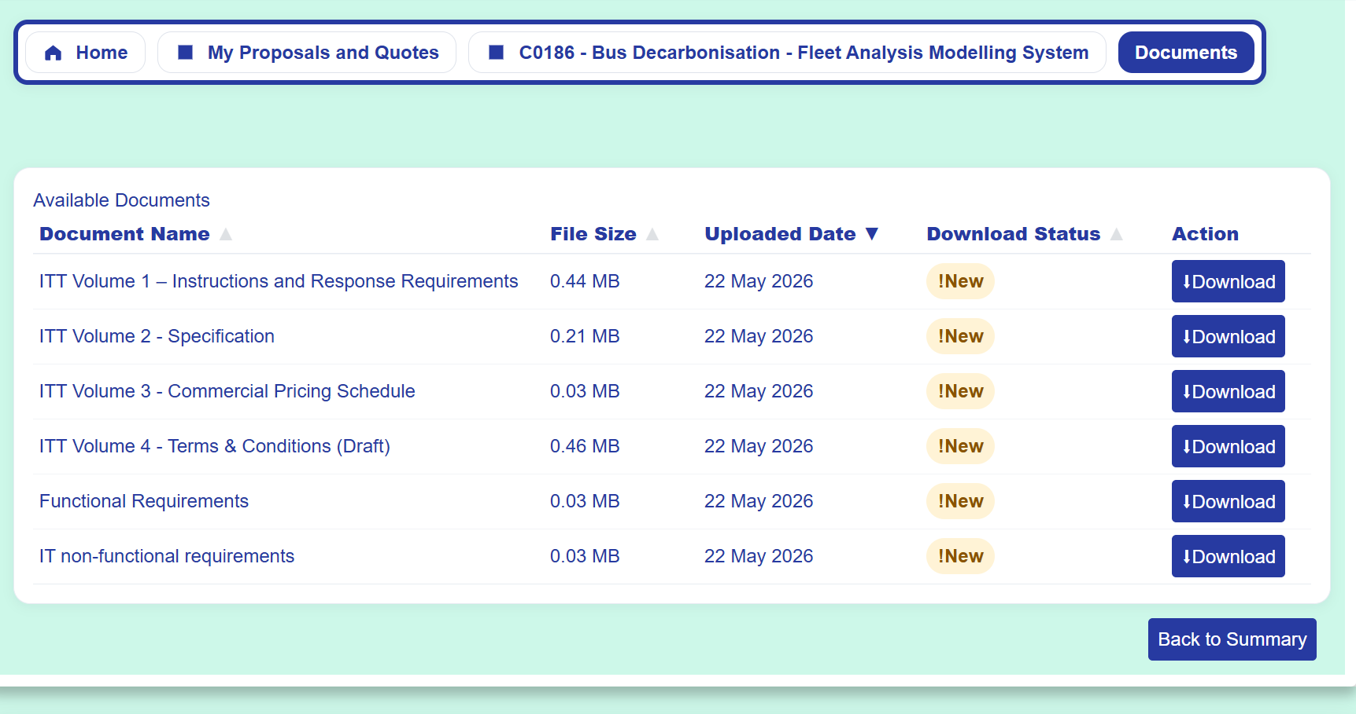
To download the tender documentation, first click on the documentation button, which will lead you to this page. You can then download the documents individually using the Download button.

Reminder of support details
For any account specific queries or issues, please Atamis directly for support.
- Phone: 029 2279 0052
- E-mail: support@atamis.co.uk

