Appendix E: Additional Information - User Stories
Contents
Appendix E: Additional Information - User Stories 1
1. How Firefighters Currently Register Their Availability on Rappel 2
2. Further Detail on the Current Mobilisation Process for MAWWFRS 3
3. How Pay Claims are Currently Put Through 5
4. How Whole-Time and Part-Time Firefighters are Currently Mobilised 8
5. How Watch/Station Managers, TAC Officers and AMs are Currently Mobilised 10
6. Managing Jump-Crewed Resources 12
7. Examples of Jump-Crewed User Stories 13
8. The One-Way Traditional Alerting Process 14
9. The Two-Way Intelligent Alerting Process 17
10. MAWWFRS’ Current Multi-Tone Station End Equipment Process 19
11. The Current Critico Station End Equipment Process 20

How Firefighters Currently Register Their Availability on Rappel
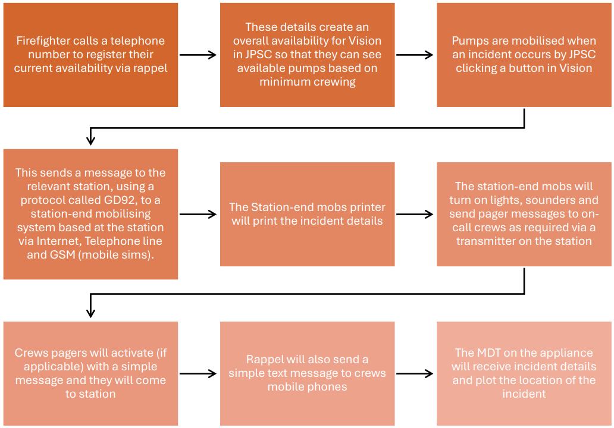

Further Detail on the Current Mobilisation Process for MAWWFRS
The process begins with a call to 999. This call is received by Joint Fire Control (JFC), which is responsible for coordinating the response.
JFC gathers crucial information about the incident. This information is then fed into the JFC vision system, which confirms the appliances to be mobilised to the incident and sends it to the relevant station/s based on the mobilising equipment.
Upon receiving the information, a signal is sent from the station's mobilisation system to the firefighter Alerters. This signal prompts firefighters to respond to the station.
As firefighters arrive at the station, they press the Man Ack button on the station-based equipment. This action confirms that the crew has responded to the station. The crews then update control via MDT (Mobile Data Terminal) and Main Scheme Radio to confirm they are mobile to the incident, providing any relevant information.
Following the incident, crews complete the relevant pay claims (see below), which confirm an attendance or turnout along with the number of additional hours worked if applicable. These pay claims are currently processed on a monthly basis by divisional response teams and are sent via email to payroll for final signoff.

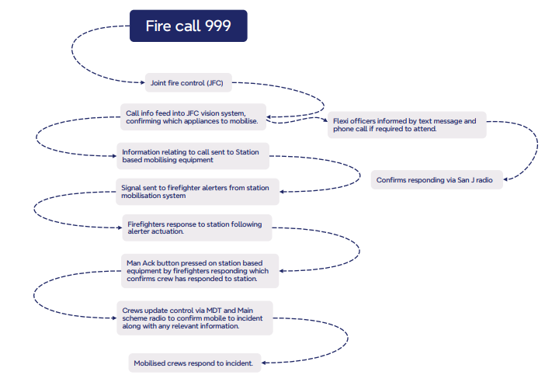

How Pay Claims are Currently Put Through

F30 Pay Claim
Supervisory officers will complete the F30 with all the details of the incident (see below). This form is completed either following every incident or monthly prior to submitting the monthly return. The information on the form is collated from the completed F35 (see F35 below).

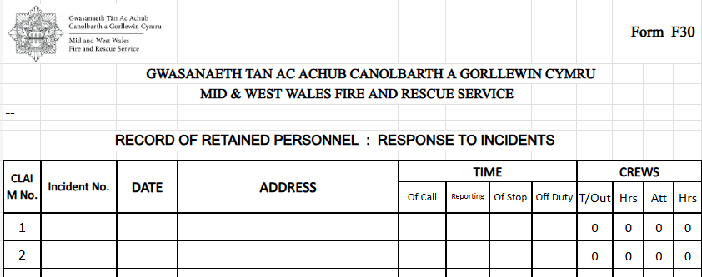

F31 Pay Claim
Supervisory officers will complete the F31 confirming which crew members achieved a turnout plus any additional hours worked at an incident or an attendance if applicable. This form is completed either following every incident or monthly prior to submitting the monthly return. The information on the from is collated from the completed F35 (see F35 below).
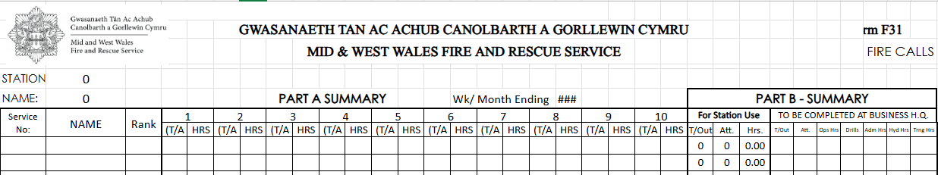

F35 Pay Claim
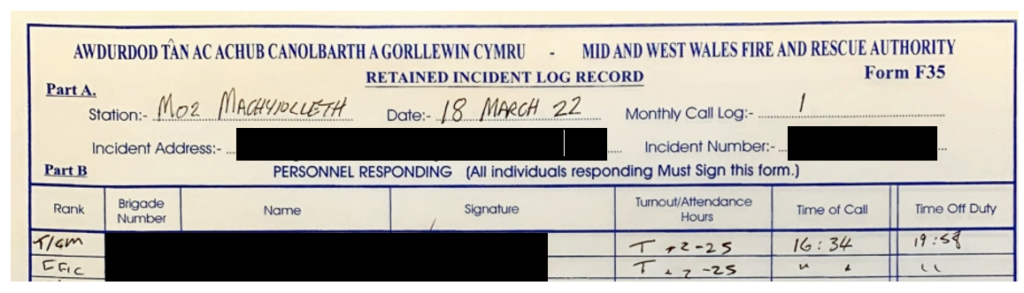
The F35 is completed immediately following the attendance at an incident or station. This form must be completed by the individual and their signature added to confirm they responded to the station and weather they are claiming for an attendance or turnout. The number of additional hours are also recorded on the F35.

Processing of pay claims
On a monthly basis on or close to the 17th of each month, the three pay forms (see above) are finalised by station supervisory officers and forwarded to the respective divisional cluster manager. The forms are checked for accuracy and signed off by the cluster manager. Finally, the forms are sent to the payroll department for scrutiny and payment.

Flexi Officers
Flexi officers are informed via text message and phone call if their attendance is required at an incident. The mobilised officer then proceeds to respond to the incident, confirming their response via San J radio.
There is no additional payment for Flexi duty officers.

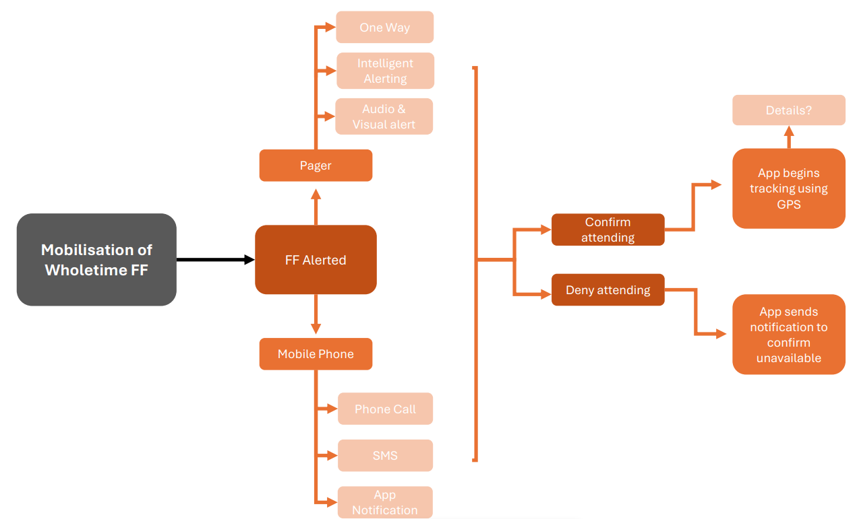
How Whole-Time and Part-Time Firefighters are Currently Mobilised

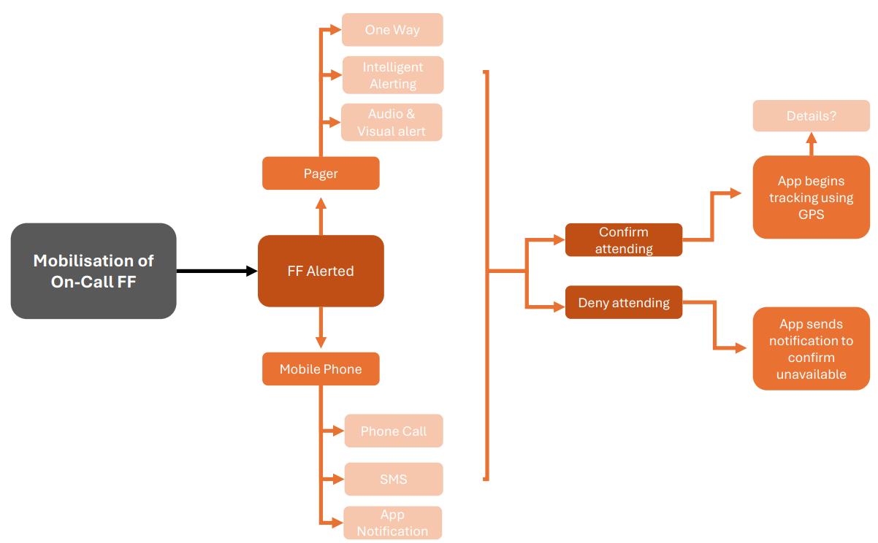

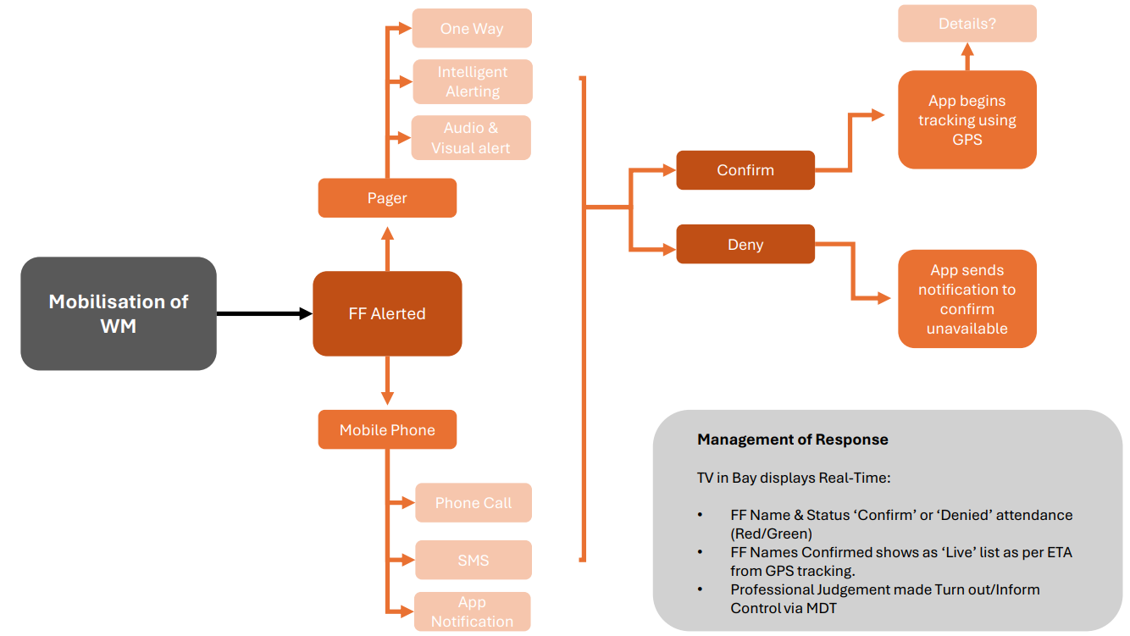
How Watch/Station Managers, TAC Officers and AMs are Currently Mobilised

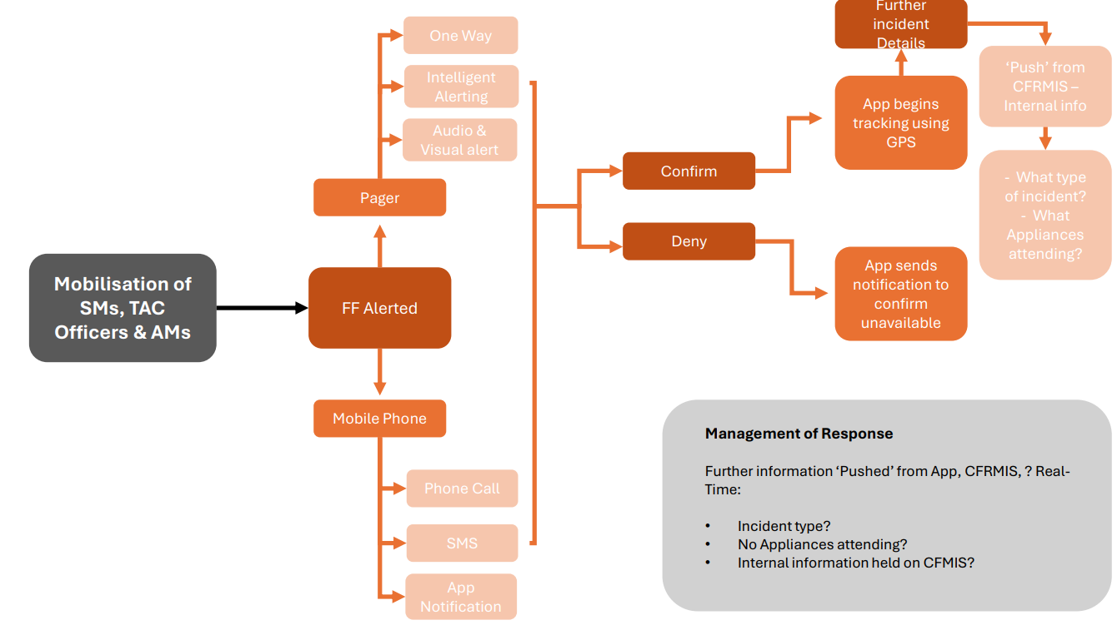

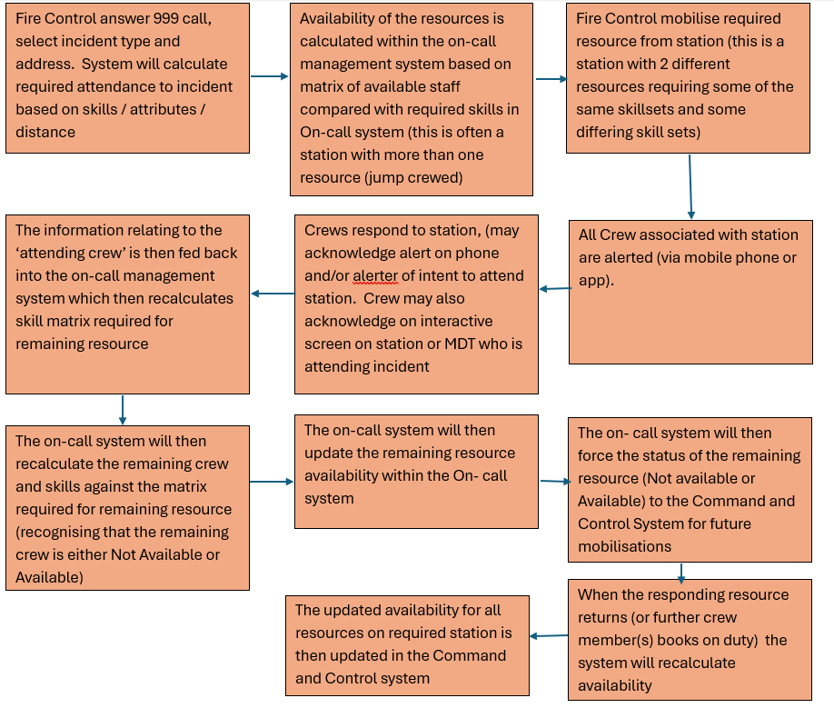
Managing Jump-Crewed Resources

Examples of Jump-Crewed User Stories

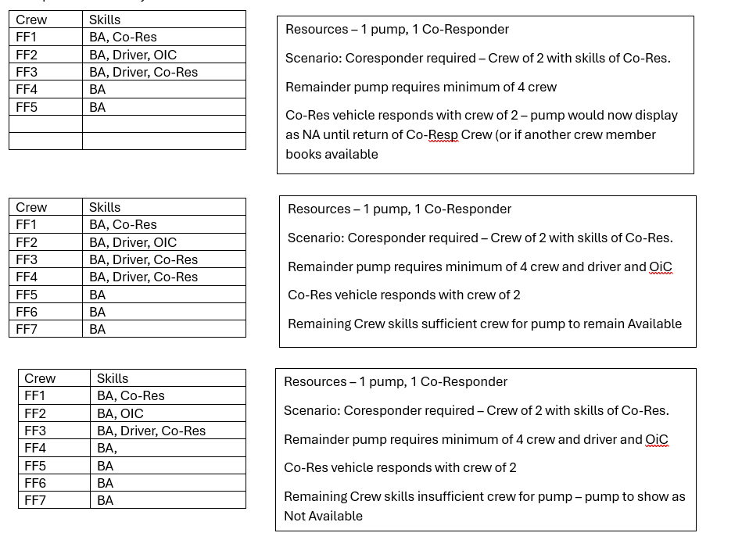

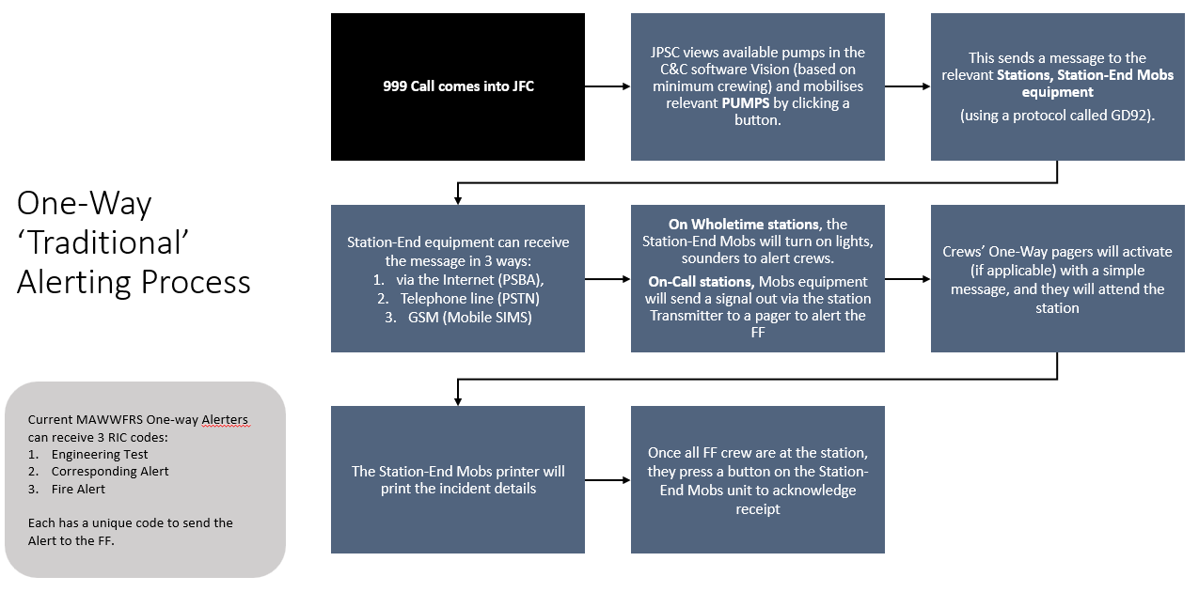
The One-Way Traditional Alerting Process

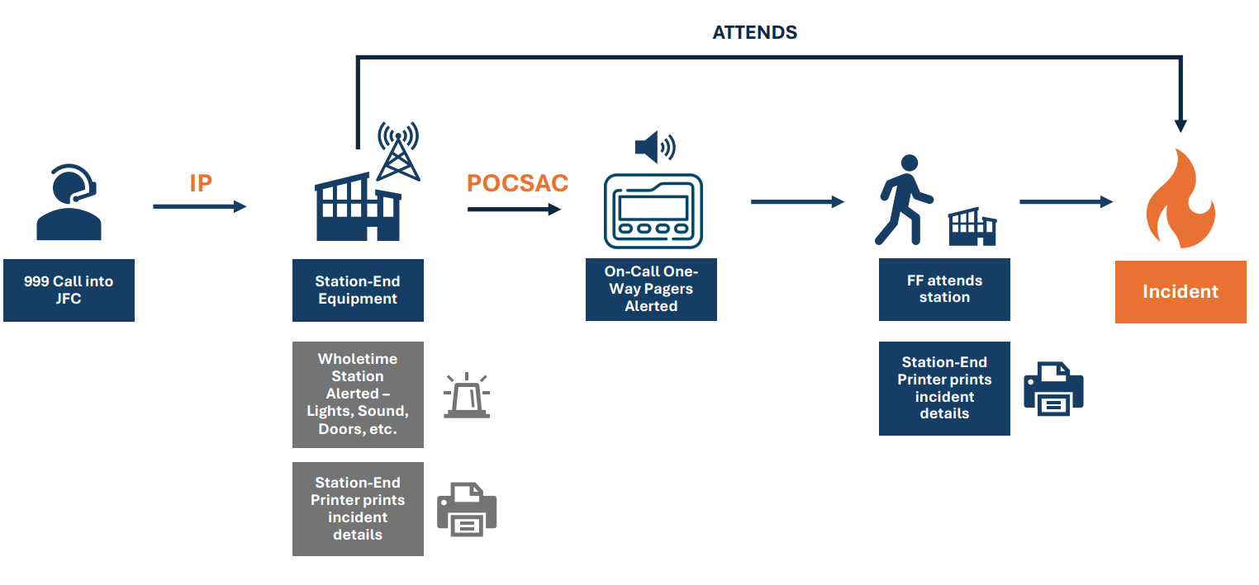

The Two-Way Intelligent Alerting Process
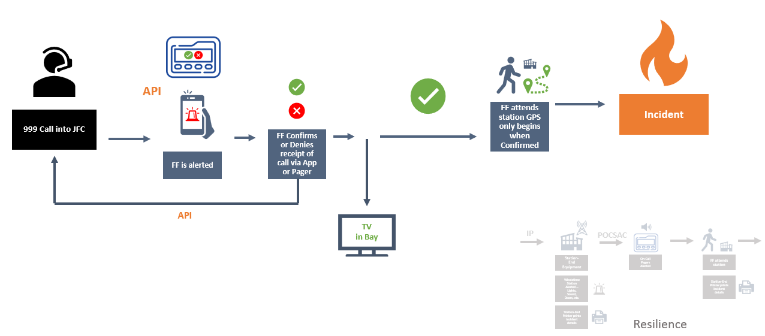

MAWWFRS’ Current Multi-Tone Station End Equipment Process
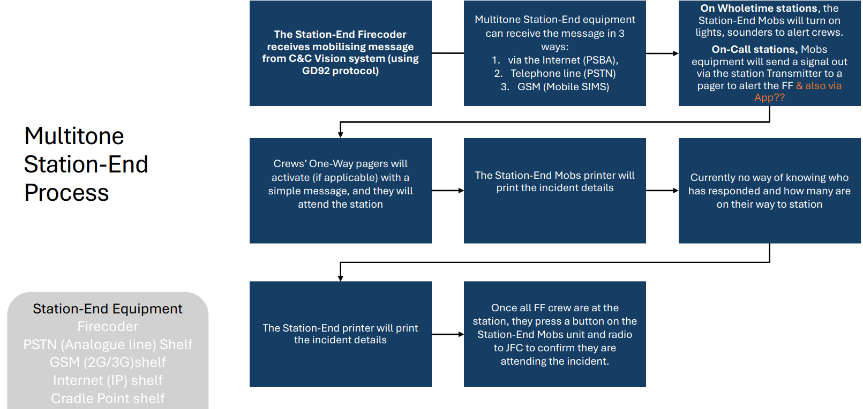

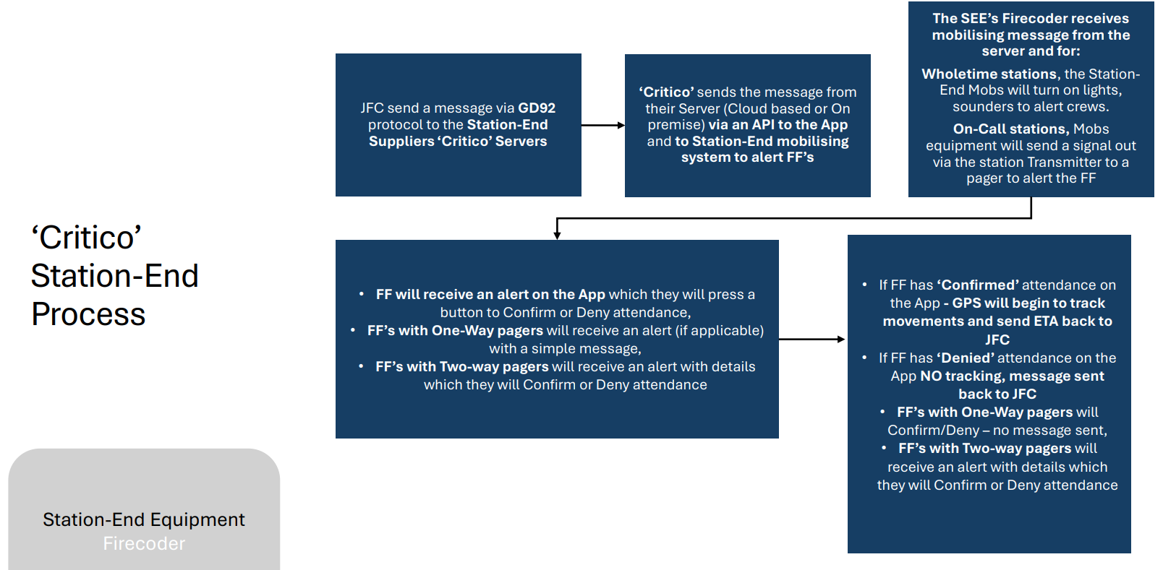
The Current Critico Station End Equipment Process
