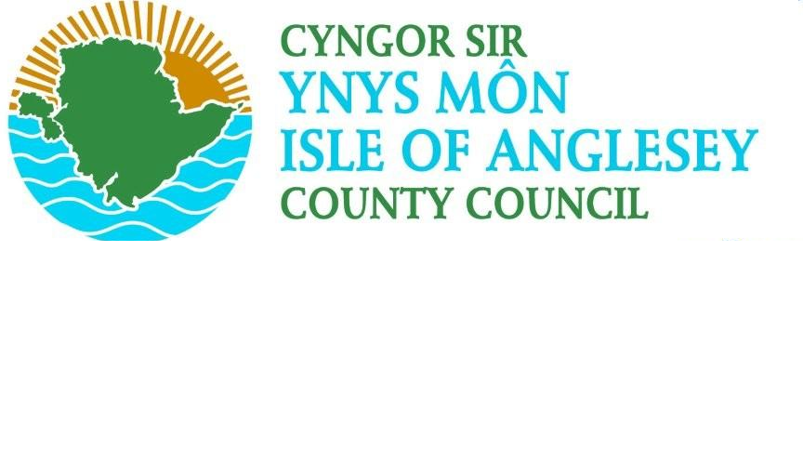

WEED
TREATMENT

Date | Brief Description of Change | Reference
12.06.15 | Updating schedules - RH | RH
01/07/16 | Update schedules - RH | RH
28/07/16 | Update schedules - RH | RH
01/08/17 | Changed format of booklet | RH

- Introduction
1.1 There are two distinct aspects of the highway weed control function;
- The first is the treatment of general weeds which are likely to interfere with the highway e.g. when they create a hazard, cause structural damage, affect drainage systems or become unsightly.
- The second aspect is the statutory duty to control harmful/noxious weeds on the highway; these are defined in the Weeds Act 1959 and the Wildlife and Countryside Act 1981.

- General Weed Control
2.1 The following problems can arise from general weed growth on the highway if left unabated:
- Weeds will cause structural damage to the footways, carriageways and cycle ways if they are allowed to grow freely. Hence in the long term, much greater maintenance costs will result from an inadequate weed control strategy.
- Weed growth is visually intrusive and heavy growth can give the impression that the highway network is being poorly maintained. This would impact upon customer satisfaction surveys and therefore Best Value.
- Weed growth in the carriageway channel will cause a build-up of detritus which will impede the effective drainage of the highway.
For these reasons, it is essential that the Council has an effective means of controlling weed growth on the highway.
2.2 Treatment intervals for the application of weed killer will vary depending on a number of factors including climatic conditions and amount of debris on highway etc. For this reason it is more appropriate to set a performance led specification for weed control rather than a specification which stipulates a fixed number of weed killer applications.

3.0 Control of Noxious/Invasive Weeds
3.1 The Weeds Act 1959
The Weeds Act 1959 empowers DEFRA to serve notice requiring an occupier of land to take action to prevent the spread of certain specified weeds. Prosecution under the Act is pursued by DEFRA specifically when agricultural land is threatened by the specified weeds. DEFRA may also elect to have a third party undertake any necessary action and recover costs from the occupier.
3.2 The Wildlife and Countryside Act 1981
Section 14 of the Wildlife and Countryside Protection Act 1981 makes it an offence, liable to a fine, to plant or otherwise cause to grow in the wild, certain specified weeds. It may be a defence to prove that all reasonable steps were taken to prevent the plants growing in the wild.

3.3 The Town and Country Planning Act (England & Wales1990)
Section 215 (England & Wales) empowers Local Authorities to serve notice on owners or occupiers of land to control weeds considered harmful to the amenity of the surrounding area. Failure to take appropriate action may be liable to a fine, or alternatively the Local Authority may recover costs incurred in employing a third party to take the appropriate action.
3.4 It is clear from the legislation that there is a duty on the authority to take practicable measures to control the growth and prevent the spread of harmful/noxious weeds on the highway. Failure to do so could potentially result in prosecution under one of the above Acts and/or compensation claims from adjacent landowners.

4.0 Policy
4.1 The Council will carry out total weed control operations on areas of paving and hard standings, kerb, and channels, back of footway, hedge bottoms and around street furniture.
- Pictures before and after will be taken by the Area Engineers to determine the effectiveness of treatment
- The weeds are sprayed with a non-toxic herbicide, which acts only on contact with the plant surface. This spot spraying is completed by our term service contractor, who has expertise in weed control.
- The treatment is cyclical, and occurs in the spring and autumn each year.
- Ongoing treatment to the same areas may be required to control significant weed growth.
- We follow an effective weed programme which is consistent with the Authority’s ‘Well managed Infrastructure.
- Spot treatment of the weeds is dependent on the weather conditions at the time of spraying.
- A non-residual herbicide which meets requirements set out by Environment Agency Wales and Health & Safety Commissions Code of Practice. This substance is called Glyphosate, which only affects plants where there is direct contact.
- The focus is on weed control rather than weed eradication. Complete removal of weeds from our network is unrealistic and expensive.

4.2 Weed control measures will be by either herbicide. Cutting may also be used to achieve the level of vegetation control required.
4.3 The Council will carry out selective weed control operations on rural highway verges to control the growth of injurious, noxious and controlled weeds including other invasive vegetation.
- The Council will treat Ragwort and Japanese Knotweed as part of the cyclical programme.
- Ragwort will be treated in early spring, by spot spraying and Japanese Knotweed in early autumn.
4.4 The Council will respond to complaints and reports of weed infestation and carry out where necessary spot treatment of vegetation with herbicide to ensure that the Council’s objectives and statutory obligations are met.

