
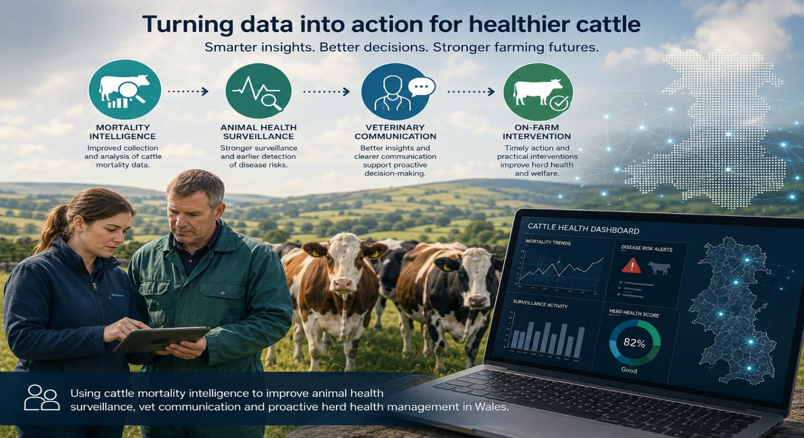


Sustainable Farming Scheme
Contracts for Innovation Cymru Phase 1 Challenge

Turning Cattle Mortality Data into Actionable Animal Health Intelligence

This challenge seeks innovation to support the delivery of transforming Cattle Mortality Intelligence to Improve Animal Health Surveillance and Proactive Herd Health in Wales

Introduction

It is the ambition of the Welsh Government to develop a thriving and confident agriculture sector in Wales built around innovation and growth, to rise to the challenges we face and make most of the opportunities available. In July 2025 the Welsh Government published its Sustainable Farming Scheme designed to ensure Welsh Government support for agriculture in Wales delivers against the four Sustainable Land Management objectives of the Agriculture (Wales) Act:

- Produce food and other goods in a sustainable manner
- Mitigate and adapt to climate change
- Maintain and enhance the resilience of ecosystems and the benefits they provide
- Conserve and enhance the countryside and cultural resources, promote public access to and engagement with them, and to sustain the Welsh language and promote and facilitate its use.

Innovation will play a key role in delivering this scheme. In 2023, the Welsh Government published an Innovation Strategy for Wales. Innovation in food and Agri-Food Tech was seen as a key part of Wales’s future economic development. In late 2023, the Welsh Government published an Agri-tech action plan for Wales. The development and adoption of Agri-Tech and Precision Agri-Tech is a strategic area of growth for the Welsh economy and one the Welsh Government deems requiring of focussed attention and a road map for development. The action plan has four priorities:

- Accelerate Home Grown Welsh Agri-tech Capabilities.
- Drive on-farm adoption to achieve productivity and efficiencies (incl. Environmental) gains ‘more for less’.
- Deliver environmental benefits and help transition to Net Zero.
- Support educational and skills development to equip future and existing agricultural professionals to exploit Agri-tech to its fullest.

The Challenge

Background

Cattle mortality data may provide valuable information on animal health, disease emergence and herd management. However, there are opportunities to make better use of mortality data alongside wider animal health surveillance information to generate timely intelligence that supports veterinary decision-making, farmer engagement and evidence-based policy.
Improving the collection, access, interpretation and communication of mortality intelligence could enable earlier identification of disease risks, encourage preventative herd health management and support the delivery of the Animal health and welfare framework | GOV.WALES for Wales, while contributing to the objectives of the Sustainable Farming Scheme.
We are therefore seeking innovative technologies, digital tools, data-driven approaches or other novel solutions that improve the collection, integration, analysis and application of cattle mortality intelligence to support proactive animal health management.

Phase 1: Feasibility - We are looking to fund up to five projects, each with a maximum value of £60,000 (excluding VAT).
Note: Projects that are successful in Phase 1 may be eligible to apply for subsequent phases. Any future phases will be subject to the outcomes of Phase 1 and the availability of future funding.

Scope

Successful proposals should improve the collection, integration, accessibility, interpretation or application of cattle mortality data to better understand mortality events, identify underlying causes and support earlier identification of disease risks.
Mortality Intelligence
Solutions should demonstrate how mortality intelligence can be used to generate actionable insights that improve herd health management, inform decision-making and support disease prevention. How will mortality data be collected, integrated, analysed and turned into actionable intelligence?

Animal Health Surveillance
Solutions should demonstrate how mortality intelligence can strengthen animal health surveillance through earlier disease detection, improved situational awareness or enhanced integration with existing surveillance data. How will intelligence improve surveillance and identify emerging disease risks earlier?
Veterinary Decision-Making and Communication
Solutions should support veterinarians in interpreting and communicating mortality and surveillance intelligence to farmers, encouraging timely intervention, greater uptake of preventative herd health practices and increased participation in surveillance activities. How will the intelligence be interpreted and communicated to vets/farmers to enable timely decisions?
On-Farm Intervention
Solutions should demonstrate how improved mortality intelligence and surveillance can support practical interventions for priority cattle health challenges, including respiratory disease, lameness and calf health. Proposals should also explain how the approach will enable earlier decision-making and disease prevention. How will those decisions translate into preventative action and improved herd health outcomes?
The key focus will be on demonstrating the affordability, scalability and practical implementation of solutions that can be deployed at pace.
Where applications build upon previous trials or small-scale testing, they must clearly explain how this funding will accelerate wider development and adoption. Applications should outline any previous barriers to implementation and demonstrate how these will be addressed.
Projects must demonstrate how their proposed solution will address all four areas of the challenge scope. Applicants are not expected to develop a fully operational solution across all four areas during Phase 1; however, proposals must demonstrate a credible end-to-end pathway linking mortality intelligence through surveillance, veterinary decision-making and communication and ultimately to on-farm intervention and preventative action.

Out of Scope
Proposals will be considered out of scope where they:
- Do not clearly and directly address the challenge scope.
- Do not clearly demonstrate engagement with the Welsh farming or Welsh Veterinary sector.
- Do not demonstrate a clear element of innovation or advancement beyond existing approaches, where appropriate.
- Do not evidence affordability, scalability and practical viability for wider implementation.
- Fail to identify potential risks, unintended consequences or environmental impacts, together with appropriate mitigation measures.
- Constitute fundamental research without a clear pathway to practical application.
- Focus solely on routine data collection without innovative analysis or application.
- Do not make meaningful use of cattle mortality and/or animal health surveillance information.

Welsh Language Requirements:

When developing innovative digital systems in Wales, compliance with the Welsh Language Act 1993 should be considered from the outset rather than retrospectively. Public-facing digital solutions must ensure that Welsh is treated no less favourably than English, providing users with an equivalent experience across all functions, content and communications. Embedding bilingual design principles throughout the innovation lifecycle helps organisations meet statutory requirements while improving accessibility, inclusivity and user experience for people across Wales. Welsh language and accessibility requirements should therefore be incorporated into system design, testing and implementation activities from the earliest stages.

Useful guidance and resources:
- https://www.gov.wales/bilingual-technology-toolkit-good-user-experience
- https://www.gov.wales/accessible-communication-and-information-standards-healthcare

Key considerations for innovation projects:
- Design bilingual functionality from the earliest stages of development.
- Ensure Welsh and English users have an equivalent digital experience.
- Incorporate accessibility requirements alongside Welsh language standards.
- Engage Welsh-speaking users in testing and evaluation activities.

Funding Allocation & Project Details

Current funding of £300,000, excluding VAT, is available to fund up to 5 projects up to a value of £60,000, excluding VAT, each – which may be subject to change, dependent upon the number/quality of submissions received.

Project costs must be clearly substantiated and value for money demonstrated. We reserve the right to adjust the provisional funding allocations, I.e., should additional funding become available or if the scale of the delivery across Wales warrants an increased allocation.

Project costs can be claimed for the innovation solution provider and for additional collaborators/subcontractors. However, this should be specified within the challenge application with clear roles stated (ideally with named individuals for each role).

Your application should:
- Demonstrate a credible end-to-end pathway across all four areas of the theme.
- Involve at least one Veterinary practice based in Wales.
- Demonstrate a clear plan for the development of a route to market for affordable, developed solutions.
- Explain the potential positive contribution where relevant to the goals of the Sustainable Farming Scheme, Animal health and welfare framework | GOV.WALES, Innovation Strategy for Wales., Agri-tech action plan for Wales, and the Wellbeing of Future Generations (Wales) Act.
- Consider, and address where necessary, equality, diversity and inclusion aspects across your project, your sector(s) and society.
- Evidence how environmental benefits have been considered (i.e. ensure increased efficiency is not at an environmental /ethical cost)
- Ensure personal safety is paramount and any risks clearly articulated with robust mitigation in place.
- Include a proportionate Phase 1 evaluation plan setting out how feasibility will be assessed, including key success criteria / benefits and indicative economic viability.

If your application is successful, you will receive a standard Contracts for Innovation contract to deliver the proposed activity. Since this is a UK wide template, the terms and conditions are not subject to change, therefore please familiarise yourself with the draft contract, prior to submitting your application.

Briefing Event
To register for the virtual Briefing Event, to be held at XXX on the 14th September, please follow the link below:
XXXXX

Application Process

Directions on how to enter this competition can be found via: XXXXX

KEY DATES
Challenge Activity – Feasibility Round 1 2026 | Date
Open date | 9th September 2026
Briefing event | 14th September 2026
Close date | 12pm, 9th October 2026
Assessment | w/c 12th Oct 2026
Shortlist agreed & Suppliers notified | 23rd October 2026
Meet and Greet with Suppliers’ | Tbc
Decision Release | 28th October 2026
Phase 1 contracts awarded | 29th October 2026
Signed contracts returned & finalised | 12th Nov 2026
Projects Commence | 16th November 2026
Projects Complete | 9th March 2027
Final Report Submission Deadline | 12noon, 16th March 2027
Final Project Board | 24th March 2027
(Dates may be subject to change)

Appendix 1 – Policy Context

Animal health and welfare framework | GOV.WALES

Agri-tech action plan for Wales.

Sustainable Farming Scheme

Well-being of Future Generations (Wales) Act 2015: the essentials [HTML] | GOV.WALES

A Healthier Wales (gov.wales)

Wales innovates: creating a stronger, fairer, greener Wales (gov.wales)
Foundational Economy,
Economic Action Plan.

