Hit & Miss Fencing Specification
1.8 or 1.2m Height
PCC Concrete Post & Gravel Board.
‘D’ Shaped Timber Top Rail.
150 x 25mm Vertical Timber Planks – offset to both sides.
75 x 50mm Timber Framing.
All timber to be Class 4 pressure treated sawn timber – UC4.
Timber to be free from large knots and defects.
63mm Hot Dipped Galvanised Ring Shank Nails.
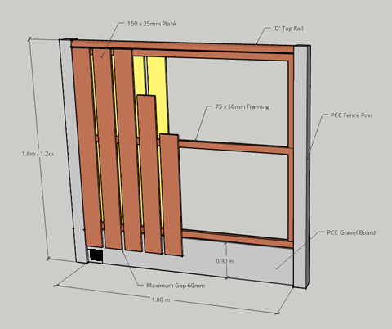
Hedgehog Highway.
A hedgehog hole is to be included at ground level at least once per side of the garden boundary. This is to come pre-installed in the gravel board, or to be cut onsite. A minimum size of 13cm x 13cm is required if this is to be cut onsite.
Hit & Miss Fencing Specification
1.8 or 1.2m Height
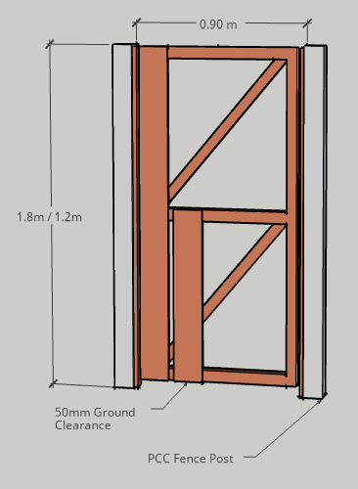 |  |  | All Gates Single Side Hit & Miss  1.8m Gate:  3no. 450mm Hinges  1no. Padbolt Lockable  1no. Barrack Latch  1.2m Gate  2no. 450mm Hinges  1no. Auto Gate Catch
Heavy Pattern Auto Gate Catch.  Galvanized | Barrack Latch Size: 225mm  Galvanised | Weighty Scotch Tee Hinge.  Size: 450mm. Galvanised. |  | ½” Padbolt  Lockable  Galvanised
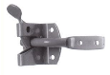 | 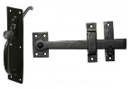 | 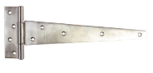 |  | 