SPECIFICATION FOR HANDRAILS AND SAFETY RAILING

External Handrails

- Key clamp railing
- Galvanised uprights and fittings, yellow powder coated handrails
- No overhanging edges, rail to terminate at post with 90 degree angled fitting
- All uprights to be evenly spaced
- The clearance between the handrail and any adjacent wall surface must be between 60mm and 75mm
- Diameter of handrail must be 42.4mm
- For flat or ramped areas, overall height from ground level must be between 900-1000mm. For steps and stairs, overall height from the pitch line (diagonal line connecting the step nosings) must be between 900mm–1000mm.
- For steps, a handrail must be fitted to one side of a flight of steps where the flight comprises three or more risers
- For steps wider than 1m, a handrail must be fitted on both sides.
- The loading criteria must comply with current BS regulations
- To be fitted as per manufacturers instructions

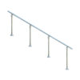

Edge Protection - Drops between 300mm-599mm

- Key clamp railing with crossbar
- Overall height from ground level must be 1100mm
- Spacing between ground level to crossbar and crossbar to handrail must not exceed 550mm
- Galvanised uprights and fittings with yellow powder coated handrails
- No overhanging edges, rail to terminate at post with 90 degree angled fitting
- All uprights to be evenly spaced
- Diameter of handrail must be a minimum of 42.4mm
- The loading criteria must comply with current BS regulations
- To be fitted as per manufacturers instructions

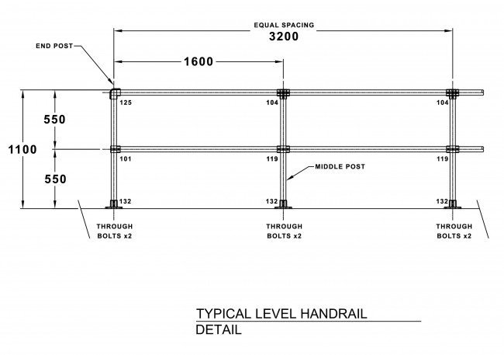

Edge protection - Drops of 600mm or more

Front of properties or communal areas

- Hoop top safety fencing (style as pictured)
- Overall height from ground level must be a minimum of 1100mm
- Spacing between vertical railings must be no larger than 100mm (so a max gap of 99mm)
- Galvanised finish (or yellow powder coated for visibility requirements)
- Safety fencing to terminate with fitted post
- The loading criteria must comply with current BS regulations
- To be fitted as per manufacturers instructions

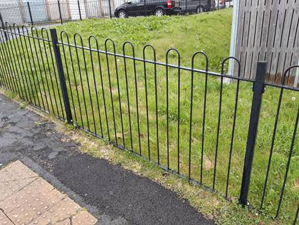

Rear of properties

- Flat top type safety fencing (style as pictured)
- Overall height from ground level must be a minimum of 1100mm
- Spacing between vertical railings must be no larger than 100mm (so a max gap of 99mm)
- Galvanised finish (or yellow powder coated for visibility requirements)
- Safety fencing to terminate with fitted post
- The loading criteria must comply with current BS regulations
- To be fitted as per manufacturers instructions

