LVT to ground floor hallway and lounge / Carpet to stairs / landing and bedrooms.
Floor Choices-Please tick your choice
NB: Products cannot be mixed – either Option 1 or Option 2.

Flooring type to be:
Furlong Flooring – Chiltern 142 Mercury clue Felt Backing
Furlong Flooring – Chiltern 135 Risotto Felt Backing
LVT – Tassell Oak 24935
LVT – Dennison Oak 22455

Option 1:

Tassell Oak 24935

AND


Chiltern 142 Mercury clue Felt Backing
-----------------------------------------------------------------------------------------------------------------------------------------------------------

Option 2:

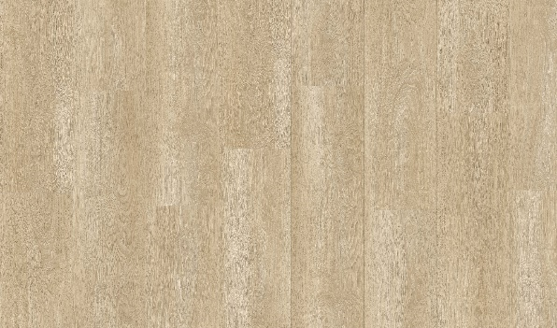
Dennison Oak 22455

AND

Print Name: _____________________________________________
Signed: _________________________________________________
Dated:__________________________________________________
Chiltern 135 Risotto Felt Backing

