

Environment, Roads & Facilities
Infrastructure (Consultancy)

ERCF2509N 05
Waterloo Cottage

Volume 2

Contract Data & Quality Questionnaire

October 2026

G.B. Edwards BEng (Hons) CEng FICE
Head of Environment, Roads & Facilities,
PO. Box 1, Colwyn Bay, LL29 0GG

01492 575337
affch@conwy.gov.uk / erf@conwy.gov.uk

Issue and Revision Record

Document Title | Volume 2 - Contract Data & Quality Questionnaire
Version | V3
Status | Tender
Filename | ERCF2509N 05 Waterloo Cottage - Volume 2 – CD v3.docx

Revision | Notes | Date
V3 | Tender Query Changes | 29/10/2026
V1 | Tender Issue | 16/10/2026

 | Signature | Name | Date
Prepared by |  | John Castle | 16/10/2026
Checked By | GRJ | Gerallt James | 19/10/2026
Approved by | BS | Bryn Shiland | 21/10/2026

Contents
Contract Data 5
The Client’s Contract Data 5
The Contractor’s Contract Data 9
The Contractor’s Offer and 10
Client’s Acceptance 10
Price List 11
Scope 14
Site Information 19
Appendix 1 - Quality Questionnaire 25


Engineering and Construction

Short Contract

A contract between | Conwy County Borough Council

and

for | Waterloo Cottage

Contract Forms

Contract Data

The Contractor’s Offer and Client’s Acceptance

Price List

Scope

Site Information

Contract Data

The Client’s Contract Data

The Client is

Name | Conwy County Borough Council
Address for communications | PO Box 1,  Colwyn Bay,  LL29 0GG

Address for electronic communications | john.castle@conwy.gov.uk or gerallt.james@conwy.gov.uk

The works are | Waterloo Cottage Retaining Wall

The site is | NGR 287294, 369190  See Location Plan - Drawing no ERCF2509 05 T101A

The starting date is | 18/01/2027

The completion date is | 09/04/2027

The delay damages are | £100 | per day
z

The period for reply is | 1 | weeks

The defects date is | 52 | weeks after Completion

The defect correction period is | 4 | weeks

The assessment day is the | Last Friday | of each month

The retention is | 5 | %

The United Kingdom Housing Grants, Construction and Regeneration Act (1996) does/does not apply
(delete as applicable)
The Adjudicator is

Name | The Institution of Civil Engineers

Address for communications

Address for electronic communications

Contract Data
The Client’s Contract Data

The interest rate on late payment is |  | % per complete week of delay.

Insert a rate only if a rate less than 0.5% per week of delay has been agreed.

The Client provides this insurance | N/A

Only enter details here if the Client is to provide insurance.

The minimum amount of
cover for the third insurance
stated in the Insurance Table is,
for any one event

The minimum amount of
cover for the fourth insurance
stated in the Insurance Table
is, for any one event

Is the Contractor’s obligation for design to use the skill and care normally used by professionals designing works similar to the works? Yes / No (delete as applicable)
The Contractor provides the following insurance cover

Insurance against | Minimum amount of cover | Period following Completion or earlier termination
Liability of the Contractor for claims made against it arising out of its failure to use the skill and care normally used by professionals designing works similar to the works | N/A | N/A
 | in respect of each claim, without limit to the number of claims | N/A

Contract Data
The Client’s Contract Data

For any one event, the liability
of the Contractor to the Client
for loss of or damage to the
Client’s property is limited to | £250,000

The Contractor’s total liability
to the Client which arises
under or in connection with
the contract is limited to | £10,000,000

The Adjudicator nominating
body is | Institution of Civil Engineers

The tribunal is | Courts

If the tribunal is arbitration, the
arbitration procedure is

The conditions of contract are the NEC4 Engineering and Construction Short Contract June 2017 (with amendments January 2023) and the following additional conditions

Option Z1 – Corrupt Practices
The Contractor has warranted that he has not committed any Prohibited Act and he does not do any of the Prohibited Acts.

The Contractor does not:

- offer to give to any person in the service of the Client any gift or consideration of any kind as an inducement or reward in relation to the obtaining or execution of this contract or any other contract with the Client or for showing favour or disfavour to any person in relation to this contract or any other contract with the Client, or
- enter into this contract or any other contract with the Client if, in connection with this contract or any such other contract, commission has been paid or an agreement for the payment of commission has been made by him or on his behalf or to his knowledge, in accordance with the terms of the Bribery Act 2010.
Option Z2 – Fair Wages and Conditions of Labour
The Contractor shall in respect of all persons employed by him (whether in execution of the contract or otherwise) in every factory, workshop or place occupied or used by him for the execution of the contract comply with the following conditions, namely:
- Pay rates of wages and observe hours and conditions of labour not less favourable than those established, for the trade or industry in the district where the work is carried out.

The Contractor shall recognise the right of his work people to be members of such trade unions as they may choose or subject to Section 58 of the Employment Protection (Consolidation) Act 1978, as amended, not to be members of a trade union or other organisation of workers or to refuse to be a member of any particular trade union in other organisation of workers.

The Contractor shall at all times during the continuance of the contract display, for the information of his work people in every factory, workshop or place occupied or used by him for the execution of the contract a copy of Clause (a) and (b) above.

The Contractor shall be responsible for the observance of this clause by sub-contractors employed in the execution of the contract, and shall if required notify the County Borough Council of the names and addresses of all such sub-contractors.

In the event of any question arising as to whether the foregoing conditions are being observed, the question shall, if not otherwise disposed of, be referred for decision to an independent arbitrator jointly agreed by the County Borough Council and the Contractor.

The Contractor shall keep proper books and time sheets in relation to wages paid to persons in his employ and engaged in the execution of the contract, and such document shall, if required by the County Borough Council, be produced for inspection by any officer so authorised by the County Borough Council.

Option Z3 – Prevention of Canvassing
- The Contractor, by submitting his tender, confirms that he has not canvassed or solicited now or in the future any Member, Officer or Employee of the Council in connection with the award of this or any other tender or proposed tender for the Council and that no person employed by him or acting on his behalf has done any such act
- Any breach of this Clause will entitle the Council to reject a tender and/or cancel a contract.
Option Z4 – Equality and Diversity
The Client is committed to the active promotion of equality and to valuing diversity in all its work. It is committed to honouring the duties and rights enshrined in legislation and where possible, will go further than the requirements of law. The Client believes that promoting diversity and equality of opportunity among its work force and more widely, will assist in meeting the needs and aspirations of the people of Wales. The Client therefore seeks to contract with companies with similar aspirations and this is reflected in the consideration of the Quality submissions made by tendering companies.

Option Z5 – VAT Invoice
The Contractor shall submit a valid VAT invoice, for the amount stated upon the payment certificate, to the Client within a maximum of 24 hours of being requested of such or at any time as requested by the Client

Option Z6 – Procurement

- During the tender period the Contractor shall establish that products named in the document for inclusion in the works are available within the programmed contract period. Should this not be the case the Contractor should put forward products of equivalent specification, which will be available within the contract period, in the tender submission for consideration.

Contract Data

The Contractor’s Contract Data

The Contractor is

Name
Address for communications

Address for electronic communications

The fee percentage is |  | %

The people rates are

category of person | unit | rate

Contracts Manager | Per Hour

Site Manager | Per Hour

Foreman | Per Hour

Plant Operative | Per Hour

Skilled Labour | Per Hour

Labourer | Per Hour

The published list of Equipment is | CECA (latest version)

The percentage for adjustment for Equipment is |  | % (state plus
 |  | or minus)

The Contractor’s Offer and

Client’s Acceptance

The Contractor offers to Provide the Works in accordance with these conditions of contract for an amount to be determined in accordance with these conditions of contract.

The offered total of the Prices is

Enter the total of the Prices from the Price List.

Signed on behalf of the Contractor

Name

Position

Signature

Date

The Client accepts the Contractor’s Offer to Provide the Works

Signed on behalf of the Client

Name

Position

Signature

Date

Price List

Item no. | Description | Unit | Quantity | Rate | Price
 | GC 990/MMHW - Contractors Preliminaries
990.1 | Establishment of temporary accommodation and equipment for the Contractor | Item | 1
990.2 | Servicing of temporary accommodation and equipment for the Contractor | Item | 1
990.3 | Removal of temporary accommodation and equipment for the Contractor | Item | 1
990.4 | Supply, erect and take down temporary scaffolding/propping of existing wall | Item | 1
990.5 | Daily Maintenance of temporary scaffolding/propping | Day | 84
990.6 | Appointment and Provision of Temporary Works Coordinator | Item | 1
 | GC 105/MMHW - Arrangements for the Overseeing Organisation
105.1 | Set of Progress still images (Weekly) | no | 12
 | GC 106/MMHW - Working on the highway
106.1 | Temporary management for all works | Item | 1
106.2 | Establishment of closure of Waterloo Road at location shown on drawing ERCF2509N 05 T101 | Item | 1
106.3 | Maintenance and adjustment for closure of Waterloo Road at location shown on drawing ERCF2509N 05 T101 | Day | 84
106.4 | Removal of closure of Waterloo Road at location shown on drawing ERCF2509N 14 T101 | Item | 1
106.5 | Establishment of temporary diversion routes for traffic | Item | 1
106.6 | Maintenance of temporary diversion routes for traffic | Day | 84
106.7 | Removal of temporary diversion routes for traffic | Item | 1
 | GC 109/MMHW Site preparation and clearance
109.1 | General site clearance | ha | 0.15
109.2 | Vegetation clearance | m² | 350
109.3 | Demolition building or structure, existing concrete sandbag wall and remove to tip off site | Item | 1
109.4 | Take up or down and remove to tip off site post and wire fence | m | 70
 | CC 201/MMHW Pavement foundation construction
201.1 | Type 1 unbound mixture sub-base in carriageway, hard shoulder and hard strip | m³ | 8
 | CC 202/MMHW Flexible pavement construction
202.1 | DBM asphalt 125 pen 32 mm aggregate base course 140mm thick in carriageway, hard shoulder and hard strip | m² | 50
202.2 | DBM asphalt 125 Pen 20 mm aggregate binder course 60mm thick in carriageway, hard shoulder and hard strip | m² | 320
202.3 | Hot Rolled Asphalt high stone content with 10 mm aggregate surface course minimum 55 PSV 40mm thick in carriageway, hard shoulder and hard strip | m² | 330
202.4 | Bond Coat K140 at 0.3-0.5 l/m2 rate of spread | m² | 650
202.5 | Saw-Cutting grooves Saw cuts exceeding 50mm but not exceeding 70mm in depth | m | 9
202.6 | Surface Course 5mm High Friction Surfacing to DMRB Clause 924 cold applied, colour buff HAPAS type 1 | m² | 150
 | CC 205/MMHW Maintenance of pavements with an asphalt surfacing
205.1 | Milling pavement 40mm thick | m² | 8
205.2 | Milling pavement 100mm thick | m² | 275
 | CC 482/MMHW Structural concrete
482.1 | Structural concrete c40/50 to facing slab and foundation (or equivalent strength gunnite mix. | m³ | 27
482.2 | Formwork class F1 inclined more than 300 mm wide (facing slab) | m² | 71
482.3 | Structural concrete lean no fines concrete fill to structure behind masonry wall | m³ | 20
482.4 | Fabric reinforcement A393 (RC Wall) | m² | 145
482.5 | steel bar reinforcement nominal size B10 1.1m in length (mesh panel splice) | t | 0.1
482.6 | Structural concrete ST5 to parapet coping, curved as per drawings in Volume 3 | m³ | 2
482.7 | B6 Stainless steel deformed wall ties average length 400mm | No | 180
482.8 | Formation of drainage outlet slots through retaining wall including concrete and stone lintels | No | 4
482.9 | Structural concrete c32/40 to shallow dish drainage channel | m³ | 2
482.10 | Polysulphide shrinkage joints | no | 20
 | CC 491/MMHW Masonry
491.1 | Imported stone from a local quarry squared random rubble uncoursed stonework in M6 mortar in retaining wall cladding | m³ | 15
491.2 | Imported stone from a local quarry squared random rubble uncoursed stonework in M6 mortar in parapet wall | m³ | 20
 | CC 500/MMHW Drainage
500.1 | 50mm diameter slotted PVC weep pipes positioning @1.5m centres as shown on ERCF2509N 05 T104 | m | 45
500.2 | 150mm internal diameter HDPE Perforated drain in trench depth to invert not exceeding 2 metres, average depth to invert 2m | m | 32
 | CC 601/MMHW Earthworks
601.1 | Establishment of plant for ground anchors used in earthworks to wall | Item | 1
601.2 | Boring raking holes not exceeding 10 metres in depth | m | 400
601.3 | Ground anchors used in earthworks exceeding 5 metres but not exceeding 10 metres in length | m | 400
 | Cementitious grout for soil nail installation | m | 400
601.4 | Excavation of unacceptable material Class U1A to retaining wall and carriageway 0 to 3 metres in depth | m³ | 120
601.5 | Extra over excavation for excavation in Hard Material in structural foundations | m³ | 120
601.6 | Disposal of unacceptable earthworks material Class U1A | m³ | 120
601.7 | Disposal of unacceptable earthworks material Class U1A (Carriageway planings) | m³ | 28
601.8 | Sampling, laboratory testing, waste classification and reporting of excavated material to determine suitability for disposal or reuse, including liaison with disposal facilities, preparation of waste classification documentation and all associated costs. | Item | 1
601.9 | Suitability testing of soil nails to 209kN | No | 3
601.10 | Acceptance testing of soil nails to 87kN | No | 3
601.11 | Grout cube manufacture, curing and laboratory testing | No | 2
601.12 | Corrosion protection to soil nail heads including bituminous coating or sprayed concrete cover | No | 66
601.13 | Excavation of acceptable material 5A and set aside for re-use for compound area | m³ | 42
601.14 | Excavation of Type 1 subbase for compound area after completion | m³ | 42
601.15 | Imported acceptable earthworks material Type 1 sub-base for compound area | m³ | 42
601.16 | Topsoiling 200mm thick after compound area removal | m² | 210
601.17 | Geotextile for compound area Tensar TX 190L-G geogrid or similar approved | m² | 210
601.18 | Disposal of unacceptable earthworks material Class U1A (compound area) | m³ | 42
 | LC 120/MMHW Landscape and ecology
120.1 | Installation of Vivara Pro Seville 32 mm nest-boxes or similar approved to be erected above 3m off ground | no | 2
120.2 | Installation of Vivara Pro Seville 28 mm nest-boxes or similar approved to be erected above 3m off ground | no | 2
120.3 | Installation of Vivara Pro Barcelona Woodstone Open nest-box or similar approved to be erected above 3m off ground | no | 1
120.4 | Tree surgery tree size category E as show in drawing ERCF2509N 05 T201 | no | 1
120.5 | Tree felling tree size category B as show in drawing ERCF2509N 05 T201 | no | 5
120.6 | Grass seeding by conventional sowing to surfaces sloping at 10º or less to the horizontal | m² | 700
120.7 | Rowan Tree 12-14cm girth in grassed area to surfaces sloping at 10º or less to the horizontal | no | 5
 | LC 127/MMHW Fencing
127.1 | Temporary Stock proof fencing | m | 90
127.2 | Timber Post and four rail fencing 1.2m High with stockproof fencing as detailed on drawings T104 | m | 36
127.3 | Galvanised mild steel field gate with welded mesh - side hinge arrangement 1.2m high 1m wide | no | 1
127.4 | Fenced tree guards timber post and rail | no | 5

The total of the Prices
The method and rules used to compile the Price List are
The contractor shall price all items accordingly and allow for all item coverages i.e. supply and install. In accordance with manufacturers recommendations or highway work specifications identified in this document.

The rates and prices entered in the Price List shall be deemed to be the full inclusive value of the work covered by the several items including the following, unless expressly stated otherwise:

i. Labor and costs in connection therewith.
ii. The supply of materials, goods, storage and costs in connection therewith including delivery to Site. Taking delivery of materials and goods supplied by others, unloading, storage, and costs in connection therewith.
iii. Plant and costs in connection therewith.
iv. Fixing, erecting and installing or placing of materials and goods in position.
v. Temporary Works.
vi. The effect on the phasing of the Works or any element of the Works to the extent set forth or reasonably implied in the documents on which the tender is based.
vii. General obligations, liabilities and risks involved in the execution of the Works set forth or reasonably implied in the documents on which the tender is based.
viii. Establishment charges, overheads and profit.
ix. Waste.
x. Attendance and transport for sampling and testing carried out by the Engineer, tests carried out by the Contractor, supplying results of tests carried out by the Contractor and providing test certificates.
xi. Complying with Quality Assurance schemes and providing certificates of conformity.
xii. Preparation and supply of detailed working drawings.
xiii. Awaiting approvals and or consents.

Scope

1 Description of the works

The Contractor is required to do the following:
Preliminaries, H&S, Environmental
- Set up temporary site welfare and secure site with double-clipped Herras type fencing around site compound.
- All health and safety in accordance with VOL 4 Pre-construction Information
- Working hours shall be agreed in advance and any noisy works shall be scheduled to minimize disruption
- Contractor is to undertake the works adjacent to occupied domestic properties with minimal disturbance. Focus on maintaining existing access and live services to the properties is to be maintained at all times.
- To minimise disruption, it is anticipated that the works located outside the access to Tan-Y-Fron will be undertaken within the shortest practicable timeframe. All remaining works may be completed at the Contractor’s discretion, subject to the requirements of the contract and site conditions.
- Adjacent property should be protected from any damage at all times.
- Provide stock proof fencing / vehicular gates on field to keep stock from Works until reinstatement is complete.
- Surrounding property should be protected from any damage at all times.
- All temporary works to be designed by the contractor. The Contractor remains fully responsible for the adequacy and stability of all temporary works.
- Appointment of Temporary Works Coordinator (TWC) in accordance with BS 5975, including management of the temporary works process, temporary works register, design reviews, inspections, approvals, monitoring and certification throughout the contract period
- Temporary support of excavations and slope stabilization required for the contractor's methodology shall be deemed included
- The Contractor shall locate, expose, support and protect all existing statutory undertakers apparatus throughout the works.
- Any damage to existing services shall be made good at the Contractor's expense.
- The Contractor shall set out the works and be responsible for the accuracy of all setting out.

Compound Area
- Establishment of Site working area
- Topsoil strip at compound area and set aside
- Installation of geotextile membrane – compound area
- Import and lay 200mm depth type 1 sub base
- Provision of temporary access and protection measures during construction.
- Temporary stock proof fencing installed at commencement of works. Rylock netting or similar approved with steel t posts or wooden posts.
- On completion of works, excavation and disposal of geotextile and type 1 sub base and reinstatement of topsoil.
- Grass seed all disturbed areas.

Traffic Management and Public Information
- Provide local letter drop informing of the works with Contractor’s contact details 1 week in advance to affected properties.
- Install advance warning signs informing that road is closed for the duration of the works.
- Establishment, maintenance and removal of road closure and temporary diversion route

Site Preparation/Clearance
- General site clearance
- General site clearance of dense vegetation Remove all vegetation, including invasive species, from the works area and the farm land below necessary to access the working area
- Dispose of arisings in accordance with environmental regulations and MCHW GC 109/MMHW
- Extents are shown on the drawings in Volume 3.
- Monitor the Met office 5 day forecast in regards to potential inclement weather events and communicate potential issues to the Client
- Clearing and levelling of the designated site area.
- Setting out works in accordance with approved drawings.
- Excavation and disposal of surplus materials to approved locations.

Testing
- At commencement of site works, 3No suitability tests to be carried out to an axial load of 209 kN, prior to the installation of the rest of the soil nails. To suit contractors method statement
- After works are complete, acceptance tests to be carried out on 3 nails to an axial load of 87 kN.
- Testing of excavated material for contamination prior to disposal
- The Contractor shall provide all testing equipment, calibrated load cells, reaction frames, measurements, monitoring and reporting
- The Contractor shall provide a factual testing report to the Supervisor within 5 working days of each test.
- Minimum two sets of grout cubes shall be prepared and tested at 3, 7 and 28 days in accordance with the design requirements
- The Contractor shall undertake all sampling, laboratory analysis, waste classification and reporting necessary to classify excavated material arising from the Works.
- Waste classification shall be undertaken prior to disposal and in accordance with the requirements of Natural Resources Wales, receiving disposal facilities and all relevant waste legislation.
- The Contractor shall make all necessary arrangements for testing, transportation and disposal of excavated material and shall allow for any waiting periods associated with obtaining test results.
- Disposal of material shall only be undertaken once sufficient information is available to demonstrate compliance with the acceptance criteria of the receiving facility

Permanent works
- Clear vegetation and undertake any required excavation to expose the existing retaining wall.
- All excavated and demolished material shall be removed from site and disposed of at appropriately licensed facilities unless otherwise agreed by the Supervisor.
- Temporary propping of existing retaining wall – Temporary works to be designed by contractor.
- Contractor to ascertain ground levels and make suitable allowances.
- Excavation/demolition of existing concrete bag wall and remove to tip off site
- Excavation to formation level
- Install galvanised R32N Minova soil nails, including drilling, grouting, testing and acceptance testing in accordance with the design. Soil nail lengths shown are indicative. The Contractor shall allow for achieving the minimum 2m rock bond length specified on the drawings.
- Construct reinforced mass concrete backfill and facing slab, including all reinforcement, B6 bar wall ties and formwork.
- Install reinforced concrete foundation and any stepped foundation sections as shown on the drawings.
- Construct natural stone cladding and parapet wall using approved local stone and specified M6 mortar.
- Install weep holes, drainage outlets, slotted pipe and insitu concrete surface drainage channels with polysulphide movement joints.
- Including stone lintels, concrete lintels, formers and making good
- Construct concrete coping to the top of the parapet wall, including polysulphide movement joints and sealant.
- Undertake proof and acceptance testing of soil nails with attendance by CCBC representatives as specified.
- The Contractor shall verify exposed rock profile and immediately notify the Supervisor of any significant deviation from the assumed ground model.
- A393 fabric reinforcement to BS 4483:2005, grade B500 steel complying with BS 4449:2005, with appropriate lap lengths and concrete cover as shown. 75mm cover to rear mesh and 50mm cover to front mesh.

Carriageway Reprofiling and Resurfacing
- Mill & remove existing carriageway surface as shown in drawings in Volume 3.
- Profile the carriageway to ensure proper crossfall and longitudinal gradient.
- Ensure surface water runoff is directed to drainage channels.
- Lay new bituminous surfacing in accordance with MCHW CC201/MMHW and CC202/MMHW.
- Reinstate verge edges as necessary.
- Installation of High Friction Surfacing at location shown of drawings in Volume 3.

Reinstatement of surroundings
- Reinstate all disturbed agricultural land, verges and soft landscaped areas.
- Reinstate to original levels and condition as a minimum.
- Any rutting, compaction or damage caused by construction activities shall be made good.
- Seed disturbed areas using an appropriate grass seed mix suitable for agricultural use
- Tree species – Rowan 12-14cm girth with timber post and rail tree guard
- Links to bird boxes specified
  - www.nhbs.com/vivara-pro-seville-32mm-woodstone-nest-box
  - www.nhbs.com/vivara-pro-seville-28mm-woodstone-nest-box
  - www.nhbs.com/vivara-pro-barcelona-woodstone-open-nest-box

Quality & Compliance

- Materials and workmanship to conform to relevant BS/EN standards.
- Inspections and approvals by the supervising engineer prior to handover.

Completion
- Disposal of all arising’s to licenced tip.
- The carriageway shall not be reopened until:
  - All permanent structural works are complete.
  - Carriageway surfacing has been completed.
  - High friction surfacing has been installed.
  - Fencing and parapets are complete.
  - Temporary traffic management has been removed.
- The Works will be deemed complete when all the works are complete the road is open, temporary welfare/site compound are removed and the surrounding area made good.
- Provision of a Health & Safety File
- Preparation and submission of soil nail installation records and as-built test documentation via an agreed format in accordance with BS8081

2 Drawings

DRAWING NUMBER | REVISION | TITLE
ERCF2509N 05 T101 | A | Site Location Plan & Site Extents
ERCF2509N 05 T102 | A | Existing General Arrangement
ERCF2509N 05 T103 | A | Proposed General Arrangement
ERCF2509N 05 T104 | A | Proposed Elevations, sections and details
ERCF2509N 05 T201 | A | Site Clearance
ERCF2509N 05 T601 | A | Earthworks
ERCF2509N 05 T701 | A | Pavements

Scope

3 Specifications

TITLE | DATE OR REVISION | TICK IF PUBLICLY AVAILABLE
Manual of Contract Documents for Highway Works. Volume 1 – Specification for Highway Works | March 1999 with revisions May 2018 | ✓

4 Constraints on how the Contractor Provides the Works

The Met Office 5 Day forecast should be monitored by the Contractor.

Land access agreements have been made by the overseeing organization

There are unlikely to be any conditions other than what is contained In Vols 2-4. If there are changes, these will be dealt with under the contract.

Road closure has been applied for by overseeing organization.

Contractor is to undertake the works at occupied farmland with minimal disturbance.

Focus on maintaining existing access to the land and local properties is to be maintained at all times.

Stock proof fencing as per scope to be installed around the site compound and the works area.

To minimise disruption, it is anticipated that the works located outside the access to Tan-Y-Fron will be undertaken within the shortest practicable timeframe. All remaining works may be completed at the Contractor’s discretion, subject to the requirements of the contract and site conditions.

Scope

5 Requirements for the programme

A Gantt bar chart programme is required showing the principal activities and their sequence, including the critical path and float.

6 Services and other things provided by the Client

ITEM | DATE BY WHICH IT WILL BE PROVIDED
Agreement for access to the farm land to undertake works | From 18/01/2027
Road closure | From 18/01/2027

Site Information

The concrete bag retaining wall that retains waterloo hill from the farmland below is failing and is at risk of collapse. Works will maintain the integrity of the highway above.

An ecological survey has been carried out in October 2026 by Marches Ecology and is attached in Appendix A of Vol 4

A geotechnical report was carried out in 2019 by e-geo solutions and is attached in Appendix B of Vol 4

Statutory Undertakers equipment searches indicate the following. See stats returns following:

- Telecom: Overhead apparatus along Waterloo Hill
- Electric: Overhead apparatus along Waterloo Hill
- Water: DCWW: ¾ inch/20mm alkathene water main
- Gas: None.
- Sewerage: None.

Contractor to CAT scan for services prior to any excavations.

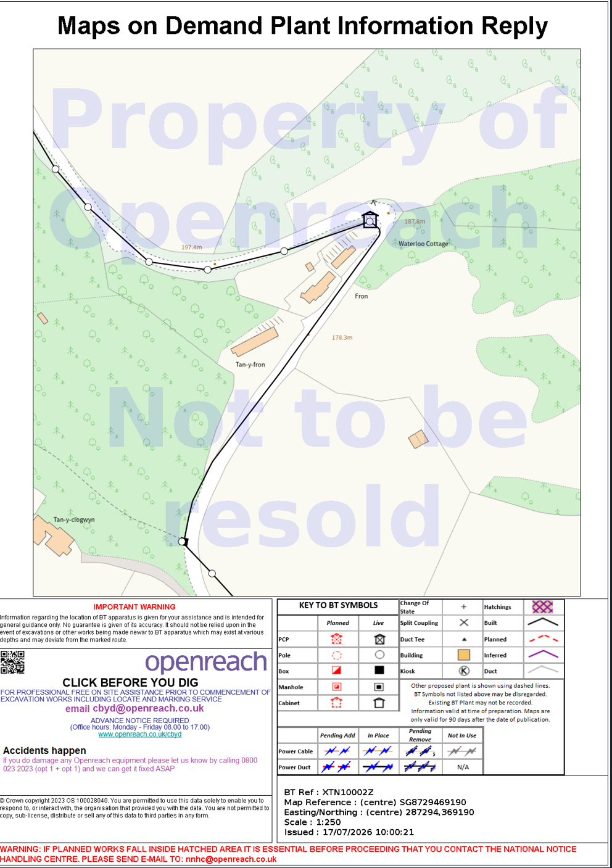
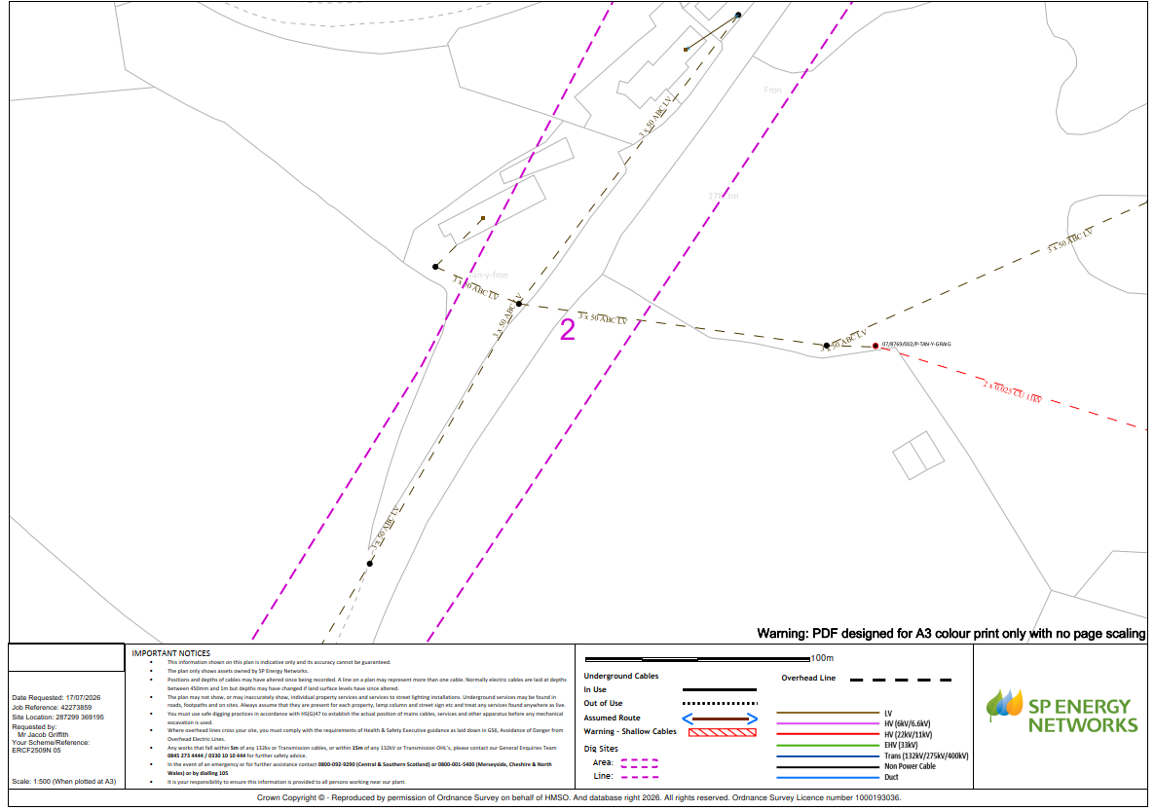
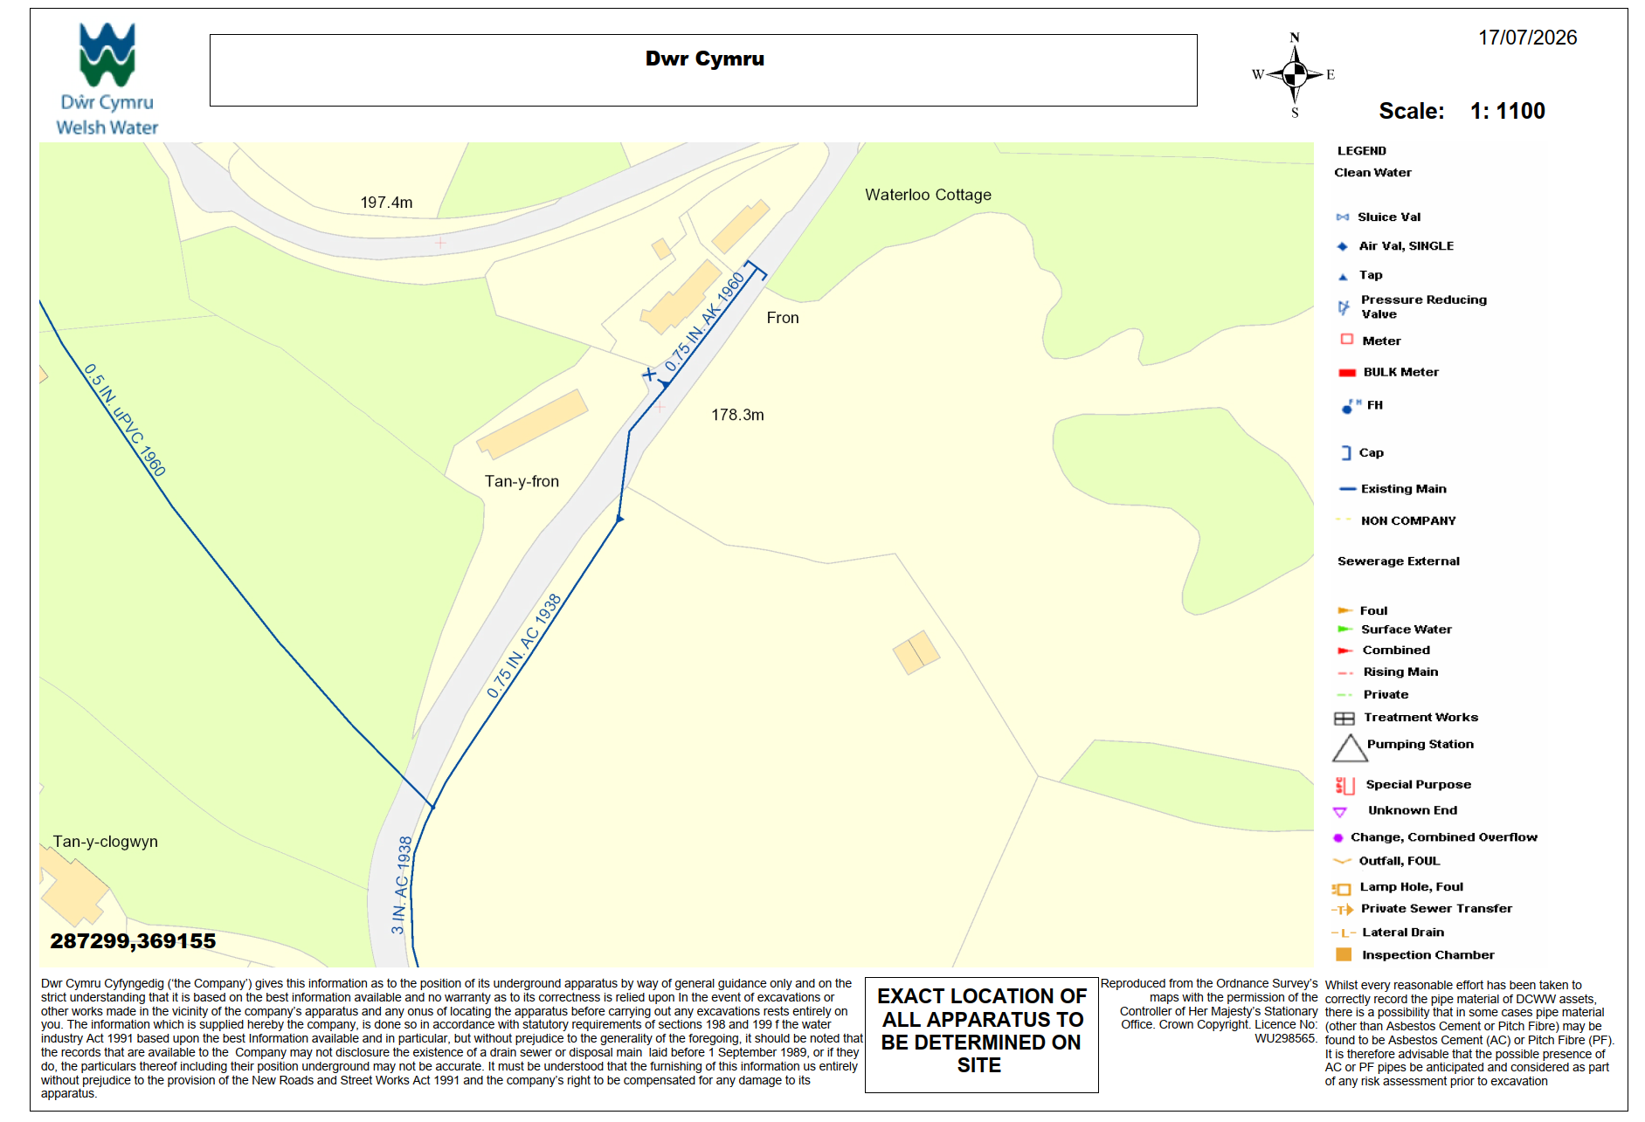
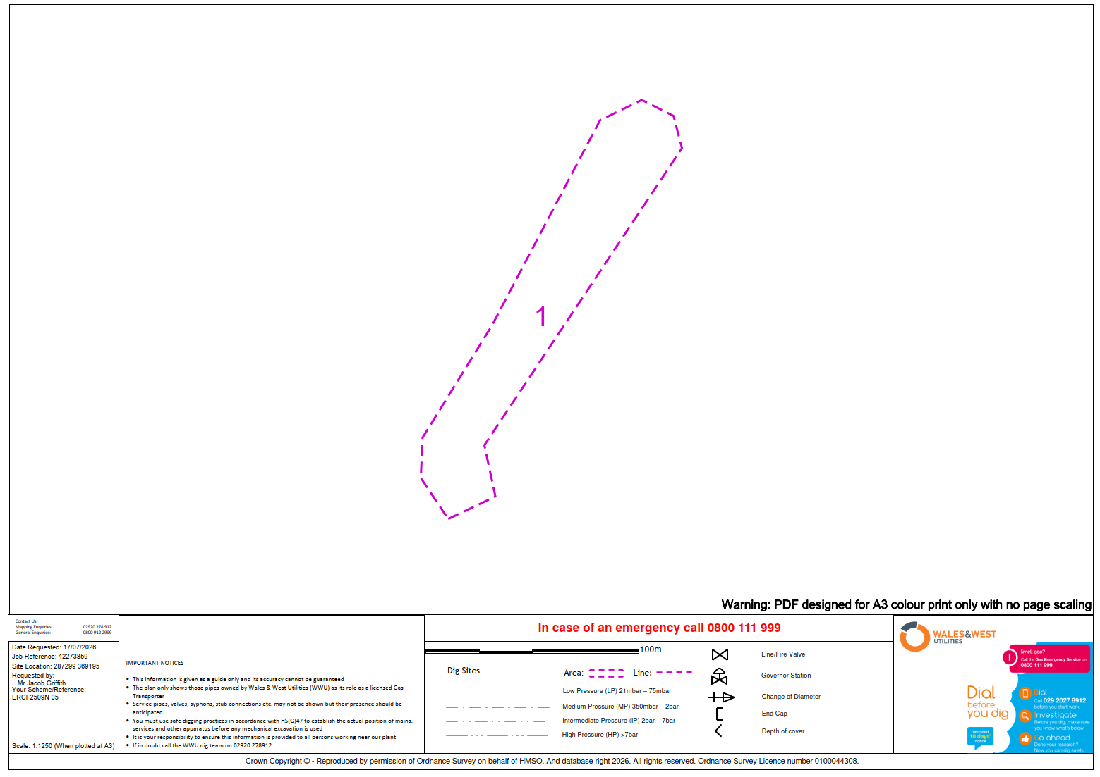

Freedom of Information Act 2000 Declaration

Conwy County Borough Council
Environment, Roads and Facilities

Waterloo Cottage

The Freedom of Information Act 2000 applies to all the activities of Conwy County Borough Council (CCBC).

As a supplier of goods and services to CCBC, you should be aware of CCBC’s obligations and responsibilities under the Freedom of Information Act 2000 to provide on request access to recorded information held by it. One of the consequences of those new statutory responsibilities is that information CCBC holds about your organisation may be subject to disclosure in response to a request, unless CCBC decides that one of the various statutory exemptions applies.

Where you provide any information to CCBC that you regard as confidential and / or commercially sensitive then you must make it clear in your documentation as to the information to which you consider a duty of confidentiality applies. The use of blanket protective markings such as “commercial in confidence” will no longer be appropriate and a clear indication as to what material is to be considered confidential and reason why should be given.

CCBC cannot accept that trivial information or information which by its very nature cannot be regarded as confidential should be subject to any obligation of confidence.

In certain circumstances where information has not been provided in confidence, CCBC may still wish to consult with you as to the application of any other exemption such as that relating to disclosure that will prejudice the commercial interests of any party. However the decision as to what information will be disclosed will be reserved to CCBC.

NOTE: Detailed cost information within the pricing document is considered to be of commercial interest and will not be disclosed.

If you require any advice on what the Freedom of Information Act 2000 involves, please contact the Information Governance Unit on 01492 577215, E-mail info-gov.unit@conwy.gov.uk.

List below any items you consider confidential or commercially sensitive:

Signed by:…………………………………………………………………………………………………………………………….…..

For and on behalf of:

Name…………………………………………………………………………………………………………………………………...…

Address……………………………………………………………………………………………………………………………….….

…………………………………………………………………………………………………………………………………………….

Date:………………………………………………………

Anti-Collusion Certificate

Conwy County Borough Council
Environment, Roads and Facilities

Waterloo Cottage

I/We certify that this tender is made in good faith, and that we have not fixed or adjusted the amount of the tender by or under or in accordance with any agreement with any other person. I/We also certify that we have not and I/We undertake that we will not before the award of any contract for the work:

(i) disclose the tender price or any other figures or other information in connection with the tender to any other party (including any other company or part of a company forming part of a group of companies of which I am/We are a part) nor to any sub-contractor (whether nominated or domestic or howsoever appointed) nor supplier (whether nominated or domestic or howsoever appointed) or any other person to whom such disclosure could have the effect of preventing, restricting or distorting competition in this tendering exercise;
(ii) enter into any agreement or arrangement with any person that they shall refrain from tendering, that they shall withdraw any tender once offered or vary the amount of any tender to be submitted;
(iii) Otherwise collude with any person with the intent of preventing, restricting or distorting competition;
(iv) pay, give or offer to pay or give any sum of money or other valuable consideration directly or indirectly to any person for doing or having done or causing or having caused to be done in relation to any other tender or proposed tender for the work any act or thing of the sort described at (i), (ii) or (iii) above.

I/We further declare that I/We have no knowledge either of the sum quoted or of any other particulars of any other tender for this work by any other party.

I/We further certify that the principles described above have been, or will be, brought to the attention of all sub-contractors, suppliers and associated companies providing services or materials connected with the tender and any contract entered into with such sub-contractors, suppliers or associated companies will be made on the basis of compliance with the above principles by all parties.

I/We acknowledge that any breach of the foregoing provisions shall lead automatically to this tender being disqualified and may lead to criminal or civil action.

Conwy County Borough Council shall treat any tender received in confidence but reserves the right to make same available to any relevant Department of the Council, other Local Authority Trading Standards Department, the Director General of Fair Trading, and/or any other statutory regulatory authority either having jurisdiction over the work or who may now or at any time in the future have statutory power to require disclosure of this tender.

In this certificate, the word ‘person’ includes a body of persons corporate or unincorporated and any undertaking for the purposes of The Competition Act 1998; any agreement includes any transactions, formal or informal and whether legally binding or not; and the ‘work’ means the work or goods or services in relation to which this tender is made.

Signature…………………………..………. in the capacity of……………………….……..….. (e.g. Director, Secretary etc)

Date……………….…………………….….

Duly authorised to sign tenders and acknowledge the contents of the anti-collusion certificate for and on behalf of:-

……………………………….………………………….…………………….……………………........................... (Name of firm)

Full postal address ………………………………………………………………………………………………..………….…..........

………………………………………………………………………………...…...........….Post Code………………………………..

Signed by :………………… . . . . . . . . . . . . . . .. . . For and on behalf of :………………………………………………… . . . .

Declaration

Conwy County Borough Council
Environment, Roads and Facilities

Waterloo Cottage
In this certificate, any reference to person or persons shall mean and include businesses, associations or corporations and any reference to arrangements or agreements shall mean any and all transactions, formal or informal, lawful or otherwise.
I / We certify that:
- We have not been convicted of nor are currently under investigation for any acts of conspiracy, corruption, bribery, fraud, money laundering, such acts as defined by the relevant UK law.
- We are not bankrupt nor have had a receiving order or administration order or bankruptcy restrictions order made against us nor are in the process of or about to commence any composition or arrangement with or for the benefit of our creditors or, if registered as a partnership under Scots law have not been granted a trust deed or is subject of a petition for sequestration of our estate.
- We have not, nor are about to, be subject of a resolution or order for winding up, nor have has a receiver, manager or administrator.
- We have not been convicted of a criminal offence relating to the conduct of our business or (being an individual) not been guilty of grave misconduct in the course of its business.
- We have fulfilled our obligations relating to the payment of social security contributions and the payment of taxes in accordance with the legal provisions of the country in which it is established and/or the United Kingdom.
- We have not been found guilty of serious misrepresentation in providing any information under Section 57 to 60 of the Procurement Act 2023 (as amended) within the last three (3) years.
- We have not suffered a deduction for liquidated or ascertained damages in respect of any contract nor had a contract cancelled, or not renewed, for failure to perform nor been the subject of a claim (contractual or otherwise) based upon a failure of quality in design, work, materials or services within the last three years.
- None of the senior personnel of the organisation have been involved (in a similar position) in any company which has gone into insolvent liquidation, voluntary arrangement, receivership or administration or been declared bankrupt.
- We comply with the requirements of the Equalities Act 2010.

I / We confirm and attest that the foregoing information and declarations are accurate to the best of my / our knowledge and that I / We acknowledge and accept that any false information could result in our application being rejected, or, in the event that any false declaration is discovered after the award of any contract, may lead to the rescission of any contract awarded.

Dated……………………………………………..……..

Signature………………………………………..………………………………………………………………………………………..

Name (printed)…………………………….……………………………………………………………………………………………..

Capacity / Title……………………………………………………………………………………………………………………………

For and on behalf of …………………………………………………………………………………………………………………..…

Appendix 1 - Quality Questionnaire

Guidance Notes

Please read these guidance notes carefully before completing this document.

All parts of the Quality Questionnaire must be answered.

- The questionnaire is to be completed by suitably qualified and experienced Companies who wish to tender for the Contract titled Waterloo Cottage

- Companies shall refer to Volume 1 - Instructions to Tenderers, which sets out the procedure which Conwy County Borough Council shall follow in procuring this Contract.

- Where an applicant is required to submit relevant supporting information, it should be provided within a separate appendix and cross-referenced to correspond with the relevant section of the questionnaire.

- Tenderers shall note that answers to questions and submitted information must be both relevant and concise. The Evaluation Team appraising these tenders shall deduct marks where answers are found to be generic in nature or contain little relevance to the work in question. The Company shall ensure that their submission is both well formatted and easily navigable by the Evaluation Team.

- Tenders returned with any sections or questions left unanswered are liable to be rejected without further consideration.

- No more than 1000 words are required per answer

Q1 | The Contractors proposed approach and methodology for the delivery of the proposed work.

Q2 | The Contractor’s proposed approach to Project Management during execution of the works including key staff, duties and management and co-ordination of sub-contractors.

Q3 | The Contractor’s proposed approach to managing Health and Safety for the works and protecting the environment.

Q4 | The Contractor’s proposed approach to progress reporting and communication with Conwy County Borough Council during execution of the works, including the approach to reporting commercial issues.

Q5 | The Contractor’s approach to managing the quality of output on site, checking and supervision of the works.

Q6 | The Contractor’s perceived key risks in undertaking the works and the outline mitigation measures.

Q7 | - The Contractor’s outline programme for the works including details of:  - Start date, access dates, key dates and completion date.  - Order and sequencing of the works.  - Provisions for risk allowance.  Details of each planned operation including any resourcing and sub-contractor requirements.

