Monmouthshire County Council
Request for Quotation

Supply of design and manufacture of Interpretation panels and digital content – Linda Vista historic Gardens, Abergavenny

October 2025

The successful candidate will be selected on their ability to meet the following specification:

  - SCOPE

Monmouthshire County Council is seeking a suitably qualified consultant/consultant team to design, manufacture and install interpretation panels and signage, and to produce supporting digital content for Linda Vista historic gardens in Abergavenny.

The council project team have worked with local stakeholders to review the existing provision and identify the interpretation needs for the site and an interpretation plan to inform the tender is included in appendix A.

2.2 BACKGROUND INFORMATION

The new interpretation is an integral part of a broader project aimed at enhancing the cultural heritage and natural environment of the site while promoting tourism and leisure. The project is funded by Brilliant Basics scheme, a key component of the Welsh Government’s tourism strategy, and supported through match funding from Abergavenny Town Council.

The Brilliant Basics scheme’s key objectives are to deliver basic but essential small scale tourism infrastructure and visitor facilities that meet the following priorities:
- Environmentally Sustainable destinations that respond to climate change.
- Alleviate Pressure points at hot spot locations.
- Inclusive tourism and enhancing accessibility.
- Enhancing the visitor offer.
- Year of Croeso.

The full project includes installation of solar panels and cycling infrastructure, improvements to paths and installation of wildlife cameras to increase accessibility, reinstatement of historic features and views, new litter bins and benches, installation of outdoor electrical supply to enhance events, new signage and enhanced online presence.

Linda Vista Gardens are a grade 2 listed historic gardens. The work is being undertaken with financial support from Abergavenny Town Council and input on content from the volunteers at Friends of Linda Vista Gardens who have worked for many years on maintaining and developing the gardens. (Details of listing can be viewed here)

Project Overview:
- This aspect of the project aims to enhance the visitor offer by improving the availability of information on site and online, to assist visitor orientation though directional signage, and reduce litter and dog fouling through higher visibility of visitor responsibilities and access to appropriately located litter bins.

The Interpretation brief
- The interpretation will be designed to enrich visitors' experiences and evoke a deeper appreciation for the historic and natural surroundings.
- Each interpretation point will serve as a focal point, offering opportunities for reflection, interpretation, and interaction with the environment.
- Directional signage will be clearly visible but subtle and appropriate to the setting.
- Through the interpretation, visitors will be encouraged to explore the site actively, engage with their surroundings, and gain insights into the unique character and significance of the gardens.
- Suppliers are encouraged to consider sustainability in their working methods and materials proposed.
- Suppliers need to consider the audience both on site and online. Linda Vista Gardens visitor demographic is wide and includes a significant number of young families as well as older people and regular dog walkers and includes many tourists unfamiliar with the gardens and its context to the town and adjacent open spaces. Online visitors are likely to be tourists, people with a specialist interest, and those seeking further information through links from site signage.

Health & Safety, and Sustainability (Lot 3, installation)
- The site is open to the public; therefore, the contractor must:
  - Submit a generic risk assessment and proof of public liability insurance with the tender submission.
  - Provide a site-specific risk assessment for approval by the project manager prior to the commencement of work.
  - Leave the site tidy to the satisfaction of the project manager – all waste removed and disposed of in accordance with legislation at the contractor’s cost, hard and soft surfaces disturbed or damaged during installation restored etc.
Deliverables
Lot 1A. Design service physical infrastructure (excluding items L & S on schedule 1)
Entrance signs, interpretation panels, directional signage incorporating maps and images as per schedule 1. Suppliers are encouraged to consider some interactive (physical or digital) element to the designs where they consider it may be appropriate and achievable within budget.

Design parameters:
The Friends of Linda Vista Gardens have developed a style for the signs for the site, particularly for the metalwork that they have commissioned at two entrances to the gardens. Where possible, designers need to consider how their design links to this metal work.

Three existing interpretation points are to be retained: Arboretum tree map designed by Friends of Linda Vista; A heritage panel related to a carved tree monolith about various episodes in Abergavenny’s history; PSPO signs close to key entrance points (required by law to enable enforcement).

Stakeholders welcome designs that are brightly coloured and visually interesting, reflecting the colourful flora of the gardens.

The panels should be designed with accessibility in mind, with particular reference to children and wheelchair users.

There should be a strong visual identity and consistency throughout the interpretation.

Generally, illustration is preferred to the use of photographs.

When choosing materials for the manufacture of the signs, bear in mind that many of the locations are under trees which can cover surfaces with leaves and honeydew, and promote the growth of algae and lichen. The materials used for panels and waymarking should be easily cleaned and resistant to vandalism.

Text will be provided as a basis for the content of the panels and the leaflet. It is not expected that all the text provided will be used.

Signs will need to be bi-lingual with Welsh before English. If a supplier requires translation service from the council, they must make it clear in their tender submission. Welsh translations will be checked for accuracy by the council.

Signs to include space for a QR code or Url – see lot 4 below.

Lot 1B. Supply of physical signage:
Supply of panels and signage (excluding hard copy of pdf leaflet)

Lot 2. Design and Supply of directional signage (items L & S in schedule 1)
Supply of items L & S.

Lot 3. Installation
Installation of signage

Lot 4. Digital content
In support of the physical signage, to create further information to be incorporated within the council webpages. Physical signs to include url or QR code to connect physical and online content.

All content will require English and Welsh versions. Suppliers to be clear if they need the council to provide the translation.

Content to be provided for item 2 in schedule 1.
A4 size Pdf leaflet to include the site map including wider landscape for orientation to the town, castle meadows and beyond.

Content to be provided for items 3 & 6 in schedule 1.
Suggested content required: 4 images plus 500 words per panel,

Content to be provided for item 4 in schedule 1.
Suggested content A5 page per tree including one image of the tree and world map with each tree’s native location. List of tree species with base text will be provided to support design.

Content to be provided for item 5 in schedule 1.
A4 size Pdf leaflet with tree trail map

Digital content will be converted to one or more web pages by the council’s digital team and incorporated into the council’s pages about our parks. Should the digital content be awarded, the council will provide the QR code and/or URL for incorporation into the signage.
Link to council website: Our Main Parks and Gardens - Monmouthshire

Lot 5. Video and or sound content
We are inviting suppliers to quote for the creation of Video and or sound content in addition to lot 4 (digital content) outside the scope of project budget, as this may be considered should an underspend across the whole funded programme of works be achieved. We welcome suggestions/options for up to three videos or sound files.

Additional information.
- Preference is to award all lots to one supplier. However, Monmouthshire County Council reserve the right to award lots 3, 4 & 5 to separate suppliers or not to award some or any of the lots if it feels that the quality is less than can be delivered in house.
- Your quote should provide a breakdown of the costs as set out in the ITT table
- Suppliers must provide a realistic programme for presentation of options, consultation and sign off by Monmouthshire County Council is to be submitted as part of this quotation.

Budget and Schedule
The budget available for the works is £12,500 exclusive of VAT. (excluding lot 5)

The funding is contingent on all work completed and invoices received and paid by the end of March 2026. It is envisaged that this commission will be completed by the end of February 2026 to allow time for invoices to be raised and paid. Specific timescales are set out for each Lot.

2.4 CONTRACT MANAGEMENT AND REVIEW
This contract will be managed by Monmouthshire County Council.

Procurement Timetable

Issue Quotation | 01st October 2025
Deadline for Quotation | 21th October 2025
Notification of Contract Award | 24th October 2025
Contract Start Date | 30th October 2025
End of contract – delivery of the products to site specified above | 27th February 2026
Invoice to be provided by | 10th March 2026

Award Criteria
Tenders will be evaluated against the award criteria set out below:-

Evaluation Criteria | Weighting
Price | 60 %
Quality | 40 %

All quotations will be evaluated and awarded on the basis of the most economically advantageous offer, not lowest cost, assessed on the following award criteria:

Price: 30% - Please submit a budget and timetable showing the total costs all work and expenses, excluding VAT.

Quality: 70% - Quality will be measured against the following criteria which have been weighted according to relative importance as follows:-

Question (Quality 40%) |  | Weighting
Q1 | Relevant Experience and Portfolio:  Please provide details of your experience in designing interpretation panels or similar interpretive materials for historic sites, gardens, or heritage environments. Include examples of previous projects, with images and references where possible. | 40%
Q2 | Approach to Interpretation and understanding of audience:  Describe your approach to developing interpretation panels that effectively communicate historical and horticultural information to a diverse audience. How do you ensure your designs are accessible, engaging, and inclusive? | 20%
Q3 | Project management and collaboration:  Outline your proposed methodology for managing this project, including timelines, key milestones, and how you will collaborate with our team and stakeholders throughout the design process. | 15%
Q4 | Sustainability and Materials:  What considerations do you give to the durability, sustainability, and environmental impact of the materials and production methods used in your interpretation panels? Please provide examples or specifications. | 15%
For Lot 5 Only
 | Please provide details of your experience in designing and producing video content, ideally in an historic sites, gardens, or heritage environments context. Include examples of previous projects, with example content and references where possible. | 40%
Q2 | Approach to Interpretation and understanding of audience:  Describe your approach to developing interpretation panels that effectively communicate historical and horticultural information to a diverse audience. How do you ensure your designs are accessible, engaging, and inclusive? | 20%
Q3 | Project management and collaboration:  Outline your proposed methodology for managing this project, including timelines, key milestones, and how you will collaborate with our team and stakeholders throughout the design process. | 15%
Q4 | Sustainability and Materials:  What considerations do you give to the durability, sustainability, and environmental impact of the materials and production methods used in your interpretation panels? Please provide examples or specifications. | 15%

The submissions will be assessed in accordance to the Scoring Matrix below.

SCORING METHODOLOGY

 | Evidence | Score (%)
Good / Strong Evidence | Strong Evidence  To be issued when evidence exceeds expectations in terms of relevance to the area being tested and when compared to the requirements of the method statement.  - Evidence is well presented and structured; and  - Evidence is consistent, comprehensive, compelling, highly credible and is directly and wholly relevant to the area being tested; and  - Evidence is judged to exceed the requirements for the response | 100
 | Good Evidence  To be issued when evidence fully meets expectations in terms of relevance to the area being tested and when compared to the requirements of the method statement.  - Evidence is well presented and structured; and  - Evidence is convincing, credible and well aligned to the area being tested; and  - Evidence is judged to fully meet the requirements of the response. | 90
Competent Evidence | Competent Evidence  To be issued when the evidence offered is sufficient in terms of relevance to the area being tested and when compared to the requirements of the method statement.  - Sufficient evidence is presented and follows a basic structure; and  - Evidence is sufficiently aligned with the area being tested; and  - Evidence is judged to meet the minimum requirements of the response with only minor gaps or to a small extent unconvincing or lacking credibility or relevance but is considered to show an appropriate level of competence. | 60
Poor / Unsatisfactory Evidence | Unsatisfactory Evidence  To be issued when the evidence offered is insufficient in terms of relevance to the area being tested and/or when compared to the requirements of the method statement.  - Some evidence is presented but assertions and statements are insufficiently supported, is unconvincing and lacks credibility; or  - Evidence offered is only partly relevant to the area being tested; and/or  - Evidence offered is/may be relevant to the area being tested but is judged to be insufficient or irrelevant when compared to the requirements of the response in terms of sophistication/complexity. | 30
 | Poor Evidence  To be issued when the evidence offered is significantly below expectations in terms of relevance to the area being tested and/or when compared to the requirements of the method statement.  - Little/no evidence is presented to support assertions or general statements; or  - Evidence does not correspond to the area being tested; and/or  - Evidence is/may be relevant to the area being tested but is judged to be far below the required level in terms of sophistication / complexity. | 10
 | No Evidence attempted  To be issued when no evidence is provided for the area being tested. | 0

Submission instructions

Your quotation will be submitted by electronic means by the date and time specified via the www.sell2wales.gov.wales portal. If you require any further assistance, including technical advice on the uploading of information please use the Sell2Wales help desk on 0800 222 9004.
Quotations received after the deadline may not be considered. Monmouthshire County Council accept no responsibility for the late delivery of quotations.

Please ensure that you sign the document, failure to do so will make your “Request for Quotation” invalid.

Quotations may be submitted in Welsh and will be treated no less favourably than a quotation in English.

If a supplier requires a copy of the quotation document in Welsh please contact the originating Officer.

If you have any questions or require any clarifications, these must be communicated electronically via the Sell2Wales portal

Please note that telephone enquiries will not be accepted.

All questions and answers will be distributed anonymously to all suppliers. The Council will attempt to answer any queries or provide any information deemed reasonable within the time available.

Confidential Details

The supplier (whether the quotation is accepted or not) and all other recipients of the quotation document (whether they submit a quotation or not) shall treat the details of the documents as private and confidential. Any quotation received in response to this enquiry shall be treated likewise by Monmouthshire County Council, except where requested in compliance with the Freedom of Information Act 2000.

Prices and costing
The submission of this quotation will be deemed to be an undertaking that the offer includes for all costs and expenses for the activities/work specified.

The Supplier shall be deemed to have checked for and removed all errors from the quotation prior to submission. If the Council suspects that there has been an error in the Commercial Schedule, the Council reserves the right to seek such clarification as it considers necessary from that supplier only.

Where quotations appear to be abnormally low in relation to the supplies or services the Council shall require suppliers to explain the price or costs proposed in the quotation. The Council may reject the quotation where the evidence supplied does not satisfactorily account for the low level of price or costs proposed.

The quotation (including price) should remain valid for a minimum period of 90 days.

Payment Terms
Subject to satisfactory state/condition the payment terms will follow the Monmouthshire County Council’s payment terms which are net 30 days payable by BACS (alternative payment methods are available upon request)

All prices are to be stated in sterling exclusive of Value Added Tax.

Monmouthshire County Council will be the commissioning agency for this project.

Expenses and Losses in Quotation

Monmouthshire County Council, will not be responsible for, or pay for expenses or losses that may be incurred by a supplier in the preparation of this quotation exercise, or subsequent interviews relating to the appointment of a preferred provider for this service.

Terms and Conditions
By providing us with a quotation you agree to be bound by the councils Terms and Conditions which will apply to any contract awarded to you after you have provided us with our quotation.

The contract will be governed by the council’s Standard Terms and Conditions (attached).

Insurance

It is a condition of the contract that if successful you must have insurance at the following levels:-

- Employers Liability - £10,000,000 (it is a legal requirement for business to have a minimum £5,000,000 level of cover, however Sole Traders are exempt)
- Public Liability - £5,000,000
- Professional Indemnity - £1,000,000

Failure to evidence that these insurances are in place at the point of award will result in the immediate termination of the contract / framework. Failure to maintain the required insurance through the life of the framework / contract will also result in immediate termination of the contract / framework.

Please upload copies of the insurance certificates into the attachment area.

PRIVATE & CONFIDENTIAL

SUPPLIER RESPONSE

Suppliers shall evidence within the spaces provided below specific responses to the above questions. Text boxes may be expanded to a macimum of 1 page of A4. Answer to Q1 may be supported by the submission of a portfolio, Answer to question 4 may be supported by the submission of technical details about products or materials:

Q1.

Q2.

Q3.

Q4.

PRICING SCHEDULE

Description | Price (£) excluding VAT (Including all reasonable expenses)
Lot 1A: Design Service
Lot 1B: Manufacture (and delivery) of signs and panels
Lot 2: Design supply of directional signs.
Lot 3: Installation of signs and panels
Lot 4: Production of Digital content
Lot 5: Production of Video/sound content

Company Name ……………………………………………………………………………………….

Address ……………………………………………………………………………………….

……………………………………………………………......................................

Contact name ……………………………………………………………………………………….

Tel ……………………………………………………………………………………….

Email ……………………………………………………………………………………….

DUNs Registration Number……………………………………………

I certify that this offer provides an accurate cost for provision of the goods or service requested in this quotation, all associated costs in providing this offer, and any subsequent pre-contract meetings;

I also confirm that this offer remains open for a period of 90 days

Signed …………………………………………………………………………………………

Position …………………………………………………………………………………………

Date ………………………………………………………………………………………….

Please return the response via Sell2wales fao of : Mark Cleaver

As instructed, please complete and attach with your response via Sell2Wales

Schedule 1: Sign/Panel Descriptions

Map ref | Quantity | Indicative size | Description
1 | 3 |  | Welcome to Linda Vista: signs on exterior of Gardens at pedestrian entrances at Byfield Lane car park and 2 pedestrian entrances from Castle Meadows. The signs should contain limited information but signal that the visitor has arrived at their destination. Dogs on leads (reference to PSPO). Please use litter bins and respect the gardens and their wildlife or similar.
1a | 1 |  | Welcome to Linda Vista sign on exterior of Gardens at pedestrian/vehicle entrance to gardens. The signs should be the essentially the same as sign 1 but emphasise that cars need to proceed to Byfield Lane car park, no on-site car parking except for staff. (sat-nav directions lead drivers to park within the gardens, which is prohibited and turning is difficult)
2 | 1 |  | Welcome/orientation board to incorporate a map of the site, features of the garden, play area, seasonal cafe, toilets, woodland walk, rockery grass border. This panel should also incorporate information about wildlife/management of the garden and contacts for MCC to report problems or enquire about holding events and Friends of Linda Vista for prospective volunteers. APHA monitoring site.
3 | 1 |  | Panel by the house with the history of the site, views across the landscape. Text has been drafted by a Friends volunteer.
4 | 10 |  | Name plates for notable trees with a QR code to further information hosted by MCC. There is a strong link between items 4 and 5. Round the world in 10 trees or something similar. (London plane, Holm oak, Ginkgo, Monkey puzzle, Dawn Redwood, Indian Bean Tree, Tulip Tree, Great White Cherry, Foxglove Tree, Walnut). Text is being prepared by a Friends volunteer.
5 | 1 |  | Notable trees and tree trail information panel. Text has been drafted by a Friends volunteer
6 | 1 |  | Victorian garden features, rockery, rose garden, cascade to pond, box edging, grass border, reasons for listing the garden.
7 | 1 |  | Framed map of the gardens for an internal wall of the cafe.
L | 1 |  | Directional signage or finger post. Main multi-directional sign to help visitors find their way to key locations in the gardens
S | 1 |  | Way-marker: secondary multi-directional sign to help visitors find their way to key locations in the gardens

Appendix 2: Map with indicative location of panels and signage
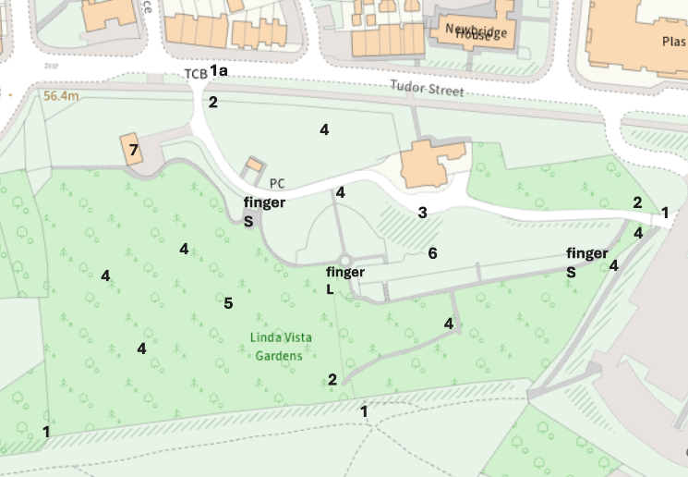

Appendix 3: Context Photos of map locations

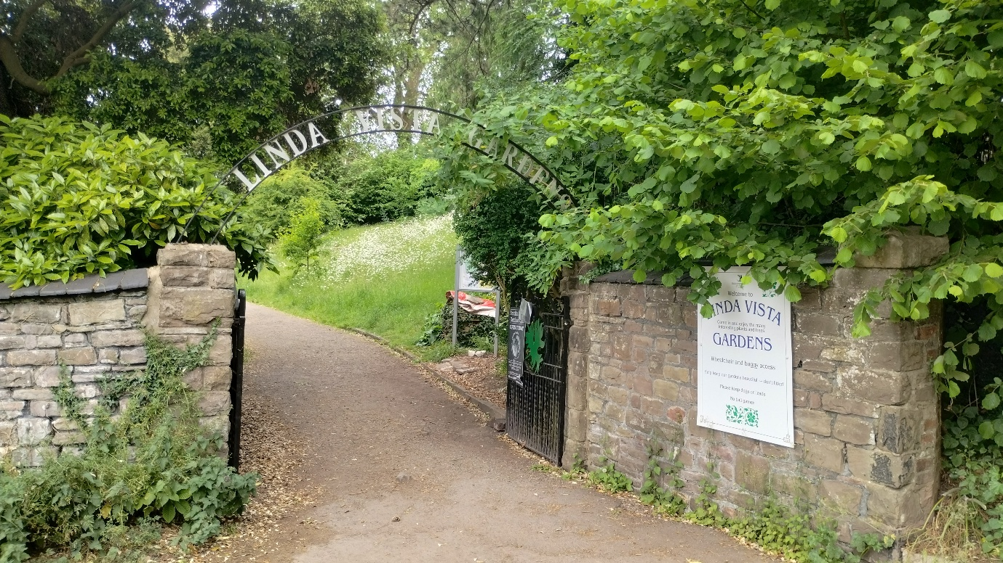
Entrance from Byefiled Lane car park (what3words: ///order.perfectly.swanky)

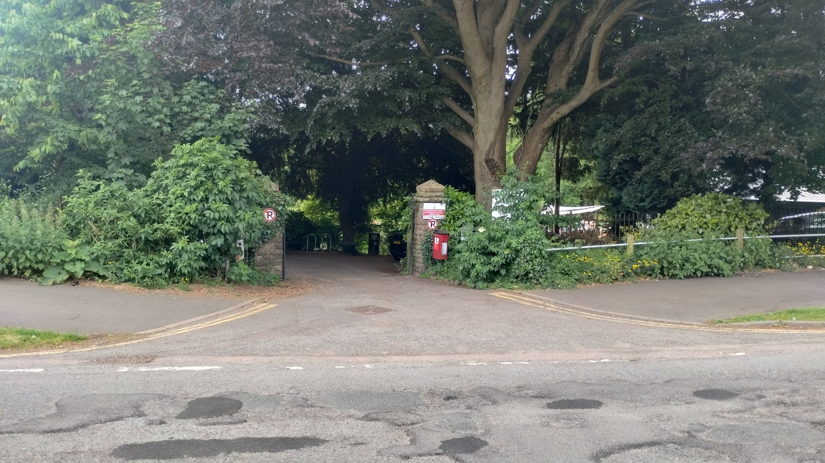
Entrance from Tudor Street (What3words: ///glider.outbound.ethic)

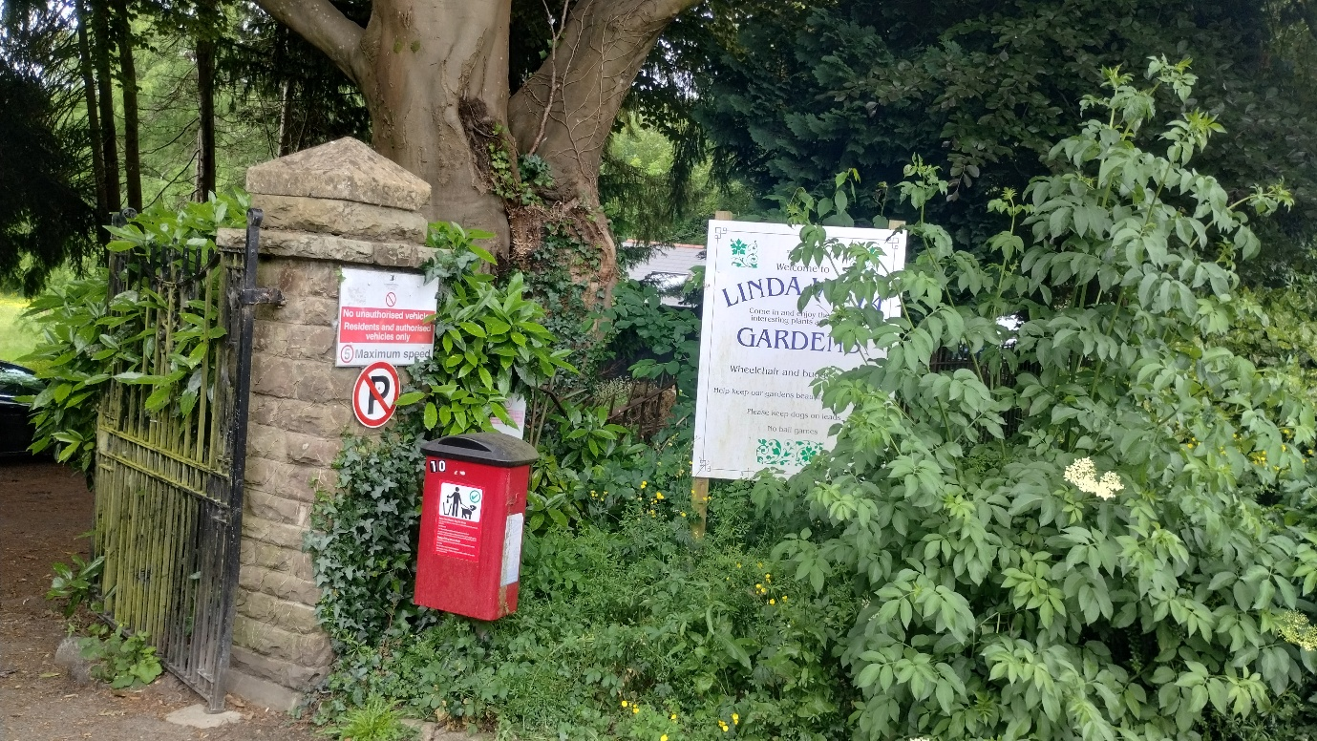
Current signs to be replaced at Tudor Street entrance

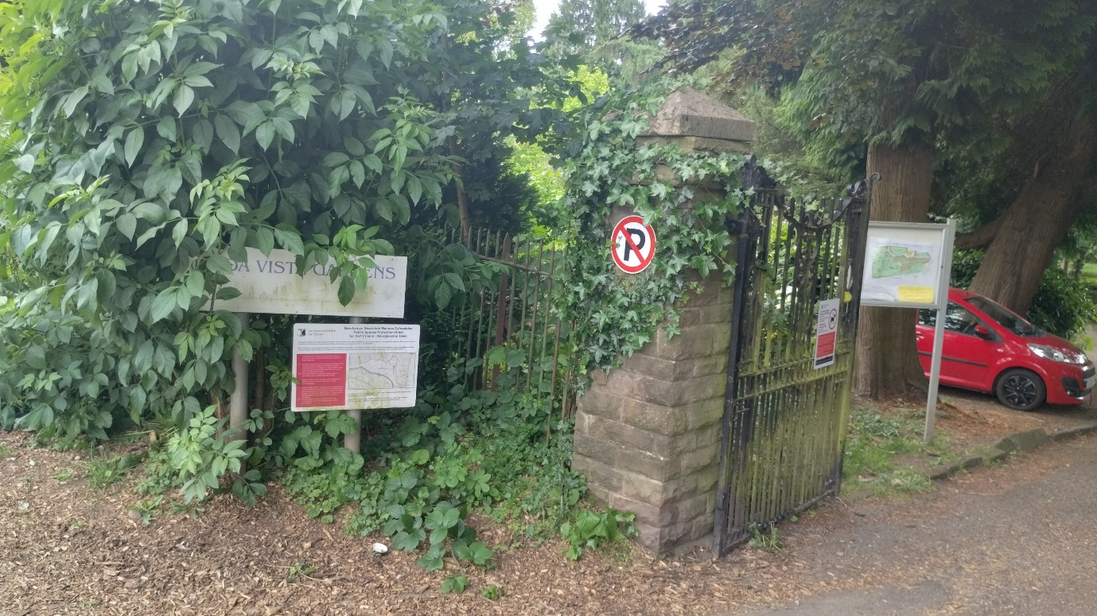
Current signs to be replaced at Tudor Street entrance

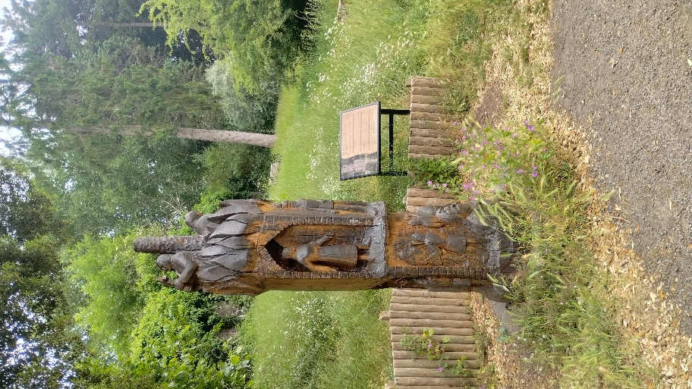
Carved tree and heritage panel to be retained
(What3words: ///hopefully.besotted.slap)

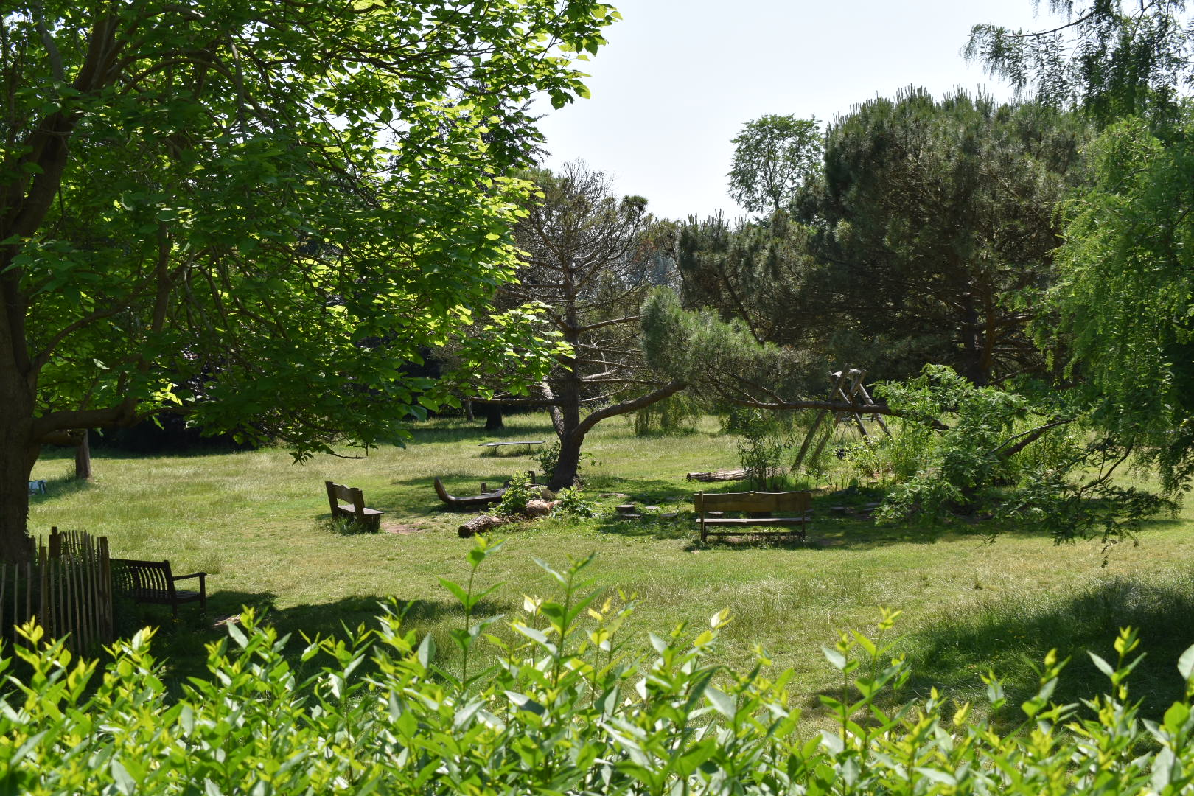
Looking out across the informal area of the gardens (what3words: ///holdings.major.revamped)

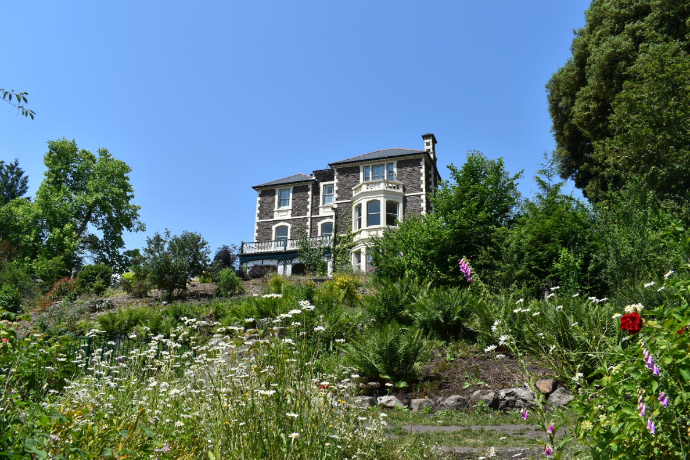
Looking up towards Linda Vista (What3words: ///montage.spaces.basically)



Example Specimen tree

